V2.10: Density Differences in Fluids

(Related to Textbook Section 2.11.1 - Archimedes' Principle)

We often think of buoyancy effects in terms of a solid object floating in a fluid, such as a boat on water. However, the effects of buoyancy can also be observed in fluid-fluid interactions. The only requirement is that density differences exist between the fluids.

The video shows several examples of a fluid rising or falling due to the density differences. The first segment shows a turbulent plume rising from the flame of a cigarette lighter, as shown in the picture below. The plume is made visible by using the Schlieren optical method. The hot gas from the flame has a lower density than the surrounding air and thus it rises. It should also be noted that you can see air rising around the arm of the person holding the lighter. The body heat warms the air in contact and lowers the density so it rises. And if you look closely, you can also see as the person exhales.
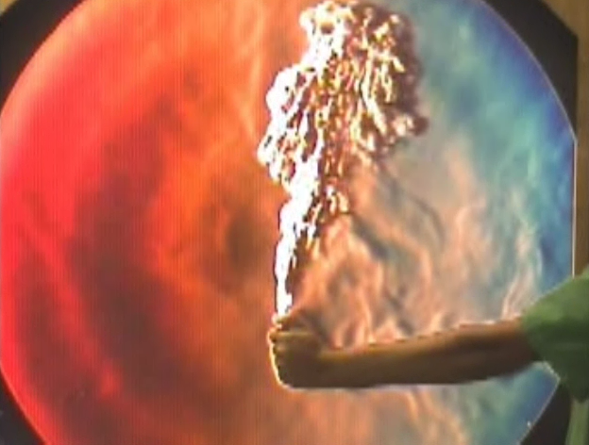

The second segment makes use of the same cigarette lighter, but with no flame. The lighter uses butane as the fuel, which is heavier than air. So when the button is depressed, it releases butane which falls due to the higher density, as shown in the image below.
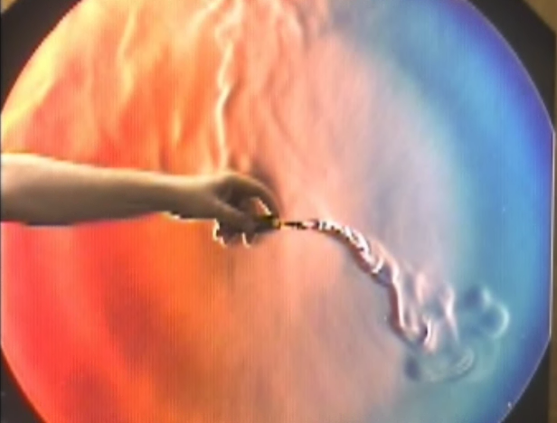
In similar fashion, a small amount of liquid acetone is placed in a beaker which produces a dense vapor. The video shows this dense vapor being poured from the beaker almost as if it were a liquid. The vapor falls because it is more dense than the surrounding air.
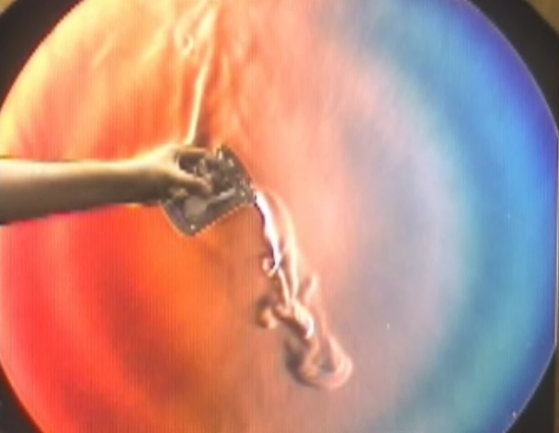
The final segment makes use of computational fluid dynamics, or CFD, simulations to demonstrate density differences. As shown below, the CFD results simulate an open freezer with cold air falling to the floor, since the cold air is more dense than the room air. For gases, the density is inversely proportional to temperature.
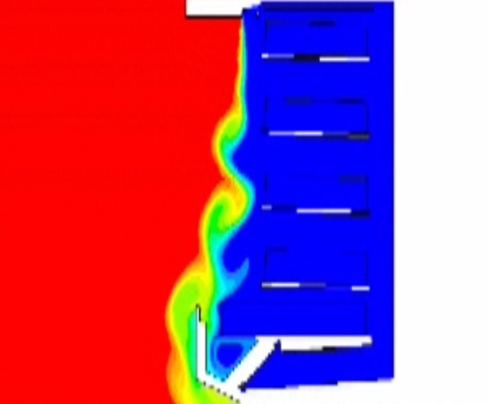

Video © 2004 Gas Dynamics Laboratory The Pennsylvania State University with a grant from the National Science Foundation.

