V5.7: Air Jet Momentum Flux

(Related to Textbook Section 5.2.2 - Application of the Linear Momentum Equation)

The video shows a simple demonstration of momentum flux and a reaction force. Compressed shop air is blown through a nozzle to produce a jet of air that impinges on a scale. The air jet is made visible through the use of the Schlieren optical method, as shown in the image below.
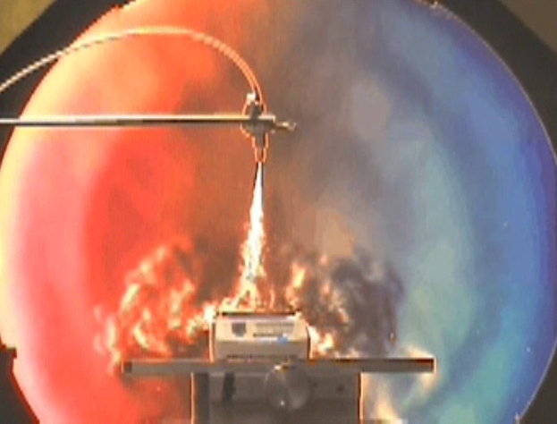

The air jet carries a certain amount of momentum as it impinges the scale. This produces a measurable force that is converted to a digital readout on the scale.
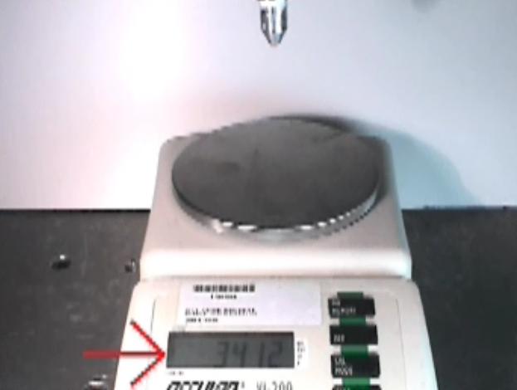

Making use of an appropriate control volume, as shown below, and summing the forces and momentum fluxes in the vertical direction, and making use of Newton's 2nd Law, we see that the force measured by the scale is equal to the momentum flux at the nozzle.
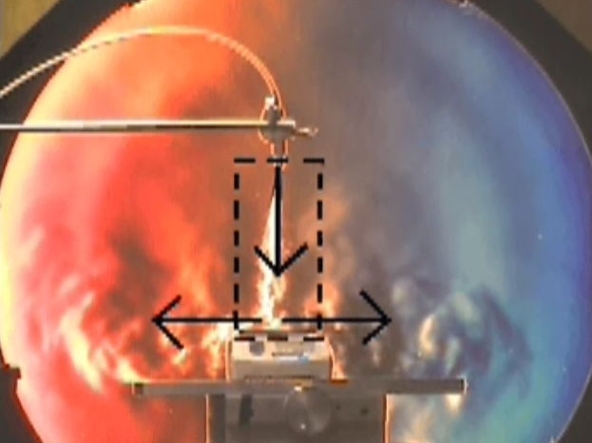

Video © 2004 Gas Dynamics Laboratory The Pennsylvania State University with a grant from the National Science Foundation.

Please click here to download video.

