GENERAL SPECIFICATION
ROTATING MACHINERY
GS EP MEC 011

Rotating Machine Package Specification
Diesel Engine Driven Emergency Generator

02 | 10/2012 | Update
01 | 01/2012 | GS Splitting in GS EP MEC 011 - 012 & 013
00 | 01/2011 | First issue
Rev. | Date | Purpose of the revision

Owning entity: DEV/TEC | Managing entity: DEV/TEC/MTH

Project Specification n° |  | Revision:
 |  | Date:

Contents
Preamble 4
1. Scope 5
1.1 Purpose 5
1.2 Application 5
1.3 General rules 5
2. Reference documents 6
3. Scope of supply and exclusions 11
3.1 Scope of supply 11
3.2 Exclusions 15
4. Basis of design 16
4.1 Engine 16
4.2 Generator 25
4.3 Particular specification for rotating equipment - Packaging 25
5. Data sheets 35
5.1 Engine 35
5.2 AC generator 35
5.3 Electric motor 35
5.4 Noise 35
5.5 Weight 35
5.6 Data sheets templates 35
6. Site conditions and utilities 36
6.1 Site conditions 36
6.2 Utilities 38
7. Tests 39
7.1 Factory tests (workshop) 39
7.2 Performance tests 39
8. Spare parts and special tools 43
8.1 Spare parts 43
8.2 Special tools 44
9. Preparation for shipment 46
9.1 Preservation 46
9.2 Packing 48
9.3 Transportation 50
Appendix 1 Definitions and abbreviations 51
Appendix 2 Baseplate installation 52
Appendix 3 Vendor Document Register (VDR) 53
Appendix 4 Minimum inspection requirements 56
Appendix 5 Deviations to the contractual documents 57
Appendix 6 Data Sheet 58

Preamble

Scope

Purpose
This specification defines the minimum design, fabrication, inspection and testing requirements for the supply of emergency diesel engine driven generator packages. It is an exhaustive document detailing the scope of supply and the associated design rules requested by TOTAL E&P for the procurement of emergency diesel engine driven generator packages.

Application
This document applies to the design of all diesel engine driven emergency generator packages. It excludes any other type of diesel engine driven generator.

General rules
All deviations from this specification or the documents referred to herein shall be stated in writing in the Appendix 5 of this specification. In the absence of such a statement, it is assumed that the requirements of the specifications are met without exception. Failure to meet the requirements of this specification and referenced documents shall be corrected at Supplier’s cost. Exceptions and deviations to the specifications shall be part of Supplier’s proposal and will be subject to Company approval.
Where this specification, or any other project document, allows the Supplier to propose an “option”, the Supplier shall clearly state the selected option in his bid.
In cases the Supplier provides outsourced equipment, he shall be responsible for the coordination of the Sub-Suppliers, and ensuring the full compatibility of all the equipment. In particular, they shall be compatible in terms of safety, environment, operability, dimensions, weight, performance, control, noise and vibration behavior.
Components not mentioned in this specification that are necessary for the operation of the equipment or required by certifying agency, regulatory bodies or by law, shall be Supplier standard components.
The present document remains a General Specification as long as the modifiable forms are not completed. It becomes the Project Specification once these modifiable forms are completed and shall therefore not be considered as a General Specification any more.
Then, the General Specification shall be attributed a Project reference number with the associated Project front page.
Preamble shall be completed with the Project description (location, number of machines, etc.).
If Project specificities require amendments to non modifiable parts of this specification or to the documents referred to herein, they shall be considered as deviations and stated in writing in the Appendix 5 of this specification.
This specification will then be issued in two steps:
- Issued “for inquiry”
- Issued “for purchase”.
The applicable documents shall be considered in the following order:
- Local regulations
- Classification Society Rules (If applicable)
- Frame agreement if available - Frame agreement: Applicable  - Not applicable
- This completed specification and associated data sheets
- Referenced General Specifications
- Referenced project specifications
- Codes and standards.

Reference documents
The reference documents listed below form an integral part of this General Specification.
External Documents
Unless otherwise stipulated, the applicable version of these documents, including relevant appendices and supplements, is the latest revision published at the effective date of this document.
Reference | Title
1999/92/EEC  (ATEX 118¹/ATEX 137²) | European Directive 1999/92/EEC (16/12/99) on minimum requirements for improving the safety and health protection of workers potentially at risk from explosive atmospheres
94/9/EC  (ATEX 100a/ATEX 95) | European Directive 94/9/EC (23/03/94) on the approximation of the laws of the Member State concerning equipment and protective systems intended for use in potentially explosive atmosphere
ASHRAE 52.2 | Method of Testing General Ventilation Air-Cleaning Devices for Removal Efficiency by Particle Size
ASME VIII Division 1 | Boiler and Pressure Vessel Code
ASME B1.20.1 | Pipe threads, general purpose (inch)
ASME B16.5 | Pipe flanges and flanged fitting: NPS ½ through 24
ASTM D975-10b | Standard Specification for Diesel Fuel Oils
DIN 55473 | Auxiliary means of packaging - Desiccant in bag - Technical delivery conditions
IEC 60034-1 | Rotating electrical machines - Part 1: Rating and performance
IP 15 | Area Classification Code for Petroleum Installation handling flammable fluids - July 2005 (3rd edition)
ISO 10816 (Parts 1; 3; 6) | Mechanical Vibration - Evaluation of machine vibration by measurements on non-rotating parts - (Parts 1; 3; 6)
ISO 155 | Belt drives - Pulleys - Limiting values for - adjustment of centres
ISO 15550 | Internal combustion engines - Determination and method for the measurement of engine power
ISO 1813 | Belt drives. V-ribbed belts, joined V-belts and V-belts including wide section belts and hexagonal belts. Electrical conductivity of antistatic belts : characteristics and methods of test
ISO 254 | Belt drives - Pulleys - Quality, finish and balance
ISO 3046 (Parts 1; 4; 5; 6) | Reciprocating internal combustion engines - Performances - (Parts 1; 4; 5; 6)
ISO 4183 | Belt drives - Classical and narrow V-belts - Grooved pulleys (system based on datum width)
ISO 4184 | Belt drives - Classical and narrow V-belts - Length in datum system
ISO 5292 | Belt drives V-belts and V-ribbed belts - Calculation of power ratings
ISO 780 | Packaging - Pictorial marking for handling of goods
ISO 8178 (Parts 1; 3; 6) | Reciprocating internal combustion engines - Exhaust emission measurement - (Parts 1; 3; 6)
ISO 8528 (Parts 1; 2; 3; 5; 6; 9) | Reciprocating internal combustion Engine Driven AC Generating Sets - (Parts 1; 2; 3; 5; 6; 9)
NF H00-310 | Industrial packagings. Flexible and heat sealing protection materials of low coefficient of water vapour transmission (P < 0.3 g/m² 24 h)
NF H00-320 | Packaging. Desiccant. Specifications and tests
NR 445 | Bureau Veritas: Rules for the classification of offshore units
SOLAS | International Convention for the Safety of Life at Sea - IMO
US MIL-STD-2073-1 E | Standard practice for military packaging
US MIL D 3464E | Desiccants, activated, bagged, packaging use and static dehumidification
US MIL PRF 131K | Performance specification: Barrier materials, watervaporproof, greaseproof, flexible, heat sealable

Total General Specifications
Unless otherwise stipulated, the applicable version of these documents, including relevant appendices and supplements, is the latest revision published in the applicable yearly collection.
TOTAL EP General Specification Referential is applicable for the following Project:

The following Company specifications are fully applicable to all purchased equipment as listed in paragraph 3.1 completed by the technical details reported in paragraph 4 and taken into account accepted deviations as listed in Appendix 5. The second level General Specifications mentioned in each individual specification are not applicable if they are not listed in the below tables. The standards, professional documents, regulations and codes mentioned in each General Specification are applicable.
The following list may also be complemented with other specific Project detailed specifications which would include additional requirements, as applicable or deemed necessary by Company or Contractor.
Reference | Title
GS EP COR 350 | External protection of offshore and coastal structures and equipment by painting
GS EP COR 351 | External protection of structures and equipment by painting. Floating structures
GS EP COR 353 | Design and application of passive fire protection coatings
GS EP COR 354 | External protection of onshore structures and equipment by painting
GS EP COR 356 | Corrosion Protection of Fasteners for Subsea and Topside Applications
GS EP ELE 001 | Electrical design criteria
GS EP ELE 011 | Electrical requirements for packaged units
GS EP ELE 013 | Electrical requirements for generating units
GS EP ELE 021 | Electrical design criteria for floating units
GS EP ELE 031 | Design of earthing and bonding systems
GS EP ELE 079 | Electrical apparatus for potentially explosive gas atmospheres
GS EP ELE 113 | AC generators
GS EP ELE 151 | DC Uninterruptible Power Systems (UPS)
GS EP ELE 161 | Electrical cables
GS EP EXP 217 | Requirements to Vendors, Suppliers and EPC’S for spare parts
GS EP INS 101 | Instrumentation engineering, supply and construction general requirements
GS EP INS 102 | Instrumentation identification
GS EP INS 107 | Design and installation of instrumentation links
GS EP INS 110 | Instrumentation for package units
GS EP INS 135 | Cyber Security requirements for design and supply of ICSS and Package Systems
GS EP MEC 292 | Rotating Machines Packages Installation Requirements
GS EP MEC 300 | Noise and Vibration of Rotating Machine Packages
GS EP PVV 112 | Piping material classes
GS EP PVV 143 | Metallic pipes
GS EP PVV 144 | Fittings
GS EP PVV 145 | Flanges
GS EP PVV 175 | Cleaning of piping and vessels
GS EP PVV 211 | Design and fabrication of pressure vessels according to ASME VIII
GS EP PVV 412 | Plate and frame heat exchanger
GS EP PVV 415 | Design and fabrication of air cooler
GS EP SAF 050 | Fire and Gas System and Fire Suppression System for Packaged Rotating Machinery Enclosures
GS EP STR 001 | Weight monitoring and weighting offshore units
GS EP STR 103 | Design and fabrication of skids and equipment supporting structures

In case one of the previous General Specifications is completed with one or more Project specific detailed specification(s), then these detailed specifications (and their respective revision) shall be added to the following list.
Project Documents (to be completed by Company or Contractor)
 | Designation | Rev | Reference
1 | PID’s (*)
2 | Layout (*)
3 | Project specification for electrical requirements for packaged units (*)
4 | Instrument tagging specification
5 | Instrument list database specification
Note: All the documents identified by (*) shall be available along with this specification for the issue for inquiry and for purchase.
Project data sheets are listed in paragraph 5.

Scope of supply and exclusions

Scope of supply
The Vendor shall be responsible for the design, supply of materials, manufacture, assembly, supply of drawings and data, all Sub-Vendor co-ordination, testing, delivery and guarantees of the below components:
Note 1: The column “Required” indicates the level of requirement of each item, according to the below rule:
- “X” means that the item is a base case requirement.
- “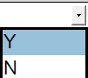 means that the item is an optional requirement specific to the project. “Y” for YES if the option is selected or “N” for NO if the option is not selected.
Note 2: The column “Description” may offer alternative technical choices that shall be fixed prior to the issue “For inquiry” by ticking the appropriate mark box .
# | Item | Description |  |  |  | Required | Tag | Quantity
1 | ON SKID EQUIPMENT
1.1 | Driven generator including but not limited to:
1.1.1 | Generator | As per GS EP ELE 113, ISO 8528-1, ISO 8528-3 and as per data sheet referenced in paragraph 5 of this specification. |  |  |  | X
1.2 | Engine as per ISO 8528-2 including but not limited to:
1.2.1 | Engine | Diesel engine |  |  |  | X
1.2.2 | Starting systems | Electric starting system as per paragraph 4.1.2.7.2 of this specification.
1.2.2 | Starting systems | Pneumatic starting system as per paragraph 4.1.2.7.3 of this specification |  |  |  | X
1.2.2 | Starting systems | Back up Hydraulic starting system as per paragraph 4.1.2.7.4 of this specification |  |  |  | X
1.2.3 | Cooling system | Engine mounted cooling system as per paragraph 4.1.2.6 of this specification. |  |  |  | X
1.2.4 | Lube oil pre/ post system | Engine mounted lube oil pre/ post system as per paragraph 4.1.2.5 of this specification. |  |  |  | X
1.2.5 | Flexible mounts | Engine flexible mounts. |  |  |  | X |  | set
1.2.6 | Gauge board | Engine mounted local gauge board. |  |  |  | X
1.3 | Liquid fuel system including but not limited to:
1.3.1 | Fuel tank | Fuel tank in AISI 316L material as per paragraph 4.1.2.4.3 of this specification.
1.3.2 | Automatic filling | Automatic filling system with all necessary auxiliaries.
1.3.3 | Heat exchanger | Fuel system return heat exchanger.
1.3.4 | Liquid fuel system shutoff valve | Liquid fuel system shutoff valve as per paragraph 4.1.2.4.2 of this specification. |  |  |  | X
1.4 | Combustion air system including but not limited to:
1.4.1 | Air shutoff flaps | Air shutoff flaps engine mounted as per paragraph 4.3.3 of this specification.
1.4.2 | Air inlet filter | Air inlet filter including ducting as per paragraph 4.1.2.2.1 of this specification. |  |  |  | X
1.5 | Exhaust gas system including but not limited to:
1.5.1 | Exhaust silencer | AISI 316 exhaust silencer as per paragraph 4.1.2.3.1 of this specification. |  |  |  | X
1.5.2 | Exhaust duct | AISI 316 exhaust ducting as per paragraph 4.1.2.3.2 of this specification. |  |  |  | X
1.5.3 | Spark arrestor | Spark arrestor in AISI 316L. |  |  |  | X
1.5.4 | Exhaust thermal insulation and sheeting | As per paragraph 4.3.10 of this specification.
1.5.5 | Auxiliaries for gas tight exhaust system | Exhaust system gas tight as per project requirements.
1.5.6 | Exhaust pipe downstream silencer | Exhaust pipe downstream silencer in AISI 316 and drain system for vertical stack installation.
1.5.7 | Supporting steel | Supporting steel structure mounted on the enclosure roof for all above equipment and associated fixation. |  |  |  |  |  | set
1.5.8 | Ladders | Access ladder to roof enclosure. |  |  |  |  |  | sets
1.5.9 | Roof handrails and walkways |  |  |  |  |  |  | sets
1.6 | Power transmission equipment including but not limited to:
1.6.1 | Coupling between engine and generator | As per paragraph 4.3.4 of this specification. |  |  |  | X
1.6.2 | Coupling guard | Rigid type as per paragraph 4.3.4 of this specification. |  |  |  | X
1.7 | Enclosure including but not limited to:
1.7.1 | Acoustic and fire resistant enclosure frame and general assembly | As per paragraph 4.3.3 of this specification. |  |  |  | X
1.7.2 | Enclosure air ventilation system | As per paragraph 4.3.3.1 of this specification. |  |  |  | X
1.7.3 | Enclosure fire and gas detection system | UV/IR flame detectors, gas detectors, heat detectors as per GS EP SAF 050. |  |  |  | X
1.7.4 | Enclosure fire fighting system | As per GS EP SAF 050. |  |  |  | X
1.7.4 | Enclosure fire fighting system | Water mist |  | CO₂ |  | X
1.7.5 | Handling inside enclosure | Monorail and associated hoist inside enclosure. |  |  |  | X
1.7.6 | Enclosure lighting systems | Normal and emergency lighting system as per paragraph 4.3.3.2. |  |  |  | X
1.8 | Base plate including but not limited to:
1.8.1 | Fabricated steel common base plate | As per paragraph 4.3.2.2 of this specification. |  |  |  | X
1.9 | Control & Instrumentation including but not limited to:
1.9.1 | Junction boxes | All necessary instrumentation junction boxes at skid edges for collect of output/ input instrumentation as per GS EP INS 101 and GS EP INS 107. |  |  |  | X |  | set
1.9.2 | Cable glands | Cable glands for departing multi-core cables, defined by Project and blinded off suitably for transport and storage. In case the option is not selected, the gland plates shall be pre-drilled and blinded off. |  |  |  |  |  | set
1.9.2 | Cable glands | For all other cables, junction boxes shall be provided with cable gland plates and associated cable glands. |  |  |  | X
1.9.3 | Instrumentation cables | All instruments cables between Instruments and skid mounted terminal junction boxes / local gauge board as per GS EP ELE 161 and GS EP INS 107. |  |  |  | X |  | set
1.9.4 | Instruments cables trays | All necessary cables with covers trays made of AISI 316L between instruments and skid mounted junction boxes / local gauge board and empty cable trays for the multicable (supplied and installed by other) between the terminal junction box and skid edge. As per GS EP INS 107. |  |  |  | X |  | set
1.10 | Electrical including but not limited to:
1.10.1 | Batteries | Batteries installed in protective box as per paragraph 4.1.2.7.2 of this specification. |  |  |  | X
1.10.2 | Battery charger | As per paragraph 4.1.2.7.2 of this specification. |  |  |  | X
1.10.3 | Electrical cables trays | All necessary cables trays with covers made of AISI 316L between all electrical consumers mounted on skid and the skid edge. |  |  |  |  |  | set
2 | OFF SKID EQUIPMENT (shipped loose)
2.1 | UCP | UCP including separate PLCs for control/safety and F&G, panel mounted HMI. As per GS EP INS 110 and paragraph 4.3.6 of this specification. Full licenses for all software. |  |  |  | X
2.2 | ICSS interface | Communication cards, relays, signal convertors, etc. to interface with ICSS and support systems (if any). |  |  |  | X
2.3 | Synchronizer | UCP synchronizer according to GS EP ELE 013 requirements. |  |  |  | X
2.4 | Interconnecting piping | All interconnecting piping, pipework between main baseplate and fire fighting cabinet. |  |  |  |  |  | set
2.5 | Flame arrestors | Heavy duty flanged type in AISI 316L as per paragraph 4.3.8.2 of this specification. |  |  |  | X
2.6 | Spare parts for commissioning and start–up | As per paragraph 8.1.1 of this specification. |  |  |  | X |  | set
2.7 | Special tools | As per paragraph 8.2 of this specification. |  |  |  | X |  | set
3 | MISCELLANEOUS
3.1 | Baseplate anchor bolts and shims | As per Appendix 2 of this specification. |  |  |  | X
3.2 | Off skid equipment anchors and shims | All anchors and shims for all off skid equipment supplied by SUPPLIER. |  |  |  | X
3.3 | Maintenance laptop | Including software for UCP configuration. |  |  |  | X
3.4 | Backup | Complete backup hard disk with application software, PLC program, HMI and any firmware prior to shipment. |  |  |  | X
3.5 | Softwares | OEM-CD/DVD for any software used with full licenses. |  |  |  | X
3.6 | Lube oil system flushing kit | Kit made of all necessary flexible hoses for machinery bearings bypass. |  |  |  |  |  | set
3.7 | Inflation kit | Inflation kit for accumulators nitrogen charging.
3.8 | Platforms and ladders, handrails and walkways | All necessary access platforms, ladders, handrail grating and access way for easy and safe maintenance. |  |  |  |  |  | set
3.9 | Lifting tools for the complete package | Certified lifting beam, slings and shackles for a single point lifting of each complete unit as per paragraph 4.3.2.3 of this specification. |  |  |  | X
3.10 | Battery limit flanges | All limit flanges as per GS EP PVV 112 or project piping classes -if any- and equipped with blind flanges for transportation. |  |  |  | X |  | set
3.11 | Documentation | Set of documents as per Appendix 3 of this specification. |  |  |  | X |  | set
3.12 | Earthing network | Earthing design and implementation as per GS EP ELE 031 and GS EP INS 107. |  |  |  | X |  | set
3.13 | Painting and coating | As per data sheet and as per paragraph 4.3.9 of this specification. |  |  |  | X |  | set
3.14 | Personal protection | As per paragraph 4.3.10 of this specification. |  |  |  | X |  | set
3.15 | Piping | All necessary piping/tubing. |  |  |  | X
3.16 | Package preservation | As per paragraph 9.1 of this specification. |  |  |  | X
3.17 | Packing | As per paragraph 9.2 of this specification. |  |  |  | X
3.18 | Specific climate considerations | Tropicalization | Winterization |  | None | X
4 | TESTS
4.1 | Factory tests
4.1.1 | Engine | As per paragraph 7.2.3 of this specification. |  |  |  | X
4.1.2 | Generator | As per paragraph 7.2.2 of this specification. |  |  |  | X
4.1.3 | Auxiliaries | As per paragraph 7.2.4 of this specification. |  |  |  | X
4.1.4 | UCP | UCP integration and communication test at sub-Vendor premises as per paragraph 7.4 and Appendix 5 of GS EP INS 110. |  |  |  | X
4.1.5 | Complete unit tests | As per paragraph 7.2.5 of this specification. |  |  |  | X
4.1.6 | Noise and vibration test | As per paragraph 7.2.5 of this specification. |  |  |  | X
4.2 | Site Acceptance Tests including but not limited to:
4.2.1 | Complete unit tests | As per paragraph 7.2.7 of this specification. |  |  |  | X
4.2.2 | Fire suppression system test | As per paragraph 3.5.2 of GS EP SAF 050. |  |  |  | X
Vendor shall be responsible for the physical and technical compatibility of the entire package and shall ensure that all equipment and components provided are suitable for the operations intended.

Exclusions
The following equipment are not included in the scope of supply:
- Gaskets and bolting for connecting flanges at battery limits of Vendor’s supply
- All piping outside the package
- Electric and instrument cables outside the package
- All earthing cables outside the package.

Basis of design
This paragraph details the technical specificities of Project that are neither covered in the Company General Specifications nor in the Project documents.

Engine
The scope of this paragraph is for diesel engines above 200 kW rated power. Special circumstances may dictate its application to smaller engines, such as for use in vital service.

Basic requirements

Range of application
The engine shall be suitable for continuous unattended base load operation for 24 hours per day at the extremes of ambient conditions given in paragraph 6 of this specification.
Engines shall be guaranteed by the Supplier to be able to accept full load within 30 seconds of receiving the starting signal.

Power output, fuel and lubricant consumption
The service power of the engine as defined in ISO 3046-1 shall be the continuous power available at the drive coupling of the engine after deduction of all engine-driven auxiliaries. The Supplier shall state the auxiliaries driven by the engine and their power absorbed in computing the rated power.
Engine-driven fuel and lubricating oil pumps and separate lubricators for valve gear or cylinders are regarded as engine components and not auxiliaries within the context of the declaration of power according to ISO 3046-1.
The ISO power shall be derated to the service power:
- At the most severe ambient conditions under which the engine will operate
and/or
- According to GS EP ELE 021, BV rule NR 445 requirements and appropriate Certifying Authority, for diesel engine driven generator sets to be installed on floating facilities such as FPSO or FPU.
The choice of the engine shall be such that the service power as defined in ISO 3046-1 shall be strictly above the maximum power required by the driven electrical generator input shaft, at any operating point and site conditions. This maximum power required by the electrical generator input shaft shall include the power tolerance of the generator, which is 10% of the generator losses according to IEC 60034-1.
The fuel and lubricant consumption at the above declared powers shall be declared by the Supplier.

Engine and auxiliaries design

General
Gearbox between the diesel engine and the electrical generator is strictly prohibited.

Proven design
Equipment shall be selected from the engine and generator Manufacturer's standard range of products. Prototype equipment will not be considered. Only equipment which is of a size, type, rating and method of manufacture with which satisfactory experience can be demonstrated shall be supplied. Details of such equipment in service shall be provided by the Supplier.

Periodic inspection and overhaul
The time between major overhauls shall be at least 25 000 running hours for engines in continuous duty. The effect of frequent starting and of periods of idleness shall be taken into account when determining the time between major overhauls of engines in intermittent duty.
The Supplier shall provide the following information:
- Recommended periods between inspections, minor and major overhauls
- Inspection, minor overhaul and major overhaul activities, together with the man-hours required for each
- Weight of the heaviest component normally removed during major overhaul
- Recommended oil and oil filter change frequency
- Engine availability based on scheduled downtime
- Spare parts and special tools required for major and minor overhauls.

Combustion air intake system

Air filter
The engine air filter shall comprise a minimum of two stages, an inertial stage followed by a replaceable dry media stage for all installations.
The air filter shall remove 98% of all particles greater than 10 μm in SAE fine test dust when tested in accordance with ASHRAE 52.2.
All air filters shall be sheltered from rain ingress.
The filter shall have means of removing debris arrested in the inertial stage.
The filter shall be fitted with a differential pressure indicator to show when the filter requires attention.
For marine, offshore or coastal installations, all components of the air filter shall be made from non-corroding materials. Stainless steel is preferred and an easily weldable grade, not less than AISI 316L, shall be used for plate materials, rolled sections and other parts that may require welding.
Paint or similar coatings shall not be applied to the internal surfaces of combustion air ducting downstream of the air filter.

Intake location and ducting
If the air filter is to be installed remotely from the engine, the engine Manufacturer shall supply the filter loose to be installed by Supplier or Contractor. The ducting between the filter and the engine shall be AISI 316L stainless steel.
The engine Manufacturer shall recommend the size of the intake pipe between the filter and the engine, and shall review the Supplier or Contractor's design to ensure that the ducting does not impose unacceptable strains on the engine. The Supplier shall supply a flexible joint between the intake pipe and the engine.
All external connections from the engine shall terminate in flanges to ASME B16.5.

Exhaust system

Silencer
The exhaust silencer shall be supplied by the Supplier, and shall attenuate the engine exhaust to 85 dB(A) at one meter. The exhaust silencer shall have an integral spark arrester.
The exhaust silencer, spark arrester and flexible ducts and connections shall be manufactured in AISI 316L stainless steel.

Exhaust duct
The routing of the exhaust ducting from the engine termination to the discharge to atmosphere shall be agreed between the Contractor and the Supplier. The Supplier shall advise the size of the exhaust pipe for remote discharge.
The design of the exhaust ducting shall be agreed between the Supplier and the engine Manufacturer to ensure that excessive forces are not transmitted to the engine termination. The design of spring or flexible supports shall be reviewed by the engine Manufacturer. The engine Manufacturer shall provide an expansion bellows at the engine termination.
All external connections from the engine shall terminate in flanges to ASME B16.5.

Diesel fuel system
The diesel fuel system shall be suitable for diesel fuel oil - ASTM D975-10b, Grade n° 2-D or equivalent as per engine data sheet (refer to paragraph 4.3.14 of this specification).

Diesel fuel supply and filtration
The diesel fuel supply and filtration system shall include at least the following:
- Water and sediment trap/pre-filter
- Engine-driven fuel supply pump
- Fuel filter
- Manual fuel priming pump(s).
Dual fuel filters with a change-over valve shall be supplied. The filters shall be of the replaceable element type and readily accessible for maintenance. The elements shall be capable of removal with the engine running without breaking any fuel connections or disturbing the fuel pumps or other engine parts.
Fuel filters shall be equipped with a differential pressure indicator. Fuel filters and pre-filters shall be fitted with sediment drain valves and vent valves for purging any air trapped in the filter.
The injector fuel spill shall be routed to the fuel day tank. This requirement does not apply if the Manufacturer has a standard system which returns the spill-back to the suction of the fuel injection pump.

Isolation valve
The Supplier shall provide a manually operated quick-acting diesel fuel isolation valve for installation in the fuel supply line to the engine. This valve shall be additional to any automatic cutoff valves specified in any certifying authority rules.

Day tank
A diesel fuel day tank shall be provided by the Supplier. The tank shall be manufactured from AISI 316L stainless steel. The tank shall be arranged to supply the engine by gravity via the pre-filter and the fuel supply pumps.
The day tank capacity shall be sufficient for not less than:
- Twelve (12) hours continuous operation at full load for installations other than Floating Facility (FPSO, FPU, etc).
- Eighteen (18) hours continuous operation at full load for a Floating Facility (FPSO, FPU, etc.).
The day tank shall be fitted with level gauge(s) and high and low level alarm transmitters. The low level alarm shall be set for half the running time design capacity of the tank. The inlet shall be fitted with a level control float valve if specified in the scope of supply, otherwise it shall be fitted with a snap-opening cap for manual filling.
The following connections are required on the tank: inlet, outlet, injector spill-back (if required), drain (with self-closing valve), overflow, vent line (with flame trap), manhole and nozzles for instrumentation. The nozzles welded to the tank shall be DN 50 minimum, concentrically reduced to the required flange size where necessary. The fuel outlet to the engine shall be not less than 50 mm above the bottom of the tank.
If the site ambient temperature given in paragraph 6 of this specification is below the cloud point of the specified fuel, the day tank shall be fitted with an electric heater. The heater shall comply with paragraph 4.1.2.6.4 of this specification, and shall maintain the fuel at a temperature 20 °C above the fuel cloud point.
The day tank shall be part of the engine installation. If its size dictates otherwise, it shall be supplied loose for installation into the Company's structure by the Contractor. Fuel lines to and from the day tank shall be made from AISI 316L stainless steel.

Lubrication system

Oil filters
Full-flow oil filters shall be fitted as standard.
Engines shall be provided with dual full-flow filters with manual changeover valves. In this case, the lubricating oil filters shall be fitted with indicators to show when the filters require changing.
Separate free-standing lubricating oil filters, if any, shall have a manual drain valve and a manual vent returning to the oil sump with a sight glass for removal of trapped air during filter changes.

Oil cooling
The lubricating oil cooler may be either included in the engine coolant circuit or the oil may be separately cooled in an air-cooled radiator or by an external water circuit. Selection of the cooling system shall be agreed between the Supplier, Company and the Contractor.
All lubricating oil piping and connections to a remotely mounted oil cooler shall be AISI 316L stainless steel.
The oil cooling system shall be designed for 110% of the heat rejection at the engine service power at site conditions with the absolute maximum ambient temperature stated in paragraph 6.1 of this specification.
The lubricating oil pressure shall at all times be greater than the coolant pressure. For seawater cooling the materials in contact with the seawater shall be of a corrosion-resistant material approved by the Company.
Air-cooled oil coolers should be included as a separate section of the engine cooling system.

Pre-lubrication
The Supplier shall advise if a pre-lubrication pump is required for rapid starting of the engine. The pre-lubrication pump shall be supplied by the Supplier.
Starting shall not be delayed by a pre-lubrication period. If the engine design requires pre-lubrication prior to starting, the Supplier shall include a pre-lubrication pump control which runs the pre-lubrication pump for five minutes in each hour that the engine is on standby.
If a turbocharged engine is fitted with a pre-lubrication pump, it shall run for not less than 10 minutes after engine shutdown to supply lubricating oil to the turbocharger during cool-down. The Supplier shall apply other arrangements to prevent heat soak into the turbocharger bearings upon engine shutdown on engines without pre-lubrication pumps. Consideration shall be given to achieving turbocharger cool-down by means of idling at no-load for an extended period before engine shutdown.

Condition monitoring
The lubricating oil circuit shall be fitted with a 1/2 inch NPT plugged connection as defined in ASME B1.20.1 between the oil pump and the oil filters for the Supplier to install magnetic chip detectors and an oil sampling point.

Fire prevention
Any external lubricating oil piping shall be designed so that a fracture of the piping or leakage from any joint will not cause lubricating oil to spray onto any surface at a temperature exceeding 250 °C.

Engine cooling

General
Each engine driven generator package shall have its dedicated complete cooling system.

Coolant
The engine shall be cooled by fresh water with added scale and corrosion inhibitors. The Supplier shall advise the method of coolant temperature control.
The cooling system shall be provided with an expansion tank, level indicators, pressure relief valve and filling connections. The expansion tank shall have sufficient volume to allow for the thermal expansion of the water or water/glycol mixture. The expansion tank may be either separate from or integral with the radiator according to the engine Manufacturer's standard design.
All low and high points in the coolant circuit shall be fitted with drain and vent valves, respectively.

Cold climates
If the minimum ambient temperature indicated in paragraph 6 of this specification is less than +5 °C, the engine jacket cooling system shall be fitted with an electric heater. The heater shall be rated to achieve a minimum temperature of 45 °C in the engine block during the lowest specified ambient temperature. The heater shall be fitted with integral thermostats to cut off the power when the coolant temperature reaches 75 °C.

Electric heaters
When required, power circuits supplying the heater shall be protected by miniature circuit breakers incorporating overload, short circuit and earth leakage protection. Heat dissipation from the heating element shall not exceed 2.3 W/cm2 on heaters in hydrocarbon heating duty.

Radiator
When a radiator is required, the coolant shall be cooled in an air-cooled radiator supplied by the Supplier. The radiator will either be attached to the engine, or free-standing. The radiator shall be designed for 110% of the engine heat rejection at the engine service power at site conditions with the absolute maximum ambient temperature given in the paragraph 6 of this specification.
The air flow through the radiator shall be away from the engine or towards the outside of the enclosure or vertically upwards as appropriate for the location of the radiator.
The blades of forced-draft fans shall be of either marine aluminum alloy or anti-static reinforced plastic. The fan blades shall be designed to withstand an operating temperature of 120 °C. The fan ring for marine aluminum alloy blades shall be of a spark-proof material such as reinforced plastic or of marine brass.

Fan drives
The radiator fans shall be either directly driven from the engine or hydraulic driven or electric driven. If electric drive fans are proposed, then they should be powered from the engine's electrical system.
For fans with a diameter of 1.5 m or greater that are directly driven from the engine, or if there are two or more fans on the same drive, a freewheeling clutch or passive hydraulic coupling shall be fitted to allow the fans to freewheel to rest upon shutdown of the engine. A single freewheel coupling on the engine power take-off will be permitted for this purpose.
Flexible couplings in the fan drives shall be of the dry type.
In case of belt driven fan, either toothed belts or V-belts are preferred for fan drives. All belt drives shall be in accordance with ISO 155, ISO 254, ISO 4183, ISO 4184 or ISO 5292. Driving belts shall be anti-static in accordance with ISO 1813.

Circulating water cooling
Engine cooling by separate water circulation systems shall be used only with the Company's approval. The jacket coolant pressure shall at all times be greater than the circulating water pressure. For seawater cooling the materials in contact with the seawater shall be of a corrosion-resistant material approved by the Company.

Starting systems

General
The package unit shall be suitable for rapid starting and loading to full capacity within 30 seconds. In case of start failure, an alarm shall be provided on the remote control panel.
Two separate starting systems, fully independent of the plant support facilities shall be provided:
- Primary electric or pneumatic starting system
- Secondary (back-up) hydraulic system.
Each system shall provide energy for six (6) consecutive starting attempts.
Each attempt shall consist of five (5) second cranking followed by ten (10) second rest.
Upon receipt of a start command signal, the UCP shall initiate an automatic start sequence by activating first the primary starting system.
In case of unsuccessful consecutive attempts a “fail to start” signal will be initiated and the engine driven generator unit shall be stopped and put into a safe condition.
The back-up starting system shall be operated locally and manually.

Electric battery starting system
The starting system shall be supplied complete with batteries, starter control, starter contactor and starter overspeed limiting switch. Starting control may be integrated with the package control system.
A single set of starting batteries shall be provided. Batteries shall be of the nickel-cadmium type and shall have the capacity to maintain the firing required engine cranking speed through 6 starting cycles (i.e. 5 seconds of cranking followed by 10 seconds of rest). The engine starter motor shall be of sufficient rating to undergo the above starting cycles without damage or overheating.
Batteries shall be provided with a ventilated, steel-reinforced plastic battery box and supplied as part of the generator package skid. The box lid shall be constructed so that, in the event of mechanical damage, the battery terminals will not be short-circuited. The lid shall also be securable when open as well as when closed. The battery boxes shall protect the batteries against displacement, excessive temperature, vibration, mechanical impact or flooding with water. The batteries within their boxes shall be readily accessible for servicing.
Batteries shall be charged by redundant and independent AC chargers supplied by Supplier.
Battery chargers and change-over systems shall be installed in the engine control panel.
The battery chargers shall be sized to return from fully discharged to fully charged condition within eight hours.
Ampmeter and floating/boost charging facility shall be provided.
When the battery chargers are used to supply control and command system, they shall be in accordance with GS EP ELE 151 requirements.

Pneumatic starting system
The Supplier shall supply control and shutdown valves to admit the pneumatic supply to the starter. The control valves shall be integrated into the engine starting control logic. The starters shall disengage when the engine has reached self-sustaining speed and not after a fixed period of time. However, if the engine fails to start within the time required for 12 complete revolutions, the starting controls shall abort the start.
Turbine-type or gear-type starter motors are preferred over sliding vane type of starter motor requiring lubricant to be injected into the pneumatic supply. All starter motors shall be fitted with overspeed cut-out valves.
The air starting system shall include:
- A compressed air amplifier fed by the plant instrument air system at 7 barg
- Or one electrical motor driven starting air compressor
- Air blast cooler
- Compressed air fine filter(s)
- Swing adsorber units
- Air receiver(s) sized for 6 successful starts
- A pressure transmitter
- Safety relief valves
- Start and stop switches.
The air compressor, if any shall be sized for replenishing the air receivers to full starting air pressure from the minimum allowable starting air pressure in not more than 15 minutes.
The air receiver sets shall be sized for six (6) consecutive starts, including any pneumatic pre-lube oil pump and/or turbocharger starting air assistance. Physical size may require more than one vessel for the air receiver.
Starting air compressor and air receivers shall be integrated in the generator package skid.

Back up Hydraulic starting system
The hydraulic starting system shall be complete and integrated with the engine.
The hydraulic system shall include charge pump, hand charge pump, accumulators, hydraulic start motor, oil reservoir, filters, cooler, pipework, instrumentation and all ancillaries. The design code for the accumulators shall be in accordance with ASME VIII division 1 standard.
The accumulator shall be automatically recharged by a hydro-pneumatic charge pump (Haskel AW type). A hand pump for recharging the accumulator shall be supplied with the system.
Based on site minimum ambient temperature, the accumulator capacity shall allow six (6) cranking cycles of not less than five (5) seconds each. One or more accumulators may be necessary depending on the size of the pressure vessels.
The hydraulic starter motor shall act on the flywheel gear ring.

Speed governing
The engine speed shall be governed in accordance with the requirements of ISO 3046-4 and according to GS EP ELE 013 requirements.

Overspeed protection
The engine shall be fitted with an overspeed device in accordance with ISO 3046-6. This device shall shut down the engine by shutting off the fuel independently of the speed governor.
The overspeed device shall be manual reset only.

Torsional vibration
The assessment and prevention of torsional vibration in the engine and its driving train shall be as specified in ISO 3046-5.
The engine Manufacturer shall provide all the necessary information regarding the engine to the Supplier to enable the torsional vibration calculations to be done.
Alternator drives shall be regarded as having a speed range of 90% to 110% of synchronous speed for the torsional analysis.
The Supplier shall advise the life of viscous type torsional dampers fitted to the engine.

Vibration suppression
Suitable anti-vibration mounts shall be supplied to limit the engine vibrations transmitted to the foundations or surroundings if a vibration analysis study reveals that the package requires isolation from the supporting structure. Anti-vibration mounts shall be of totally enclosed design suitable for the environment, and shall have an isolation efficiency of at least 90% in respect of all engine-induced vibrations.
Full details, including drawings, of the anti-vibration mounts shall be submitted to the Company together with the frequencies and magnitude of any unbalanced forces and moments that will be transmitted through the supports into the supporting structure.

Crankcase explosion relief
Engines having a crankcase volume of over 0.6 m3 shall be provided with crankcase explosion relief devices. Explosion relief valves with integral flame traps shall be used.

Engine gauge board
An AISI 316L stainless steel gauge board shall be attached to the engine, equipped with the following:
- Lubricating oil pressure gauge
- Engine coolant temperature gauge
- Lubricating oil temperature gauge
- Engine tachometer and service hours meter
- Start and stop pushbuttons
- ESD pushbutton.

Generator
Generator shall be according to GS EP ELE 113 requirements.

Particular specification for rotating equipment - Packaging

General considerations / safety and environment
The complete package shall be designed for years of operation at least.
Environmental conditions for the equipment design are indicated in the paragraph 6 of this specification.
When packages have to be installed in hazardous area zone 2, as per IP 15, they shall be specified for gas group IIA and temperature class T3 (200°C) and ATEX European directives 94/9/EC and 1999/92/EEC shall be applied.
In this case, packages shall be certified ATEX εx II 3G and CE marked with the following requirements:
- Any instrumentation component shall be certified ATEX εx II 2G and CE marked. For facilities located outside the European Union (EU countries), alternative IECEx scheme can be applied (IEC Scheme for Certification relating to Equipment for use in Explosive Atmospheres)
- Any electrical component shall be selected in accordance with GS EP ELE 079
- Any mechanical component certified ATEX εx II 3G and CE marked.
Any equipment or system required to be left in operation when a safe or a hazardous area zone 2 becomes a hazardous area zone 1 (such as presence of gas, ventilation failure, etc.) shall be certified ATEX εx II 2G and CE marked.
Package and all accessories shall bear their own marking, according to the mode of protection used.

Package configuration

Base plate supporting points
Base plate shall be multipoint rigid design with jacking bolts for leveling purpose.
Supporting shall comply with the requirements of GS EP MEC 300 and GS EP STR 103.
The supporting structure shall be machined prior to welding the soleplates.
Refer to Appendix 2 for details.

Base plate construction details
Base plate design shall conform to GS EP STR 103 to maintain alignment of the line shaft under all operating condition whether normal, transient and abnormal.
Base plate shall be designed with either:
- A non slip decking steel plate covering the top of the base plate and a drip pan and gutter all around with 2 drains points of 2” diameter minimum
or
- Grating covering the top of the baseplate and a steel plate continuously welded at the bottom of base plate recovering any oil spill and drain points of 2” diameter minimum.
All the equipment supported by the skid shall be contained within the skid projection footprint (meaning that no equipment overhung/projection outside the skid footprint is allowed).

Package lifting appliances
Package lifting appliances, such as lifting beams or spreader bars, slings, shackles, etc., shall be included in the Vendor scope of supply and designed, tested and certified by an approved authority in accordance with GS EP STR 103.
Lifting appliances shall be load tested at 125% of the safe working load and certified. Visual inspections and NDT (dye penetrant and ultra sonic inspections) shall be performed after the load test.

Package enclosure
Diesel engine driven generator package shall be installed in an enclosure protected by internal ventilation.
Enclosure internal ventilation shall be designed to:
- Provide temperature control to ensure the intended operation of equipment is achieved
- Control hazardous zones and promote the dilution of flammable gas, vapour and mist leaks.
Enclosure internal ventilation shall be insured by a main ventilation system backed up by a standby ventilation system.
Main ventilation system fan may be either directly driven by the diesel engine when diesel engine cooling is by radiator or electric driven or hydraulic driven.
Main and Standby ventilation shall be sized 2 X 100%.
Diesel engine shall be equipped with:
- A combustion air shut-off valve with limit switch and manual reset that shall be triggered in case of engine overspeed
- A spark arrester with an ash removal trap.
For engine driven generator packages to be installed in a hazardous area, package enclosure shall be:
- Classified as safe area (I.E.C. codes) when pressurization and ventilation are in operation with no presence of gas
- Classified as Zone 1 area (I.E.C. codes) category 2G as per ATEX Directives upon ventilation failure and gas detection.
However, the following equipment and systems shall be certified ATEX εx II 2G and CE marked:
- Enclosure ventilation systems
- Fire and gas detection and monitoring systems
- Fire dampers with associated power supply distribution panels
- Fire suppression systems
- Emergency lube oil systems with associated power distribution panels, if any
- Turning gear systems with associated power distribution panels, if any
- Emergency lightings.

Air ventilation system
This chapter only applies to machinery enclosures.
The internal perforated liners shall be made of AISI 316L stainless steel.
The enclosure shall include side doors and removable panels, to allow equipment maintenance and removal.
Hinges, rod assemblies and door handles shall be of heavy duty type, made of AISI 316L stainless steel.
Doors shall be fitted with anti-panic handles on the inside.
The complete air ventilation system shall be made of AISI 316L stainless steel.
Damper hinges shall be of heavy duty type and made of AISI 316L stainless steel that does not require periodic greasing.
The air inlet ventilation duct shall be equipped with cleanable, barrier type filters.
Scope of supply for ducting shall be clarified during bid evaluation.
Fresh air intakes to any machinery enclosure shall be located in a safe area, at least 2 meters away from a hazardous area, and should be up the prevailing wind from the rest of the installation.
Machinery enclosure ventilation air outlet shall be located 5 meters at least from any machinery combustion air exhaust termination.

Lighting
The lighting inside package enclosure shall be designed for routine maintenance and inspection. It shall be permanent and supplied from the essential switchboard.
An emergency lighting shall be provided with dedicated battery sets suitable for use in Zone 1 hazardous area to allow for escape.

Fire and gas system and fire suppression system
The fire and gas system (FGS) and the fire suppression system (FSS) of the package shall comply with GS EP SAF 050 requirements.

Shaft couplings and guards
The Vendor shall supply any shaft couplings between the engine and the driven generator.
All couplings shall either be flange-bolted to shafts or be hydraulically fitted to cylindrical or tapered shafts. Couplings requiring heating for installation or removal shall not be used.
All couplings shall be of the non-lubricated type.
All moving parts shall be protected from human contact by suitable guards of either sheet or mesh material. All such guards shall be non-sparking. Aluminum is not regarded as a non-sparking material. Guards for belt drives, if any, shall be of the open mesh type.

Installation
The package shall be installed as per GS EP MEC 292 requirements.
Vendor scope of supply shall include a vibration study according to and if required by GS EP MEC 300.

Offshore installation

Certifying authority
When the unit is specified to be located on an offshore installation, diesel engine and its auxiliaries shall be designed, constructed, installed, tested and certified in accordance with the requirements of the SOLAS and appropriate Certifying Authority.

Weight control
The Supplier shall provide as part of the proposal an estimate of the total installed and operating weight of each item of equipment to be supplied as per paragraph 4.3.14 of this specification.
This includes all auxiliaries regardless of whether they are supplied loose or not. The estimate shall not be exceeded by more than 10%.
The package weight control shall be according to GS EP STR 001 requirements.

Hull effect
For packages to be installed on a floating structure, Vendor shall indicate the special devices installed to cope with the floating structure motions and accelerations indicated in the paragraph 6 of this specification. In any case, Vendor shall clearly indicate his layout requirements to ensure proper operation of the lube oil system and the drain system.

Vibration
Vendor scope of supply shall include a vibration study according to GS EP MEC 300.

Instrumentation
The package instrumentation shall comply with GS EP INS 101, GS EP INS 102, GS EP INS 107 and GS EP INS 110.

General
These packages are categorized as “P3 type Package”.
Package instrumentation shall comply with GS EP INS 110.
Supplier shall provide with its technical proposal a preliminary set of vibration and temperature P&ID and interconnecting diagram.

Package control system configuration
Each package unit shall be supplied with its dedicated UCP compliant with GS EP INS 110 and GS EP INS 135 requirements.
When required, a separate PLC shall be used for F&G function, certified for SIL-2 application and Vendor shall apply the SIL-2 application instructions of PLC Manufacturer.
Signals from any on package skid instrument required by the package control or F&G system, or by the ICSS, shall be wired up to dedicated junction boxes located at the package skid edges.
Refer to GS EP SAF 050 for details.
Interconnecting cables between UCP and skid, and in between UCP and ICSS/MCC will be supplied and installed by Contractor. Package Vendor shall adapt the number of terminals in marshalling cabinets and junction boxes to the type of multi-core cables in accordance with Contractor specifications. All spare wires shall be earthed through individual terminals, bonding is not permitted.

Package control system philosophy
The package control system philosophy shall be according to GS EP ELE 013 requirements.
The control system of the package shall perform the main following functions:
- Sequencing
- Control
- Protection
- Monitoring and display and maintenance functions.
If an automatic sequence is necessary, electrical auxiliaries such as cooling fans shall be started and stopped by signals initiated in the Supplier’s start and stop sequence controls. The signal shall operate the electrical starters in the MCC provided by Contractor.

Sequencing
Sequencing shall include:

Starting
If a pre-lubrication is required, refer to paragraph 4.1.2.5.3 of this specification.

Loading
Sequencing shall include:
- Generator breaker positions
- Generator purging, if required
- Generator auto synchronization with the plant network, if required.

Stopping
The package may be shutdown either manually or automatically.
Automatic stops shall be the responses of the control system to specific malfunction conditions of the packages or of the plant.
For a normal stop of the engine it shall be unloaded and, if the nature of the driven generator allows, the speed shall be reduced to idling for a cool-down period. The Supplier shall advise the required cool-down idling period. The engine shall then be stopped by cutting off the injection of fuel.
Upon receipt of an ESD signal, the engine shall be stopped immediately.

Monitoring, display and maintenance functions
Refer to GS EP INS 110.

Electrical
The design, manufacture, inspection and testing of electrical equipment provided with the packaged unit shall comply with GS EP ELE 001 and GS EP ELE 011.

Piping, valves and vessels

Piping, tubing and pressure vessels
The fabrication, inspection and shipment of pipes, fittings and flanges shall comply with GS EP PVV 143, GS EP PVV 144 and GS EP PVV 145.
Package limit flanges shall be in accordance with GS EP PVV 112 or Project piping classes (if any).
The pressure vessels shall be designed, manufactured and inspected as per GS EP PVV 211.
The drains and vents shall terminate with an isolating valve plugged.
All interconnecting piping at skid edge shall be identified and tagged.
The thermal and mechanical designs and the fabrication of heat exchangers shall comply with GS EP PVV 412.
The engineering, design, fabrication and inspection of air cooled heat exchangers shall comply with GS EP PVV 415.
Any required cleaning of interconnecting piping systems and/or vessels at Vendor’s facilities shall comply with GS EP PVV 175.

Vents
All vents, which are interfaced between Supplier and Company, shall be routed to the skid edge or to a more appropriate location to be mutually agreed, and shall terminate by a flange fitted with a blind flange for transportation purpose.
Oil fume vents shall be provided with oil demisters and flanged flame arrestors made of AISI 316L stainless steel.

Baseplate drains
All drains which are an interface between the Supplier and Contractor shall be routed to the skid edge and shall terminate by 2" ANSI 150 # flanges fitted with a blind flange.
Drains shall be routed to plant hazardous open drain by Contractor.

Painting
Package unit shall be painted according to GS EP COR 350, GS EP COR 351 or GS EP COR 354 according to site environment.
For packages to be operated offshore or in coastal environment:
- Package skids and support structures, piping and pressure vessels within the scope of supply shall be painted according to GS EP COR 350 system P01
- When required by GS EP COR 350, paragraph 3.2, components made of stainless steel shall be painted according to GS EP COR 350, paragraph 3.2
- Rotating machines shall be painted according to Supplier standard suitable for offshore environment, if approved by Company, or according to GS EP COR 350 system P14.
For emergency diesel generators where a Passive Fire Protection (PFP) coating is required, the fire protection of the generator unit enclosure shall be compliant to GS EP COR 353 requirements.

Health Safety and Environment

Hot surfaces
Any hot surface that can be reached by Operators shall be insulated in such a way that their maximum skin temperature be lower than 70°C.
Combustion air exhaust ducting located in a restricted area shall be insulated in such a way to limit their skin temperature at 80% of the ignition point temperature, of the hydrocarbon mixture that can be present in the Hazardous area. By default, the surface temperature shall not exceed 200°C (corresponding to ATEX requirement for T3 skin temperature).
Screening shall also be installed to ensure that the discharge from a crankcase breather and any leaks from the lubrication or fuel systems cannot reach any surfaces with a temperature greater than the auto-ignition temperature of lubricating oil or fuel.

Noise level
All definitions, notations, testing methods, calculation methods and calculation procedures shall be in accordance with GS EP MEC 300.
All efforts shall be deployed to limit the average sound pressure level around the package (and air coolers located off the main package skid) at 85 dB(A) at one meter.
Supplier shall submit during Tender the expected noise map at one meter of the sound pressure levels in dBa per octave bands, and the maximum sound power level for each of the following:
- Package
- Driver inlet filter and exhaust
- Coolers (if located outside the main package skid).

Miscellaneous

Bolting
Package bolting shall be as follows:
- For diameter above 24 mm, bolting shall be according to GS EP COR 356 paragraph 6
- For diameter up to and including 24 mm, bolting shall be of AISI 321 Stainless steel as a minimum.

Interconnections
The package shall be designed to maximize factory assembly and testing, thus simplifying and reducing to a minimum installation and commissioning operations.
The package shall be wired and designed to ensure minimum installation operations on site. All external connections shall be brought to skid edge:
- Within interconnecting junction boxes for instruments and controls, except for the electrical generator, electric motors and heaters power cables. Segregation shall be as per GS EP INS 110 requirements
- Each utility which is interfaced between the Supplier and Contractor shall be routed through a manifold to a single point.
Interconnecting instruments junction boxes shall be provided with cable gland plates and associated cable glands.
For DC connection (if any), intermediate junction box shall be provided by Vendor, if required to accommodate Contractor interconnecting cables.
Any structure or item not installed for the transportation shall in any case be fully erected in the Supplier’s workshop, match-marked for ease of reassembly at site.
In addition, the package shall be suitable for an exposure to firewater deluge, sea water when located offshore.

Name plates tags and labels
All major equipment shall be identified by AISI 316L stainless steel nameplates attached by AISI 316L stainless steel pins or screws. All operating notices, warning notices and nameplates shall be in the English and language.

Rotation arrows
Direction of rotation arrows shall be clearly and permanently marked on all rotating equipment.

Maintainability and accessibility
For all items within the package, Vendor shall comply with the following requirements:
- Accessibility for operation (position of instruments, legibility of readouts, operation of valves, etc.) and for maintenance. If necessary, an access platform with stairs or ladder shall be provided for equipment that cannot be accessible from the ground
- Removable gratings or plates shall be provided around the machines to allow access and to protect equipment located in the bottom part of the package
- Maintainability (disassembly, reassembly, adjustment) with the necessary space and handling devices as appropriate to bring any piece of equipment to dedicated lay down areas
- Safety instructions.
All the above requirements shall be fully supported by an engineering handling study during Contract execution, for the following components but not limited to: driver, rotors, couplings, electric motors, piping spools, etc.
A design review of the package accessibility and maintainability shall be organized with Company and Contractor prior to package construction. This review shall be supported by Vendor 3D CAD models.
For equipment over 20 kg, jack screws, lifting lugs, eyebolts, or equivalent shall be provided to perform alignment, disassembly and re-assembly.
Equipment/driver alignment must include a minimum of:
- 20 mm AISI 316 stainless steel machined shims
- 3 mm AISI 316 stainless steel final adjustment shims.
These shims are part of the Vendor scope of supply.

Inspections
The inspections shall be conducted according to the Project ITP. As a minimum, the requirements reported in Appendix 4 shall apply. The weight control shall be performed as per GS EP STR 001.

Engineering documentation language and units
The engineering documentation shall be developed as follows:
Language: English and
Units:

Data sheets

Engine
Reference / Revision: /

AC generator
Reference / Revision: /

Electric motor
Reference / Revision: /

Noise
Reference / Revision: /

Weight
Reference / Revision: /

Data sheets templates
Each data sheet requested in the VDR enclosed in the Appendix 3 of this specification shall be filled in by the Vendor in the Company template format.

Site conditions and utilities

Site conditions
LOCATION
ALTITUDE
CLIMATE
ATMOSPHERIC PRESSURE
Average |  | mbar
Minimum |  | mbar
Maximum |  | mbar

AMBIENT TEMPERATURE
Design (minimum / maximum) |  |  | °C
Normal |  |  | °C
Minimum |  |  | °C
Maximum |  |  | °C

WIND
Normal |  | m/s
Design |  | m/s
Direction

RELATIVE HUMIDITY
Minimum |  | %
Maximum |  | %

ENVIRONMENT
Dust
Smoke
Other

BLAST
Equivalent static pressure (mbar)
CLASSIFICATION TYPE AREA
OPERATIONAL DESIGN CONDITIONS
Project Phase: | During towing | On site | On site
Condition: | Dry | Operating | Damaged
Longitudinal acceleration (Surge) |  |  |  | m/s²
Transversal acceleration (Sway) |  |  |  | m/s²
Vertical acceleration (Heave) |  |  |  | m/s²
Trim angle (Pitch) |  |  |  | °
List angle (Roll) |  |  |  | °

The motions and accelerations are given in the following way (typical):
Surge | X | Roll / List | Rotation / X
Sway | Y | Pitch / Trim | Rotation / Y
Heave | Z | Yaw | Rotation / Z

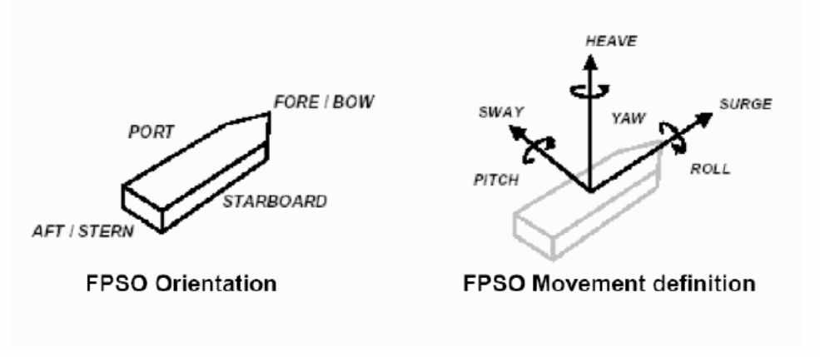
TECHNICAL ROOM ENVIRONMENTAL CONDITIONS
The environmental conditions of technical room in which the UCP will be installed are specified in the document revision .
PACKAGE ORIENTATION ON FPSO
FPSO axis
FPSO axis
Package main axis
Package main axis

Utilities
ELECTRICITY
Refer to:
- Project specification for electrical requirements for packaged units:
rev
- GS EP ELE 011
UCP UPS Earthing Regime:
UCP Normal Power Regime:
INSTRUMENT AIR and NITROGEN
Type | Instrument Air | Nitrogen
Min/max operating temperature |  |  | °C
Operating temperature |  |  | °C
Min/max operating pressure |  |  | Barg
Operating pressure |  |  | Barg
Oil concentration
Dew point |  |  | °C @ barg

COOLING WATER SYSTEM
Type | Sea Water | Fresh Water
Normal inlet temperature |  |  |  | °C
Min/max inlet temperature |  |  |  | °C
Min outlet temperature |  |  |  | °C
Max outlet temperature |  |  |  | °C
Supply pressure |  |  |  | Barg
Max allowable delta P |  |  |  | Bar
Calorific capacity |  |  |  | kJ/kg°C
Fouling factor |  |  |  | m².°C.h/kcal

FLARE
Type | HP | LP
Max operating temperature |  |  | °C
Normal temperature |  |  | °C
Max operating pressure |  |  | Barg
Normal pressure |  |  | Barg

DIESEL FUEL
See engine data sheet.

Tests

Factory tests (workshop)
The scope of this chapter is to describe the factory tests to be carried on the completely assembled engine driven generator package in Vendor facilities before unit shipment.
Factory tests shall demonstrate the correct design, manufacture and operation of the equipment and its satisfactory performance in accordance with the conditions identified in the mechanical data sheet.
The following tests shall be carried on the completely assembled package:
- Performance testing of individual equipment item (diesel engine, generator)
- Pre-test activities
- Performance and Mechanical running test of engine driven generator package. This activity shall include the functional test of all the main auxiliary systems of the package
- Assembled package shall be weighted before packing and shipment (except particular requirements of Project ITP).
The following documentation shall be issued by Supplier prior to the factory tests in workshop:
- Issue of the factory test procedures
- Issue “As built” drawings relevant to factory test.
The test procedure shall be issued 8 weeks prior to the test (including noise and vibration measurement proposed procedure).
Detailed procedures for all tests, which shall include the acceptance criteria for all monitored parameters, shall be reviewed and accepted by the Company prior to the commencement of tests. Failure of any aspect of the testing shall require corrective action and a full complete re-test.
The results of each test shall be recorded in appropriate log sheets provided by Vendor and signed as “witnessed” by all the parties.
After the completion of the tests, Vendor shall issue an official test report including all the above log sheets. Copy of raw data registered during the tests shall be handed over right after each test activity for Contractor inspection record.
All tests identified as factory tests will be witnessed by Company or their representative.

Performance tests

Acceptance criteria
The acceptance criteria shall be those indicated in the Exhibit D of the Contract.
Following acceptance criteria are valid for both Vendor facilities and field tests:
- Performances and tolerances:
- Generator as per GS EP ELE 113
- Diesel driver as per ISO 15550.
- Mechanical:
Vibration limits shall be in accordance with following table:
Component | Standard | Classification number | Vibration acceptance criteria
Generator | ISO 10816-1  ISO 10816-3 | N/A | 4.5 mm/s (r.m.s.)
Diesel engine | ISO 10816-6 | To be mutually agreed
Baseplate | ISO 8528-9 | To be mutually agreed
- When required, diesel engine exhausts emission as per ISO 8178-1, ISO 8178-3 and ISO 8178-6.

Generator performance test
Generator performance test shall be conducted according to GS EP ELE 113 requirements.

Engine test
Engine tests shall be performed according to Test method 1 of ISO 15550 requirements. Diesel engine Manufacturer shall provide used performance correction calculation method compliant with Certifying authorities requirements, if any.

Pre-test activities
Before commencing the factory testing of the completely assembled packages, the following minimum pre-test activities shall be carried out:
- Checking the compliance of the equipment with the project specifications
- Weights and dimensional checks
- Checking the certificates of compliance for the hazardous area components
- Calibration of all Project instruments. Relevant calibration certificates shall be available at the time of the test for Contractor review. Spot checks of instruments calibration shall be required before test commencing
- Instrumentation and electrical equipment insulation and continuity tests
- All instrumentation and electrical equipment functions shall be verified, including simulation, shut-downs and remote signals
- Control loops check and functional test
- Instruments, controls, alarms and safety devices
- Safety and protection devices operational checks
- Serial link test
- Equipment tagging and labelling checks
- Mechanical equipment alignment checks
- Pneumatic pressure tested piping system
- Leakage tests
- Lube oil flushing and cleanliness
- Verification of the dynamic stiffness of the test bench as per GS EP MEC 300, when specified.
The reports relevant to the mechanical equipment alignment check and to flushing and cleanliness checks shall be available for Contractor review during test.
Before commencing the tests the package shall be cleaned by Vendor and shall be visually inspected by Contractor.

Diesel engine driven AC generator package full load string test
Supplier shall provide all temporary equipment required for implementation of the tests, including, but not limited to temporary connections, hardware to simulate signals and interfaces external to the supplied equipment etc.
Supplier shall be responsible, as well for providing all utility services needed to perform the test in proper conditions.
The full load string test of each engine driven AC generator package shall be carried out in accordance with ISO 8528-6.
Testing program shall be mutually agreed between Company/EPSCC Contractor and Vendor on the following basis:
Each complete engine driven generator package shall undergo a Complete Unit test, four (4) hours uninterrupted continuous duration and be carried out on units fully erected, commissioned and shall involve all Contract equipment listed in the scope of supply.
The complete unit test shall demonstrate the proper functioning of all sub-systems, instruments, controls and safety systems.
The complete unit test shall consist of:
- Performance and mechanical test of engine driven generator with Contract engine, Contract generator, all Contract auxiliaries, Contract UCP and associated instrumentation
- The primary and backup engine starting sequence shall be demonstrated. A manual start using the back-up system shall be made with the engine cold, and with all electrical power isolated prior to any other start-up
- The capacity of the back-up starting system accumulator(s) shall be demonstrated
- The proper functioning of the primary starting system shall be demonstrated by starting the engine manually and via a signal on the controller
- Operational checks such as but not limited to start/stop normal sequences, emergency stop sequences etc.

Noise measurements
Noise measurement shall be performed in accordance with GS EP MEC 300 for all equipment.
Sound level tests with the engine driven generator package operating at rated conditions shall be performed for all packages.
During this step noise emissions shall be measured and recorded according to the testing procedure proposed by Vendor and approved by Contractor and/or Company.

Vibration measurements
Vibration shall be measured during the shop test of the assembled machine operating over the agreed power-load range.
Vibration levels over the whole operating range shall be as per ISO 8528-9.

Test duration
The mechanical running test shall be conducted initially at full load and when oil temperatures and all other parameters have been observed stabilized.
- Four hours (4 hours) at the maximum continuous load
- Load impact and load rejection test according to GS EP ELE 013 and ISO 8528-5 requirements.
All running parameters shall be recorded every thirty (30) minutes.
Each test shall be subject to a test report issued by Supplier and submitted to Company and Contractor.

Communication link test
Factory test shall also include PLC communication tests with Contractor supplied control system.
Contract UCP shall be 100% checked and tested, including all input/ output simulations and all logic and sequences at the control panel Manufacturer’s premises prior to dispatch the equipment to the unit assembling location.

Site acceptance tests
Site acceptance of the unit will be pronounced only after the satisfactory completion of the field acceptance tests.
Such tests shall demonstrate that the engine driven generator package meets the mechanical and performance requirements within the specified operating range and conditions.
This test shall be carried out on the site or at integration yard, in operating conditions, with the engine driven generator package connected to the distribution network.

Spare parts and special tools
This paragraph gives the minimum requirements of spare parts and special tools for this project. It shall be read in conjunction with GS EP EXP 217.

Spare parts
Supplier shall provide the spare part lists on Company SPL forms, fully filled up. Company will provide electronic format of these SPL forms.
All spare parts shall have protective coatings applied and be uniquely packed and tagged.
Supplier shall be fully responsible for all claims attributable to unsuitable or unsatisfactory packing and protection.
Spare parts shall be separately crated from package loose items.

Commissioning and start up spare parts
Supplier shall include in the scope of supply spare parts for commissioning and start up covering the whole scope of supply.
As a minimum the following spare parts shall be included in the Supplier scope of supply:
- Recommended spare parts for driver
- Recommended spare parts for driven equipment
- Recommended spare parts for any auxiliaries of the here above machinery’s
- Air filter elements
- Ten (10) sets of oil filter cartridges
- Ten (10) sets of diesel filter cartridges
- Ten (10) sets of gas fuel filter cartridges, if any
- For the Unit Control Panel:
  - One (1) power supply card
  - One (1) digital input card
  - One (1) analogue input card
  - One (1) digital output card
  - One (1) analogue output card
  - One (1) communication interface card.
- For the UCP fire and gas system:
  - One (1) FG detector of each type
  - One (1) FG power supply card
  - One (1) FG digital input card
  - One (1) FG analogue input card
  - One (1) FG digital output card.
- Miscellaneous:
  - Five (5) IS barriers of each type
  - Five (5) relays of each type
  - Two (2) fuses of each type
  - Ten (10) lamp bulbs (CO₂, etc.)
  - One (1) UCP HMI screen.

Operating spare parts
Supplier shall provide the priced list of spare parts recommended for the first two years of operation covering the whole scope of supply based on his own experience.

Special tools
All special tools required for the site installation, commissioning and maintenance of the package and their auxiliaries shall be furnished.
All special tools required to perform the following activities shall be provided:
- Erection, operation and maintenance:
These tools will remain the property of Company.
- Commissioning:
These tools will be sent back to Supplier at his own cost.
As a minimum the following shall be supplied:
- For erection, operation and maintenance:
  - All necessary spreader bars and slings to lift into position the unit
  - Jigs for shaft alignment
  - Removal tool kit for any main load coupling
  - Driver special tools
  - AC generator special tools
  - Recharging kit for any bladder accumulator, if any.
- For PLC, a programming console with a laptop computer, as applicable, shall be supplied complete with:
  - Development software
  - Application programs
  - Diagnostic software
  - Cord sets i.e. power supply and link with PLC
  - Calibration kits for each type of fire and gas sensors.
- For site commissioning and start up:
  - Portable multi channel analyzer
  - Digital voltmeter
  - Portable electronic RPM counter
  - Millivolt and milliamp sources
  - DC power supply
  - Variable resistor
  - Pneumatic pressure pump.
- Flushing kits for all lube oil systems consisting of:
  - Portable electric pump unit
  - Hoses and flange adapters to bypass all bearings and to establish flushing circuits
  - Flushing blocks for electro-hydraulic servo-valves
  - Screen mesh or equivalent.
A detailed list with comprehensive identification, part number, tool drawing and application tool drawing shall be provided during Contract stage.
Any standard and special tools, required to perform the pre-commissioning and commissioning activities at the Supplier premises shall be provided.
All special tools shall be properly identified and tagged.
Their functionality shall be described in the operating manuals.
Supplier shall provide a lockable weatherproof container for storage of special tools fitted with shelves and bench with vice.

Preparation for shipment
The purpose of the preservation and shipment requirement is to assure the best economical protection against adverse atmospheric weather, corrosion build up and mechanical damage due to storage and transportation from Vendor (Manufacturers, Packagers and Contractors) premises to Contractor yard and from Contractor yard to Company site.
The Vendor and/or Manufacturer shall issue necessary procedures which shall be applied to any equipment to cover:
- The preservation during workshop storage
- The preservation, packing and fastening of equipment during transportation from Vendor facilities to Contractor yard construction
- The preservation during the construction works on the Contractor yard
- The preservation, packing and fastening of equipment during towing from Construction yard to Company site.
The procedures shall contain a check list including all preservation and packing tasks.

Preservation
The preservation duration will be selected by the Project in the package data sheet and/or equipment data sheets.
Two types of preservation can be applied depending on Project needs: short term preservation or long term preservation.
The considered preservation shall be valid for shipment between:
- Vendor premises and Contractor yard
- Contractor yard and site.
The short term preservation shall cover a period up to six (6) consecutive months after processing of the preservation. The considered storage shall be outdoor without protection.
The long term preservation shall cover a period up to twelve (12) consecutive months and be annually renewable during five (5) years.
The desiccant products shall be free of DMF (dimethyl fumarate) content and shall be selected from Silica base. The regeneration of desiccant products is a mandatory requirement and shall be done by heating.
The desiccant products shall conform to the NF H00-320 or DIN 55473 or US MIL D 3464E standards.
The VCI (Volatile Corrosion Inhibitor) and VPI (Vapor Phase Inhibitor) shall conform to the US MIL-STD-2073-1 E standard. However necessary care shall be taken to use approved products compatible with the materials needing to be preserved.
All desiccant products locations shall be provided with a metallic label indicating their presence.
The last mechanical and/or performance runs can be done with anti-corrosion additives mixed with the lube oil. However Vendor shall demonstrate that the anti-corrosion additives shall not compromise the life of the equipment.
All opening shall be closed with metallic blind and gasket to be air and water sealed.
Metallic labels with necessary cautions and instruction to remove preservative products prior equipment start-up shall be provided.
The labels shall be made of metal with black marking on yellow back ground.

Diesel engine
After completion of the tests, the following shall be performed as a minimum:
- Draining of liquid as water, diesel, lube oil from systems
- Drying of systems
- Cleaning of reservoirs with non pilled clothes
- Spraying of TectylTM or VCI in the diesel system including reservoir
- Spraying of TectylTM or VCI in the air system
- Spraying of TectylTM or VCI in the water cooling system
- Spraying of TectylTM or VCI in the lube oil system
- Insertion of dessicant product in the diesel, water, oil and air systems by means of perforated metallic baskets fixed to blinds
- Preservation from foreign matters entrance
- Sealing of opening.

Generator
After completion of the tests, the following shall be performed as a minimum:
- Draining of liquid such as water, lube oil from systems where required
- Drying of circuits
- Spraying of TectylTM or VCI in the air system
- Spraying of TectylTM or VCI in the water cooling system
- Spraying of TectylTM or VCI in the lube oil system
- Insertion of desiccant product in the generator junction boxes, in exciter, in generator bearing cases, and in coolers by means of perforated metallic baskets fixed to blinds
- Preservation from foreign matters entrance
- Sealing of openings.

Instrumentation and electrical auxiliaries
After completion of the tests, the following shall be performed as a minimum:
- Draining
- Drying
- Insertion of soft bags desiccant products in instrument junction boxes and in instrument head
- Sealing of openings.

Control panels
After completion of the tests, the following shall be performed as a minimum:
- Draining of liquid such as water, where needed
- Drying of systems
- Cleaning of panels with lint-free rags
- Packing of all equipments not rack mounted
- Insertion of desiccant product inside the control panel, by means of soft bags
- Preservation from foreign matters entrance by metallic blinds
- Positive locking of all doors
- Sealing of openings.

Auxiliaries
After completion of the tests, the following shall be performed as a minimum:
- Draining of liquid such as water, lube oil from systems where required
- Drying of circuits
- Cleaning of reservoirs lint-free rags
- Spraying of TectylTM or VCI in the air system
- Spraying of TectylTM or VCI in the water cooled system
- Spraying of TectylTM or VCI in the lube oil system
- Spraying Water resistant wax TectylTM and wrapping on all non painted interfaces
- Insertion of desiccant product in the piping system, junction boxes, equipments cases (including ducting) by means of perforated metallic baskets fixed to blinds or soft bags
- Preservation from foreign matters entrance
- Sealing of opening.

Packing

Weather protection
The design of the packing shall procure an optimal weather protection during oversea transportation and Contractor yard storage.
During the detail engineering phase, Contractor, in conjunction with Vendor, has to issue and submit the preservation and sea fastening procedures to Company representative for approval.
Contractor shall be fully responsible of equipment preservation until provisional acceptance on site.
The weather protection shall be made of heat welded multilayer film (polyester, aluminum, polyethylene) and shall be installed around the package. All lifting appliances and lifting points shall be provided outside the weather protection and shall not be subject to losses of sealing. The film shall conform to the NF H00-310 or US MIL PRF 131K standards.
Prior to weld and seal the multilayer film, the hereafter sequences shall be applied, but are not limited to:
- A sweeping with nitrogen shall be performed in order to remove the internal moisture as much as possible to get low residual humidity
- A set of desiccant bags shall be included to absorb residual moisture and trap during transportation and storage the moisture passing through the multilayer film envelope
- A moisture indicator (sensitive paper) shall be included inside the envelope prior sealing to perform the traceability of the internal atmosphere during transport and storage.

Mechanical and infestation protection
The mechanical and infestation protection shall be performed by a use of multilayer wooden plates (plywood).
The multilayer wooden plates shall be sea water resistant in case of overseas transportation. A selection of multilayer wooden plates in accordance with marine immersion resistant, french standard CTBX or equal classification requirements is required.
The construction of the overall mechanical protection shall be done in such a way that internal or external members shall not damage the weather protection.
The construction shall be in such a way that rodents and insects cannot enter inside the box.
All sensitive parts like antifriction bearing, rotor shaft, shall be locked in place and insulated by means of shock absorber. The rotor locking devices shall be labeled with metallic instructions and cautions label with black making on yellow colored back ground labels shall be provided.

Fastening
All devices needed for the fastening whatever the transportation mode considered (sea, onshore, dirty and/or ice road) shall be provided external to the mechanical protection. The fastening shall not affect the weather/mechanical protection integrity.
The fastening shall be part of the equipment engineering design and shall be provided to avoid any modification and/or welding on the equipment during its installation until completion.

Marking
The minimal requirements for marking shall conform to the ISO 780 code in addition to the specific requirement of the Project.

Loose shipped items and auxiliaries
The loose shipped items delivered with the Contract (including commissioning and start-up spare parts) shall be preserved as per clause 9.1 and shall be packed inside a VCI plastic bags as per clause 9.2.1 and clause 9.2.2 during transportation from Vendor facilities to Contractor yard and from Contractor yard to Company site, except for structural frames and ducting when part of the scope of supply.
The packing boxes shall be provided with:
- Internal or external vibrations and shocks absorbers
- External lifting and handling devices and fastening provisions
- External marking in accordance with ISO 780 and Project specific requirements
- Internal harness and/or means for fastening
- Moisture indicator
- Internal or external provision for documentation storage
- External blank marking area and/or location to attached the AWB (Air Way Bill).
The structural frames and ducting (when part of the scope) shall be packed as follow:
- Transportation steel frame where required including all necessary certified means for handling, lifting, loading, unloading
- Metallic blinds on all openings provided with welded metallic baskets for desiccant bags storage
- External marking in accordance with ISO 780 and Project specific requirements
- Internal or external provision for documentation storage
- External blank marking area and/or location to attached the AWB (Air Way Bill).

Transportation
The Notified body responsible for transportation between Vendor facilities and port of shipment shall perform the assessment of the means, risks and constraints.
It shall be clearly specified in the Vendor proposal the means to be used for transportation, the loading of the equipments and the induce constraints due to sea, road, rails transportation in term of equipment assembly and number of packs.
A preliminary packing list including packing dimensions and weight table shall be attached to the Vendor proposal to give possibility to Company to assess the transportation impacts prior Contract award.
The handling, loading and unloading procedures and the lifting drawings shall be part of the engineering phase and shall be developed by the Vendor.
The spreader bars, the lifting beams and ancillaries (slings, shackles) shall be supplied by Vendor and shall be load tested and certified by third party notified body. The use of synthetic slings is not allowed.

- Definitions and abbreviations
Company Total E&P or any Total E&P subsidiary
Contractor Any Company Total E&P has signed a Contract with for the Engineering, Procurement, Construction and Installation of a part of a project
DMF Dimethyl Fumarate
ESDV Emergency Shut Down Valve
FSS Fire Suppression System
HMI Human Machine Interface
ICSS Integrated Control and Safety System
ITP Inspection and Tests Plan
MCC Motor Control Center
OEM Original Equipment Manufacturer
Package Prefabricated process or utility self-contained unit, generally able to operate on its own, supplied fully tested and ready for immediate installation
PLC Programmable Logic Controller
NDT Non Destructive Test
RO Restriction orifice
SAT Site Acceptance Test
SDV Shut Down Valve
SPL Spare Parts List
Supplier or Vendor The package Supplier or Vendor
UCP Unit Control Panel
VCI Volatile Corrosion Inhibitor
VPI Vapor Phase Inhibitor
- Baseplate installation
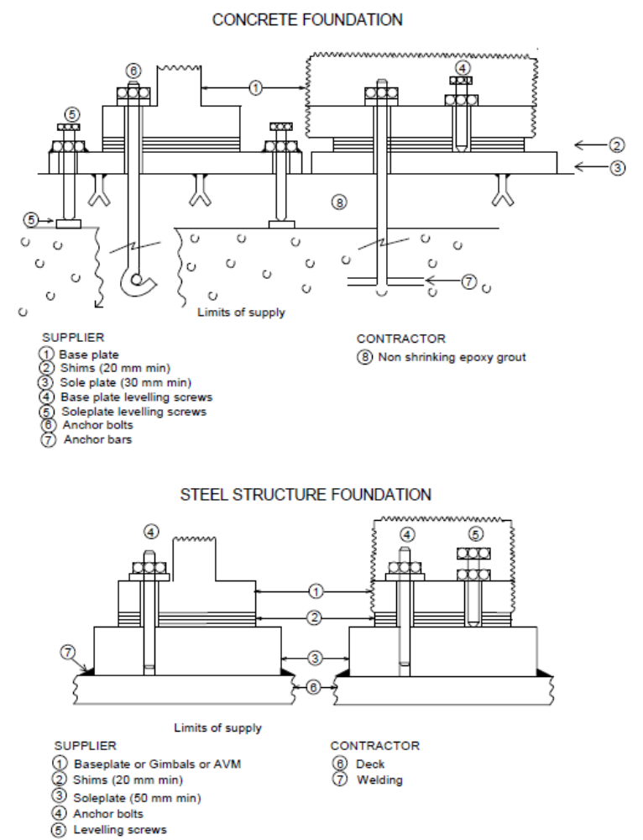
- Vendor Document Register (VDR)
The following documents shall be delivered by the Package Vendor. This list is a mandatory base frame but might be extended on a Project basis.
(1) Documents to be supplied with offer.
Item | Designation | (1)
1 | General
1.1 | Vendor document register | X
1.2 | Deviation list | X
1.3 | Monthly report
1.4 | Sub-Vendors list | X
1.5 | Quality plan
1.6 | Inspection and Test Plan | X
1.7 | Declaration of conformity for ATEX
2 | Arrangements
2.1 | General arrangement drawing for engine driven generator package | X
2.2 | Foundation drawings
2.3 | Limits of supply table (interface and connection schedule) | X
2.4 | Lifting drawing
2.5 | Unit Control Panel
2.6 | Fire fighting system cabinet
3 | Data sheets
3.1 | Engine data sheet (as per Appendix 6) | X
3.2 | AC generator data sheet | X
3.3 | Noise data sheet
3.4 | Weight data sheet
3.5 | Maintenance data sheet
3.6 | Instruments data sheet
3.7 | Other data sheets (LV motors, valves, lube oil filters etc.)
4 | P&IDs & Lists
4.1 | P&ID symbols table
4.2 | PFD and PID’s | X
4.3 | Equipment list / Bill of materials | X
4.4 | Load and utilities list | X
4.5 | Lubrication list and schedule
5 | Detail drawings
5.1 | Outline drawings (AC generator, silencers, vessels, coupling, heat exchangers, filters…)
5.2 | Electric motors outline drawing
5.3 | Electric motors sectional drawing and associated part list
5.4 | Fire fighting cabinet outline drawing
5.5 | Local gauge outline drawing
5.6 | Fuel tank outline drawing
5.7 | Starting systems outline drawing
5.8 | Equipment data plate drawing
5.9 | Flexible mounts outline drawing
5.10 | Interconnecting piping Isometrics
5.11 | Piping classes | X
6 | Electrical, Instrumentation and Controls
6.1 | Junction boxes dimension and termination diagram
6.2 | Control philosophy and functional analysis
6.3 | Instruments hook up diagrams
6.4 | Instruments list
6.5 | HMI displays
6.6 | PLC software data base exchange
6.7 | Instruments and electrical cables list
6.8 | Modbus list including addressing
6.9 | I/O list
6.10 | Instrument index S4l format
6.11 | Alarm / shut down list
6.12 | Interconnecting diagram (instrumentation and electrical)
6.13 | Earthing diagrams
6.14 | Logic diagrams
6.15 | Cause and effect chart
6.16 | Instrument loop diagrams
6.17 | UCP terminal strips
6.18 | Junction boxes terminal strips
6.19 | Wiring diagrams
6.20 | Obsolescence dossier
6.21 | Single line diagram
6.22 | Block diagrams
7 | Calculations and Performances data
7.1 | Lateral and torsional critical speed analysis calculation note
7.2 | Baseplate calculation note including modal analysis and lifting appliance
7.3 | Safety relief valve calculation according API RP520
7.4 | Starting systems calculation note
7.5 | Other calculation notes (AVM, etc.)
8 | Manuals/procedures/other lists
8.1 | Painting specification
8.2 | Installation and operating manual index
8.3 | Installation and operating manual
8.4 | Special tools list
8.5 | Start up and commissioning spare parts list | X
8.6 | Priced operating spare parts list
8.7 | Packing index and final packing list
8.8 | Storage prior and after erection procedure
8.9 | Weighing procedure
8.10 | Performance/ mechanical running test procedures
8.11 | UCP test procedure
8.12 | Factory test for complete package procedure
8.13 | SAT procedure
8.14 | Preservation procedure
8.15 | Packing procedure
9 | Manufacturing/Quality/HSE documents
9.1 | NDE procedures
9.2 | Welding procedures
9.3 | Material certificates
9.4 | All tests and inspections certificates
9.5 | QA/ QC (Manufacturing data book) index
9.6 | QA/ QC (Manufacturing data book) dossier
(2) The package string test report shall include pictures of the package (four side views and four isometric views).
- Minimum inspection requirements
As a minimum, the following inspections shall be conducted on the package:
- AC generator test
- Functional, performance and mechanical running test of the engine driven generator package
- Final inspection
- Final dossier data book review.

Note: This list does not include the inspections to be conducted on each individual component constituting the package.
- Deviations to the contractual documents
If deviations are waived during the bid phase, they shall be listed in the following pages in the purchase revision.

The deviation list shall exhibit at least the following:
- Reference of the specification,
- Paragraph of the specification,
- Description of the deviation,
- Reason for deviation,
- Vendor proposal,
- Company final position.

The deviations that are not accepted by Company shall appear in this list in order to give a complete overview of the technical discussions.

The following list contains pages.

Note: The deviation list might not be attached to this specification but referenced under a project document (as reported below).

Project document reference:
Revision
- Data Sheet
Gas and Diesel Engines Data Sheets DS EP MEC 140.
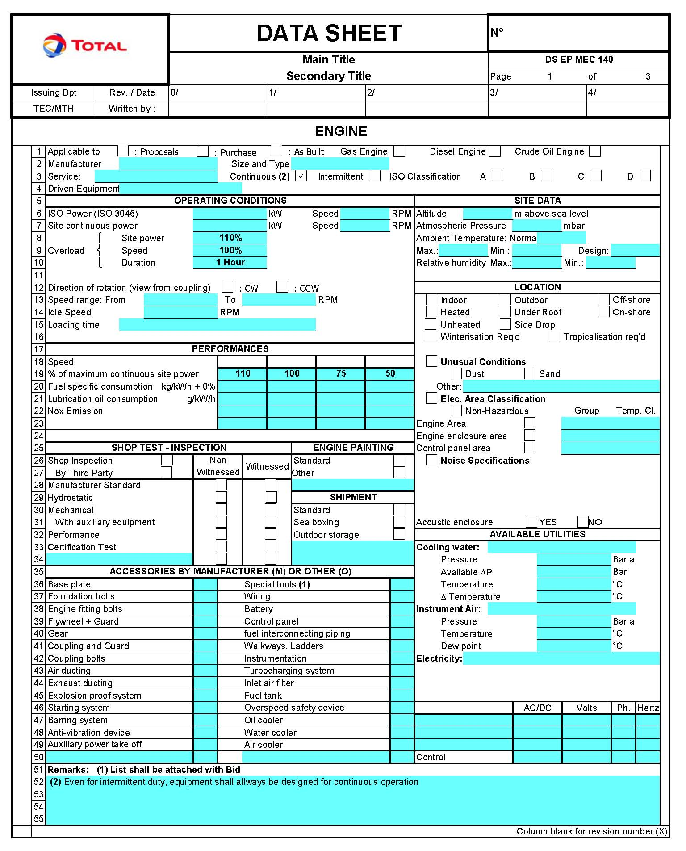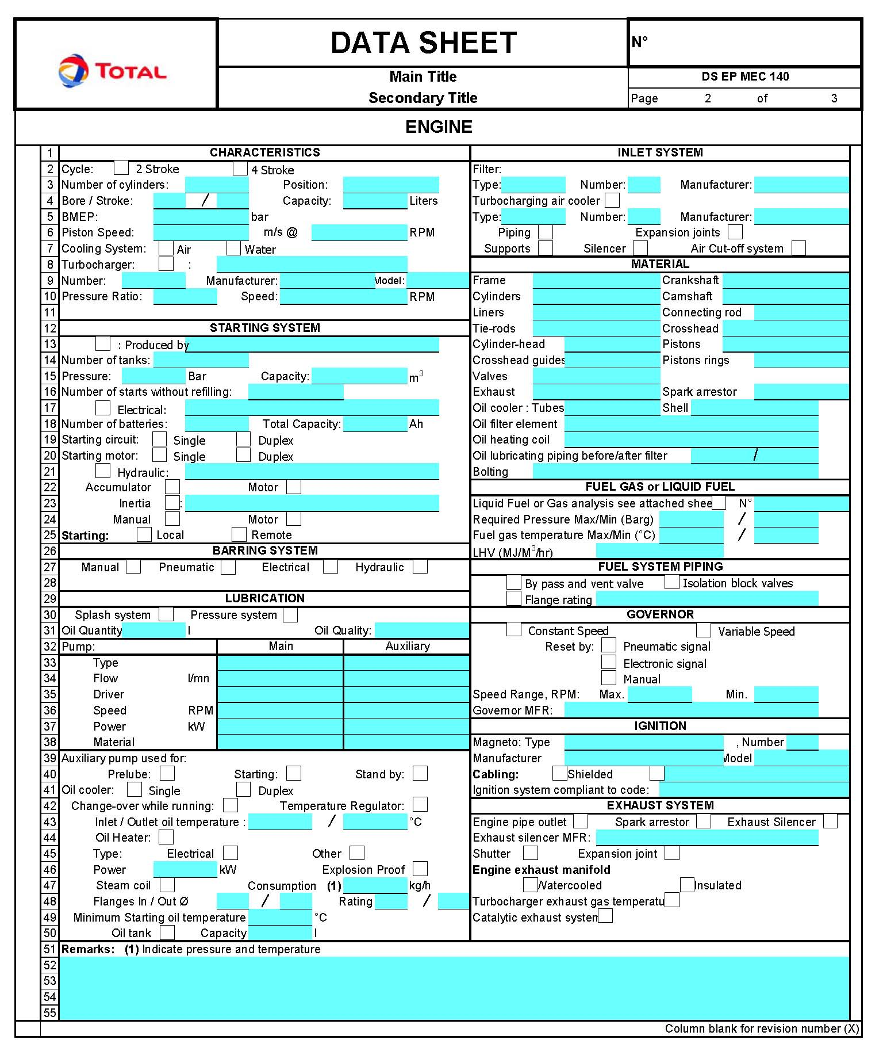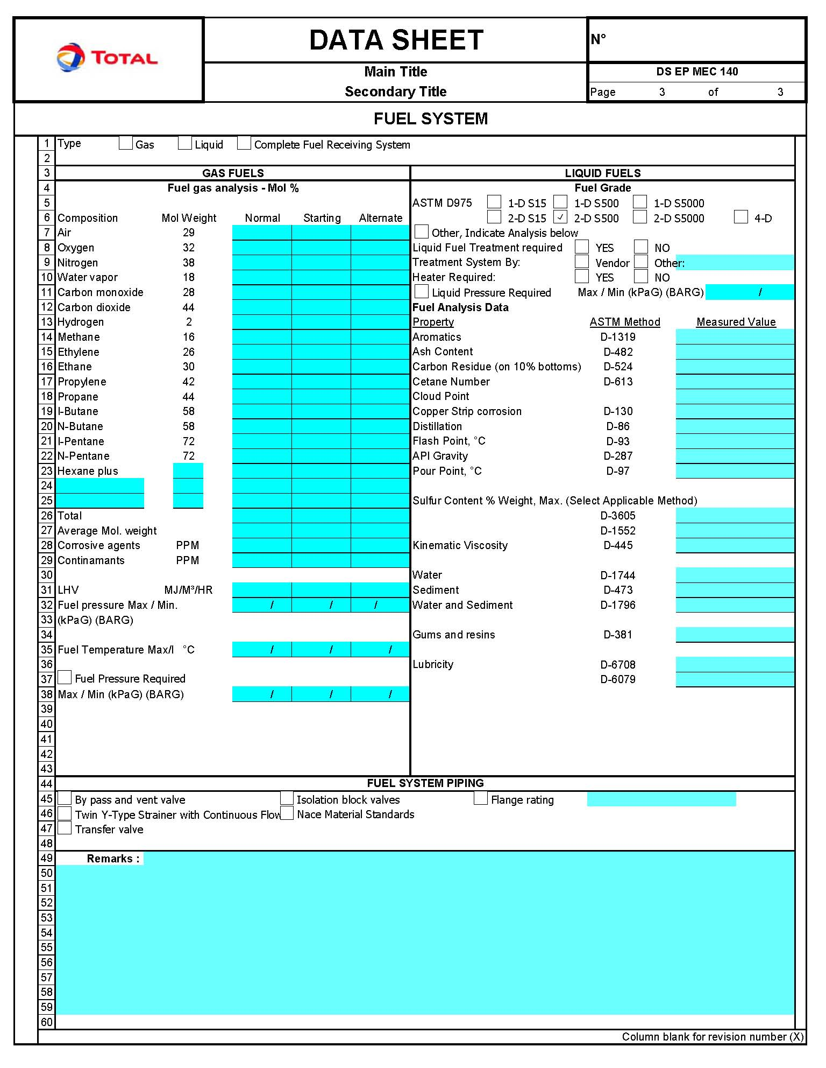

Reference to Articles 100/118 of the Treaty of Rome
Reference to Articles 95/137 of the Treaty of Amsterdam

