GENERAL SPECIFICATION
ROTATING MACHINERY
GS EP MEC 023

Rotating Machine Package Specification
Fire Fighting Diesel Hydraulic Driven Pump

01 | 10/2012 | Update
00 | 01/2012 | First issue
Rev. | Date | Purpose of the revision

Owning entity: DEV/TEC | Managing entity: DEV/TEC/MTH

Project Specification n° |  | Revision:
 |  | Date:

Contents
Preamble 4
1. Scope 5
1.1 Purpose 5
1.2 Application 5
1.3 General rules 5
1.4 Order of precedence 6
2. Reference documents 6
3. Scope of supply and exclusions 11
3.1 Scope of supply 11
3.2 Exclusions 16
4. Basis of design 17
4.1 General considerations / Safety and environment 17
4.2 Package design 18
4.3 Pumps design 19
4.4 Comments and/or additions to NFPA 20 21
4.5 Equipment protection 22
4.6 Package configuration 24
4.7 Hydraulic Power System 25
4.8 Diesel engine 26
4.9 Fire and gas system and Fire suppression system 31
4.10 Electrical 31
4.11 Instrumentation 32
4.12 Operating philosophy 35
4.13 Piping, valves and pressure vessels 37
4.14 Installation 37
4.15 Painting 37
4.16 Health Safety and Environment 38
4.17 Miscellaneous 38
5. Data sheets 41
5.1 Submerged hydraulic lift pump (refer to Appendix 6) 41
5.2 Booster pump 41
5.3 Diesel engine (refer to Appendix 7) 41
5.4 Noise 41
5.5 Weight 41
5.6 Data sheets templates 41
6. Site conditions and utilities 42
6.1 Site conditions 42
6.2 Utilities 44
7. Tests 45
7.1 Factory tests (workshop) 45
7.2 Performance tests 46
8. Spare parts and special tools 51
8.1 Spare parts 51
8.2 Special tools 52
8.3 Software and programming back-up 52
9. Preparation for shipment 53
9.1 Preservation 53
9.2 Packing 55
9.3 Transportation 57
Appendix 1 Definition and abbreviations 59
Appendix 2 Baseplate installation 60
Appendix 3 Vendor Document Register (VDR) 61
Appendix 4 Minimum inspection requirements 64
Appendix 5 Deviations to the contractual documents 65
Appendix 6 Data Sheet 66
Appendix 7 Data Sheet 75

Preamble

Scope

Purpose
This specification defines the minimum design, fabrication, inspection and testing requirements for the supply of the Fire Fighting Diesel Hydraulic Driven Pump Packages. It is an exhaustive document detailing the scope of supply and the associated design rules requested by TOTAL E&P for the procurement of Fire Fighting Diesel Hydraulic Driven Pump Packages.

Application
This document applies to the design of all Fire Fighting Diesel Hydraulic Driven Pump Packages. The submersible hydraulic vertical centrifugal pump is powered by hydraulic power unit driven by diesel engine. It excludes any other type Fire Fighting Pump packages.

General rules
All deviations from this specification or the documents referred to herein shall be stated in writing in the Appendix 5 of this specification. In the absence of such a statement, it is assumed that the requirements of the specifications are met without exception. Failure to meet the requirements of this specification and referenced documents shall be corrected at Supplier’s cost. Exceptions and deviations to the specifications shall be part of Supplier’s proposal and will be subject to Company approval.
Where this specification, or any other project document, allows the Supplier to propose an “option”, the Supplier shall clearly state the selected option in his bid.
In cases the Supplier provides outsourced equipment, he shall be responsible for the coordination of the Sub-Suppliers, and ensure the full compatibility of all the equipment. In particular, they shall be compatible in terms of safety, environment, operability, dimensions, weight, performance, control, noise and vibration behavior.
Components not mentioned in this specification that are necessary for the operation of the equipment or required by certifying agency, regulatory bodies or by law, shall be Supplier standard components.
The present document remains a General Specification as long as the modifiable forms are not completed. It becomes the Project Specification once these modifiable forms are completed and shall therefore not be considered as a General Specification any more.
Then, the General Specification shall be attributed a Project reference number with the associated Project front page.
Preamble shall be completed with the Project description (location, number of machines, etc.).
If Project specificities require amendments to non modifiable parts of this specification or to the documents referred to herein, they shall be considered as deviations and stated in writing in the Appendix 5 of this specification.
This document may modify or complement some requirements of NFPA 20, when deemed necessary in the light of Company experience.
This specification will then be issued in two steps:
- Issued “for inquiry”
- Issued “for purchase”.

Order of precedence
The applicable documents shall be considered in the following order:
- Local regulations
- Classification Society Rules (If applicable)
- Frame agreement if available - Frame agreement: Applicable  - Not applicable
- This completed specification and associated data sheets
- Referenced General Specifications
- Referenced Project documents
- Codes and standards.

Reference documents
The reference documents listed below form an integral part of this General Specification.
External Documents
Unless otherwise stipulated, the applicable version of these documents, including relevant appendices and supplements, is the latest revision published at the effective date of this document.
Reference | Title
1999/92/EEC  (ATEX 118¹/ATEX 137²) | European Directive 1999/92/EEC (16/12/99) on minimum requirements for improving the safety and health protection of workers potentially at risk from explosive atmospheres
94/9/EC  (ATEX 100a/ATEX 95) | European Directive 94/9/EC (23/03/94) on the approximation of the laws of the Member State concerning equipment and protective systems intended for use in potentially explosive atmosphere
API Std 610 | Centrifugal Pumps for Petroleum, Petrochemical and Natural Gas Industries
ASME VIII Division 1 | Boiler and Pressure Vessel Code
ASTM D975-10b | Standard Specification for Diesel Fuel Oils
DIN 55473 | Auxiliary means of packaging - Desiccant in bag - Technical delivery conditions
EN 1834-1 | Reciprocating internal combustion engines. Safety requirements for design and construction of engines for use in potentially explosive atmospheres - Part 1: Group II engines for use in flammable gas and vapour atmospheres
IP 15 | Area Classification Code for Petroleum Installation handling flammable fluids - July 2005 (3rd edition)
ISO 10816-6 | Mechanical Vibration - Evaluation of machine vibration by measurements on non-rotating parts - Part 6: Reciprocating machines with power ratings above 100 kW
ISO 1940-1 | Mechanical Vibration - Balance quality requirements for rotors in a constant (rigid) state - Part 1: Specification and verification of balance tolerances
ISO 3046 (Parts 1; 3) | Reciprocating internal combustion engines - Performances - (Parts 1; 3)
ISO 780 | Packaging. Pictorial marking for handling of goods
NF H00-310 | Industrial packaging. Flexible and heat sealing protection materials of low coefficient of water vapour transmission (P < 0.3 g/m² 24 h).
NF H00-320 | Packaging. Desiccant. Specifications and tests
NFPA 20 | Standard for the Installation of Stationary Pumps for Fire Protection - 2010 Edition
SOLAS | International Convention for the Safety of Life at Sea - IMO
US MIL D 3464E | Desiccants, activated, bagged, packaging use and static dehumidification
US MIL PRF 131K | Performance specification: barrier materials, watervaporproof, greaseproof, flexible, heat-sealable
US MIL-STD-2073-1 E | Standard practice for military packaging

Total General Specifications
Unless otherwise stipulated, the applicable version of these documents, including relevant appendices and supplements, is the latest revision published in the applicable yearly collection.
TOTAL EP General Specification Referential is applicable for the following Project:

The following Company specifications are fully applicable to all purchased equipment as listed in paragraph 3.1 completed by the technical details reported in paragraph 4 and taken into account accepted deviations as listed in Appendix 5. The second level General Specifications mentioned in each individual specification are not applicable if they are not listed in the below tables. The standards, professional documents, regulations and codes mentioned in each General Specification are applicable.
The following list may also be complemented with other specific Project detailed specifications which would include additional requirements, as applicable or deemed necessary by Company or Contractor.
Reference | Title
GS EP COR 350 | External protection of offshore and coastal structures and equipment by painting
GS EP COR 351 | External protection of structures and equipment by painting. Floating structures
GS EP COR 353 | Design and application of passive fire protection coatings
GS EP COR 354 | External protection of onshore structures and equipment by painting
GS EP COR 356 | Corrosion Protection of Fasteners for Subsea and Topside Applications
GS EP ELE 011 | Electrical requirements for packaged units
GS EP ELE 031 | Design of earthing and bonding systems
GS EP ELE 079 | Electrical apparatus for potentially explosive gas atmospheres
GS EP ELE 111 | Induction motors
GS EP ELE 161 | Electrical cables
GS EP EXP 217 | Requirements to Vendors, Suppliers and EPC’S for spare parts
GS EP INS 101 | Instrumentation engineering, supply and construction general requirements
GS EP INS 102 | Instrumentation identification
GS EP INS 107 | Design and installation of instrumentation links
GS EP INS 110 | Instrumentation for package units
GS EP INS 120 | Control and Choke Valves
GS EP INS 135 | Cyber Security requirements for design and supply of ICSS and Package Systems
GS EP INS 900 | Instrument hook-up diagrams
GS EP MEC 101 | Driver Power Sizing
GS EP MEC 270 | Supply of Mechanical Seal according to API Standard 682
GS EP MEC 271 | Centrifugal Pumps for the Petroleum, Chemical and Gas Industry Services according to API Standard 610
GS EP MEC 292 | Rotating Machines Packages Installation Requirements
GS EP MEC 300 | Noise and Vibration of Rotating Machine Packages
GS EP PVV 102 | Piping Hook-up Standards
GS EP PVV 112 | Piping material classes
GS EP PVV 143 | Metallic pipes
GS EP PVV 144 | Fittings
GS EP PVV 145 | Flanges
GS EP PVV 175 | Cleaning of piping and vessels
GS EP PVV 211 | Design and fabrication of pressure vessels according to ASME VIII
GS EP PVV 614 | Welding of duplex and superduplex stainless steel
GS EP SAF 050 | Fire and Gas System and Fire Suppression System for Packaged Rotating Machinery Enclosures
GS EP STR 001 | Weight monitoring and weighing offshore units
GS EP STR 103 | Design and fabrication of skids and equipment supporting structures

In case one of the previous General Specifications is completed with one or more Project specific detailed specification(s), then these detailed specifications (and their respective revision) shall be added to the following list.
Project Documents (to be completed by Company or Contractor)
 | Designation | Rev | Reference
1 | PID’s (*)
2 | Layout (*)
3 | Project specification for electrical requirements for packaged units (*)
4 | Instrument tagging specification
5 | Instrument list database specification
Note: All the documents identified by (*) shall be available along with this specification for the issue for inquiry and for purchase.
Project data sheets are listed in paragraph 5.

Scope of supply and exclusions

Scope of supply
The Vendor shall be responsible for the design, supply of materials, manufacture, assembly, supply of drawings and data, all Sub-Vendor co-ordination, testing, delivery and guarantees of the below components:
Note 1: The column “Required” indicates the level of requirement of each item, according to the below rule:
- “X” means that the item is a base case requirement.
- “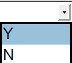 means that the item is an optional requirement specific to the project. “Y” for YES if the option is selected or “N” for NO if the option is not selected.
Note 2: The column “Description” may offer alternative technical choices that shall be fixed prior to the issue “For inquiry” by ticking the appropriate mark box .
# | Item | Description |  |  |  | Required | Tag | Quantity
1 | ON SKID EQUIPMENT
1.1 | Submerged Lift Pump including but not limited to:
1.1.1 | Submersible hydraulic driven pump | As per GS EP MEC 271 and data sheet referenced in paragraph 5. |  |  |  | X
1.1.2 | Hydraulic driven pump unit | As per paragraph 4.3.2. Material in D-2 super duplex and external coating as per GS EP COR 350. |  |  |  | X
1.1.3 | Pipestack section | As per paragraph 4.3.2.2. Material in D-2 super duplex and external coating as per GS EP COR 350. |  |  |  | X
1.1.4 | Pump top plate | External coating as per GS EP COR 350. |  |  |  | X
1.1.5 | Pump top bend | Material in D-2 super duplex. |  |  |  | X
1.1.6 | Centralizer | External coating as per GS EP COR 350. |  |  |  | X
1.1.7 | Hypochlorite injection line | Chemical hose with titanium interface flange and titanium injector at pump suction strainer. |  |  |  | X
1.2 | Diesel engine and accessories as per ISO 3046 and GS EP MEC 101 including but not limited to:
1.2.1 | Diesel engine | As per ISO 3046 and GS EP MEC 101, paragraph 4.8 and data sheet DS EP MEC 140 in Appendix 7 of this specification. |  |  |  | X
1.2.2 | Lube oil pre/post circulation unit | Electric motor driven circulation pump as per paragraph 4.8.5. |  |  |  | X
1.2.3 | Jacket water pre/post heating/ cooling circulation unit | Electric motor driven circulation pump.  Heater as per paragraph 4.8.3. |  |  |  | X
1.2.4 | Main fuel filters | Dual filters with changeover valves including pressure transmitters. |  |  |  | X
1.2.5 | Pre fuel filters | Dual filters with changeover valves including differential pressure transmitter and water level alarm. |  |  |  | X
1.2.6 | Starting systems | Two separated independent starting systems per Package as per paragraph 4.8.2 of this specification. |  |  |  | X
1.2.7 | Combustion air system | As per paragraph 4.5.1.3 of this specification. |  |  |  | X
1.2.8 | Air shutoff flaps | Air shutoff flaps engine mounted. |  |  |  | X
1.2.9 | Exhaust system | As per paragraph 4.8.7 of this specification. |  |  |  | X
1.2.10 | Exhaust silencer | AISI 316 exhaust silencer as per paragraph 4.8.7 of this specification. |  |  |  | X
1.2.11 | Exhaust Ducting | AISI 316 exhaust ducting as per paragraph 4.8.7 of this specification. |  |  |  | X
1.2.12 | Spark arrestor | Spark arrestor in AISI 316L. |  |  |  | X
1.2.13 | Exhaust thermal insulation and sheating | As per paragraph 4.1.1 of this specification.
1.2.14 | Auxiliaries for gas tight exhaust system | Exhaust system gas tight as per Project requirements.
1.2.15 | Exhaust pipe downstream silencer | Exhaust pipe downstream silencer in AISI 316L and drain system for vertical stack installation.
1.2.16 | Couplings front end and rear end and associated guards | As per paragraph 4.8.8 of this specification. |  |  |  | X
1.2.17 | Diesel fuel system | As per paragraph 4.8.4 of this specification. |  |  |  | X
1.2.18 | Diesel fuel day tank | Fuel tank in AISI 316L material and as per paragraph 4.8.4.3 of this specification. |  |  |  | X
1.2.19 | Automatic filling | Automatic filling system with all necessary auxiliaries. |  |  |  | X
1.2.20 | Diesel fuel shutoff valve | As per paragraph 4.8.4.5 of this specification. |  |  |  | X
1.2.21 | Jacket water system | Including but not limited to piping, heat exchangers, expansion tanks HT and LT for cooling system. |  |  |  | X
1.2.22 | Seawater cooling system | As per paragraph 4.8.3 of this specification in D-2 super duplex material. |  |  |  | X
1.2.23 | Main and secondary heat exchangers | Combined jacket water HT circuit and hydraulic oil plate heat exchanger.  Jacket water LT circuit plate heat exchanger for charge air cooling. Plates in Titanium material. |  |  |  | X
1.2.24 | Oil filters for lube oil | Twin AISI 316 stainless steel oil filters with continuous flow transfer valve for lube oil. |  |  |  | X
1.2.25 | Booster pump | As per GS EP MEC 271, paragraph 4.3.3 and data sheet as per paragraph 4.1.1 of this specification. |  |  |  | X
1.2.26 | Hydraulic power system | As per paragraph 4.7 of this specification. |  |  |  | X
1.2.27 | Hydraulic power unit | Hydraulic oil tank in SS316L stainless steel.  Hydraulic pump unit with adjustable setting.  Hydraulic oil return filter. |  |  |  | X
1.2.28 | Hydraulic oil circulation pump unit | Electric motor driven circulation pump. |  |  |  | X
1.2.29 | Hydraulic piping and valves skid mounted | High pressure system (metric) in D-1 duplex material.  Low pressure system as per piping specification. |  |  |  | X
1.2.30 | Hydraulic accumulator | Material in SS316L stainless steel. |  |  |  | X
1.2.31 | Surge tank assembly | As per paragraph 4.3.5 in this specification.  D-2 material. |  |  |  | X
1.2.32 | Automatic air release valve | As per paragraph 4.4.5 of this specification.  D-2 material. |  |  |  | X
1.2.33 | Discharge check valve | Duo check type.  D-2 material. |  |  |  | X
1.2.34 | Local gauge panel | Made of AISI 316/316L stainless steel.
1.3 | Enclosure assembly including but not limited to:
1.3.1 | Acoustic and fire resistant enclosure frame | As per paragraph 4.5.1 of this specification.
1.3.2 | Mechanical handling equipment | Monorail and associated hoist inside enclosure.
1.3.3 | Engine slide out arrangement. | Internal arrangement and necessary tools for pulling off engine through opening in enclosure sidewall.
1.3.4 | Enclosure ventilation system | As per paragraph 4.5.1 in this specification.
1.3.5 | Air cooling unit | As per paragraph 4.5.1.4 in this specification.
1.3.6 | Fire & gas detection system | UV/ IR flame detectors, gas detectors, heat detectors as per GS EP SAF 050.
1.3.7 | Platform and ladders | All necessary access platforms, ladders, roof handrail grating and access way for easy and safe maintenance on the enclosure roof for all above equipment and associated fixation.
1.4 | Baseplate including but not limited to:
1.4.1 | Fabricated steel common base plate | As per paragraph 4.6.1 of this specification. |  |  |  | X
1.5 | Controls and instrumentation including but not limited to:
1.5.1 | Control Panel (UCP) | As per GS EP INS 110 and paragraph 4.11.2 of this specification. UCP is including PLC, panel mounted HMI. |  |  |  | X
1.5.2 | ICSS interface | Communication cards, relays, signal convertors, etc. to interface with ICSS and support systems. |  |  |  | X
1.5.3 | FGS system requirement | SIL2 Fire and Gas PLC system integrated in package UCP. |  |  |  | X
1.5.4 | FGS system integrated | Control and monitoring of package fire extinguishing system integrated in UCP Fire and Gas PLC.
1.5.5 | Terminal junction boxes | All terminal junction boxes located at skid edge as per GS EP INS 101 and GS EP INS 107. |  |  |  | X
1.5.6 | Cable glands | Cable glands for departing multi-core cables, defined by Project and blinded off suitably for transport and storage. In case the option is not selected, the gland plates shall be pre-drilled and blinded off.
1.5.6 | Cable glands | For all other cables, junction boxes shall be provided with cable gland plates and associated cable glands. |  |  |  | X
1.5.7 | Instrumentation cables | All instrument cables between instruments and skid mounted junction boxes / local gauge board indicator as per GS EP ELE 161 and GS EP INS 107. |  |  |  | X
1.5.8 | Instrumentation Cable trays | All necessary cables trays with covers made of AISI 316 between instruments and skid mounted junction boxes as per GS EP INS 107.  Empty cable trays shall be installed for the departing multi-core cables -supplied and installed by others- between the terminal junction boxes and the skid edge. |  |  |  | X
1.6 | Electrical including but not limited to:
1.6.1 | Electrical cables trays | All necessary cables trays with covers made of AISI 316 between all electrical consumers mounted on skid and the skid edge. |  |  |  | X
1.6.2 | Batteries and charger | As per paragraph 4.10.2 of this specification. |  |  |  | X
1.6.3 | MCC | Skid mounted MCC for all electrical motors and consumers mounted on skid.
1.6.4 | Electrical cables | As per GS EP ELE 161, between the MCC and the electrical consumers mounted on skid.
1.6.5 | Cable glands | All electrical equipment shall be provided with cable glands. |  |  |  | X
1.6.6 | Normal and emergency lighting | As per GS EP ELE 011 and paragraph 4.10.4 of this specification. |  |  |  | X
2 | OFF SKID EQUIPMENT (shipped loose)
2.1 | Mini flow recirculation valve | As per paragraph 4.3.4 and GS EP PVV 112 or Project Piping class. D-2 super duplex material code |  |  |  | X
2.2 | Interconnecting firewater piping | Piping between Submerged lift pump and module in D-2 super duplex material.
2.3 | Interconnecting Hydraulic Oil piping | High pressure system (metric) in D-1 duplex material.  Low pressure system as per project piping specification.
2.4 | Interconnecting Extinguishing piping | Piping between fire fighting cabinet and module in SS316L material.
2.5 | Flame arrestors | As per paragraph 4.17.4 of this specification. |  |  |  | X
2.6 | Pressure transmitter | Pressure transmitter located downstream minimum flow recirculation valve.
2.7 | Enclosure fire fighting system | As per GS EP SAF 050 and paragraph 4.9 of this specification.
2.7 | Enclosure fire fighting system | Water mist |  | CO₂
2.8 | Spare parts for commissioning and start–up | Detailed scope is given in the paragraph 8.1.1 of this specification. |  |  |  | X
2.9 | Capital spare parts | Detailed scope is given in the paragraph 8.1.2 of this specification. |  |  |  | X
2.10 | Special tools | Detailed scope is given in the paragraph 8.2 of this specification. |  |  |  | X
2.11 | Anodes | Set of sacrificial anodes for submerged pump and pipe stack, 5 years lifetime duration. |  |  |  | X
3 | MISCELLANEOUS
3.1 | Baseplate anchors and shims | As per Appendix 2 of this specification. |  |  |  | X
3.2 | Off skid equipment anchors and shims | All anchors and shims for all off skid equipment supplied by SUPPLIER. |  |  |  | X
3.3 | Grating arrangement | Hot dip galvanized carbon steel grating. |  |  |  | X
3.4 | Documentation | Set of documents as per Appendix 3 of this specification. |  |  |  | X
3.5 | Package 3D model review | Review of the package 3D models for maintenance areas review. |  |  |  | X
3.6 | Maintenance laptop | Including software for UCP configuration.
3.7 | Personal protection | As per paragraph 4.16 of this specification. |  |  |  | X
3.8 | Painting and coating | As per paragraph 4.15 of this specification. |  |  |  | X
3.9 | Battery limit flanges | All limit flanges as per GS EP PVV 112 or project piping classes-if available- equipped with blind flanges for transportation. |  |  |  | X
3.10 | Package packing, marking and preservation | As per paragraph 9 of this specification. |  |  |  | X
3.11 | Earthing network | Earthing design and implementation as per GS EP ELE 031 and GS EP INS 107. |  |  |  | X
3.12 | Hydraulic oil system flushing kit | Kit made of all necessary flexible hoses for machinery bypass.
3.13 | Inflation kit | Inflation kit for accumulators nitrogen charging.
3.14 | Lifting tools for the complete package | Consists of slings, shackles, and spreader bar as per paragraph 4.17.5 of this specification and as per GS EP STR 103. |  |  |  | X
3.15 | Backup | Complete backup hard disk with application software, PLC program, HMI and any firmware prior to shipment. |  |  |  | X
3.16 | Software | OEM CD/DVD for any software used with full licenses. |  |  |  | X
3.17 | Specific climate considerations | Tropicalization | Winterization |  | None | X
4 | TESTS
4.1 | Factory tests
4.1.1 | Diesel Engine | As per paragraph 7 of this specification |  |  |  | X
4.1.2 | Submerged electric pump | As per paragraph 7 of this specification |  |  |  | X
4.1.3 | Booster pump | As per paragraph 7 of this specification |  |  |  | X
4.1.4 | Auxiliaries | As per paragraph 7 of this specification |  |  |  | X
4.1.5 | UCP | UCP integration and communication test at Sub-vendor premises as per paragraph 7 of this specification and and paragraph 7.4 and Appendix 5 of GS EP INS 110. |  |  |  | X
4.1.6 | Complete unit tests | As per paragraph 7 of this specification. |  |  |  | X
4.1.7 | Inclination Test | As per paragraph 7 of this specification.
4.1.8 | Noise and vibration test | As per paragraph 7 of this specification. |  |  |  | X
4.2 | Site acceptance tests
4.2.1 | Complete unit tests | As per paragraph 7.2.8 of this specification. |  |  |  | X
4.2.2 | Fire suppression system test | As per paragraph 3.5.2 of GS EP SAF 050. |  |  |  | X

Vendor shall be responsible for the physical and technical compatibility of the entire package and shall ensure that all equipment and components provided are suitable for the operations intended.

Exclusions
The following equipment are not included in the scope of supply:
- Counter flanges, gasket and bolting for connecting flanges at battery limits of Vendor’s supply
- All piping outside the package except when specified here above
- Electric and instrument cables outside the package
- All earthing cables outside the package.

Basis of design
This paragraph details the technical specificities of Project that are not covered in the Company General Specifications nor in the Project documents.

General considerations / Safety and environment
The complete package shall be designed for years of operation at least.
Environmental conditions for the equipment design are indicated in the paragraph 6 of this specification.
When packages have to be installed in hazardous area zone 2, as per IP 15, they shall be specified for gas group IIA and temperature class T3 (200°C) and ATEX European directives 94/9/EC and 1999/92/EEC shall be applied.
In this case, packages shall be certified ATEX εx II 3G and CE marked with the following requirements:
- Any diesel engine shall be selected in accordance with EN 1834-1, certified ATEX εx II 3G and CE marked
- Unit Control Panel shall be ATEX εx II 3G and CE marked
- Any instrumentation component shall be certified ATEX εx II 2G and CE marked. For facilities located outside the European Union (EU countries), alternative IECEx scheme can be applied (IEC Scheme for Certification relating to Equipment for use in Explosive Atmospheres)
- Any electrical component shall be selected in accordance with GS EP ELE 079
- Any mechanical component certified ATEX εx II 3G and CE marked.
Any equipment or system required to be left in operation when a safe or a hazardous area zone 2 becomes a hazardous area zone 1 (such as presence of gas, ventilation failure, etc.) shall be certified ATEX εx II 2G and CE marked.
Package and all accessories shall bear their own marking, according to the mode of protection used.
Fire fighting package shall be subject to SOLAS requirements.

Package enclosure
- Classified as safe area when pressurization and ventilation are in operation with no presence of gas.
- Classified as Zone 1 area category 2G as per ATEX Directives upon ventilation failure and gas detection.
However, the following equipment and systems shall be certified ATEX εx II 2G and CE marked:
- Unit enclosure ventilation systems
- Fire and gas detection and monitoring systems
- Fire dampers with associated power supply distribution panels
- Fire suppression system
- Emergency lightings.

Package design
The design of Fire Fighting Diesel Hydraulic Driven Pump Package shall include provision for full replacement / component replacement with minimum disruption to plant operations.
Only high integrity and proven equipment shall be considered. Prototype equipment and components shall not be used.
The fire fighting pump package may be run continuously for long periods during the construction and the commissioning phases and also capable of intermittent duty (1 hour per week).

Fixed structures
For Fire Fighting pump applications in fixed structures where the total riser column length does not exceed 15 m, long-shaft vertical suspended pumps and pumps driven by a submerged electrical or hydraulic motor shall be accepted.
For applications where the total riser column length exceeds 15 m, long-shaft vertical pumps are not allowed.

Floating structures
Only submerged electrical or hydraulic motor driven pumps shall be accepted.
The Fire Fighting Diesel Hydraulic Driven Pump Package data sheets will specify whether the fire fighting pump package is to be installed in a fire pump room supplied by others or in a dedicated enclosure furnished by the Vendor.
Fire fighting pump package that are to be installed in enclosure shall be supplied fully assembled, except for the submerged pump and its associated column risers.

Tropicalization
For pumps and equipment installed and operated in tropical conditions, special design considerations shall be taken for ventilation systems, air and cooling systems, material choices, surface treatment etc and shall be based on environmental conditions such as air humidity, air temperature, air temperature variations, surface temperature, cooling water design temperature.

Winterization
For Fire Fighting Diesel Hydraulic Driven Pump Package installed in arctic or in extremely low temperature areas, following measures shall be taken to secure the equipment:
- All seawater in the cooling water system shall be automatically drained during standby
- Riser pipe sections installed below sea level shall be thermally insulated, heated to avoid stagnant water and freezing in the riser pipe sections and submerged pump
- Hydraulic oil circulation shall create rotation of pump impeller to prevent stagnant water
- Diesel tank heater to maintain adequate fuel viscosity
- Thermostatically controlled heater and circulation pump shall be installed to preheat charge air cooler on diesel engine to ensure sufficient temperature in cylinders to start combustion
- Measures to avoid freezing of air inlet louvers (de-icing heaters, heat tracing, snow cowls etc.) shall be taken if deemed necessary
- Measures to facilitate cold restart of Fire Fighting Diesel Hydraulic Driven Pump Package after a period of complete blackout of all systems shall be taken.

Pumps design

Shaft speed
Pumps maximum operating speed shall be as follows:
Pump Power Rating | < 200 kW | > 200 kW
Submerged Vertical pump | 3000 RPM | 1800 RPM

Drivers maximum operating speed shall be as follows:
Driver Power Rating | < 200 kW | > 200 kW
Diesel Engine | 3600 RPM  Subject to Company approval | 1800 RPM

For submerged vertical pumps, riser pipe sections and pump hydraulics will be delivered loose for field reassembly by Contractor under the responsibility of the Vendor.

Submerged lift pump

Pump unit
Static submergence shall be as specified in the data sheet DS EP MEC 023 in Appendix 6 of this specification. NPSHr shall be at least 1 m less than NPSHa for all flow conditions between minimum and maximum flow rates. Pump discharge head elevation shall be as specified on the data sheet DS EP MEC 023.

Pipestack riser sections
A riser pipe length of up to six (6) meters is preferred providing necessary space for maintenance purpose. Three (3) meters riser pipe length could be considered as an alternative.
Pipe stacks shall be equipped with Aluminum Anodes designed for minimum 5 years lifetime.

Caisson
Submerged pump shall be installed in a dedicated caisson provided by other. Caisson free alternative could be considered when pump is installed in moon pool or sea chest floater under Company approval.

Anti fouling
The Vendor shall provide anti-fouling dosing system at the vertical pump suction strainer within the caisson. Single flanged connection on the top plate and bottom injector shall be in titanium material.

Booster pump
Booster pump shall be designed to withstand dry running during short periods to prevent damage during start-up.
The pump shall be directly connected to the diesel engine driver with a flexible spacer coupling. The booster pump shall be in D-2 super duplex horizontal radial split, OH2 single overhung impeller, end suction type as per API Std 610.

Minimum flow protection
For Floater applications, each Fire Fighting Diesel Hydraulic Driven Pump Package shall be provided with a “self-controlled combined check and minimum flow recirculation valve” type Schroeder or Schroedahl. The valve shall be provided shipped loose for vertical installation as close as possible to the surge tank. Dump and ring main pipes shall be upward routed in such a way that minimum flow recirculation valve is always kept water filled. A small bore bypass line across this minimum flow recirculation valve shall be installed in order to water fill the section between the minimum flow recirculation valve and the main check valve installed on the surge tank. In such a configuration, the air release (starting sequence) and vacuum breaker (stopping sequence) combined valve shall be installed on the dump outlet surge tank.
Other alternative like self controlled valve or pneumatic operated control valve installed on the dump outlet surge tank may be proposed for fixed structures but subject to Company approval.

Surge protection
The pump shall start against a restricted air release / vent line normally routed to overboard by Contractor. If deemed necessary, an anti-surge tank shall be installed at the pump outlet, upstream the discharge check valve, to provide damping of water hammer.

Comments and/or additions to NFPA 20
Following are the comments and/or additions to the corresponding paragraph numbers of NFPA 20:

NFPA 20 - paragraph 4.8 - Centrifugal fire pump capacities
The fire fighting pump package duty is given in the data sheets. Individual capacity shall not exceed 2800 m³/h. The fire fighting pump package capacity shall additionally include any cooling water requirements of the diesel engine driver, hydraulic oil cooling. The additional capacity shall be determined by the Vendor.

NFPA 20 - paragraph 6 - Centrifugal pumps
The pump design, construction and testing shall meet the requirements of NFPA 20 and API Std 610 as supplemented by this specification and the equipment data sheets listed in paragraph 5 of this specification.
All Fire Fighting Diesel Hydraulic Driven Pumps shall be suitable for parallel operation even if normal operation does not require all fire pumps running in parallel.

NFPA 20 - paragraph 7.1.2 - Characteristics
According to NFPA 20 paragraphs 7.1.2.1 and 7.1.2.2, Fire Fighting Diesel Hydraulic Driven Pump shall have a stable head / capacity curve rising continuously to shut-off. The head at shut-off shall not exceed 140% of the head at the rated capacity.
Fire fighting pump shall provide not less than 150% of the rated capacity at a total head of not less than 65% of the head at the rated capacity.
Submergence requirements to satisfy NPSH margin requirements shall be determined at the NFPA 20 150% flow case.

NFPA 20 - paragraph 7.3 - Pump
Fire Fighting Diesel Hydraulic Driven Pump materials shall be as specified in the equipment data sheets listed in paragraph 5 of this specification.
Guidance for the selection of the pump materials shall be as follow:
- For seawater application, pump materials and wetted parts shall be selected according to API Std 610 Table H1, material class D-2.
- For fresh water application, pump materials shall be selected according to API Std 610 Table H1, S6 minimum.
In his proposal, Vendor shall clearly identify selected materials for all parts of the pump unit, with reference to Company approved standards including the material grade as per ASTM or equivalent.

NFPA 20 - paragraph 7.3.5.2 - Automatic air release
Submersible pumps installed in a pump caisson shall be fitted with an Automatic Air Release valve (AAR). The AAR valve can be either installed inside the enclosure directly mounted on the surge tank or tied onto the discharge of vertical pump, immediately upstream of the check valve and the minimum flow connection.
The AAR valve shall be sized according to NFPA 20 paragraph 7.3.5.2.
The AAR valve shall be made of super duplex D-2 material code for sea water service for offshore applications.

Bolting
To facilitate dismantling and maintenance, internal and external bolting shall be fully resistant to the fluid pumped. Bolting material including the material grade as per ASTM shall be specified in the proposal.

Pump mechanical seals
Submerged hydraulic driven lift pumps and booster pumps shall be equipped with dynamically balanced single mechanical seals. The seals shall have configuration 1CW as per standard API Std 610 and as per GS EP MEC 270.
Spacer couplings shall be provided for replacement of the mechanical seals so as to minimize any removing or dismantling.

Suction strainer
The Vendor shall furnish a coarse mesh strainer meeting the requirements of NFPA 20 clause 7.3.4. Material shall be selected in super duplex D-2.

Equipment protection

Enclosure
Acoustic enclosure shall be provided if required to comply with the specified environment conditions and noise requirements. The enclosure shall be made of painted carbon steel or SS316 if Project duration life is higher than 20 years. The internal perforated liners shall be made of AISI 316L stainless steel.
The enclosure shall include side doors and removable panels to allow equipment maintenance and removal. Hinges, rod assemblies and door handles shall be of heavy duty type and made of AISI 316L stainless steel. Doors shall be fitted with anti-panic handles on the inside.
Provision inside the enclosure shall be done for diesel engine removal by side away pulling through removable enclosure panel.
Certified travelling hoist and lifting lugs as required for lighter maintenance shall be provided inside the enclosure.

Fire rating
The enclosure shall be designed to fulfill requirements for fire rating specified in paragraph 6.1 of this specification. This may be achieved with external spray-on passive fire protection, internal fire rated insulation or a combination of both.

Design loads
The enclosure shall be designed to withstand environmental loads, including blast load as described in paragraph 6.1 of this specification.

Air ventilation system/ air combustion intake
If the Fire Fighting Diesel Hydraulic Driven Pump Package is located in hazardous area, the diesel engine shall be installed in an enclosure protected by internal ventilation.
Enclosure internal ventilation shall be designed to:
- Provide temperature control to ensure the intended operation of equipment is achieved
- Control hazardous zones and promote the dilution of flammable gas, vapour and mist leaks.
The Vendor shall source the air combustion and the inlet ventilation ducting system in AISI 316L for fresh air intakes to enclosure with following main features:
- Fresh air intakes to enclosure shall be located in a safe area, at least 2 meters away from a hazardous area
- The location of the air filter intake shall not be less than 2 meters above local ground level to prevent from ingress of swirling dust, insects, etc.
- Enclosure Ventilation air outlet shall be located 5 meters at least from any machinery combustion air exhaust termination
The Vendor shall provide a complete air intake system as following:
- Air inlet filter designed to meet diesel engine Manufacturer requirements. Filter shall be equipped with weather louvers and coalescer to prevent rain ingress
- Filter differential pressure gauge
- If installed in hazardous area, provisions for a gas detector shall be included in the inlet ducting
- A silencer shall be installed in the inlet ducting if required to meet external noise requirements
- Flexible joints between ducting and engine
- Emergency over-speed shut-down flaps with fully closed and open limit switches and manual reset facilities
- If installed in hazardous area, the combustion air ducting upstream the filter unit shall be ducted to safe area location and provided with a weather louver at the inlet.
Stainless steel grade AISI 316L shall be used for ducting upstream flaps. The air inlet system downstream the flaps shall be designed to withstand complete vacuum.
Enclosure internal ventilation shall be insured by a main ventilation system backed up by a standby ventilation system. Ventilation of the enclosure shall be achieved by a fan powered from an engine power take off through either a mechanical or hydraulic or electrical transmission as per GS EP ELE 111. Driven ventilation fans shall be in 2 x 100% duty.
Enclosure ventilation system shall be designed to limit the enclosure internal temperature to a temperature compatible with electronic devices within the enclosure and outlet air temperature to the rated site temperature plus 15°C at the rated engine power.
Pneumatically operated fire dampers shall be installed on both inlet and outlet connections. The fire dampers shall have limit switches and shall be designed for direct and remote actuation via the F&G system.
If the Fire Fighting Diesel Hydraulic Driven Pump Package is located in hazardous area, the ventilation outlet shall have a pressure control damper installed to maintain a constant overpressure of 50 Pa.

Module cooling
The enclosure shall be equipped with an internal independent cooling system to maintain an acceptable room temperature in cases where the ventilation system is shut down due to external fire or gas detection.

Package configuration
Whatever the type of supporting structure is concrete or offshore structure, package base plate shall be multipoint rigid design with jacking bolts for leveling purpose.
Supporting shall comply with the requirements of GS EP MEC 300 and GS EP STR 103.
Vendor shall provide matched loose soleplates intended for welding to structure on deck, and set of necessary SS316 shims for alignment of package in compliance with Appendix 2 of this specification.
Contractor shall install and weld the sole plates on all packages in accordance with the Project specifications, if any, and Vendor requirements.
The supporting structure shall be machined prior to welding soleplates.

Base plate construction details
Package base plate shall be in carbon steel material and coated as per GS EP COR 350. It shall be multipoint rigid design with jacking bolts for leveling purpose. Package base plate design shall conform to GS EP STR 103 to maintain alignment of the machinery under all operating conditions whether normal, transient and abnormal.
Package base plate shall be designed with either:
- A non slip decking steel plate covering the top of the base plate and a drip pan and gutter all around with 2 drains points of 2” diameter minimum
or
- Grating covering the top of the base plate and a steel plate continuously welded at the bottom of base plate recovering any oil spill and drain points of 2” diameter minimum.
All the equipment supported by the skid shall be contained within the skid projection footprint (meaning that no equipment overhung/projection outside the skid footprint is allowed).
The base plate shall incorporate a drip pan to collect spillage from the engine and its accessories. The design of the drain pan and the location of the drain openings shall ensure complete drainage under the most adverse floating vessel motions.
Baseplate structural welds shall be continuous and closed.
If part of an enclosed package, the baseplate shall be insulated to fulfill applicable requirements for fire rating and/or noise emission from package as specified in the paragraph 6.1 in this specification.
Baseplate design and its anchor bolting shall take into consideration requirements for blast load as listed in paragraph 6.1 of this specification.

Base plate drains
All drains which are an interface between the Vendor and Contractor shall be routed to the skid edge and shall terminate by 2" ANSI 150 # RF flanges fitted with a blind flange.
The drains shall be routed to plant hazardous open drain by the Contractor.

Hydraulic Power System
Hydraulic power system consists of but not limited to:

Hydraulic power unit
A variable displacement pump fixed at the required oil flow. Site adjustment of flow shall be possible. The pump shall be directly driven by the diesel engine and installed inside the hydraulic oil reservoir.

Hydraulic reservoir
The reservoir shall be fabricated in SS AISI 316 material.
The reservoir shall be equipped with a 12 micron combined return and filling filter. The filter shall be equipped with differential pressure transmitter and spring loaded bypass valve. The reservoir shall be fitted with level gauge, level transmitter and temperature transmitter.

Hydraulic circulation unit
An electric motor driven hydraulic oil circulation pump shall be installed to circulate oil in the system during standby of the Fire Fighting Diesel Hydraulic Driven Pump. The circulation shall be sufficient to rotate the hydraulic motor in the submerged lift pump to secure the system.

Cooling
The hydraulic system shall include a hydraulic fluid exchanger. The heat exchanger shall be made with titanium plates. Seawater is taken from the fire pump discharge as the cooling medium. Seawater shall be at a pressure lower than the hydraulic fluid.

Diesel engine
Engine rating shall be as per GS EP MEC 101, NFPA 20, section 11.2.2 requirements, in accordance with ISO 3046-1, ICFN rating.
The Vendor shall provide details of engine rating calculation in his proposal.
When installed in hazardous area zone 2, the diesel engine shall be ATEX Category 3 certified, designed for T3 surface temperature.

Engine heater
Vendor shall provide electric heating and pre/post circulation for the diesel engine cooling water so that, on start-up, the diesel engine can immediately run safely under full load.
Heaters shall be powered from the unit control panel, be thermostatically controlled and be de-energized when the engine starts.

Starting systems
Diesel engine shall be provided with two distinct starting systems completely independent of the plant support facilities:

Main starting system
- Electric starting if chosen shall be in accordance with NFPA 20 section 11.2.7.2, and the following additional requirements:
- Nickel Cadmium batteries
- Battery banks shall be installed in SS 316 battery racks with removable protective covers made of glass reinforced plastic
- Two battery chargers powered from the control panel
- Manual start-up facility by-passing the driver controller
- Electric starters shall be 24 Volts DC pre-engaged pinion type. Electric start systems shall include load disconnect circuit breaker.
- Air starting shall be selected when Fire Fighting Diesel Hydraulic Driven Pump packages are installed in hazardous area zone 2 and will be in accordance with NFPA 20 section 11.2.7.4 and the following additional requirements:
The air starter shall be rotor type starter motor. The air start device shall include:
- Compressed air vessel(s) located in the mainframe, sized according to NFPA 20 paragraph 11.2.7.4.4.1, i.e. “180 seconds of continuous cranking without recharging”. These vessel(s) shall be easily accessible and removable, designed and built in accordance with the ASME VIII
- Non return valve(s) on the air vessel
- Pressure transmitter on the air vessel
- Vessel pressure gauge
- Compressed air amplifier fed by the instrument air system at 7 barg
- Manual push button on the solenoid valve
- Air pressure reducing valve designed to feed the starter with the correct pressure and flow if necessary.

Back up starting system
Engine shall be provided with a hydraulic back-up start system as per NFPA 20 paragraph 11.2.7.3 requirements consisting of:
- An hydraulic motor starter
- Hydraulic storage bottle(s) sized according to NFPA 20 paragraph 11.2.7.3.5 (5), but as this hydraulic starting system is a backup system, bottles capacity shall allow three cranking cycles of not less than 5 seconds each. These bottles shall be easily accessible and removable, designed and built in accordance with the ASME VIII
- Electric motor or pneumatic driven pump to permanently pressurize the storage bottle(s) with the powering fluid (diesel engine driven pump is not allowed)
- Manual pump to pressurize the storage bottle(s)
- Safety devices and associated instrumentation to safely operate and monitor the system
- Manual starting facility by-passing the driver controller.
Both systems shall be installed on the diesel engine base plate and shall be arranged to facilitate ease of maintenance.
When required by Vendor, the diesel engine shall be provided with starting aids such as pre-lube system and water jackets heaters or other devices to ensure safe and reliable start-up.

Cooling system
Diesel engine cooling system shall be based on closed treated water cooling system and either an air cooler or a water to water heat exchanger.
When the pump unit is installed offshore, treated water to sea water heat exchanger shall be provided and the sea water shall:
- Be fed from the firewater pump discharge
- Be delivered to the various users through a Y type strainer
- Return to the pump caisson or a separate overboard dump caisson.
Each user branch shall be provided with restrictive orifice for field flow and pressure adjustment purpose.
Cooling piping system shall be rigid. Flexible parts shall be limited to join static and moving equipment and shall be as short as possible. Piping between pump and engine exchanger shall be made of duplex stainless steel.
Expansion cooling tank shall be provided with low alarm level, relief valves, valved drain and filling connections.
Low points and high points in the coolant circuit shall be fitted with a drain valve or a vent valve, as appropriate.

Diesel fuel system

Fuel quality
The engine shall be capable of operation on diesel fuel oil - ASTM D975-10b, Gr 2-D. Supplier shall advise the maximum allowable quantity and size of solids and water in the fuel oil upstream of the engine-mounted filters.

Fuel supply pumps and filtration
The fuel supply and filtration system shall include at least the following:
- Water coalescer separator with drain valves and vent valves
- Engine-driven fuel supply pump
- Fuel filters with a differential pressure indicator, drain valves and vent valves
- Manual fuel priming pump.
Dual fuel filters with a change-over valve shall be supplied.
Fuel spill-back shall be routed to the fuel day tank. If recommended by the engine manufacturer a fuel return cooler shall be installed.

Diesel fuel day tank
The diesel fuel shall be fed from a day tank. For Fire Fighting Diesel Hydraulic Pump package supplied in enclosure, the day tank shall be located within the enclosure and mounted on the pump unit base-plate, the elevation being such that the maximum permissible static pressure head at the diesel engine is not exceeded.
The day tank shall be sized for 12 hours (18 hours for Floater application) continuous running based on the engine driver consumption at its rated power, after the low alarm level is reached.
The tank shall be made of stainless steel AISI 316L.
The day tank shall be fitted with a remote and locally operated automatic filling system, an overflow and a flow glass, a sludge trap, a valved drain point, a level gauge and transmitter, a flanged vent connection provided with a flanged SS316L flame arrestor.
The following connections are required on the tank but not limited to:
- Diesel fuel supply inlet/ outlet to engine
- Fuel spill-back line (if any)
- Valved drain connection
- Overflow and flow glass
- Flanged vent connection line with flanged flame arrestor
- Manhole
- Accessible level gauge and level transmitter.
The fuel outlet to the engine shall be not less than 50 mm above the bottom of the tank.
Automatic top-up is required and manual filling shall also be possible. Diesel filling will be via an automatically operated pneumatically actuated on/off valve, controlled from a separate tank level transmitter.
All fuel lines shall be in AISI SS 316L. For floater application, it may be required to install adequate internal baffle plates to limit roll and pitch motions.

Fuel interconnecting piping
All piping shall be metallic. High pressure fuel lines on engine shall be double wall design. All fuel piping off engine shall be AISI 316L stainless steel.
When required, flexible connections shall be reduced to the minimum and special care shall be taken to ensure adequate support at the rigid end pipes.

Fuel shut-off valve
An instrumented manual isolation fuel valve installed between the day tank and the diesel engine and operable from outside the enclosure shall be provided by the Vendor. The release device shall be installed in a cabinet with breakable glass, located easily accessible from outside enclosure.

Fuel cooling
The fuel oil return line shall include if required seawater cooled titanium plate heat exchanger to prevent heat to accumulate in the day tank during continuous running.

Lube oil system
Electric driven pre/post lube oil circulation pump shall be installed adjacent to engine to keep engine bearings and turbocharger lubricated and ready for start and run down after stop at full engine load.
Lube oil pan for engines shall be selected based on package installation, design roll and pitch to ensure adequate lubrication in all conditions.

Driver installation
Diesel engine shall be installed with flexible isolator mountings.
Base plate supporting structure in front of the flexible isolator mountings shall be locally reinforced.
Drip pan underneath the diesel engine shall be provided to protect any accessories from oil spillage.
If necessary, platform with access ladders shall be provided at each side of the diesel engine to have access to top of the diesel engine, for operation and maintenance purpose (manual speed control lever arm, injectors, valve rockers, cooling expansion tank).

Exhaust system
Machinery combustion exhausts shall meet the following criteria:
- Be located 2 meters away from any hazardous area
- Be completely heat insulated with an appropriate thermal insulation in accordance with hazardous area classification.
A complete exhaust system made from stainless steel AISI 316L supported from the package base-plate shall be provided and shall consist of:
- AISI 316 exhaust silencer and ducting
- Expansion bellows between engine and ducting
- Roof mounted exhaust silencer fitted with AISI 316L spark arrestor designed to meet the Project noise specification
- Exhaust pipe downstream silencer in AISI 316L and drain system for vertical stack installation
- Adequate supporting steel structure mounted on the enclosure roof for all above equipment and associated fixation
- Access ladder to roof enclosure
- Roof handrails and walkways.
The routing of the exhaust ducting from the engine expansion joint to discharge to atmosphere shall be agreed between Contractor and Vendor.
Diesel engine Manufacturer shall advise the maximum allowable back pressure at the exhaust Customer connection at the rated power exhaust gas flow.
Exhaust system shall be suitably cooled or lagged to obtain surface temperature less than 70°C for personnel protection.
If Fire Fighting Diesel Hydraulic Driven Pump Package is installed in hazardous area, measures to keep the exhaust system surface temperature below temperature class T3 are required. Preference shall be given to gas tight insulation rather than water-spray exhaust cooler.

Couplings and guards
Couplings between engine/ power packs and engine/ booster pump shall be flexible elastomere type and shall not require continuous lubrication. Shafts and couplings shall be capable of withstanding 120% of the maximum possible torque that can be generated by driver at start up without exceeding allowable yield stress of any components.
Couplings shall be dynamically balanced to ISO 1940-1 Grade G6.3 and balance certificates must be provided.
All moving parts shall be protected from human contact by suitable guards made in non-sparking material. Aluminum and stainless steel are not considered as a non-sparking material.

Flexible hoses
If used, flexible hoses shall be of oil resistant rubber of two-ply reinforced construction and external metal braid protection. Each flexible hose shall terminate in an approved screwed union connection with shrouded ferrules. Mating screwed connectors shall be provided at each rigid pipe end. Union connectors shall be arranged so that no bending or torsion is applied to either the hose, ferrule ends or rigid pipe ends.

Fire and gas system and Fire suppression system
The fire and gas system and the fire suppression system of the Fire Fighting Diesel Hydraulic Driven Pump Package shall comply with GS EP SAF 050.

Electrical

General
The design, manufacture, inspection and testing of electrical equipment provided with the packaged unit shall comply with GS EP ELE 011.
- Electrical equipment shall be selected from Project nominated Vendor list
- All electrical equipment that shall remain energized in an emergency situation shall be designed for Zone 1 operation
- Cable glands for all interface cables, defined by Project shall be installed and blinded off suitably for transport and storage. In case the option is not selected, the gland plates shall be pre-drilled and blinded off
- Cable trays made of AISI 316L shall be installed between electrical equipment and UCP or multi cable transits for project cables.

Batteries and charger
The Vendor shall provide batteries type Cadmium Nickel designed for 72 hours standby power and 18 hours power supply during operation for engine and control system. The batteries shall be housed in Ex certified boxes, self-ventilated, non-corrosive battery boxes and located on the package. They shall be mechanically protected against shock and liquid projection.

Electrical earthing
Electrical earthing shall be as per GS EP ELE 031. Two earthing bosses at each opposite side of all skid units shall be provided for connection to Project’s earthing system. All on skid equipment shall be bonded to these earthing bosses, directly or via earth rails on the skid unit.

Lighting
The lighting inside enclosed areas, such as package enclosure shall be designed for routine maintenance and inspection. It shall be permanent and supplied from the essential switchboard. An emergency lighting shall be provided with dedicated battery sets suitable for use in Zone 1 hazardous area to allow for escape.

Instrumentation
The package instrumentation shall comply with GS EP INS 101, GS EP INS 102, GS EP INS 107, GS EP INS 110 and GS EP INS 120.

General
The package is categorized as “P3 type Package”.
- Instruments shall in general be selected from project nominated Vendor list. For particular items on the package (typically diesel engine), for which no nominated instrument is available on the market or impractical to install, manufacturer’s standard instrumentation shall be selected upon case-by-case agreement of Company.
- Instrument tubing and fittings shall be of a single manufacturer and size (imperial or metrical sized) as chosen for the entire facility (by Company or EPC Contractor) and comply with GS EP INS 107.
- All instruments shall be installed and terminated up to skid edge junction boxes, local gauge boards or to unit control panel.
- Cable glands for all interface cables, defined by Project shall be installed and blinded off suitably for transport and storage. In case the option is not selected, the gland plates shall be pre-drilled and blinded off.
- All instruments cables between instruments and skid mounted terminal junction boxes / local gauge board/ UCP shall be as per GS EP ELE 161 and GS EP INS 107.
- Segregation of signals between LV, control, safeguarding, digital and analog cables and terminals shall be done as per GS EP INS 110 requirements. I/O signals for control/alarm, voting and safeguarding shall have segregated I/O cards.
- Cable trays with cover made of AISI 316L shall be installed between instruments and skid mounted junction boxes as per GS EP INS 107. Cable trays may share various types of signal cables as long as they are of the same voltage level (i.e. < 50 Volt), although only the same type of signal cables (i.e. analogue, digital, LV) may be bundled together, and cables of different signal type shall have some spacing between them. Cables powering high-wattage (> 1 Amp) solenoids shall remain at least 50 mm (2 inch) spacing from any other type of signal cable. Cable wraps shall be plastic-covered AISI 316; non-metallic cable wraps are not permitted.
- Empty cable trays shall be installed for the departing multi-core cables -supplied and installed by others- between junction boxes and the skid edge. Potential clash between package cabling and interconnecting cables shall be avoided; the layout and routing of interconnecting cables towards the junction boxes is considered a shared responsibility between the Package Vendor and Contractor.
- Instrument hook-up, including isolation valves, shall comply with GS EP PVV 102 and GS EP INS 900. Exceptions may be granted for Vendor or machine specific sensors for which no alternative is possible, subject to a case-by-case approval by Company.
- All electronic instruments shall be SMART, analogue 4-20 mA, HART protocol, 24 VDC, full AISI 316 housing and support, with LCD indicator for sensors. Exceptions may be granted for Vendor or machine specific sensors for which no alternative is possible, subject to a case-by-case approval by Company

Unit Control Panel
Each Fire Fighting Diesel Hydraulic Driven Pump Package shall be supplied with its dedicated UCP compliant with GS EP INS 110 and GS EP INS 135 requirements. The various earthing systems (i.e. IE, IPE, ISE) and their segregation, isolation and bonding shall be in compliance with GS EP INS 107 and/or with the equivalent project specification for instrument and UCP earthing principles.
The various possible interfaces with ICSS and facility support systems (e.g. IMS, PDS) shall comply with GS EP INS 110 and/or with the equivalent project specification, which may require the provision of particular interface equipment inside the UCP (e.g. a HART MUX board for HART compliant instruments), as per project requirements.
The Package Vendor shall apply the specific SIL application and configuration instructions of PLC Manufacturer associated to the required SIL level. Design details which may cause common-mode failures (e.g. a collective fuse in the power feeder to a number of relays) shall be searched for and eliminated.
The UCP shall integrate all main controls with an HMI, which shall also display the information from subsystems such as engine electronic control module. HMI sand subsystem controllers shall be panel mounted. HMI shall be touch screen and provide adequate protection against modifications by password as per GS EP INS 135.
UCP functionality shall comply with the NFPA 20, enclosed to IP 65 standard as per GS EP INS 101 and GS EP INS 102, fitted with anti-condensation heater, installed on the main unit base plate with anti-vibration mountings.
The Unit Control Panel shall be:
- Designed to execute the operating philosophy described in paragraph 4.12 of this specification.
- Provided with the following devices, not limited to:
  - Mode selector switch
  - Control of the start and shutdown sequences
  - Manual start
  - Test start
  - Control of both starting systems
  - Control of diesel engine and auxiliaries
  - Diesel engine over-speed reset.
- Provided with the following metering devices, not limited to:
  - Diesel engine tachometer
  - Hours run meter
  - Diesel engine oil pressure and water temperature
  - Diesel engine exhaust temperature
  - Battery voltage and ammeter.
- Provided with the following status, alarms, shutdown, not limited to:
  - Status
    - FWP available
    - FWP on demand
    - FWP running
    - FWP failed to start
    - FWP start inhibited
    - Fire fighting activated
    - Diesel engine air flaps status, open and close.
  - Alarms
    - Low cooling water level
    - Low fuel level
    - Low engine lube oil pressure
    - High engine lube oil temperature
    - High cooling water temperature
    - Diesel engine high exhaust temperature
    - Starting systems (low pressure, low voltage)
    - Weekly start due
    - Shutdown
    - Diesel engine over-speed
    - Oil circulation unit (pressure, flow, temperature), if any.
The controller circuitry shall be arranged to provide volt free contacts to give remote annunciation as follows:
- "FWP on demand": upon reception of the starting signal and during the starting sequence
- "FWP started": when the driver has reached 90% of the rated speed
- "FWP fail to start": when all start attempts have failed
- "FWP available": when the pump unit is ready for a remote start
- "FWP unit fault": when any of the alarms, shutdowns and abnormal status as here above listed have been annunciated at the controller
- "FWP start inhibited acknowledgement": upon reception of the "inhibit automatic start" remote signal
- Fire dampers status.
The controller shall accept the following remote signals:
- "Start": upon reception of any of the start signals, the pump unit automatic start sequence must be initiated
- "Inhibit automatic start": upon reception of this signal, the pump unit automatic start sequence is inhibited
- Ultimate start from a dedicated pressure transmitter on fire ring main.

Operating philosophy

Stand-by/ startup conditions
Each Fire Fighting Diesel Hydraulic Driven Pump Package will normally be held in stand-by. In this condition the package shall be available for immediate start-up on receipt of a remote signal, or under local manual control.

Operating modes
Four modes will be made available by means of a mode selector switch:
- Automatic
- Manual
- Test
- Off.

Automatic mode
The Fire Fighting Diesel Hydraulic Driven Pump Package shall start automatically and immediately upon reception of anyone of the following signals:
- A remote signal from the main Fire and Gas detection system
- A remote signal from the main control room
- A signal indicating a low pressure in the fire water ring main through the pressure signal on the UCP (ultimate start).
Once the starting signals have been cleared, the shutdown shall be possible only manually at the fire fighting pumps package by pressing the stop push button located on the UCP. Only the diesel over-speed device shall remain operative as a trip in automatic mode, all other malfunctions shall annunciate an alarm only.

Manual mode
The Fire Fighting Diesel Hydraulic Driven Pump Package shall start immediately upon manual activation of the start local push button on the UCP.
Shut-down shall be possible only manually at the fire fighting pumps package by pressing the stop push button located on the UCP.
Only the diesel over-speed device shall remain operative as a trip in manual mode, all other malfunctions shall annunciate an alarm only.

Test mode
Test mode is activated by pressing the test start pushbutton on the UCP with the mode selector switch in Automatic mode. In this mode the package shall be running with enhanced protection and shall be tripped on all critical alarms mode (ex low cooling water level, low lube oil pressure, high lube oil temperature, high cooling water temperature etc).
Shut-down shall be possible only manually at the fire fighting pumps package by pressing the stop push button located on the UCP.
If the UCP receives a remote start signal when running in test, the mode shall automatically and immediately change to automatic mode. The unit shall continue running with the over-speed trip as the only operative protection device.

Off mode
Automatic start up and manual start up initiated from the UCP are inoperative.
All starting devices are inoperative. This mode shall be used only for maintenance purposes and shall be indicated at the main Fire and Gas system.

Start up and operation in case of gas detection
In the event of flammable gas detection by the plant system, or locally if Fire Fighting Diesel Hydraulic Driven Pump Package is located in a hazardous area, a signal will be generated to the fire fighting pumps package UCP and the following actions shall occur:
- Electrical power supplies to the fire fighting pumps package shall be interrupted
- The batteries shall be isolated by means of isolators.
Nevertheless, Fire Fighting Diesel Hydraulic Driven Pump Package shall remain capable of being started manually using the non electrical starting facility even with all electrical systems isolated,
- The UCP shall be provided with a local annunciator that the fire fighting pump package has been electrically isolated
- The diesel engine shall be inhibited from starting automatically
- Fire fighting pumps package that are already running shall continue. The governor system of the diesel engine shall therefore not require external power.

Additional shutdown facilities

Over-speed shutdown
The over-speed shut-down is operational under all operating conditions. The diesel engine air flaps shall be triggered closed during an over-speed shutdown by the fire fighting pumps package UCP.
Before restarting, the engine air flaps must be manually reset as well as the diesel engine over-speed device, if any.

Fuel valve
By closing manually the diesel fuel supply valve.

Piping, valves and pressure vessels
The fabrication, inspection and shipment of pipes, fittings and flanges shall comply with Company GS EP PVV 143, GS EP PVV 144, GS EP PVV 145 and GS EP PVV 614.
Package limit flanges shall be in accordance with GS EP PVV 112 or Project piping classes (if any).
If the interconnecting piping between main base plate and fire fighting cabinet, main base plate and submersible lift pump are part of Vendor scope of supply, the GS EP PVV 112 or Project piping classes (if any) will be applicable.
Tubing material shall be sourced in SS904L, fittings in SS316.
The pressure vessels shall be designed, manufactured and inspected as per GS EP PVV 211.
All main piping systems shall have low point drains. These drains and vents shall terminate with an isolating valve plugged.
All interconnecting piping at skid edge shall be identified and tagged.
Any required cleaning of interconnecting piping systems and/or vessels at Vendor’s facilities shall comply with GS EP PVV 175.

Installation
The package shall be installed as per GS EP MEC 292 requirements.
For packages to be installed on a floating structure, Vendor shall indicate the special devices installed to cope with the FPSO motions and accelerations indicated in the paragraph 6 of this specification. In any case, Vendor shall clearly indicate his layout requirements to ensure proper operation of the lube oil system and the drain system.
Vendor scope of supply shall include a vibration study according to GS EP MEC 300.

Painting
Package unit shall be painted according to GS EP COR 350 or GS EP COR 354 according to site environment.
For packages to be operated offshore or in coastal environment:
- Package skids and support structures, piping and pressure vessels within the scope of supply shall be painted according to GS EP COR 350 system P01
- When required by GS EP COR 350, paragraph 3.2, components made of stainless steel shall be painted according to GS EP COR 350, paragraph 3.2
- Rotating machines shall be painted according to Supplier standard suitable for offshore environment, if approved by Company, or according to GS EP COR 350 system P14.
All submerged parts including pump head, pipestacks, etc. shall be painted as per GS EP COR 351.
For fire fighting package where a Passive Fire Protection coating is required, the fire protection of the unit shall be compliant to GS EP COR 353 requirements.

Health Safety and Environment

Hot surfaces
Any hot surface that can be reached by Operators shall be insulated in such a way that their maximum skin temperature be lower than 70°C.

Noise requirements
All definitions, notations, testing methods, calculation methods and calculation procedures shall be in accordance with GS EP MEC 300.
All efforts shall be deployed to limit the average sound pressure level around the package at following values :
- Equipment within an enclosure: 85 dB(A) at one meter
- Equipment without enclosure: 90 dB(A) at one meter.
Supplier shall submit during tender the expected noise map at one meter of the sound pressure levels in dBa per octave bands, and the maximum sound power level for each of the following:
- Package
- Driver inlet filter and exhaust
- Lube oil air coolers (if located off the main package skid).

Miscellaneous

Bolting
Package bolting shall be as follows:
- For diameter above 24 mm, bolting shall be according to GS EP COR 356 paragraph 6
- For diameter up to and including 24 mm, bolting shall be of AISI 321 Stainless steel as a minimum.

Name plate’s tags and labels
All major equipment shall be identified by AISI 316L stainless steel nameplates attached by AISI 316L stainless steel pins or screws.
Instruments shall be tagged with stainless steel tag signs attached by stainless steel wire and identified with signs fixed adjacent to each instrument.
All operating notices, warning notices and nameplates shall be in the English and language.

Rotation arrows
Direction of rotation arrows shall be clearly and permanently marked on all rotating equipment.

Vents
All vents which are interfaced between the Supplier and Contractor shall be routed to the skid edge or to a more appropriate location to be agreed with Contractor and shall terminate by a flange fitted with a blind flange for transportation purpose.
Flame arrestors shall be heavy duty type, flanged design in AISI 316L material.

Package lifting appliances
Package lifting appliances, such as lifting beams or spreader bars, slings, shackles, etc., shall be included in the Vendor scope of supply and designed, tested and certified by an approved authority in accordance with GS EP STR 103.
Lifting appliances shall be load tested at 125% of the safe working load and certified. Visual inspections and NDT (dye penetrant and ultra sonic inspections) shall be performed after the load test.

Maintainability and accessibility
For all items within the package, Vendor shall comply with the following requirements:
- Accessibility for operation (position of instruments, legibility of readouts, operation of valves, etc.) and for maintenance. If necessary, an access platform with stairs or ladder shall be provided for equipment that cannot be accessible from the ground
- Removable gratings or plates shall be provided around the machines to allow access and to protect equipment located in the bottom part of the package
- Maintainability (disassembly, reassembly, adjustment) with the necessary space and handling devices as appropriate to bring any piece of equipment to dedicated lay down areas
- Safety instructions.
All the above requirements shall be fully supported by an engineering handling study during Contract execution, for the following components but not limited to: driver, rotors, couplings, electric motors, gears, piping spools, etc.
A design review of the package accessibility and maintainability shall be organized with Company and Contractor prior to package construction. This review shall be supported by Vendor 3D CAD models.
For equipment over 20 kg, jack screws, lifting lugs, eyebolts, or equivalent shall be provided to perform alignment, disassembly and re-assembly.
Equipment/driver alignment must include a minimum of:
- 20 mm AISI 316 stainless steel machined shims
- 3 mm AISI 316 stainless steel final adjustment shims.
These shims are part of the Vendor scope of supply.

Inspections
The inspections shall be conducted according to the Project ITP. As a minimum, the requirements reported in Appendix 4 shall apply. The weight control shall be performed as per GS EP STR 001.

Engineering documentation language and units
The engineering documentation shall be developed as follows:
Language: English and
Units:

Data sheets

Submerged hydraulic lift pump (refer to Appendix 6)
Reference / Revision: /

Booster pump
Reference / Revision: /

Diesel engine (refer to Appendix 7)
Reference / Revision: /

Noise
Reference / Revision: /

Weight
Reference / Revision: /

Data sheets templates
Each data sheet requested in the VDR enclosed in the Appendix 3 of this specification shall be filled in by the Vendor in the Company template format.

Site conditions and utilities

Site conditions
LOCATION
ALTITUDE
CLIMATE
ATMOSPHERIC PRESSURE
Average |  | mbar
Minimum |  | mbar
Maximum |  | mbar

AMBIENT TEMPERATURE
Design (minimum / maximum) |  |  | °C
Normal |  |  | °C
Minimum |  |  | °C
Maximum |  |  | °C

WIND
Normal |  | m/s
Design |  | m/s
Direction

RELATIVE HUMIDITY
Minimum |  | %
Maximum |  | %

ENVIRONMENT
Dust
Smoke
Other

BLAST
Equivalent static pressure (mbar)
FIRE RATING
CLASSIFICATION TYPE AREA
OPERATIONAL DESIGN CONDITIONS
Project Phase: | During towing | On site | On site
Condition: | Dry | Operating | Damaged
Longitudinal acceleration (Surge) |  |  |  | m/s²
Transversal acceleration (Sway) |  |  |  | m/s²
Vertical acceleration (Heave) |  |  |  | m/s²
Trim angle (Pitch) |  |  |  | °
List angle (Roll) |  |  |  | °

The motions and accelerations are given in the following way (typical):
Surge | X | Roll / List | Rotation / X
Sway | Y | Pitch / Trim | Rotation / Y
Heave | Z | Yaw | Rotation / Z

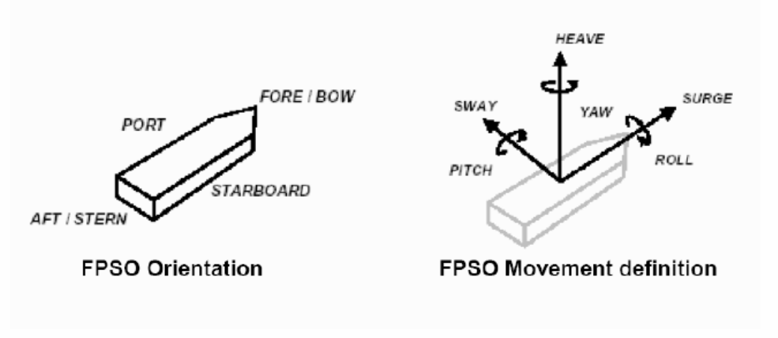
PACKAGE ORIENTATION ON FPSO
FPSO axis
FPSO axis
Package main axis
Package main axis

Utilities
ELECTRICITY
Refer to:
- Project specification for electrical requirements for packaged units:
rev
- GS EP ELE 011
UCP UPS Earthing Regime:
UCP Normal Power Regime:
INSTRUMENT AIR
Type | Instrument Air
Min/max operating temperature |  | °C
Operating temperature |  | °C
Min/max operating pressure |  | Barg
Operating pressure |  | Barg
Oil concentration
Dew point |  | °C @ barg

COOLING WATER SYSTEM
Type | Sea Water | Fresh Water
Normal inlet temperature |  |  |  | °C
Min/max inlet temperature |  |  |  | °C
Min outlet temperature |  |  |  | °C
Max outlet temperature |  |  |  | °C
Supply pressure |  |  |  | Barg
Max allowable delta P |  |  |  | Bar
Calorific capacity |  |  |  | kJ/kg°C
Fouling factor |  |  |  | m².°C.h/kcal

Tests

Factory tests (workshop)
The scope of this chapter is to describe the factory tests to be carried on the Fire Fighting Diesel Hydraulic Driven Pump package in Vendor facilities before unit shipment.
Factory tests shall demonstrate the correct design, manufacture and operation of the equipment and its satisfactory performance in accordance with the conditions identified in the mechanical data sheet.
The following tests shall be carried out:
- Performance testing of individual equipment item (diesel engine, booster pump, Submerged hydraulic pump, UCP)
- Pre-test activities
- Performance and mechanical running test of Fire Fighting Diesel Hydraulic Driven Pump package. This activity shall include the functional test of all the main auxiliary systems of the package
- Mock-up test with complete pipestack assembly and top plate
- Assembled package shall be weighted before packing and shipment.
The following documentation shall be issued by Supplier prior the factory tests in workshop:
- Factory test procedures
- “As built” drawings relevant to factory test.
The test procedure shall be issued 8 weeks prior the test (including noise and vibration measurement proposed procedure).
Detailed procedures for all tests, which shall include the acceptance criteria for all monitored parameters, shall be reviewed and accepted by the Company prior to the commencement of tests. Failure of any aspect of the testing shall require corrective action and a full complete re-test.
The results of each test shall be recorded in appropriate log sheets provided by Vendor and signed as “witnessed” by all the parties.
After the completion of the tests, Vendor shall issue an official test report including all the above log sheets. Copy of raw data registered during the tests shall be handed over immediately after each test activity for Contractor inspection record.
All tests identified as factory tests will be witnessed by Company or their representative.

Performance tests

Acceptance criteria
Following acceptance criteria are valid for both Vendor facilities and field tests:
- Performances and tolerances:
  - Submersible hydraulic pump and Booster pump as per NFPA 20 and API Std 610
  - Diesel engine as per ISO 3046-3.
- Mechanical:
Vibration levels over the whole operating range:
  - Submersible vertical pump as per API Std 610 (bearing housing velocity 5 mm/s RMS in [10-1000 Hz] frequency range),
  - Booster pump as per API Std 610 (bearing housing velocity 3 mm/s RMS in [10-1000 Hz] frequency range),
  - Driver as per ISO 10816-6 (global velocity 17.8 mm/s RMS in [10-1000 Hz] frequency range as per Table A-1, classification number 4, zone A/B) at rated flow point,
  - HPU as per ISO 10816-6: (global velocity 17.8 mm/s RMS in [10-1000 Hz] frequency range as per Table A-1, classification number 4, zone A/B) at rated flow point,
  - Base-plate: global velocity 4.5 mm/s RMS in [10-1000 Hz] frequency range.
- Noise as specified in Project specification. If not, guaranteed noise level as per paragraph 4.16.2.

Pump performance test
Fire Fighting Diesel Hydraulic Driven Pump package performance test shall be conducted at rated speed. Testing of Fire Fighting submerged Hydraulic Pump could be carried out with shortened pipestack section due to limitations of test bench facilities. Prior to such tests, the Vendor shall make and indicate the necessary correction factors to be made to the test results to account for the pipestack length and friction losses.
The Fire Fighting Diesel Hydraulic Driven Pump package performance guarantee shall be for the fully assembled unit.
The Fire Fighting Diesel Hydraulic Driven Pump package shall include at least the following test points:
- Closed valve for 5 minutes
- Minimum continuous stable flow for 15 minutes
- Intermediate between minimum continuous stable flow and rated flow for 15 minutes
- Rated flow for 15 minutes
- And 150% rated flow for 15 minutes.
Additional test points shall be taken as necessary to accurately establish the full Fire Fighting Diesel Hydraulic Driven Pump curve.

NPSH and mini submergence test
NPSH test for both pumps shall be carried out at the following points:
- Minimum continuous stable flow
- Intermediate between minimum continuous stable flow and rated flow
- Rated flow
- Intermediate between rated flow and 150% of rated flow.
Minimum submergence test is required on the Submersible hydraulic pump.
The Submerged hydraulic pump shall be capable to satisfy NPSH requirements of the Booster pump from minimum continuous stable flow to 150% of rated flow.
The Vendor shall provide the method to achieve the above test and the correspondent test procedure.

Diesel engine test
The diesel engine tests at the engine Manufacturer's works shall include measurement of power, fuel consumption and lubricating oil consumption according to ISO 3046-3 requirements.

Pre-test activities
Before commencing the factory testing of the completely assembled packages, the following minimum pre-test activities shall be carried out:
- Checking the compliance of the equipment with the project specifications
- Checking the certificates of compliance for the hazardous area components
- Calibration of all Project instruments. Relevant calibration certificates shall be available at the time of the test for Purchaser review. Spot checks of instruments calibration shall be required before test commencing.
- Instrumentation and electrical equipment insulation and continuity tests
- All instrumentation and electrical equipment functions shall be verified, including simulation, shut-downs and remote signals
- Control loops check and functional tests
- Instruments, controls, alarms and safety devices
- Safety and protection devices operational checks
- Serial link test
- Equipment tagging and labeling check
- Mechanical equipment alignment check
- Pneumatic pressure tested piping system
- Leakage tests
- Hydrostatic tests
- Lube oil flushing and cleanliness
- Weights and dimensional checks
- Verification of the dynamic stiffness of the test bench as per GS EP MEC 300.
The reports relevant to the mechanical equipment alignment check and to flushing and cleanliness checks shall be available for Contractor review during test.
Before commencing the tests the package shall be cleaned by Vendor and shall be visually inspected by Contractor.

Performance and mechanical running tests
Supplier shall provide all temporary equipment required for implementation of the tests, including, but not limited to temporary connections, hardware to simulate signals and interfaces external to the supplied equipment etc.
Supplier shall be responsible, as well for providing all utility services needed to perform the test in proper conditions.
Each complete Fire Fighting Diesel Hydraulic Driven Pump package shall undergo a complete unit test, four (4) hours uninterrupted continuous duration and be carried out on units fully erected, pre-commissioned and shall involve all contract equipment listed in the scope of supply.
The complete unit test shall demonstrate the proper functioning of all sub-systems, instruments, controls and safety systems.
The complete unit test shall consist of but not limited to:
- Performance and mechanical test of Fire Fighting Diesel Hydraulic Driven Pump package with all contract components and sub-components, all contract off-skid auxiliaries items, contract UCP and associated instrumentation etc.
- The primary and backup diesel engine functional tests including starting sequence shall be demonstrated. A manual start using the back-up system shall be made with the engine cold.
- The capacity of starting systems accumulator(s) shall be demonstrated.
- The proper functioning of the primary (battery) starting system if selected shall be demonstrated by starting the engine manually from the UCP.
- Operational checks such as but not limited to Start/Stop normal sequences, Emergency stop sequences etc.
- Diesel engine over-speed test, air flap reset test and Emergency fuel shut-off valve test.
- The parameters to be monitored, but not limited to, shall include suction and discharge pressures, pump flow, speed, temperatures, vibration levels on booster and submerged lift bearings, baseplate vibration, cooling flows.
- Sound level tests with the Fire Fighting Diesel Hydraulic Driven Pump package operating at rated conditions shall be performed for all Fire Fighting Diesel Hydraulic Driven Pump packages. Noise measurement shall be performed in accordance with GS EP MEC 300 for all equipment. Sound power levels and sound pressure levels shall not exceed the data sheet values.
- Vibration shall be measured during the shop test of the assembled machine operating over the agreed speed.
- Package vibration test as per GS EP MEC 300.
- Inclination test of Fire Fighting Diesel Hydraulic Driven Pump package if selected. Angle to be defined as per Project requirements.
- Fire Fighting Diesel Hydraulic Driven Pump package fuel consumption shall be measured.
Test duration
The mechanical running test shall be conducted initially at operating point and when oil temperatures and all other parameters have been observed stabilized.
- Four (4) hours continuous running at the operating point
- Minimum one (1) hour continuous running at 150% of rated flow.
All running parameters shall be recorded every thirty minutes.Each test shall be subject to a test report issued by Vendor and submitted to Company and Contractor.

UCP and ICSS communication link test
The FAT shall include exhaustive UCP FAT and ICSS communication link(s) tests, as detailed and in compliance with paragraph 7.4 and appendix 5 of GS EP INS 110. The principle rule and objective shall be that all outstanding punch item(s) from these tests shall be closed out before expedition of the UCP.
The Package Vendor shall include and provide all the necessary means for the ICSS vendor to participate in the ICSS communication link test. The ICSS communication link(s) test may be conducted at a different time and place when deemed more practical, but it shall be conducted and successfully closed out before UCP FAT. The ICSS communication link(s) tests shall be conducted with ICSS equipment and link being identical to the final ICSS equipment and link, i.e. not by means of simulating/emulating PC/laptops through a general PLC communication port.
All I/O shall be fully simulated with real analogue and digital signals/indicators, i.e. not by forcing /monitoring the I/O via the application software. Voting inputs function (e.g. F&G detectors) shall be fully tested.
Verification and validation of the package’s instrument ranges (i.e. instrument index), alarm & trip setting list, as well as data exchange table list with the ICSS shall be an integral and mandatory part of the UCP FAT, and be included in the FAT procedure and FAT report.

Site acceptance tests (SAT)
All packages shall be submitted to Site Acceptance Tests (SAT). Such tests shall demonstrate that the Fire Fighting Diesel Hydraulic Driven Pump package meets the mechanical and performance requirements within the specified operating range and conditions.
Site acceptance of the units will be pronounced only after the satisfactory completion of the field acceptance tests.
This test shall be carried out on the site or at integration yard, in operating conditions, with the fire fighting pump package connected to the distribution network. Each pump shall be tested at 150% rated capacity.

Post-test activities
After the SAT, the Vendor shall supply a detailed SAT report including as a minimum the following elements:
- List of the instruments used during the test
- Test points log sheets
- Summary chart of the package performances converted from the test to the data sheet conditions.

Spare parts and special tools
This paragraph gives the minimum requirements of spare parts and special tools for this project. It shall be read in conjunction with GS EP EXP 217.

Spare parts

Commissioning and start-up spare parts
Following spares shall be provided but not limited to:
- Diesel Engine
  - Lube oil filter cartridges
  - Diesel main and pre-fuel filter cartridges
  - Air filter elements (pre-filter, coalescer)
  - Filter elements for air starting system if any
  - Shims for diesel engine alignment.
- Submerged Hydraulic Pump
  - O-Rings, backup rings, bolts, nuts and washers
  - Bearings and sleeve
  - Mechanical seals
  - Wear rings.
- Booster Pump
  - O-Rings
  - Bearings and sleeve
  - Mechanical seals
  - Wear rings.
- Top Bend
  - O-Rings.
- UCP including Fire and Gas panel
  - Relays, Fuses, Lamps and bulbs
  - One (1) power supply card
  - One (1) communication interface card
  - One (1) analogue/ digital input card
  - One (1) analogue/ digital output card,

Capital spare parts
The Vendor shall quote a spare submerged hydraulic pump (pumphead including hydraulic motor), complete with testing identified as per paragraph 7 of this specification.

Special tools
Where special tools and fixtures are required to disassemble, assemble or maintain the packages unit, they shall be identified, listed and included in the Supplier quotation and furnished as part of the initial supply of the package.
Cradle for vertical pumphead storage is required.

Software and programming back-up
As per GS EP INS 110, a dedicated engineering laptop, with original application software and actual PLC/VDU programming on CD/DVD, including full and unlimited duration licenses, shall be supplied for the PLC and VDU with the package. If any modifications have been made during on-site commissioning or acceptance tests, then the Package vendor shall ensure that a backup of the latest programming/configuration is supplied with the final IOM documents.

Preparation for shipment
The purpose of the preservation and shipment requirement is to assure the best economical protection against adverse atmospheric weather, corrosion build up and mechanical damage due to storage and transportation from Vendor (manufacturers, packagers and contractors) premises to Contractor yard and from Contractor yard to Company site.
The Vendor and/or Manufacturer shall issue necessary procedures which shall be applied to any equipment to cover:
- The preservation during workshop storage
- The preservation, packing and fastening of equipment during transportation from Vendor facilities to Contractor yard construction
- The preservation during the construction works on the Contractor yard
- The preservation, packing and fastening of equipment during towing from Construction yard to Company site.
The procedures shall contain a check list including all preservation and packing tasks.
The hereafter requirements shall also be applied to the capital spares delivered with the contract. The capital spares shall always be preserved and packed for long term outdoor storage.

Preservation
The preservation duration will be selected by the Project in the package data sheet and/or equipment data sheets.
Two types of preservation can be applied depending on Project needs: short term preservation or long term preservation.
The considered preservation shall be valid for shipment between:
- Vendor premises and Contractor yard
- Contractor yard and site.
The short term preservation shall cover a period up to six (6) consecutive months after processing of the preservation. The considered storage shall be outdoor without protection.
The long term preservation shall cover a period up to twelve (12) consecutive months and be annually renewable during five (5) years.
The desiccant products shall be free of DMF (dimethyl fumarate) content and shall be selected from Silica base. The regeneration of desiccant products is a mandatory requirement and shall be done by heating.
The desiccant products shall conform to the NF H00-320 or DIN 55473 or US MIL D 3464E standards.
The VCI (Volatile Corrosion Inhibitor) and VPI (Vapor Phase Inhibitor) shall conform to the US MIL-STD-2073-1 E standard. However necessary care shall be taken to use approved products compatible with the materials needing to be preserved.
All desiccant products locations shall be provided with a metallic label indicating their presence.
The last mechanical and/or performance runs can be done with anti-corrosion additives mixed with the lube oil. However Vendor shall demonstrate that the anti-corrosion additives shall not compromise the life of the equipment.
All opening shall be closed with metallic blind and gasket to be air and water sealed.
Metallic labels with necessary cautions and instruction to remove preservative products prior equipment start-up shall be provided. The labels shall be made of metal with black marking on yellow back ground.

Diesel engine
After completion of the tests, the following shall be performed as a minimum:
- Draining of liquid as water, diesel from systems
- Drying of systems
- Cleaning of reservoirs with non pilled clothes
- Spraying of TectylTM or VCI in the diesel system including reservoir
- Spraying of TectylTM or VCI in the air system
- Spraying of TectylTM or VCI in the water cooling system
- Spraying of TectylTM or VCI in the lube oil system
- Insertion of dessicant product in the diesel, water, oil and air systems by means of perforated metallic baskets fixed to blinds
- Preservation from foreign matters entrance
- Sealing of opening.

Pump
After completion of the tests, the following shall be performed as a minimum:
- Draining of liquid such as water from systems
- Drying of systems
- Cleaning of reservoirs with lint-free rags
- Spraying of TectylTM or VCI in the reservoir, lube system and casing
- Spraying of TectylTM or VCI in the air system
- Spraying of TectylTM or VCI in the pump casing
- Spraying of TectylTM or VCI in the seal system
- Insertion of desiccant product inside the reservoir, the pump casing and the seal system by mean of metallic basket welded to the closing blinds
- Sealing of openings with metallic blinds.

Instrumentation and electrical auxiliaries
After completion of the tests, the following shall be performed as a minimum:
- Draining
- Drying
- Insertion of soft bags desiccant products in instrument junction boxes and in instrument head
- Sealing of openings.

Control panels
After completion of the tests, the following shall be performed as a minimum:
- Draining, where needed
- Drying
- Cleaning of panels
- Packing of all equipments not rack mounted
- Insertion of soft bags desiccant product inside the control panel
- Positive locking of all doors
- Sealing of openings.

Auxiliaries
The package auxiliaries generally include piping, filters, heat exchangers, valves, ducting, structural frames.
- Draining
- Drying
- Cleaning
- Spraying, if any, of TectylTM or VCI
- Spraying Water resistant wax TectylTM and wrapping on all non painted interfaces
- Sealing of opening.

Packing

Weather protection
The design of the packing shall procure an optimal weather protection during oversea transportation and contractor yard storage.
During the detail engineering phase, Contractor, in conjunction with Vendor, has to issue and submit the preservation and sea fastening procedures to Company representative for approval.
Contractor shall be fully responsible of equipment preservation until provisional acceptance on site.
The weather protection shall be made of heat welded multilayer film (polyester, aluminum, polyethylene) and shall be installed around the package. All lifting appliances and lifting points shall be provided outside the weather protection and shall not be subject to losses of sealing. The film shall conform to the NF H00-310 or US MIL PRF 131K standards.
Prior to weld and seal the multilayer film, the hereafter sequences shall be applied, but are not limited to:
- A sweeping with Nitrogen shall be performed in order to remove the internal moisture as much as possible to get low residual humidity.
- A set of desiccant bags shall be included to absorb residual moisture and trap during transportation and storage the moisture passing through the multilayer film envelope.
- A moisture indicator (sensitive paper) shall be included inside the envelope prior sealing to perform the traceability of the internal atmosphere during transport and storage.

Mechanical and infestation protection
The mechanical and infestation protection shall be performed by a use of multilayer wooden plates (plywood).
The multilayer wooden plates shall be sea water resistant in case of overseas transportation. A selection of multilayer wooden plates in accordance with marine immersion resistant, french standard CTBX or equal classification requirements is required.
The construction of the overall mechanical protection shall be done in such a way that internal or external members shall not damage the weather protection.
The construction shall be in such a way that rodents and insects cannot enter inside the box.
All sensitive parts like antifriction bearing, rotor shaft, shall be locked in place and insulated by means of shock absorber. The rotor locking devices shall be labeled with metallic instructions and cautions label with black making on yellow colored back ground labels shall be provided.

Fastening
All devices needed for the fastening whatever the transportation mode considered (sea, onshore, dirty and/or ice road) shall be provided external to the mechanical protection. The fastening shall not affect the weather/mechanical protection integrity.
The fastening shall be part of the equipment engineering design and shall be provided to avoid any modification and/or welding on the equipment during its installation until completion.

Marking
The minimal requirements for marking shall conform to the ISO 780 code in addition to the specific requirement of the project.

Pump specific
The pumps shall be preserved as per clause 9.1.2 and packed as per clause 9.2 during transportation from Vendor facilities to Contractor yard and from Contractor yard to Company site.
For light pump rotors, the use of own bearing supports during transportation is allowed. However Vendor has to demonstrate that transportation with pump rotor in place shall not impact the integrity and capability of the pump to recover original performances during commissioning and start-up at site.
Rotor shall be locked in position for transportation. The locking devices shall be supplied by the Vendor.
For capital spares, internal or external vibrations and shocks absorbers and shock loggers shall be provided. Drop acceleration limit shall be indicated by the Supplier.

Loose shipped items and auxiliaries
The loose shipped items delivered with the contract (including commissioning and start-up spare parts) shall be preserved as per clause 9.1 and shall be packed inside a VCI plastic bags as per clause 9.1 during transportation from Vendor facilities to Contractor yard and from Contractor yard to Company site, except for structural frames and ducting when part of the scope of supply.
The packing boxes shall be provided with:
- Internal or external vibrations and shocks absorbers.
- External lifting and handling devices and fastening provisions
- External marking in accordance with ISO 780 and Project specific requirements
- Internal harness and/or means for fastening
- Moisture indicator
- Internal or external provision for documentation storage
- External blank marking area and/or location to attached the AWB (Air Way Bill).

Transportation
The Notified body responsible for transportation between Vendor facilities and port of shipment shall perform the assessment of the means, risks and constraints.
It shall be clearly specified in the Vendor proposal the means to be used for transportation, the loading of the equipments and the induce constraints due to sea, road, rails transportation in term of equipment assembly and number of packs.
A preliminary packing list including packing dimensions and weight table shall be attached to the Vendor proposal to give possibility to Company to assess the transportation impacts prior contract award.
The handling, loading and unloading procedures and the lifting drawings shall be part of the engineering phase and shall be developed by the Vendor.
The spreader bars, the lifting beams and ancillaries (slings, shackles) shall be supplied by Vendor and shall be load tested and certified by third party notified body. The use of synthetic slings is not allowed.

- Definition and abbreviations
AAR Automatic Air Release
Company Total E&P or any Total E&P subsidiary
Contractor Any Company Total E&P has signed a contract with for the Engineering, Procurement, Construction and Installation of a part of a project
DMF Dimethyl Fumarate
ESD Emergency Shut down
FGS Fire and Gas System
FO Field Operations
FSS Fire Suppression System
HMI Human Machine Interface
ICSS Integrated Control and safety System
ITP Inspection Test Plan
MCC Motor Control Center
NDT Non Destructive Test
OEM Original Equipment Manufacturer
Package Prefabricated process or utility self-contained unit, generally able to operate on its own, supplied fully tested and ready for immediate installation
PLC Programmable Logic Controller
SAT Site Acceptance Test
SIL Safety Integrity Level
SPL Spare Parts List
Supplier or Vendor The package Supplier or Vendor
UCP Unit Control Panel (or Controller as per NFPA 20)
VCI Volatile Corrosion Inhibitor
VPI Vapor Phase Inhibitor
VTMS Vibration & Temperature Monitoring System
- Baseplate installation
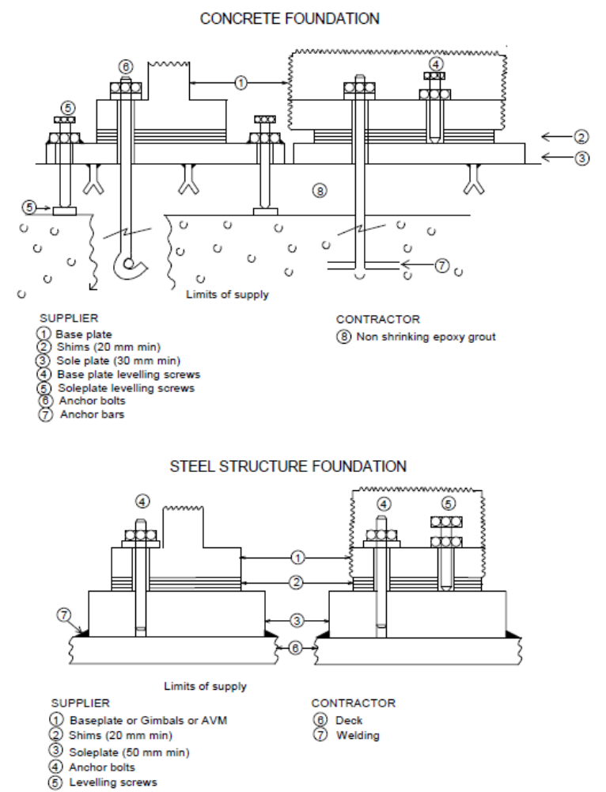
- Vendor Document Register (VDR)
The following documents shall be delivered by the Package Vendor. This list is a mandatory base frame but might be extended on a Project basis.
(1) Documents to be supplied with offer.
Item | Designation | (1)
1 | General
1.1 | Vendor document register | X
1.2 | Deviation list | X
1.3 | Monthly report
1.4 | Sub-Vendors List | X
1.5 | Quality Plan
1.6 | Inspection and Test Plan | X
1.7 | Declaration of conformity for ATEX
2 | Arrangements
2.1 | General Arrangement drawing for FWP Package | X
2.2 | General Arrangement drawing for submersible lift Pump | X
2.3 | Foundation Drawings
2.4 | Limits of supply table (interface and connection schedule) | X
2.5 | Allowable nozzles loads
2.6 | Lifting Drawing
2.7 | Unit Control Panel drawing
2.8 | Fire fighting cabinet drawing
3 | Data sheets
3.1 | Driver data sheet | X
3.2 | Submerged hydraulic Pump data sheet | X
3.3 | Booster pump data sheet | X
3.4 | Hydraulic power pack data sheet
3.5 | Mini Flow valve data sheet (if any) | X
3.6 | Noise data sheet
3.7 | Weight data sheet
3.8 | Maintenance data sheet
3.9 | Instruments data sheet
3.10 | Other data sheets (LV motors, valves, lube oil filters, transformer etc.)
4 | P&IDs & Lists
4.1 | P&ID symbols table | X
4.2 | PFD and PID’s | X
4.3 | Equipment list / Bill of materials | X
4.4 | Load and Utilities List
4.5 | Lubrication list and schedule
4.6 | Sign and Tag schedule
4.7 | List of hazardous area certificates
5 | Detail drawings
5.1 | Submerged pump, booster pump Outline drawings
5.2 | Submerged pump, booster pump sectional drawing and associated part list
5.3 | Outline drawings equipment (mini flow valve, flexible mounts, silencers, vessels, coupling, heat exchangers, filters…)
5.4 | HPU Outline drawing
5.5 | HPU sectional drawing and associated part list
5.6 | Fire fighting cabinet outline drawing
5.7 | Local gauge outline drawing
5.8 | Fuel tank outline drawing
5.9 | Starting systems Outline drawing
5.10 | Equipment data plate drawing
5.12 | Interconnecting piping Isometrics
5.13 | Piping Classes | X
6 | Electrical / Instrumentation and Controls
6.1 | Junction Boxes dimension and termination diagram
6.2 | Control philosophy and Functional analysis
6.3 | Instruments hook up Diagrams
6.4 | Instruments list
6.5 | HMI displays
6.6 | PLC software data base exchange
6.7 | Instruments and electrical cables list
6.8 | Modbus list including addressing
6.9 | I/O list
6.10 | Instrument index S4l format
6.11 | Alarm / shut down list
6.12 | Interconnecting diagram (instrumentation and electrical)
6.13 | Earthing diagrams
6.14 | Logic diagrams
6.15 | Cause and effect chart
6.16 | Instrument loop diagrams
6.17 | UCP terminal strips
6.18 | Junction boxes terminal strips
6.19 | Wiring diagrams
6.20 | Obsolescence dossier
6.21 | Single line diagram
6.22 | Block Diagrams
7 | Calculations and Performances data
7.1 | Pump(s) performance curves | X
7.2 | Lateral and Torsional critical speed analysis calculation note
7.3 | Baseplate calculation note
7.4 | Safety relief valve calculation
7.5 | Starting systems calculation note
7.6 | Other calculation notes (anodes, water hammer etc.)
8 | Manuals/procedures/other lists
8.1 | Painting specification
8.2 | Installation and operating manual index
8.3 | Installation and operating manual
8.4 | Special tools list
8.5 | Start up and commissioning spare parts list | X
8.6 | Priced operating spare parts list
8.7 | Capital spare parts list | X
8.8 | Packing index and final packing list
8.9 | Storage prior and after erection procedure
8.10 | Weighing procedure
8.11 | Performance/ mechanical running test procedures
8.12 | UCP test procedure
8.13 | Factory test for complete package procedure
8.14 | SAT procedure
8.15 | Reports for the above tests (2)
8.16 | Preservation procedure
8.17 | Packing procedure
9 | Manufacturing/Quality/HSE documents
9.1 | NDE procedures
9.2 | Welding procedures
9.3 | Material certificates
9.4 | All tests and inspections certificates
9.5 | QA/ QC (Manufacturing data book) index
9.6 | QA/ QC (Manufacturing data book) Dossier
(2) The package string test report shall include pictures of the package (four side views and four isometric views).
- Minimum inspection requirements
As a minimum, the following inspections shall be witnessed by the Company:
- Submerged Hydraulic Pump & Booster pump performance test
- Submerged Hydraulic Pump NPSH/ Submergence test
- Booster Pump NPSH test
- Functional, performance and mechanical running test of the Fire Fighting Diesel Hydraulic Driven Pump package
- Final inspection
- Final dossier data book review.

Note: This list does not include the inspections to be conducted on each individual component constituting the package.
- Deviations to the contractual documents
If deviations are waived during the bid phase, they shall be listed in the following pages in the purchase revision.

The deviation list shall exhibit at least the following:
- Reference of the specification
- Paragraph of the specification
- Description of the deviation
- Reason for deviation
- Vendor proposal
- Company final position.

The deviations that are not accepted by Company shall appear in this list in order to give a complete overview of the technical discussions.

The following list contains pages.

Note: The deviation list might not be attached to this specification but referenced under a project document (as reported below).

Project document reference:
Revision

- Data Sheet
Fire Fighting Submerged Hydraulic centrifugal pump data sheet and booster data sheet DS EP MEC 023.
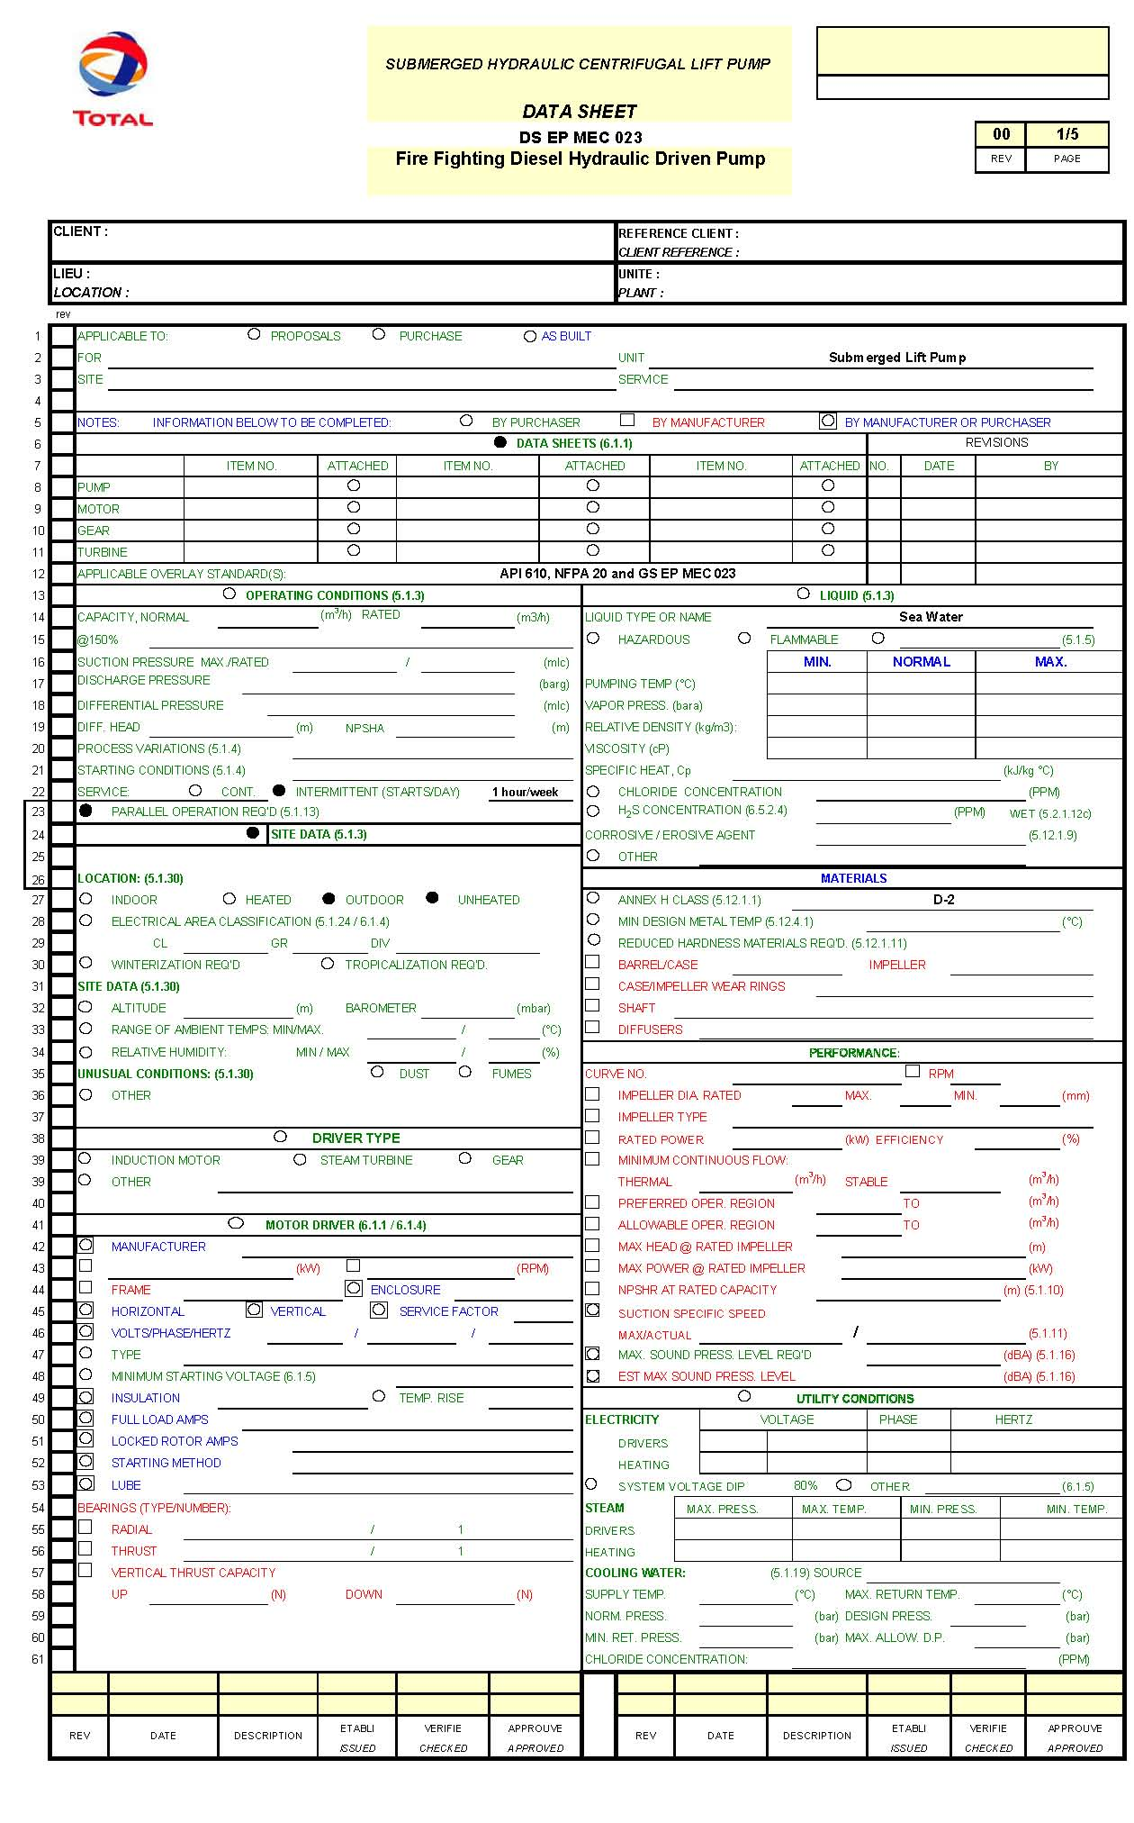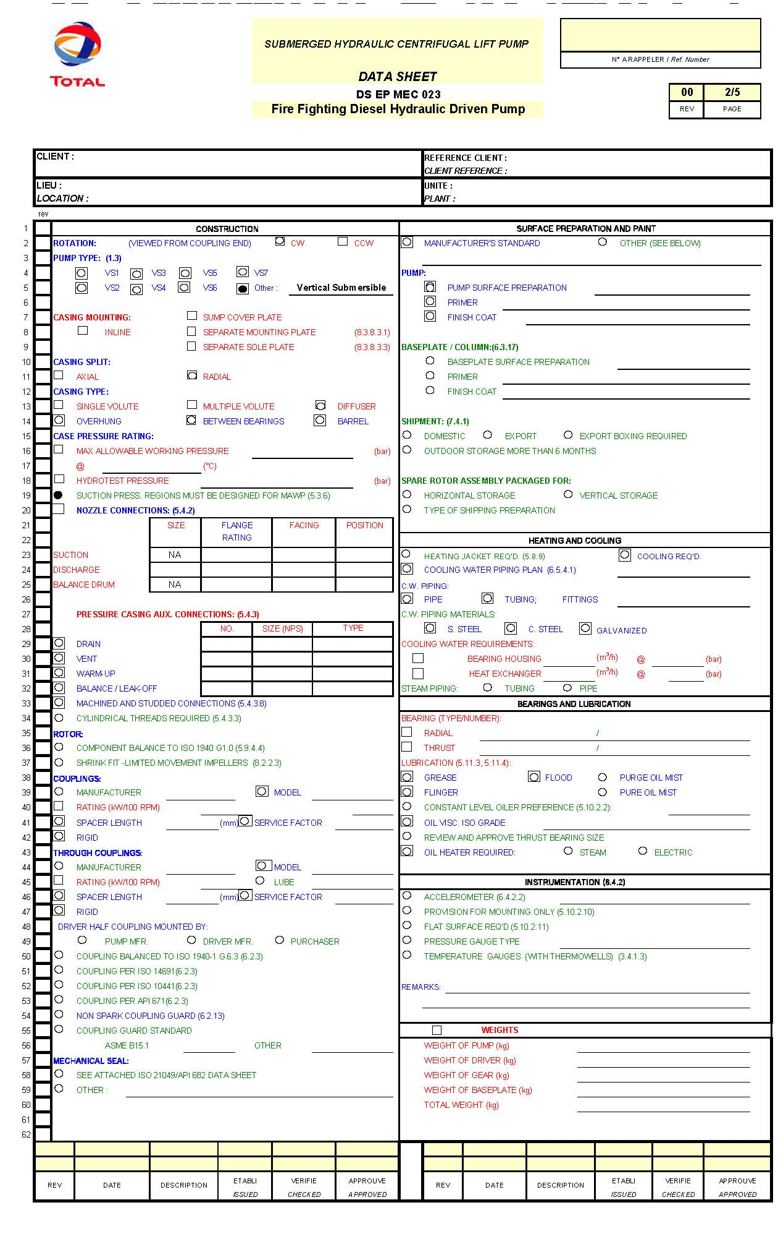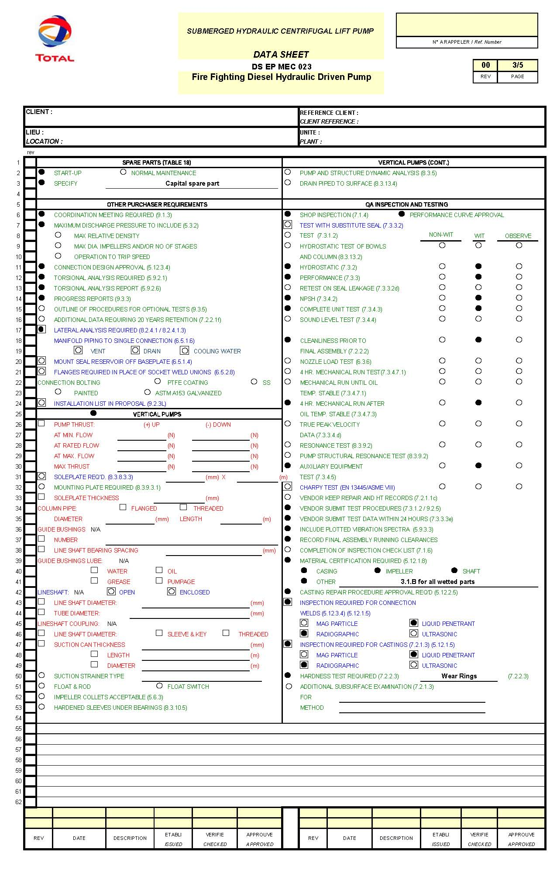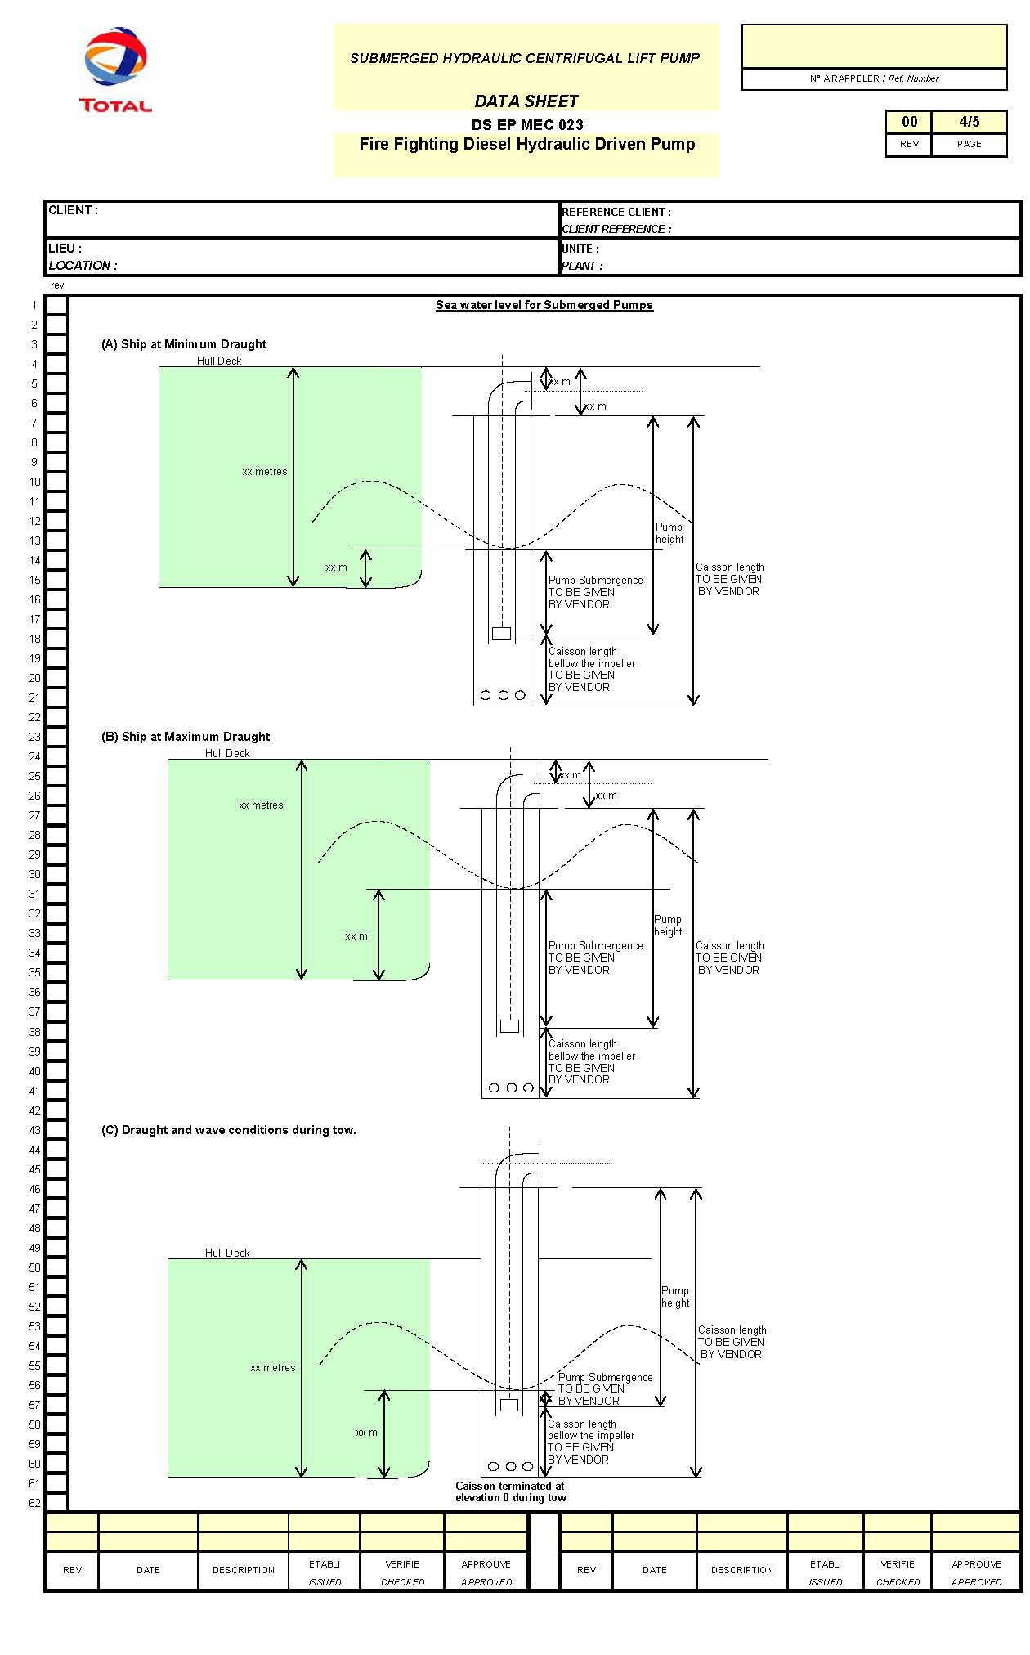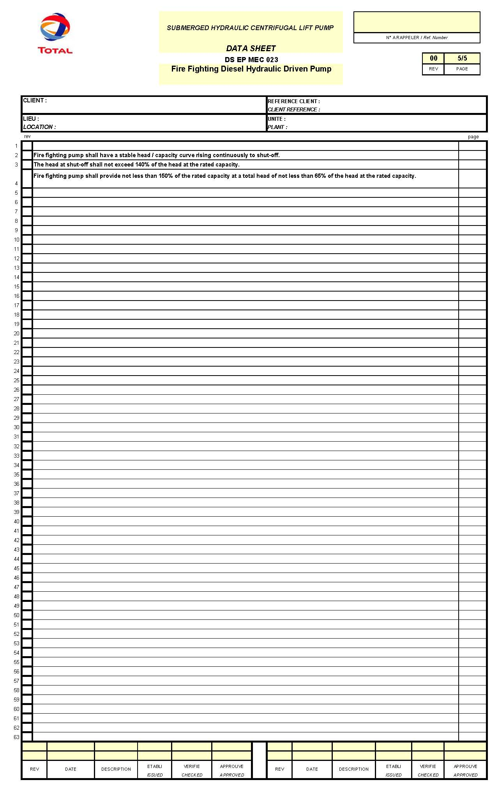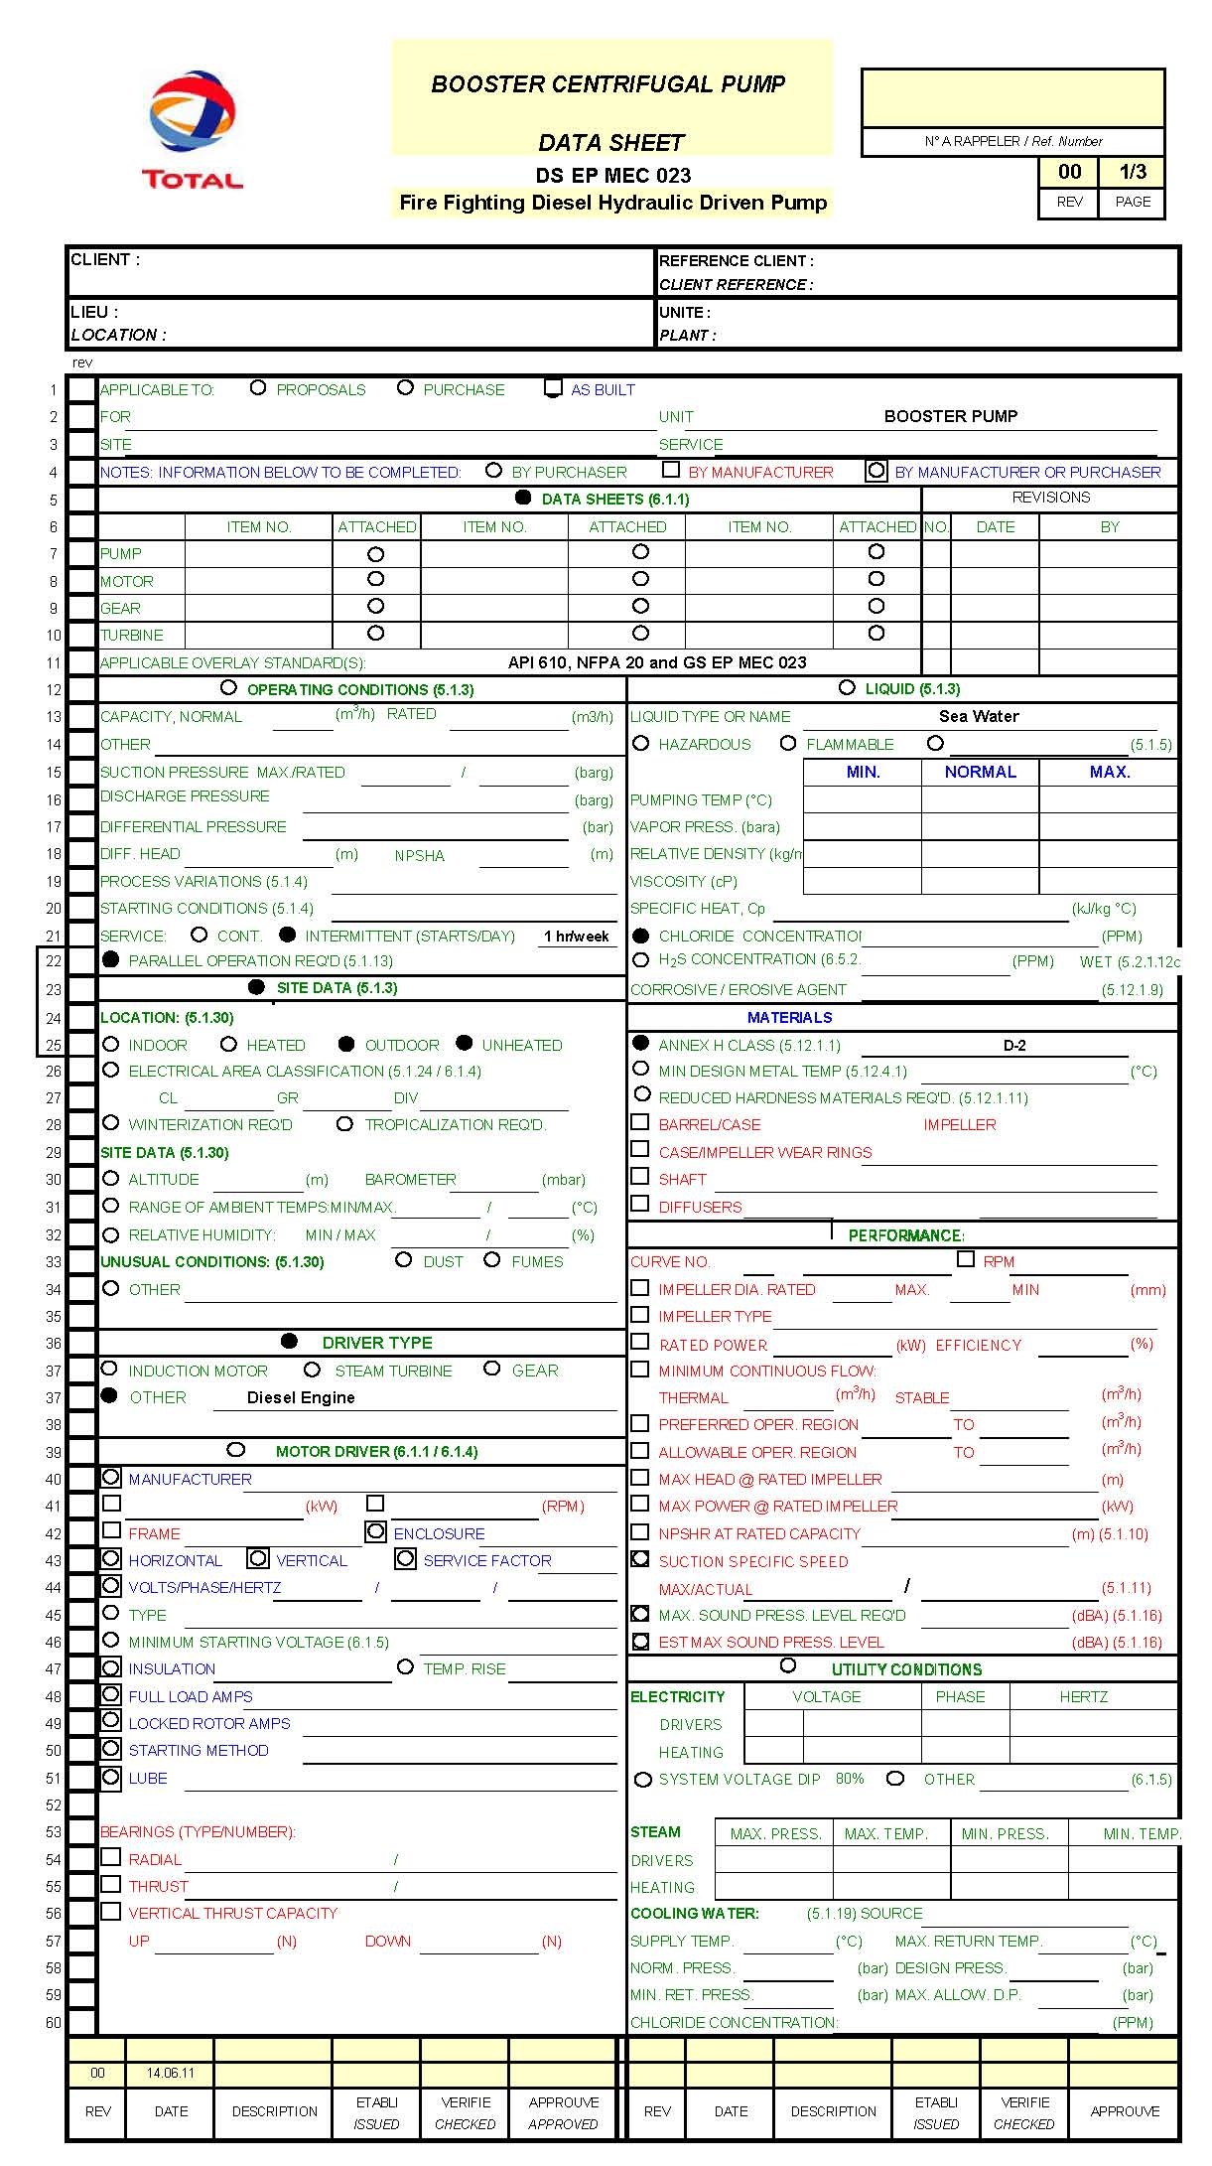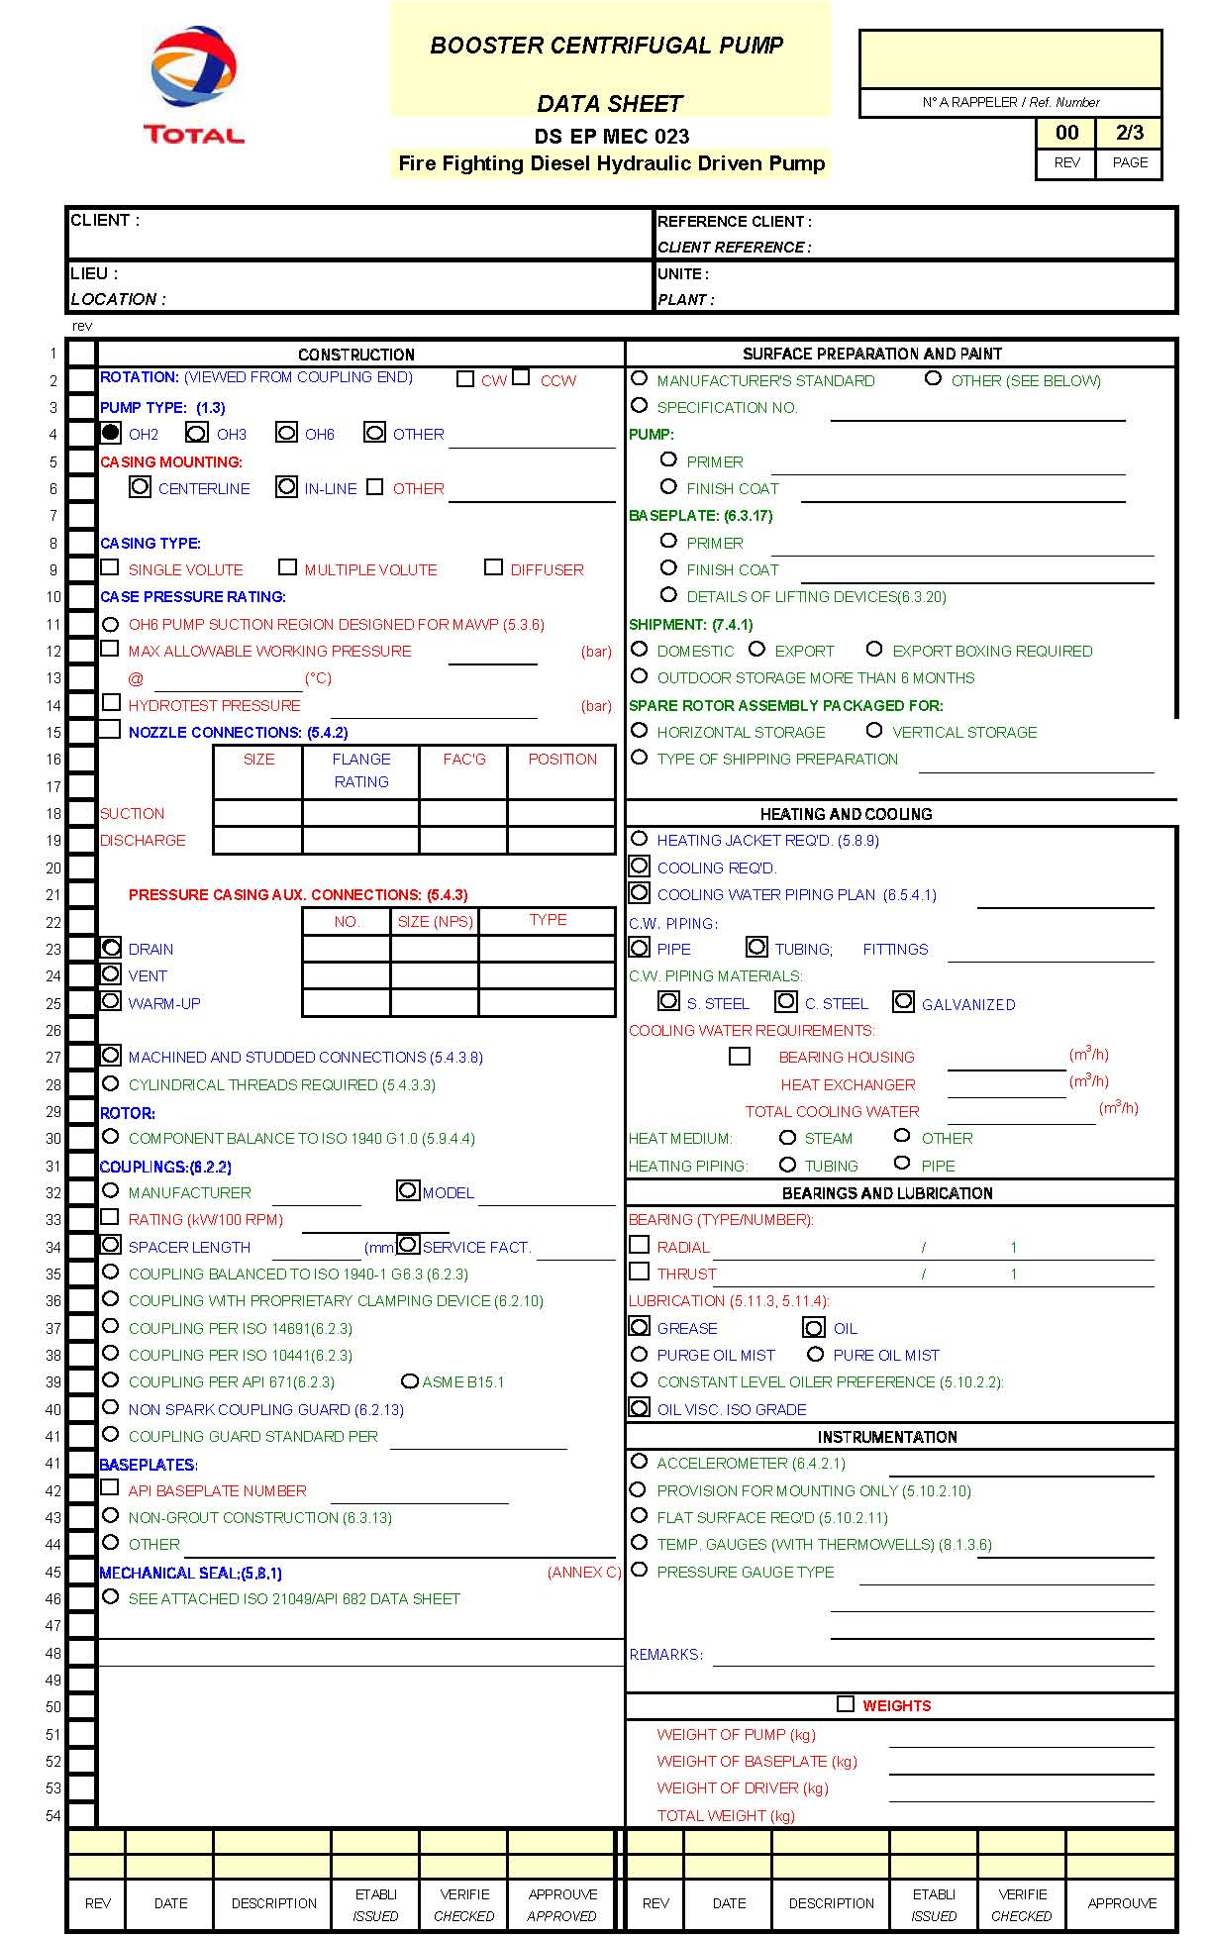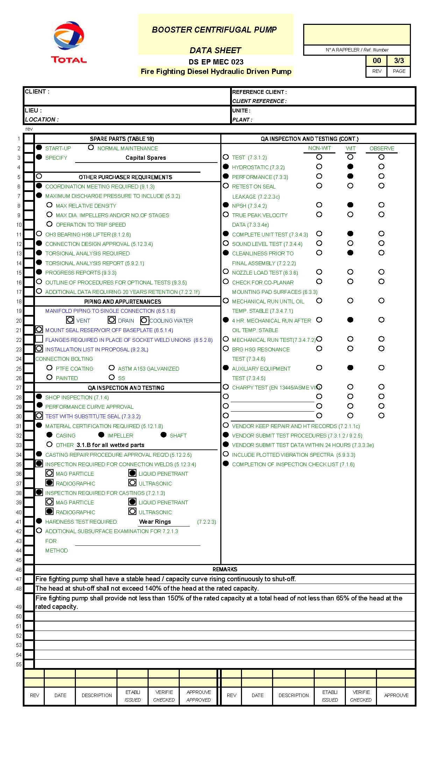
- Data Sheet
Gas and Diesel Engines Data Sheets DS EP MEC 140
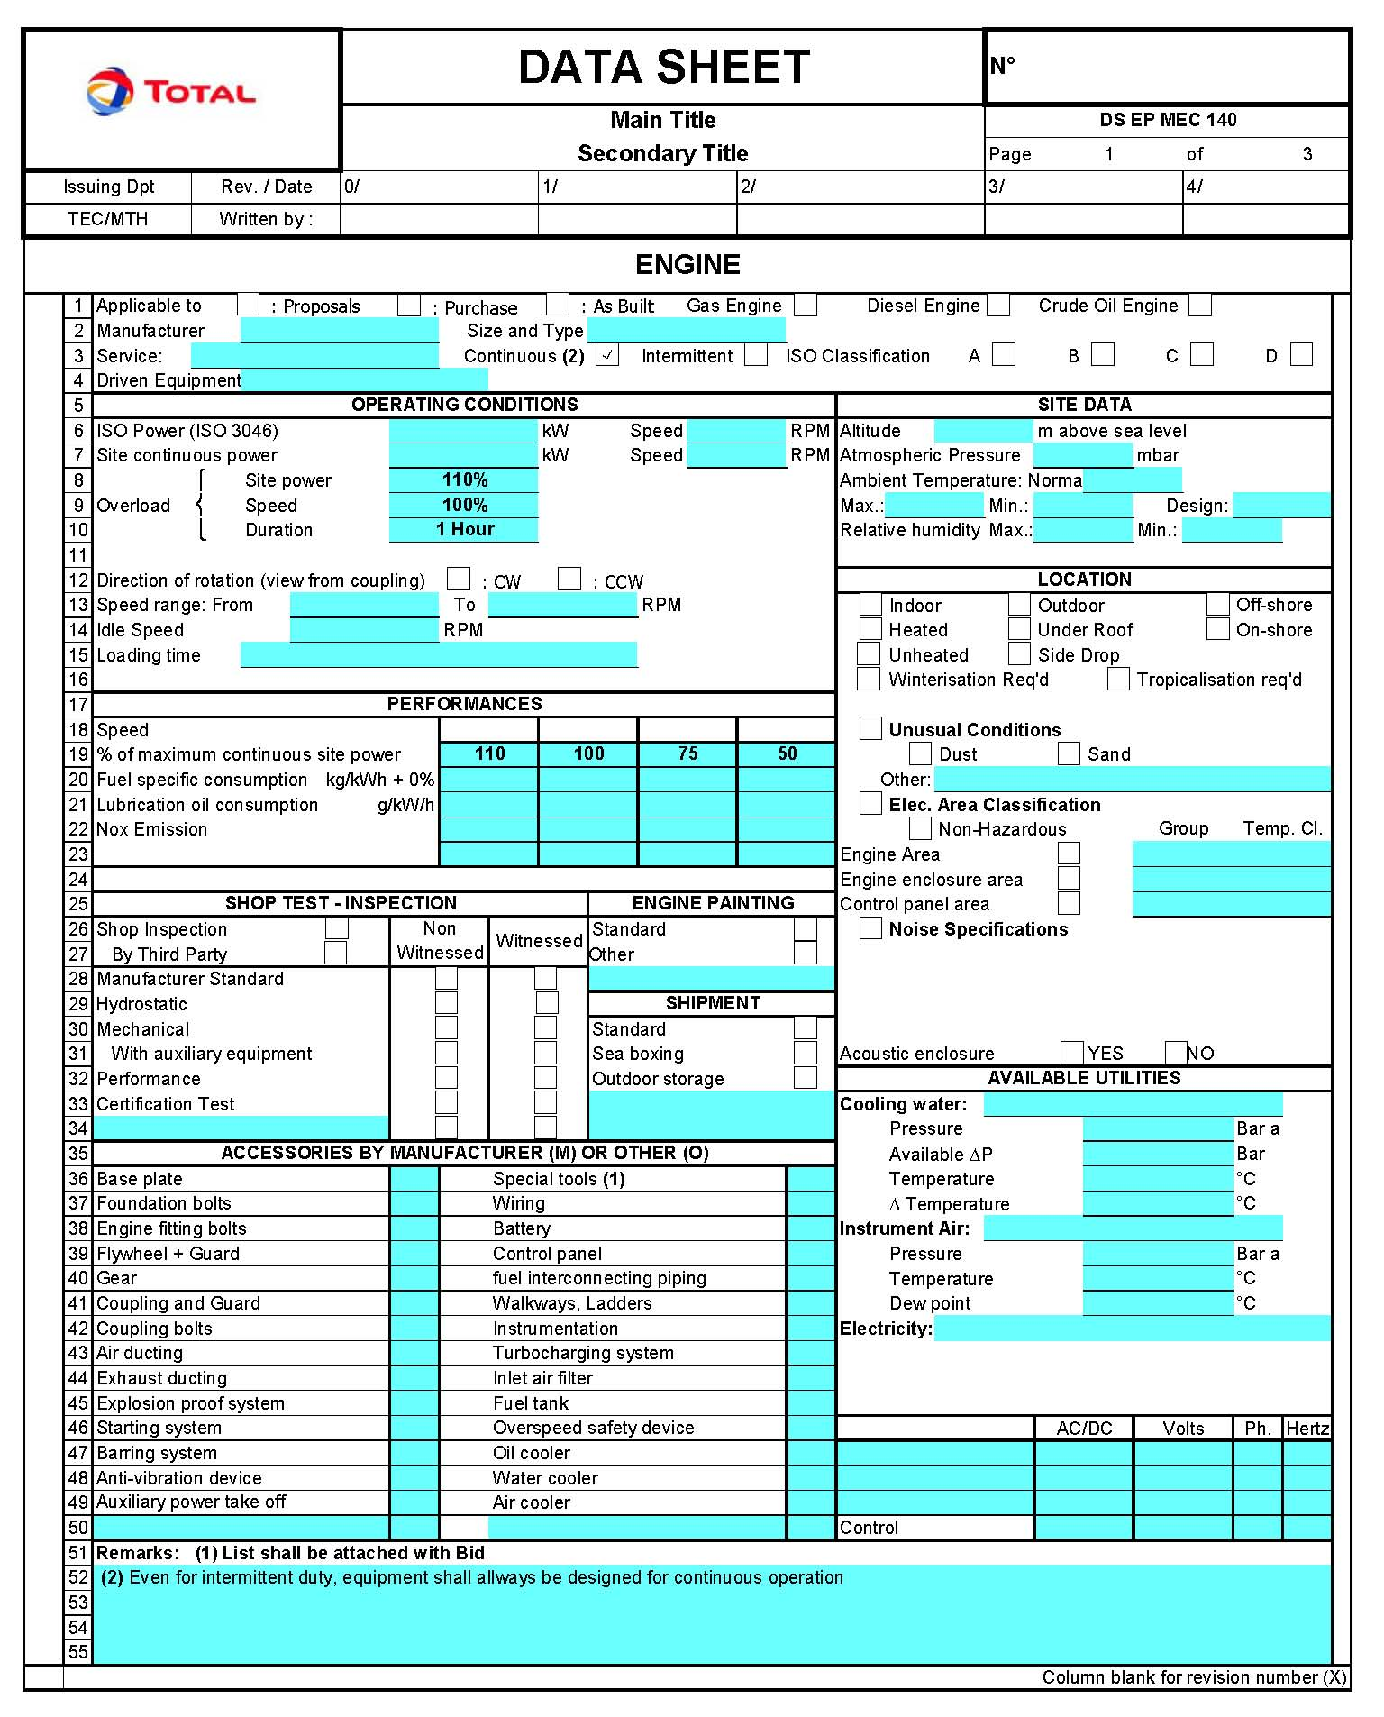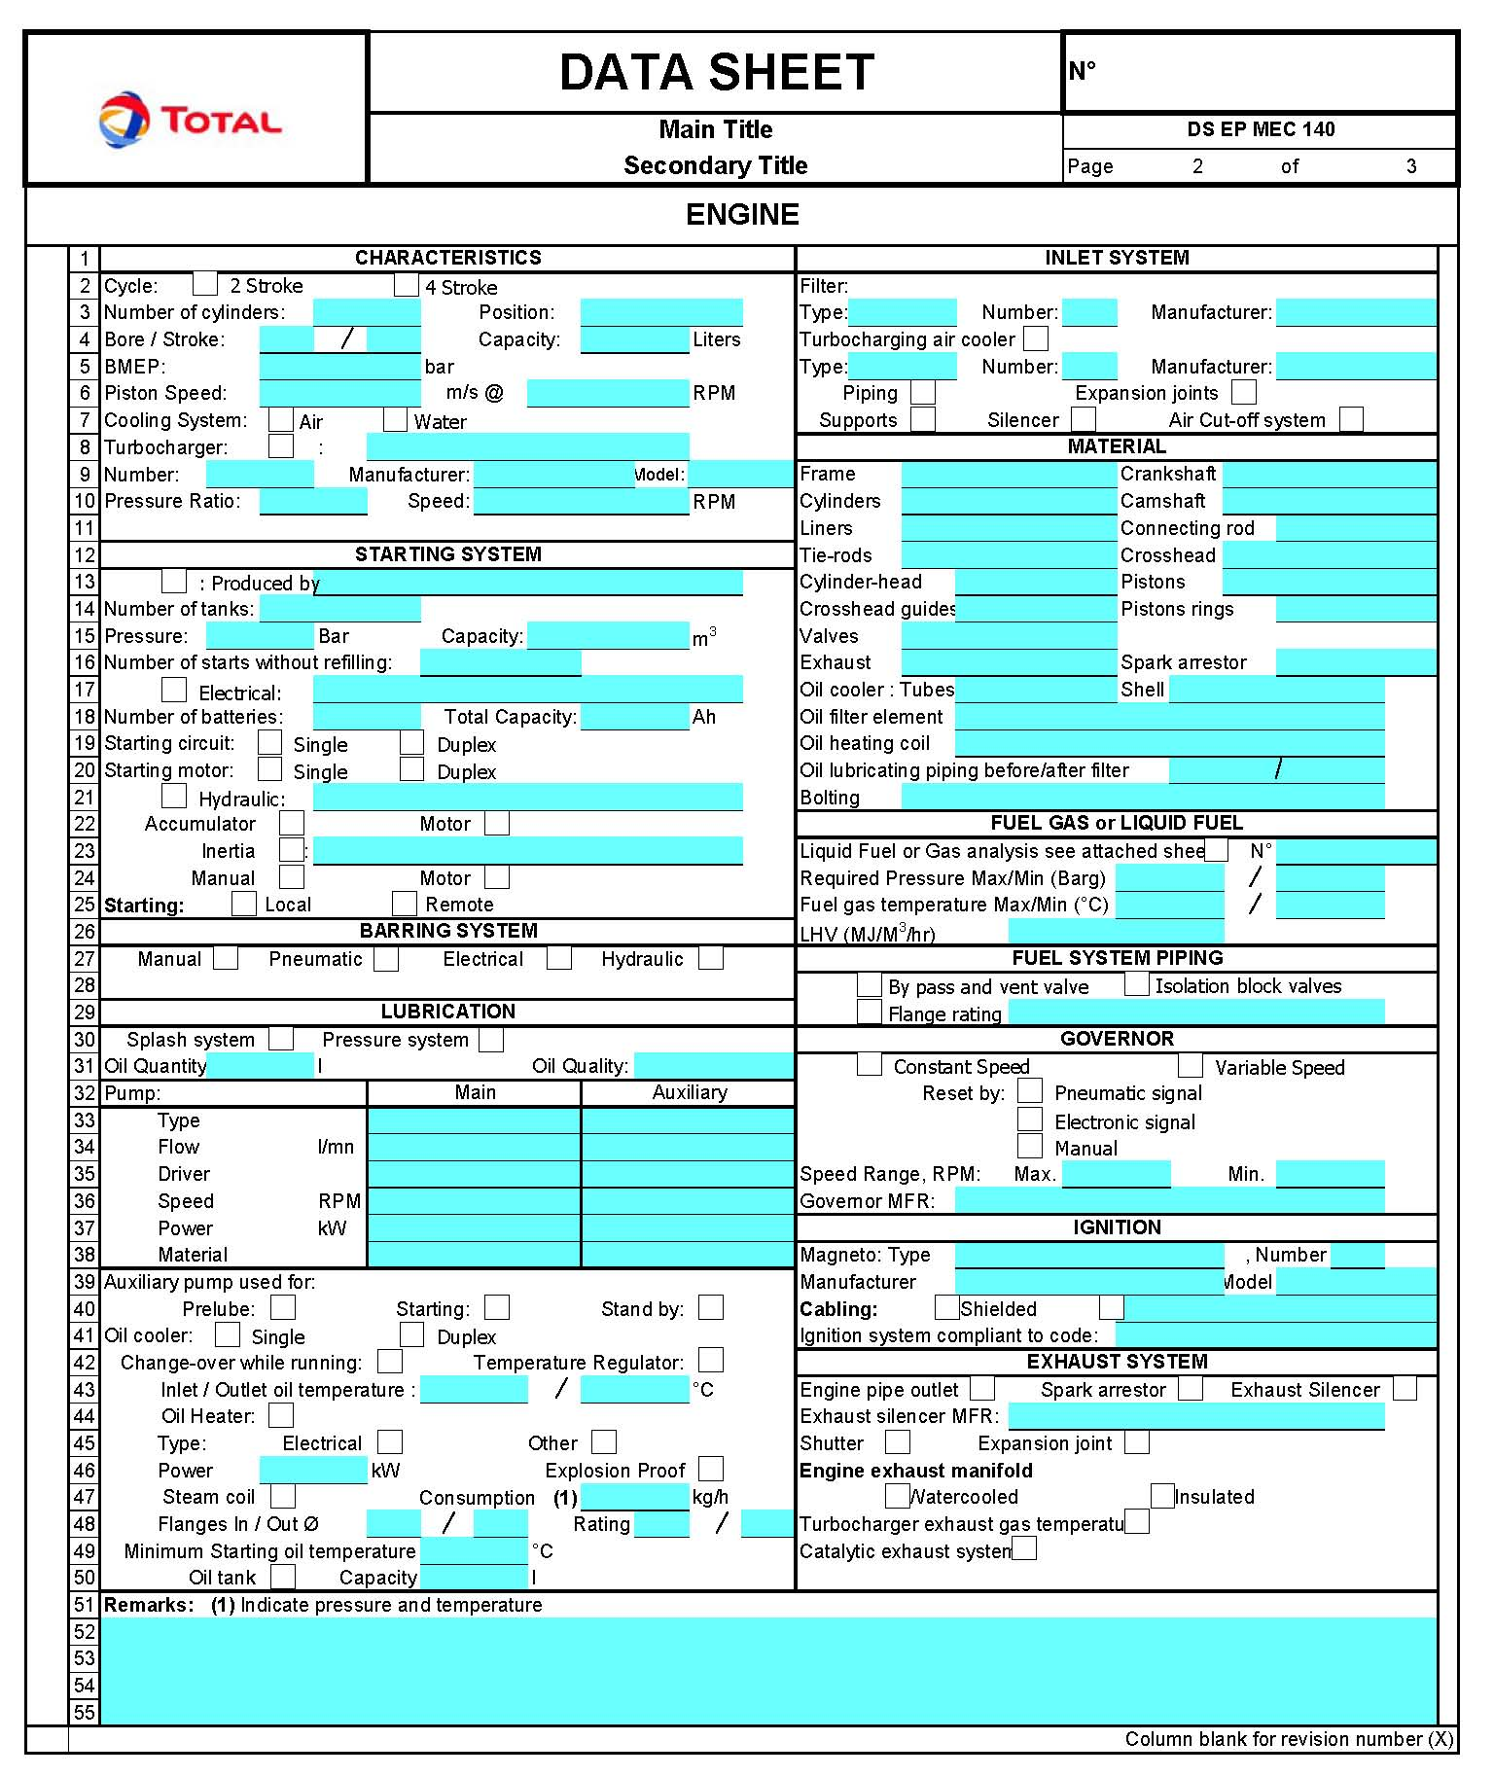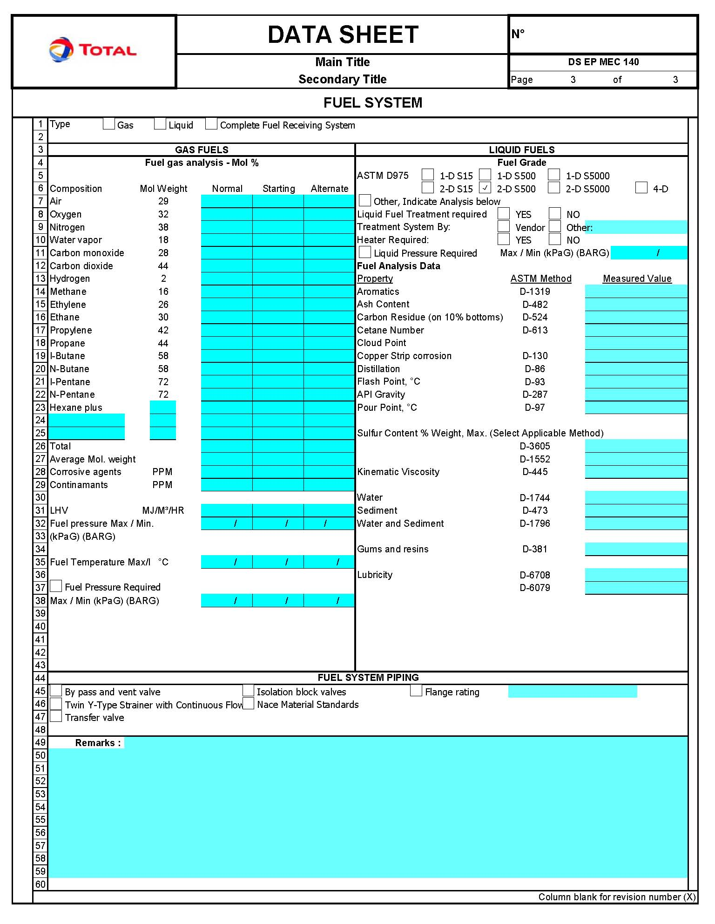

Reference to Articles 100/118 of the Treaty of Rome
Reference to Articles 95/137 of the Treaty of Amsterdam

