GENERAL SPECIFICATION
ROTATING MACHINERY
GS EP MEC 025

Rotating Machine Package Specification
Fire Fighting Electric Driven Horizontal Pump

01 | 10/2012 | Update
00 | 01/2012 | First issue
Rev. | Date | Purpose of the revision

Owning entity: DEV/TEC | Managing entity: DEV/TEC/MTH

Project Specification n° |  | Revision:
 |  | Date:

Contents
Preamble 4
1. Scope 5
1.1 Purpose 5
1.2 Application 5
1.3 General rules 5
1.4 Order of precedence 6
2. Reference documents 6
3. Scope of supply and exclusions 10
3.1 Scope of supply 10
3.2 Exclusions 12
4. Basis of design 13
4.1 General considerations / safety and environment 13
4.2 Package design 13
4.3 Shafts speed 14
4.4 Comments and/or additions to NFPA 20 14
4.5 NFPA 20 - paragraph 6 - Centrifugal pumps 14
4.6 Instrumentation 15
4.7 Operating philosophy 18
4.8 Coupling and guards 19
4.9 Package configuration 20
4.10 Electrical 21
4.11 Piping, valves and pressure vessels 21
4.12 Installation 21
4.13 Painting 21
4.14 Health Safety and Environment 22
4.15 Miscellaneous 22
5. Data sheets 24
5.1 Fire Fighting Pump (refer to Appendix 6) 24
5.2 Electric motor driver 24
5.3 Noise 24
5.4 Weight 24
5.5 Data sheet templates 24
6. Site conditions and utilities 25
6.1 Site conditions 25
6.2 Utilities 27
7. Tests 28
7.1 Factory tests (workshop) 28
7.2 Performance tests 29
8. Spare parts and special tools 33
8.1 Spare parts 33
8.2 Special tools 33
8.3 Software and programming back-up 34
9. Preparation for shipment 35
9.1 Preservation 35
9.2 Packing 37
9.3 Transportation 39
Appendix 1 Definitions and Abbreviations 40
Appendix 2 Baseplate installation 41
Appendix 3 Vendor Document Register (VDR) 42
Appendix 4 Minimum inspection requirements 45
Appendix 5 Deviations to the contractual documents 46
Appendix 6 Data sheet 47

Preamble

Scope

Purpose
This specification defines the minimum design, fabrication, inspection, and testing requirements for supply of Fire Fighting Electric Driven Horizontal Pump Packages. It is an exhaustive document detailing the scope of supply and the associated design rules requested by TOTAL E&P for the procurement of Fire Fighting Electric Driven Horizontal Pump Packages.

Application
This document applies to the design of all Fire Fighting Electric Driven Horizontal Pump packages. The centrifugal horizontal mounting pump is driven by electric motor.
It excludes any other type Fire Fighting Pump packages.

General rules
All deviations from this specification or the documents referred to herein shall be stated in writing in the Appendix 5 of this specification. In the absence of such a statement, it is assumed that the requirements of the specifications are met without exception. Failure to meet the requirements of this specification and referenced documents shall be corrected at Supplier’s cost. Exceptions and deviations to the specifications shall be part of Supplier’s proposal and will be subject to Company approval.
Where this specification, or any other project document, allows the Supplier to propose an “option”, the Supplier shall clearly state the selected option in his bid.
In cases the Supplier provides outsourced equipment, he shall be responsible for the coordination of the Sub-suppliers, and ensuring the full compatibility of all the equipment. In particular, they shall be compatible in terms of safety, environment, operability, dimensions, weight, performance, control, noise and vibration behavior.
Components not mentioned in this specification that are necessary for the operation of the equipment or required by certifying agency, regulatory bodies or by law, shall be Supplier standard components.
The present document remains a General Specification as long as the modifiable forms are not completed. It becomes the Project Specification once these modifiable forms are completed and shall therefore not be considered as a General Specification any more. Then, the General Specification shall be attributed a Project reference number with the associated Project front page.
Preamble shall be completed with the Project description (location, number of machines, etc.).
If Project specificities require amendments to non modifiable parts of this specification or to the documents referred to herein, they shall be considered as deviations and stated in writing in the Appendix 5 of this specification.
This document may modify or complement some requirements of NFPA 20, when deemed necessary in the light of Company experience.
This specification will then be issued in two steps:
- Issued “for inquiry”
- Issued “for purchase”.

Order of precedence
The applicable documents shall be considered in the following order:
- Local regulations
- Classification Society Rules (If applicable)
- Frame agreement if available - Frame agreement: Applicable  - Not applicable
- This completed specification and associated data sheets
- Referenced General Specifications
- Referenced Project documents
- Codes and standards.

Reference documents
The reference documents listed below form an integral part of this General Specification.
External Documents
Unless otherwise stipulated, the applicable version of these documents, including relevant appendices and supplements, is the latest revision published at the effective date of this document.
Reference | Title
1999/92/EEC  (ATEX 118¹/ATEX 137²) | European Directive 1999/92/EEC (16/12/99) on minimum requirements for improving the safety and health protection of workers potentially at risk from explosive atmospheres
94/9/EC  (ATEX 100a/ATEX 95) | European Directive 94/9/EC (23/03/94) on the approximation of the laws of the Member State concerning equipment and protective systems intended for use in potentially explosive atmosphere
API Std 610 | Centrifugal Pumps for Petroleum, Petrochemical and Natural Gas Industries
DIN 55473 | Auxiliary means of packaging - Desiccant in bag - Technical delivery conditions
IP 15 | Area Classification Code for Petroleum Installation handling flammable fluids - July 2005 (3rd edition)
ISO 1940-1 | Mechanical Vibration - Balance quality requirements for rotors in a constant (rigid) state - Part 1: Specification and verification of balance tolerances
ISO 780 | Packaging. Pictorial marking for handling of goods
NF H00-310 | Industrial packaging. Flexible and heat sealing protection materials of low coefficient of water vapour transmission (P < 0.3 g/m² 24 h).
NF H00-320 | Packaging. Desiccant. Specifications and tests
NFPA 20 | Standard for the Installation of Stationary Pumps for Fire Protection - 2010 Edition
US MIL D 3464E | Desiccants, activated, bagged, packaging use and static dehumidification
US MIL PRF 131K | Performance specification: barrier materials, watervaporproof, greaseproof, flexible, heat-sealable
US MIL-STD-2073-1 E | Standard practice for military packaging

Total General Specifications
Unless otherwise stipulated, the applicable version of these documents, including relevant appendices and supplements, is the latest revision published in the applicable yearly collection.
TOTAL EP General Specification Referential is applicable for the following Project:

The following Company specifications are fully applicable to all purchased equipment as listed in paragraph 3.1 completed by the technical details reported in paragraph 4 and taken into account accepted deviations as listed in Appendix 5. The second level General Specifications mentioned in each individual specification are not applicable if they are not listed in the below tables. The standards, professional documents, regulations and codes mentioned in each General Specification are applicable.
The following list may also be complemented with other specific Project detailed specifications which would include additional requirements, as applicable or deemed necessary by Company or Contractor.
Reference | Title
GS EP COR 350 | External protection of offshore and coastal structures and equipment by painting
GS EP COR 354 | External protection of onshore structures and equipment by painting
GS EP COR 356 | Corrosion Protection of Fasteners for Subsea and Topside Applications
GS EP ELE 011 | Electrical requirements for packaged units
GS EP ELE 031 | Design of earthing and bonding systems
GS EP ELE 079 | Electrical apparatus for potentially explosive gas atmospheres
GS EP ELE 111 | Induction motors
GS EP ELE 161 | Electrical cables
GS EP EXP 217 | Requirements to Vendors, Suppliers and EPC’S for spare parts
GS EP INS 101 | Instrumentation engineering, supply and construction general requirements
GS EP INS 102 | Instrumentation identification
GS EP INS 107 | Design and installation of instrumentation links
GS EP INS 110 | Instrumentation for package units
GS EP INS 135 | Cyber Security requirements for design and supply of ICSS and Package Systems
GS EP INS 900 | Instrument hook-up diagrams
GS EP MEC 101 | Driver Power Sizing
GS EP MEC 240 | Special Purpose Couplings for Petroleum, Chemical, and Gas Industry Services according to API Standard 671
GS EP MEC 270 | Supply of Mechanical Seal according to API Standard 682
GS EP MEC 271 | Centrifugal Pumps for the Petroleum, Chemical and Gas Industry Services according to API Standard 610
GS EP MEC 292 | Rotating Machines Packages Installation Requirements
GS EP MEC 300 | Noise and Vibration of Rotating Machine Packages
GS EP PVV 102 | Piping Hook-up Standards
GS EP PVV 112 | Piping material classes
GS EP PVV 143 | Metallic pipes
GS EP PVV 144 | Fittings
GS EP PVV 145 | Flanges
GS EP PVV 175 | Cleaning of piping and vessels
GS EP PVV 614 | Welding of duplex and superduplex stainless steel
GS EP STR 001 | Weight monitoring and weighing offshore units
GS EP STR 103 | Design and fabrication of skids and equipment supporting structures

In case one of the previous General Specifications is completed with one or more Project specific detailed specification(s), then these detailed specifications (and their respective revision) shall be added to the following list.
Project Documents (to be completed by Company or Contractor)
 | Designation | Rev | Reference
1 | PID’s (*)
2 | Layout (*)
3 | Project specification for electrical requirements for packaged units (*)
4 | Instrument tagging specification
5 | Instrument list database specification
Note: All the documents identified by (*) shall be available along with this specification for the issue for inquiry and for purchase.
Project data sheets are listed in paragraph 5.

Scope of supply and exclusions

Scope of supply
The Vendor shall be responsible for the design, supply of materials, manufacture, assembly, supply of drawings and data, all Sub-vendor co-ordination, testing, delivery and guarantees of the below components:
Note 1: The column “Required” indicates the level of requirement of each item, according to the below rule:
- “X” means that the item is a base case requirement.
- “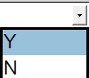 means that the item is an optional requirement specific to the project. “Y” for YES if the option is selected or “N” for NO if the option is not selected.
Note 2: The column “Description” may offer alternative technical choices that shall be fixed prior to the issue “For inquiry” by ticking the appropriate mark box .
# | Item | Description |  |  | Required | Tag | Quantity
1 | ON SKID EQUIPMENT
1.1 | Driven pump including but not limited to:
1.1.1 | Centrifugal horizontal Pump | As per GS EP MEC 271 and as per data sheet referenced in paragraph 5.1 of this specification. |  |  | X
1.2 | Electric motor including but not limited to:
1.2.1 | Main electric motor | As per GS EP ELE 111 and GS EP MEC 101 and as per data sheet referenced in paragraph 5.2 of this specification. |  |  | X
1.2.2 | Terminal box cable glands | The supply of the cable glands is defined in the data sheet referenced in paragraph 5.2 of this specification. |  |  | X
1.2.3 | All associated Instrumentation, terminal and auxiliary junction boxes |  |  |  | X
1.3 | Power transmission equipment including but not limited to:
1.3.1 | Spacer type coupling | As per paragraph 4.8 of this specification and GS EP MEC 240. |  |  | X
1.3.2 | Coupling guard | As per paragraph 4.8 of this specification and GS EP MEC 240. |  |  | X
1.4 | Base plate including but not limited to:
1.4.1 | Fabricated steel common base plate | As per paragraph 4.9.2 of this specification. |  |  | X
1.5 | Control and instrumentation including but not limited to:
1.5.1 | Control panel (UCP) | As per GS EP INS 110 and paragraph 4.6.2 of this specification. UCP is including PLC, panel mounted HMI. Full licenses for all software. |  |  | X
1.5.2 | ICSS interface | Communication cards, signal convertors, etc. to interface with ICSS and support systems.
1.5.3 | Junction boxes | All necessary instrumentation junction boxes at skid edges for collect of output/ input instrumentation as per GS EP INS 101 and GS EP INS 107. |  |  | X
1.5.4 | Cable glands | Cable glands for departing multi-core cables, defined by Project and blinded off suitably for transport and storage. In case the option is not selected, the gland plates shall be pre-drilled and blinded off.
1.5.4 | Cable glands | For all other cables, junction boxes shall be provided with cable gland plates and associated cable glands. |  |  | X
1.5.5 | Instrumentation cables | All instruments cables between instruments and skid mounted terminal junction boxes / UCP as per GS EP ELE 161 and GS EP INS 107. |  |  | X
1.5.6 | Instruments cables trays | All necessary cables trays with covers made of AISI 316L between instruments and skid mounted junction boxes as per GS EP INS 107.  Empty cable trays shall be installed for the departing multi-core cables -supplied and installed by others- between the terminal junction boxes and the skid edge. |  |  | X
1.6 | Electrical including but not limited to:
1.6.1 | Electrical cables trays | All necessary cables trays with covers made of AISI 316 between all electrical consumers mounted on skid and the skid edge.
2 | OFF SKID EQUIPMENT (shipped loose)
2.1 | Mini flow recirculation valve | As per paragraph 4.4.1.1 and GS EP PVV 112 or Project piping classes. |  |  | X
2.2 | Pressure transmitter | Pressure transmitter located downstream minimum flow recirculation valve.
2.3 | Special tools | Refer to paragraph 8.2 of this specification. |  |  | X
2.4 | Spare parts for commissioning and start–up | Refer to paragraph 8.1.1 of this specification. |  |  | X
2.5 | Capital spare parts | Refer to paragraph 8.1.2 of this specification. |  |  | X
3 | MISCELLANEOUS
3.1 | Base plate anchor bolts and shims | As per Appendix 2 of this specification. |  |  | X
3.2 | Off skid equipment anchors and shims | All anchors and shims for all off skid equipment supplied by SUPPLIER. |  |  | X
3.3 | Lifting tools for the complete package | Certified lifting beam, slings and shackles for a single point lifting of each complete unit as per paragraph 4.15.4 of this specification. |  |  | X
3.4 | Battery limit flanges | All limit flanges as per GS EP PVV 112 or project piping classes if available and equipped with blind flanges for transportation. |  |  | X
3.5 | Documentation | Set of documents as per Appendix 3 of this specification. |  |  | X
3.6 | Earthing network | Earthing design and implementation as per GS EP ELE 031 and GS EP INS 107. |  |  | X
3.7 | Package preservation, packing, marking | As per paragraph 9.1 of this specification. |  |  | X
3.8 | Painting and coating | As per paragraph 4.13 of this specification. |  |  | X
3.9 | Backup | Complete backup hard disk with application software, PLC program, HMI and any firmware prior to shipment. |  |  | X
3.10 | Software | OEM CD/DVD for any software used with full licenses. |  |  | X
3.11 | Specific climate considerations | Tropicalization | Winterization | None | X
4 | TESTS
4.1 | Factory tests
4.1.1 | Electric motor driver | As per paragraph 7 of this specification. |  |  | X
4.1.2 | Centrifugal pump | As per paragraph 7 of this specification. |  |  | X
4.1.3 | UCP | UCP integration and communication test at Sub-vendor premises as per paragraph 7.2.5 of this specification and paragraph 7.4 and Appendix 5 of GS EP INS 110. |  |  | X
4.1.4 | Complete unit tests | As per paragraph 7 of this specification. |  |  | X
4.1.5 | Noise and vibration test | As per paragraph 7 of this specification. |  |  | X
4.2 | Site Acceptance Tests
4.2.1 | Complete unit tests | As per paragraph 7.2.6 of this specification. |  |  | X

Vendor shall be responsible for the physical and technical compatibility of the entire package and shall ensure that all equipment and components provided are suitable for the operations intended.

Exclusions
The following equipment are not included in the scope of supply:
- Counter flanges, gaskets and bolting for connecting flanges at battery limits of Vendor’s supply
- All piping outside the package except when specified here above
- Electric and instrument cables outside the package
- All earthing cables outside the package.

Basis of design
This paragraph details the technical specificities of project that are not covered in the Company General Specifications nor in the Project documents.

General considerations / safety and environment
The complete package shall be designed for years of operation at least.
Environmental conditions for the equipment design are indicated in the paragraph 6 of this specification.
When packages have to be installed in hazardous area zone 2, as per IP 15, they shall be specified for gas group IIA and temperature class T3 (200°C) and ATEX European directives 94/9/EC and 1999/92/EEC shall be applied.
In this case, packages shall be certified ATEX εx II 3G and CE marked with the following requirements:
- Unit Control Panel shall be ATEX εx II 3G and CE marked.
- Any instrumentation component shall be certified ATEX εx II 2G and CE marked. For facilities located outside the European Union (EU countries), alternative IECEx scheme can be applied (IEC Scheme for Certification relating to Equipment for use in Explosive Atmospheres).
- Any electrical component shall be selected in accordance with GS EP ELE 079.
- Any mechanical component certified ATEX εx II 3G and CE marked.
Any equipment or system required to be left in operation when a safe or a hazardous area zone 2 becomes a hazardous area zone 1 such as presence of gas shall be certified ATEX εx II 2G and CE marked.
Package and all accessories shall bear their own marking, according to the mode of protection used.

Package design
The design of Fire Fighting Electric Driven Horizontal Pump package shall include provision for full replacement / component replacement with minimum disruption to plant operations.
Only high integrity and proven equipment shall be considered. Prototype equipment and components shall not be used.
The Fire Fighting Electric Driven Horizontal Pump package may be run continuously for long periods during the construction and the commissioning phases and also capable of intermittent duty (1 hour per week).

Tropicalization
For pumps and equipment installed and operated in tropical conditions, special design considerations shall be taken for air and cooling systems, material choices, surface treatment etc. and shall be based on environmental conditions such as air humidity, air temperature, air temperature variations, surface temperature, cooling water design temperature.

Shafts speed
Pumps maximum operating speed shall be as follows:
Pump Power Rating | < 200 kW | > 200 kW
Horizontal mounting | 3600 RPM  Subject to Company approval | 1800 RPM

Drivers maximum operating speed shall be as follows:
Driver Power Rating | < 200 kW | > 200 kW
Electric Motor | 3600 RPM  Subject to Company approval | 1800 RPM

Comments and/or additions to NFPA 20
Following are the comments and/or additions to the corresponding paragraph numbers of NFPA 20:

NFPA 20 - paragraph 4 - General requirements

Minimum flow protection
Each Fire Fighting Electric Driven Horizontal Pump package shall be provided with a “self-controlled combined check and minimum flow recirculation valve” type Schroeder or Schroedahl. The valve shall be provided shipped loose for vertical installation. Dump and ring main pipes shall be upward routed in such a way that minimum flow recirculation valve is always kept water filled. A small bore bypass line across this minimum flow recirculation valve shall be installed in order to water fill the section between the minimum flow recirculation valve and the main check valve.
Other alternative like self controlled valve or pneumatic operated control valve may be proposed for fixed structures but subject to Company approval.

NFPA 20 - paragraph 6 - Centrifugal pumps
The pump design, construction and testing shall meet the requirements of NFPA 20 and API Std 610 as supplemented by this specification and the equipment data sheets listed in paragraph 5 of this specification.
All Fire Fighting Electric Driven Horizontal Pump shall be suitable for parallel operation even if normal operation does not require all fire pumps running in parallel.

NFPA 20 - paragraph 7.1.2 - Characteristics
According to NFPA 20 paragraphs 7.1.2.1 and 7.1.2.2, Fire Fighting Electric Driven Horizontal Pump shall have a stable head / capacity curve rising continuously to shut-off. The head at shut-off shall not exceed 140% of the head at the rated capacity.
Fire fighting pump shall provide not less than 150% of the rated capacity at a total head of not less than 65% of the head at the rated capacity.
Submergence requirements to satisfy NPSH margin requirements shall be determined at the NFPA 20 150% flow case.

NFPA 20 - paragraph 7.3 - Pump
Fire Fighting Electric Driven Horizontal Pump materials shall be as specified in the equipment data sheets listed in paragraph 5 of this specification.
Guidance for the selection of the pump materials shall be as follow:
- For seawater application, pump materials and wetted parts shall be selected according to API Std 610 Table H1, material class D-2.
- For fresh water application, pump materials shall be selected according to API Std 610 Table H1, S6 minimum.
In his proposal, Vendor shall clearly identify selected materials for all parts of the pump unit, with reference to Company approved standards including the material grade as per ASTM or equivalent

Bolting
To facilitate dismantling and maintenance, internal and external bolting shall be fully resistant to the fluid pumped. Bolting material including the material grade as per ASTM shall be specified in the proposal.

Mechanical Seal

The Fire Fighting Electric Driven Horizontal Pump shall be equipped with dynamically balanced single mechanical seals. The seals shall have configuration 1CW as per standard API Std 610 and as per GS EP MEC 270.
Spacer couplings shall be provided for replacement of the mechanical seals so as to minimize any removing or dismantling.

Instrumentation
The package instrumentation shall comply with GS EP INS 101, GS EP INS 102, GS EP INS 107 and GS EP INS 110.

General
The package is categorized as “P3 type Package”.
- Instruments shall be selected from project nominated Vendor list.
- Instrument tubing and fittings shall be of a single manufacturer and size (imperial or metrical sized) as chosen for the entire facility (by Company or EPC Contractor) and comply with GS EP INS 107.
- All instruments shall be installed and terminated up to skid edge junction boxes, local gauge boards or to unit control panel.
- Cable glands for all interface cables, defined by Project shall be installed and blinded off suitably for transport and storage. In case the option is not selected, the gland plates shall be pre-drilled and blinded off.
- All instruments cables between instruments and skid mounted terminal junction boxes / UCP as per GS EP ELE 161 and GS EP INS 107.
- Segregation of signals between LV, control, safeguarding, digital and analog cables and terminals shall be done as per GS EP INS 110 requirements. I/O signals for control/alarm and safeguarding shall have segregated I/O cards.
- Cable trays with cover made of AISI 316L shall be installed between instruments and skid mounted junction boxes as per GS EP INS 107. Cable trays may share various types of signal cables as long as they are of the same voltage level (i.e. < 50 Volt), although only the same type of signal cables (i.e. analogue, digital, LV) may be bundled together, and cables of different signal type shall have some spacing between them. Cables powering high-wattage (> 1 Amp) solenoids shall remain at least 50 mm (2 inch) spacing from any other type of signal cable. Cable wraps shall be plastic-covered AISI 316; non-metallic cable wraps are not permitted.
- Empty cable trays shall be installed for the departing multi-core cables -supplied and installed by others- between the terminal junction boxes and the skid edge. Potential clash between package cabling and interconnecting cables shall be avoided; the layout and routing of interconnecting cables towards the junction boxes is considered a shared responsibility between the Package Vendor and EPC Contractor.
- Instrument hook-up, including isolation valves, shall comply with GS EP PVV 102 and GS EP INS 900.
- All electronic instruments shall be SMART, analogue 4-20 mA, HART protocol, 24 VDC, full AISI 316 housing and mounting minimum, with LCD indicator for sensors.
- Furthermore, machinery protection and monitoring system shall comply with API Std 670 requirements.

Unit Control Panel
Each Fire Fighting Electric Driven Horizontal Pump Package shall be supplied with its dedicated UCP compliant with GS EP INS 110 and GS EP INS 135 requirements. The (various) earthing systems (i.e. IE, IPE, ISE) and their segregation, isolation and bonding shall be in compliance with GS EP INS 107 and/or with the equivalent project specification for instrument and UCP earthing principles.
The various possible interfaces with ICSS and facility support systems (e.g. IMS, DMCMS, PDS) shall comply with GS EP INS 110 and/or with the equivalent project specification, which may require the provision of particular interface equipment inside the UCP (e.g. a HART MUX board for HART compliant instruments), as per project requirements.
The Package Vendor shall apply the specific SIL application and configuration instructions of PLC Manufacturer associated to the required SIL level. Design details which may cause common-mode failures (e.g. a collective fuse in the power feeder to a number of relays) shall be searched for and be eliminated.
The UCP shall integrate all main control with an HMI and subsystems. All HMI and subsystem controllers shall be panel-mounted.
UCP functionality shall comply with the NFPA 20, enclosed to IP 65 standard as per GS EP INS 101 and GS EP INS 102, fitted with anti-condensation heater, installed on the main unit base plate with anti-vibration mountings.
The Unit Control Panel shall be:
- Designed to execute the operating philosophy described in paragraph 4.7 of this specification.
- Provided with the following devices, not limited to:
  - Mode selector switch
  - Control of the start and shutdown sequences
  - Manual start.
- Provided with the following status, alarms, shutdown, not limited to:
  - Status
    - FWP available
    - FWP on demand
    - FWP running
    - FWP failed to start
    - FWP start inhibited.
  - Alarms
    - Weekly start due
    - Shutdown.
The controller circuitry shall be arranged to provide volt free contacts to give remote annunciation as follows:
- "FWP on demand": Upon reception of the starting signal and during the starting sequence.
- "FWP Fail to start": When all start attempts have failed.
- "FWP available": When the pump unit is ready for a remote start.
- "FWP unit fault": When any of the alarms, shutdowns and abnormal status as here above listed have been annunciated at the controller.
- "FWP start inhibited acknowledgement": Upon reception of the "inhibit automatic start" remote signal.
The controller shall accept the following remote signals:
- "Start": Upon reception of any of the start signals, the pump unit automatic start sequence must be initiated.
- "Inhibit automatic start": Upon reception of this signal, the pump unit automatic start sequence is inhibited.
- Ultimate start from pressure transmitter on fire ring main.

Operating philosophy

Stand-by/ startup conditions
Each Fire Fighting Electric Driven Horizontal Pump package will normally be held in stand-by. In this condition the package shall be available for immediate start-up on receipt of a remote signal, or under local manual control.

Operating modes
Four modes will be made available by means of a mode selector switch:
- Automatic
- Manual
- Test
- Off.

Automatic mode
The Fire Fighting Electric Driven Horizontal Pump package shall start automatically and immediately upon reception of anyone of the following signals:
- A remote signal from the main Fire and Gas detection system
- A remote signal from the main control room
- A signal indicating a low pressure in the fire water ring main through the pressure signal on the UCP (ultimate start).
Once the starting signals have been cleared, the shutdown shall be possible only manually at the Fire Fighting Electric Driven Horizontal Pump package by pressing the stop push button located on the UCP.

Manual mode
The Fire Fighting Electric Driven Horizontal Pump package shall start immediately upon manual activation of the start local push button on the UCP.
Shut-down shall be possible only manually at the Fire Fighting Electric Driven Horizontal Pump package by pressing the stop push button located on the UCP.

Test mode
Fire Fighting Electric Driven Horizontal Pump package shall start immediately upon manual activation of the start local push button on the UCP.
Shut-down shall be possible only manually at the Fire Fighting Electric Driven Horizontal Pump package by pressing the stop push button located on the UCP.
All trips devices shall remain operative in test mode.
If the UCP receives a remote start signal when running in test, the mode shall automatically and immediately change to automatic mode.

Off mode
Automatic start up and manual start up initiated from the UCP are inoperative.
All starting devices are inoperative. This mode shall be used only for maintenance purposes and shall be indicated at the main Fire and Gas system.

Start up and operation in case of gas detection
In the event of flammable gas detection by the plant system or locally if the Fire Fighting Electric Driven Horizontal Pump package is located in a hazardous area, a signal will be generated to the Fire Fighting Electric Driven Horizontal Pump package UCP and the following actions shall occur:
- Electrical power supplies to the Fighting Electric Driven Horizontal Pump package shall be interrupted
- The UCP shall be provided with a local annunciator that the Fire Fighting Electric Driven Horizontal Pump package has been electrically isolated.
- Fire fighting pumps package that are already running shall continue.

Coupling and guards
Couplings shall conform to GS EP MEC 240. Power transmissions shall be balanced to G 2.5 according to ISO 1940-1.
In all cases, the coupling shall be non-lubricated type, flexible disc with spacer. Couplings shall be equipped with structurally rigid spark-proof coupling guard.
Shafts and couplings shall be capable of withstanding 120% of the maximum possible torque that can be generated by driver at start up without exceeding allowable yield stress of any component.

Package configuration
The electric motor driver and centrifugal pump shall be mounted on a common base plate.

Number of package base plate supporting points and type
Whatever the type of supporting structure is, concrete or offshore structure, package base plate shall be multipoint rigid design with jacking bolts for leveling purpose.
Supporting shall comply with the requirements of GS EP STR 103.
Contractor shall install and weld sole plates on all packages in accordance with the Project specifications, if any, and Supplier requirements.
The supporting structure shall be machined prior to welding the soleplates.
Refer to Appendix 2 for details.

Base plate construction details
Package base plate shall be multipoint rigid design with jacking bolts for leveling purpose. Package base plate design shall conform to GS EP STR 103 to maintain alignment of the line shaft under all operating conditions whether normal, transient and abnormal.
Package base plate shall be designed with either:
- A non slip decking steel plate covering the top of the base plate and a drip pan and gutter all around with 2 drains points of 2” diameter minimum
or
- Grating covering the top of the base plate and a steel plate continuously welded at the bottom of base plate recovering any oil spill and drain points of 2” diameter minimum.
All the equipment supported by the skid shall be contained within the skid projection footprint (meaning that no equipment overhung/projection outside the skid footprint is allowed).
The base plate shall incorporate a drip pan to collect spillage. The design of the drain pan and the location of the drain openings shall ensure complete drainage under the most adverse Floating vessel motions.
Baseplate structural welds shall be continuous and closed.

Base plate drains
All drains which are an interface between the Supplier and Contractor shall be routed to the skid edge and shall terminate by 2" ANSI 150 # RF flanges fitted with a blind flange.
The drains shall be routed to plant hazardous open drain by the Contractor.

Electrical

The design, manufacture, inspection and testing of electrical equipment provided with the packaged unit shall comply with GS EP ELE 011.
- Electrical equipment shall be selected from Project nominated Vendor list
- All electrical equipment that shall remain energized in an emergency situation shall be designed for Zone 1 operation
- Cable glands for all interface cables, defined by Project shall be installed and blinded off suitably for transport and storage. In case the option is not selected, the gland plates shall be pre-drilled and blinded off
- Cable trays made of AISI 316L shall be installed between electrical equipment and UCP or multi cable transits for project cables.

Piping, valves and pressure vessels
The fabrication, inspection and shipment of pipes, fittings and flanges shall comply with Company GS EP PVV 143, GS EP PVV 144 and GS EP PVV 145 and GS EP PVV 614.
Package limit flanges shall be in accordance with GS EP PVV 112 or Project piping classes (if any).
Tubing material shall be sourced in SS904L, fittings in SS316.
All main piping systems shall have low point drains. These drains and vents shall terminate with an isolating valve plugged.
All interconnecting piping at skid edge shall be identified and tagged.
Any required cleaning of interconnecting piping systems and/or vessels at Vendor’s facilities shall comply with GS EP PVV 175.

Installation
The package shall be installed as per GS EP MEC 292 requirements.
For packages to be installed on a floating structure, Vendor shall indicate the special devices installed to cope with the FPSO motions and accelerations indicated in the paragraph 6 of this specification. In any case, Vendor shall clearly indicate his layout requirements to ensure proper operation of the lube oil system and the drain system.

Painting
Package unit shall be painted according to GS EP COR 350 or GS EP COR 354 according to site environment.
For packages to be operated offshore or in coastal environment:
- Package skids and support structures, piping and pressure vessels within the scope of supply shall be painted according to GS EP COR 350 system P01
- When required by GS EP COR 350, paragraph 3.2, components made of Stainless steel shall be painted according to GS EP COR 350, paragraph 3.2
- Rotating machines shall be painted according to Supplier standard suitable for offshore environment, if approved by Company, or according to GS EP COR 350 system P14.

Health Safety and Environment

Noise requirements
All definitions, notations, testing methods, calculation methods and calculation procedures shall be in accordance with GS EP MEC 300.
All efforts shall be deployed to limit the average sound pressure level around the package at 90 dB(A) at one meter.
Supplier shall submit during tender the expected noise map at one meter of the sound pressure levels in dBa per octave bands, and the maximum sound power level.

Miscellaneous

Bolting
Package bolting shall be as follows:
- For diameter above 24 mm, bolting shall be according to GS EP COR 356 paragraph 6
- For diameter up to and including 24 mm, bolting shall be of AISI 321 Stainless steel as a minimum.

Name plate’s tags and labels
All major equipment shall be identified by AISI 316L Stainless Steel nameplates attached by AISI 316L Stainless Steel pins or screws.
Instruments shall be tagged with SS316 tag signs attached by stainless steel wire, and identified with signs permanently fixed adjacent to each instrument. All operating notices, warning notices and nameplates shall be in the English and language as indicated in Project Documents.

Rotation arrows
Direction of rotation arrows shall be clearly and permanently marked on all rotating equipment.

Package lifting appliances
Package lifting appliances, such as lifting beams or spreader bars, slings, shackles, etc., shall be included in the Vendor scope of supply and designed, tested and certified by an approved authority in accordance with GS EP STR 103.
Lifting appliances shall be load tested at 125% of the safe working load and certified. Visual inspections and NDT (dye penetrant and ultra sonic inspections) shall be performed after the load test.

Maintainability and accessibility
For all items within the package, Vendor shall comply with the following requirements:
- Accessibility for operation (position of instruments, legibility of readouts, operation of valves, etc.) and for maintenance
- Removable gratings or plates shall be provided around the machines to allow access and to protect equipment located in the bottom part of the package
- Maintainability (disassembly, reassembly, adjustment) with the necessary space and handling devices as appropriate to bring any piece of equipment to dedicated lay down areas
- Safety instructions.
All the above requirements shall be fully supported by an engineering handling study during contract execution, for the following components but not limited to: pumps, rotors, couplings, electric motors, piping spools, etc.
A design review of the package accessibility and maintainability shall be organized with Company and Contractor prior to package construction. This review shall be supported by Vendor 3D CAD models.
For equipment over 20 kg, jack screws, lifting lugs, eyebolts, or equivalent shall be provided to perform alignment, disassembly and re-assembly. Equipment/driver alignment must include a minimum of:
- 20 mm AISI 316 stainless steel machined shims
- 3 mm AISI 316 stainless steel final adjustment shims.
These shims are part of the Vendor scope of supply.

Inspections
The inspections shall be conducted according to the Project ITP. As a minimum, the requirements reported in Appendix 4 shall apply. The weight control shall be performed as per GS EP STR 001.

Engineering documentation language and units
The engineering documentation shall be developed as follows:
Language: English and
Units:

Data sheets

Fire Fighting Pump (refer to Appendix 6)
Reference / Revision: /

Electric motor driver
Reference / Revision: /

Noise
Reference / Revision: /

Weight
Reference / Revision: /

Data sheet templates
Each data sheet requested in the VDR enclosed in the Appendix 3 of this specification shall be filled in by the Vendor in the Company template format.

Site conditions and utilities

Site conditions
LOCATION
ALTITUDE
CLIMATE
ATMOSPHERIC PRESSURE
Average |  | mbar
Minimum |  | mbar
Maximum |  | mbar

AMBIENT TEMPERATURE
Design (minimum / maximum) |  |  | °C
Normal |  |  | °C
Minimum |  |  | °C
Maximum |  |  | °C

WIND
Normal |  | m/s
Design |  | m/s
Direction

RELATIVE HUMIDITY
Minimum |  | %
Maximum |  | %

ENVIRONMENT
Dust
Smoke
Other

BLAST
Equivalent static pressure (mbar)
CLASSIFICATION TYPE AREA
OPERATIONAL DESIGN CONDITIONS
Project Phase: | During towing | On site | On site
Condition: | Dry | Operating | Damaged
Longitudinal acceleration (Surge) |  |  |  | m/s²
Transversal acceleration (Sway) |  |  |  | m/s²
Vertical acceleration (Heave) |  |  |  | m/s²
Trim angle (Pitch) |  |  |  | °
List angle (Roll) |  |  |  | °

The motions and accelerations are given in the following way (typical):
Surge | X | Roll / List | Rotation / X
Sway | Y | Pitch / Trim | Rotation / Y
Heave | Z | Yaw | Rotation / Z

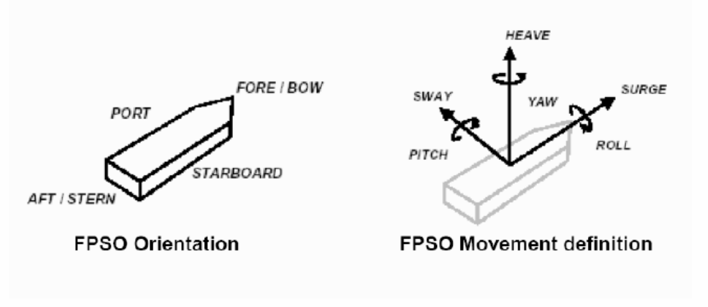
PACKAGE ORIENTATION ON FPSO
FPSO axis
FPSO axis
Package main axis
Package main axis

Utilities
ELECTRICITY
Refer to:
- Project specification for electrical requirements for packaged units:
rev
- GS EP ELE 011
UCP UPS Earthing Regime:
UCP Normal Power Regime:
INSTRUMENT AIR
Type | Instrument Air
Min/max operating temperature |  | °C
Operating temperature |  | °C
Min/max operating pressure |  | Barg
Operating pressure |  | Barg
Oil concentration
Dew point |  | °C @ barg

COOLING WATER SYSTEM
Type | Sea Water | Fresh Water
Normal inlet temperature |  |  |  | °C
Min/max inlet temperature |  |  |  | °C
Min outlet temperature |  |  |  | °C
Max outlet temperature |  |  |  | °C
Supply pressure |  |  |  | Barg
Max allowable delta P |  |  |  | Bar
Calorific capacity |  |  |  | kJ/kg°C
Fouling factor |  |  |  | m².°C.h/kcal

Tests

Factory tests (workshop)
The scope of this chapter is to describe the factory tests to be carried on the completely assembled Fire Fighting Electric Driven Horizontal Pump package in Vendor facilities before unit shipment.
Factory tests shall demonstrate the correct design, manufacture and operation of the equipment and its satisfactory performance in accordance with the conditions identified in the mechanical data sheet.
The following tests shall be carried on the completely assembled package:
- Performance testing of individual equipment item (electric motor, centrifugal pump)
- Pre-test activities
- Performance and mechanical running test of Fire Fighting Electric Driven Horizontal Pump package. This activity shall include the functional test of all the main auxiliary systems of the package
- Assembled package shall be weighted before packing and shipment.
The following documentation shall be issued by Supplier prior the factory tests in workshop:
- Test procedures
- “As built” drawings relevant to factory test.
The test procedure shall be issued 8 weeks prior the test (including noise and vibration measurement proposed procedure).
Detailed procedures for all tests, which shall include the acceptance criteria for all monitored parameters, shall be reviewed and accepted by the Company prior to the commencement of tests. Failure of any aspect of the testing shall require corrective action and a full complete re-test.
The results of each test shall be recorded in appropriate log sheets provided by Vendor and signed as “witnessed” by all the parties.
After the completion of the tests, Vendor shall issue an official test report including all the above log sheets. Copy of raw data registered during the tests shall be handed over immediately after each test activity for Contractor inspection record.
All tests identified as factory tests will be witnessed by Company or their representative.

Performance tests

Acceptance criteria
Following acceptance criteria are valid for both Vendor facilities and field tests:
- Performances and tolerances:
  - Pump as per NFPA 20 and API Std 610
  - Electric motor as per GS EP ELE 111.
- Mechanical:
Vibration levels over the whole operating range:
  - Pump as per API Std 610
  - Electric motor as per GS EP ELE 111
  - Base-plate and pump supports: 4.5 mm/s RMS.
- Noise as specified in Project specification. If not, guaranteed noise level as per paragraph 4.14.1.
- Pump performance test
Fire Fighting Electric Driven Horizontal Pump performance test shall be conducted at rated speed.
Fire Fighting Electric Driven Horizontal Pump guarantee shall be for the fully assembled unit.
Fire Fighting Electric Driven Horizontal Pump test points shall include at least the following test points:
- Closed valve for 5 minutes
- Minimum continuous stable flow for 15 minutes
- Intermediate between minimum continuous stable flow and rated flow for 15 minutes
- Rated flow for 15 minutes
- And 150% rated flow for 15 minutes.
Additional test points shall be taken as necessary to accurately establish the full Fire Fighting Electric Driven Horizontal Pump curve.

NPSH test
NPSH test shall be carried out at the following points:
- Minimum continuous stable flow
- Intermediate between minimum continuous stable flow and rated flow
- Rated flow
- Intermediate between rated flow and 150% of rated flow.
The Manufacturer shall provide the method of NPSH test and the correspondent test procedure.

Pre-test activities
Before commencing the factory testing of the completely assembled packages, the following minimum pre-test activities shall be carried out:
- Checking the compliance of the equipment with the project specifications
- Weights and dimensional checks
- Checking the certificates of compliance for the hazardous area components
- Calibration of all Project instruments. Relevant calibration certificates shall be available at the time of the test for Purchaser review. Spot checks of instruments calibration shall be required before test commencing
- Instrumentation and electrical equipment insulation and continuity tests
- All instrumentation and electrical equipment functions shall be verified, including simulation, shut-downs and remote signals
- Control loops check and functional test
- Instruments, controls, alarms and safety devices
- Safety and protection devices operational checks
- Serial link test
- Equipment tagging and labeling check
- Mechanical equipment alignment check
- Pneumatic pressure tested piping system
- Leakage tests
- Lube oil flushing and cleanliness.
The reports relevant to the mechanical equipment alignment check and to flushing and cleanliness checks shall be available for Contractor review during test.
Before commencing the tests the package shall be cleaned by Vendor and shall be visually inspected by Contractor.

Performance and mechanical running tests
Supplier shall provide all temporary equipment required for implementation of the tests, including, but not limited to temporary connections, hardware to simulate signals and interfaces external to the supplied equipment etc.
Supplier shall be responsible, as well for providing all utility services needed to perform the test in proper conditions.
Each complete Fire Fighting Electric Driven Horizontal Pump package shall undergo a complete unit test, four (4) hours uninterrupted continuous duration and be carried out on units fully erected, commissioned and shall involve all contract equipment listed in the scope of supply.
The complete unit test shall demonstrate the proper functioning of all sub-systems, instruments, controls and safety systems.
The complete unit test shall consist of:
- Performance and mechanical test of Fire Fighting Electric Driven Horizontal Pump with contract electric motor, recirculation valve if any, all contract auxiliary items, contract UCP and associated instrumentation.
- Operational checks such as but not limited to Start/Stop normal sequences, Emergency stop sequences etc.
- The parameters to be monitored shall include suction and discharge pressures, pump flow, speed, temperatures, vibration levels of bearings and baseplate as a minimum.
- Sound level tests with the Fighting Electric Driven Horizontal Pump package operating at rated conditions shall be performed for all Fighting Electric Driven Horizontal Pump packages. Noise measurement shall be performed in accordance with GS EP MEC 300 for all equipment. Sound power levels and sound pressure levels shall not exceed the data sheet values.
- Vibration shall be measured during the shop test of the assembled machine operating. Contract vibration monitoring equipment shall be used, if any.
Test duration
The mechanical running test shall be conducted initially at operating point and when oil temperatures and all other parameters have been observed stabilized.
- Four (4) hours continuous running at the operating point
- Minimum one (1) hour continuous running at 150% of rated flow.
All running parameters shall be recorded every thirty minutes.
Each test shall be subject to a test report issued by Supplier and submitted to Company and Contractor.

UCP and ICSS communication link test
The FAT shall include exhaustive UCP FAT and ICSS communication link(s) tests, as detailed and in compliance with paragraph 7.4 and appendix 5 of GS EP INS 110. The principle rule and objective shall be that all outstanding punch item(s) from these tests shall be closed out before expedition of the UCP.
The Package Vendor shall include and provide all the necessary means for the ICSS Vendor to participate in the ICSS communication link test. The ICSS communication link(s) test may be conducted at a different time and place when deemed more practical, but it shall be conducted and successfully closed out before UCP FAT. The ICSS communication link(s) tests shall be conducted with ICSS equipment and link being identical to the final ICSS equipment and link, i.e. not by means of simulating/emulating PC/laptops through a general PLC communication port.
All I/O shall be fully simulated with real analogue and digital signals/indicators, i.e. not by forcing /monitoring the I/O via the application software. Voting inputs function shall be fully tested.
Verification and validation of the package’s instrument ranges (i.e. instrument index), alarm & trip setting list, as well as data exchange table list with the ICSS shall be an integral and mandatory part of the UCP FAT, and be included in the FAT procedure and FAT report.

Site acceptance tests (SAT)
All packages shall be submitted to Site Acceptance Tests (SAT). Such tests shall demonstrate that the Fire Fighting Electric Driven Horizontal Pump package meets the mechanical and performance requirements within the specified operating range and conditions.
Site acceptance of the units will be pronounced only after the satisfactory completion of the field acceptance tests.
This test shall be carried out on the site or at integration yard, in operating conditions, with the fire fighting pump package connected to the distribution network. Each pump shall be tested at 150% rated capacity.

Post-test activities
After the SAT, the Vendor shall supply a detailed SAT report including as a minimum the following elements:
- List of the instruments used during the test
- Test points log sheets
- Summary chart of the package performances converted from the test to the data sheet conditions.

Spare parts and special tools
This paragraph gives guidelines to set the choice of spare parts and special tools for this project. It shall be read in conjunction with GS EP EXP 217.

Spare parts

Commissioning and start-up spare parts
As a minimum the following spare parts shall be included in the Supplier scope of supply:
- For the Fire Fighting pump
  - Two (2) sets of O-Rings
  - One (1) set of bearings and sleeve
  - One (1) set of mechanical seals DE and NDE
  - Two (2) sets of wear rings static and dynamic.
- For the UCP Control Panel:
  - One power supply card
  - One digital input card
  - One analogue input card
  - One digital output card
  - One analogue output card
  - One communication interface card.
- Miscellaneous:
  - Five IS Barriers of each type
  - Five Relays of each type
  - Two fuses of each type.

Capital spare parts
The following spare parts shall be included in the Supplier scope of supply
- One (1) set of bearing for the electric motor
- Centrifugal pump: one (1) pump complete rotor with testing identified as per paragraph 7 of this specification and including bearings and mechanical seals cartridges, with N2 pressurized and pressure monitored steel container
- Coupling: one (1) coupling.

Special tools
Where special tools and fixtures are required to disassemble, assemble or maintain the packages unit, they shall be identified, listed and included in the Supplier quotation and furnished as part of the initial supply of the package.

Software and programming back-up
As per GS EP INS 110, a dedicated engineering laptop, with original application software and actual PLC/VDU programming on CD/DVD, including full and unlimited duration licenses, shall be supplied for the PLC and VDU with the package. If any modifications have been made during on-site commissioning or acceptance tests, then the Package vendor shall ensure that a backup of the latest programming/configuration is supplied with the final IOM documents.

Preparation for shipment
The purpose of the preservation and shipment requirement is to assure the best economical protection against adverse atmospheric weather, corrosion build up and mechanical damage due to storage and transportation from Vendor (manufacturers, packagers and contractors) premises to Contractor yard and from Contractor yard to Company site.
The Vendor and/or Manufacturer shall issue necessary procedures which shall be applied to any equipment to cover:
- The preservation during workshop storage
- The preservation, packing and fastening of equipment during transportation from Vendor facilities to Contractor yard construction
- The preservation during the construction works on the Contractor yard
- The preservation, packing and fastening of equipment during towing from Construction yard to Company site.
The procedures shall contain a check list including all preservation and packing tasks.
The hereafter requirements shall also be applied to the capital spares delivered with the contract. The capital spares shall always be preserved and packed for long term outdoor storage.

Preservation
The preservation duration will be selected by the Project in the package data sheet and/or equipment data sheets.
Two types of preservation can be applied depending on Project needs: short term preservation or long term preservation.
The considered preservation shall be valid for shipment between:
- Vendor premises and Contractor yard
- Contractor yard and site.
The short term preservation shall cover a period up to six (6) consecutive months after processing of the preservation. The considered storage shall be outdoor without protection.
The long term preservation shall cover a period up to twelve (12) consecutive months and be annually renewable during five (5) years.
The desiccant products shall be free of DMF (dimethyl fumarate) content and shall be selected from Silica base. The regeneration of desiccant products is a mandatory requirement and shall be done by heating.
The desiccant products shall conform to the NF H00-320 or DIN 55473 or US MIL D 3464E standards.
The VCI (Volatile Corrosion Inhibitor) and VPI (Vapor Phase Inhibitor) shall conform to the US MIL-STD-2073-1 E standard. However necessary care shall be taken to use approved products compatible with the materials needing to be preserved.
All desiccant products locations shall be provided with a metallic label indicating their presence.
The last mechanical and/or performance runs can be done with anti-corrosion additives mixed with the lube oil. However Vendor shall demonstrate that the anti-corrosion additives shall not compromise the life of the equipment.
All opening shall be closed with metallic blind and gasket to be air and water sealed.
Metallic labels with necessary cautions and instruction to remove preservative products prior equipment start-up shall be provided.
The labels shall be made of metal with black marking on yellow back ground.

Pump
After completion of the tests, the following shall be performed as a minimum:
- Draining of liquid such as water, lube oil from systems
- Drying of systems
- Cleaning of reservoirs with lint-free rags
- Spraying of TectylTM or VCI in the pump casing
- Spraying of TectylTM or VCI in the seal system
- Insertion of desiccant product inside the pump casing and the seal system by mean of metallic basket welded to the closing blinds
- Sealing of openings with metallic blinds.

Instrumentation and electrical auxiliaries
After completion of the tests, the following shall be performed as a minimum:
- Draining
- Drying
- Insertion of soft bags desiccant products in instrument junction boxes and in instrument head
- Sealing of openings.

Control panels
After completion of the tests, the following shall be performed as a minimum:
- Draining, where needed
- Drying
- Cleaning of panels
- Packing of all equipments not rack mounted
- Insertion of soft bags desiccant product inside the control panel
- Positive locking of all doors
- Sealing of openings.

Auxiliaries
The package auxiliaries generally include piping, filters, heat exchangers, valves, ducting, structural frames.
- Draining
- Drying
- Cleaning
- Spraying, if any, of TectylTM or VCI
- Spraying Water resistant wax TectylTM and wrapping on all non painted interfaces
- Sealing of opening.

Packing

Weather protection
The design of the packing shall procure an optimal weather protection during oversea transportation and contractor yard storage.
During the detail engineering phase, Contractor, in conjunction with Vendor, has to issue and submit the preservation and sea fastening procedures to Company representative for approval.
Contractor shall be fully responsible of equipment preservation until provisional acceptance on site.
The weather protection shall be made of heat welded multilayer film (polyester, aluminum, polyethylene) and shall be installed around the package. All lifting appliances and lifting points shall be provided outside the weather protection and shall not be subject to losses of sealing. The film shall conform to the NF H00-310 or US MIL PRF 131K standards.
Prior to weld and seal the multilayer film, the hereafter sequences shall be applied, but are not limited to:
- A sweeping with Nitrogen shall be performed in order to remove the internal moisture as much as possible to get low residual humidity.
- A set of desiccant bags shall be included to absorb residual moisture and trap during transportation and storage the moisture passing through the multilayer film envelope.
- A moisture indicator (sensitive paper) shall be included inside the envelope prior sealing to perform the traceability of the internal atmosphere during transport and storage.

Mechanical and infestation protection
The mechanical and infestation protection shall be performed by a use of multilayer wooden plates (plywood).
The multilayer wooden plates shall be sea water resistant in case of overseas transportation. A selection of multilayer wooden plates in accordance with marine immersion resistant, french standard CTBX or equal classification requirements is required.
The construction of the overall mechanical protection shall be done in such a way that internal or external members shall not damage the weather protection.
The construction shall be in such a way that rodents and insects cannot enter inside the box.
All sensitive parts like antifriction bearing, rotor shaft, shall be locked in place and insulated by means of shock absorber. The rotor locking devices shall be labeled with metallic instructions and cautions label with black making on yellow colored back ground labels shall be provided.

Fastening
All devices needed for the fastening whatever the transportation mode considered (sea, onshore, dirty and/or ice road) shall be provided external to the mechanical protection. The fastening shall not affect the weather/mechanical protection integrity.
The fastening shall be part of the equipment engineering design and shall be provided to avoid any modification and/or welding on the equipment during its installation until completion.

Marking
The minimal requirements for marking shall conform to the ISO 780 code in addition to the specific requirement of the project.

Pump specific
The pumps shall be preserved as per clause 9.1.1 and packed as per clause 9.2 during transportation from Vendor facilities to Contractor yard and from Contractor yard to Company site.
For light pump rotors, the use of own bearing supports during transportation is allowed. However Vendor has to demonstrate that transportation with pump rotor in place shall not impact the integrity and capability of the pump to recover original performances during commissioning and start-up at site.
Rotor shall be locked in position for transportation. The locking devices shall be supplied by the Vendor.
For capital spares, internal or external vibrations and shocks absorbers and shock loggers shall be provided. Drop acceleration limit shall be indicated by the Supplier.

Loose shipped items and auxiliaries
The loose shipped items delivered with the contract (including commissioning and start-up spare parts) shall be preserved as per clause 9.1 and shall be packed inside a VCI plastic bags as per clause 9.2.1 and clause 9.2.2 during transportation from Vendor facilities to Contractor yard and from Contractor yard to Company site, except for structural frames and ducting when part of the scope of supply.
The packing boxes shall be provided with:
- Internal or external vibrations and shocks absorbers
- External lifting and handling devices and fastening provisions
- External marking in accordance with ISO 780 and Project specific requirements
- Internal harness and/or means for fastening
- Moisture indicator
- Internal or external provision for documentation storage
- External blank marking area and/or location to attached the AWB (Air Way Bill).

Transportation
The Notified body responsible for transportation between Vendor facilities and port of shipment shall perform the assessment of the means, risks and constraints.
It shall be clearly specified in the Vendor proposal the means to be used for transportation, the loading of the equipments and the induce constraints due to sea, road, rails transportation in term of equipment assembly and number of packs.
A preliminary packing list including packing dimensions and weight table shall be attached to the Vendor proposal to give possibility to Company to assess the transportation impacts prior contract award.
The handling, loading and unloading procedures and the lifting drawings shall be part of the engineering phase and shall be developed by the Vendor.
The spreader bars, the lifting beams and ancillaries (slings, shackles) shall be supplied by Vendor and shall be load tested and certified by third party notified body. The use of synthetic slings is not allowed.

- Definitions and Abbreviations
AAR Automatic Air Release
Company Total E&P or any Total E&P subsidiary
Contractor Any company Total E&P has signed a contract with for the Engineering, Procurement, Construction and Installation of a part of a project
DMF Dimethyl Fumarate
FSS Fire Suppression System
HMI Human Machine Interface
ICSS Integrated Control Safety System
ITP Inspection Test Plan
MCC Motor Control Center
NDT Non Destructive Test
OEM Original Equipment Manufacturer
Package Prefabricated process or utility self-contained unit, generally able to operate on its own, supplied fully tested and ready for immediate installation
PLC Programmable Logic Controller
SAT Site Acceptance Test
SPL Spare Parts List
Supplier or Vendor The package Supplier or Vendor
UCP Unit Control Panel (or Controller as per NFPA 20)
VCI Volatile Corrosion Inhibitor
VPI Vapor Phase Inhibitor
- Baseplate installation
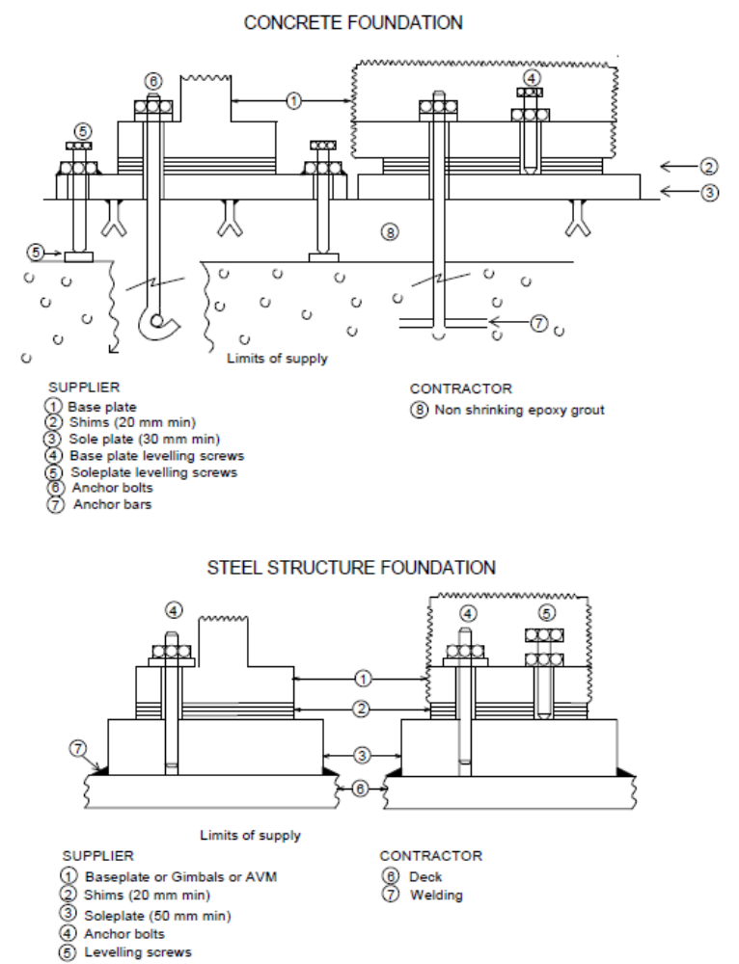
- Vendor Document Register (VDR)
The following documents shall be delivered by the Package Vendor. This list is a mandatory base frame but might be extended on a Project basis.
(1) Documents to be supplied with offer.
Item | Designation | (1)
1 | General
1.1 | Vendor document register | X
1.2 | Deviation list | X
1.3 | Monthly report
1.4 | Sub-Vendors List | X
1.5 | Quality Plan
1.6 | Inspection and Test Plan | X
1.7 | Declaration of conformity for ATEX
2 | Arrangements
2.1 | General Arrangement drawing for FWP Package | X
2.2 | General Arrangement drawing for Centrifugal Pump | X
2.3 | Foundation Drawings
2.4 | Limits of supply table (interface and connection schedule) | X
2.5 | Allowable nozzles loads
2.6 | Lifting Drawing
2.7 | Unit Control Panel drawing
3 | Data sheets
3.1 | Fire fighting Pump data sheet | X
3.2 | Electric motor data sheet | X
3.3 | Mini Flow valve data sheet (if any) | X
3.4 | Noise data sheet
3.5 | Weight data sheet
3.6 | Maintenance data sheet
3.7 | Instruments data sheet
3.8 | Other data sheets
4 | P&IDs & Lists
4.1 | P&ID symbols table | X
4.2 | PFD and PID’s | X
4.3 | Equipment list / Bill of materials | X
4.4 | Load and Utilities List | X
4.5 | Lubrication list and schedule
5 | Detail drawings
5.1 | Centrifugal pump Outline drawings
5.2 | Centrifugal pump sectional drawing and associated part list
5.3 | Outline drawings (mini flow valve, coupling…)
5.4 | Electric motors Outline drawing
5.5 | Electric motors sectional drawing and associated part list
5.6 | Equipment data plate drawing
5.7 | Piping Classes
6 | Elec/ Instrumentation and Controls
6.1 | Junction Boxes dimension and termination diagram
6.2 | Control philosophy and Functional analysis
6.3 | Instruments hook up Diagrams
6.4 | Instruments list
6.5 | HMI displays
6.6 | PLC software data base exchange
6.7 | Instruments and electrical cables list
6.8 | Modbus list including addressing
6.9 | I/O list
6.10 | Instrument index S4l format
6.11 | Alarm / shut down list
6.12 | Interconnecting diagram (instrumentation and electrical)
6.13 | Earthing diagrams
6.14 | Logic diagrams
6.15 | Cause and effect chart
6.16 | Instrument loop diagrams
6.17 | UCP terminal strips
6.18 | Junction boxes terminal strips
6.19 | Wiring diagrams
6.20 | Obsolescence dossier
6.21 | Block Diagrams
7 | Calculations and Performances data
7.1 | Pump performance curves | X
7.2 | Lateral and Torsional critical speed analysis calculation note
7.3 | Baseplate calculation note
7.4 | Safety relief valve calculation according
7.5 | Other calculation notes
8 | Manuals/procedures/other lists
8.1 | Painting specification
8.2 | Installation and operating manual index
8.3 | Installation and operating manual
8.4 | Special tools list
8.5 | Start up and commissioning spare parts list | X
8.6 | Priced operating spare parts list
8.7 | Capital spare parts list | X
8.8 | Packing index and final packing list
8.9 | Storage prior and after erection procedure
8.10 | Weighing procedure
8.11 | Performance/ mechanical running test procedures
8.12 | UCP test procedure
8.13 | Factory test for complete package procedure
8.14 | SAT procedure
8.15 | Reports for the above tests (2)
8.16 | Preservation procedure
8.17 | Packing procedure
9 | Manufacturing/Quality/HSE documents
9.1 | NDE procedures
9.2 | Welding procedures
9.3 | Material certificates
9.4 | All tests and inspections certificates
9.5 | QA/ QC (Manufacturing data book) index
9.6 | QA/ QC (Manufacturing data book) Dossier
(2) The package string test report shall include pictures of the package (four side views and four isometric views)
- Minimum inspection requirements
As a minimum, the following inspections shall be witnessed by the Company:
- Centrifugal Pump performance test
- Centrifugal Pump NPSH test
- Functional, performance and mechanical running test of the Fire Fighting Electric Driven Horizontal Pump package
- Final inspection
- Final dossier data book review.

Note: This list does not include the inspections to be conducted on each individual component constituting the package.
- Deviations to the contractual documents
If deviations are waived during the bid phase, they shall be listed in the following pages in the purchase revision.
The deviation list shall exhibit at least the following:
- Reference of the specification
- Paragraph of the specification
- Description of the deviation
- Reason for deviation
- Vendor proposal
- Company final position.

The deviations that are not accepted by Company shall appear in this list in order to give a complete overview of the technical discussions.

The following list contains pages.

Note: The deviation list might not be attached to this specification but referenced under a project document (as reported below).

Project document reference:
Revision
- Data sheet
Fire Fighting Electric Driven Horizontal Pump data sheet DS EP MEC 025.
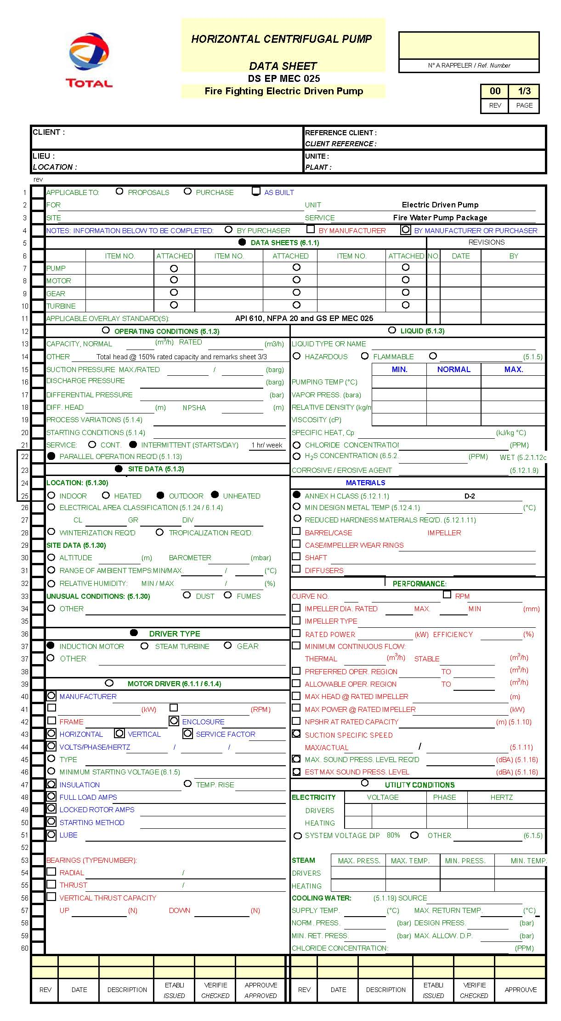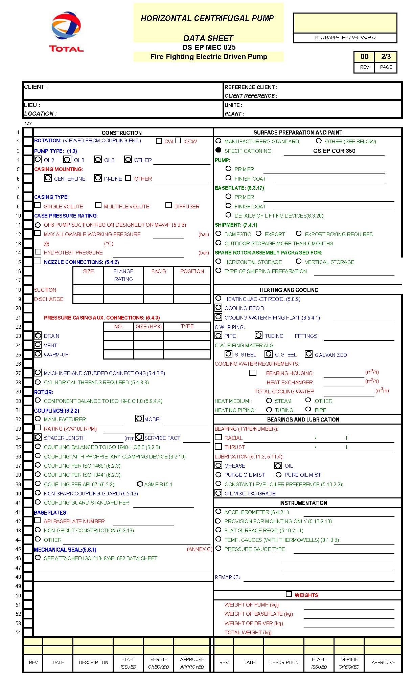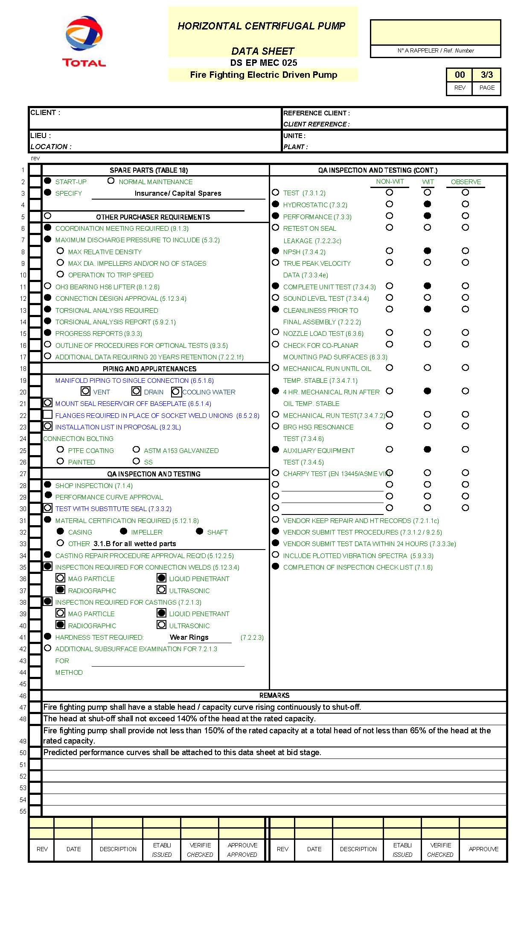

Reference to Articles 100/118 of the Treaty of Rome
Reference to Articles 95/137 of the Treaty of Amsterdam

