GENERAL SPECIFICATION
ROTATING MACHINERY
GS EP MEC 028

Rotating Machine Package Specification
Positive Displacement Motopump according to API Standard 674

00 | 10/2012 | First issue
Rev. | Date | Purpose of the revision

Owning entity: DEV/TEC | Managing entity: DEV/TEC/MTH

Project Specification n° |  | Revision:
 |  | Date:

Contents
Preamble 4
1. Scope 5
1.1 Purpose 5
1.2 Application 5
1.3 General Rules 5
2. Reference documents 6
3. Scope of supply and exclusion 10
3.1 Scope of supply 10
3.2 Exclusions 14
4. Basis of design 15
4.1 Particular specification for rotating equipment 15
4.2 Reciprocating pump - Comments to API Std 674 17
4.3 Particular specification for rotating equipment - Packaging 23
5. Data Sheets 30
5.1 Pump API Std 674 (template in Appendix 6) 30
5.2 Electric motor 30
5.3 Variable speed drive 30
5.4 Power transformer 30
5.5 Gearbox (if any) 30
5.6 Lube oil system (if applicable) 30
5.7 Noise 30
5.8 Weight 30
5.9 Data sheets templates 30
6. Site conditions and utilities 31
6.1 Site conditions 31
6.2 Utilities 33
7. Testing 34
7.1 Pre-test activities 35
7.2 Reciprocating pump API Std 674 performance test 36
7.3 Package full load test 37
7.4 Electrical 38
7.5 Site acceptance test 38
8. Spare parts and special tools 40
8.1 Spare parts 40
8.2 Special tools 41
9. Preparation for shipment 43
9.1 Preservation 43
9.2 Packing 46
9.3 Transportation 47
Appendix 1 Definitions and abbreviations 49
Appendix 2 Baseplate installation 50
Appendix 3 Vendor Document Register (VDR) 51
Appendix 4 Minimum inspection requirements 54
Appendix 5 Deviations to the contractual documents 55
Appendix 6 Data sheets 56

Preamble

Scope

Purpose
This specification defines the minimum design, fabrication, inspection and testing requirements for the supply of the Positive Displacement Pumps - Reciprocating. It is an exhaustive document detailing the scope of supply and the associated design rules requested by TOTAL E&P for the procurement of Positive Displacement Pumps - Reciprocating electric motor driven packages.

Application
This document applies to the design of all Positive Displacement Pumps driven by electrical motors. This document applies to API Std 674 pumps.

General Rules
All deviations from this specification or the documents referred to herein shall be stated in writing in the Appendix 5 of this specification. In the absence of such a statement, it is assumed that the requirements of the specifications are met without exception. Failure to meet the requirements of this specification and referenced documents shall be corrected at Supplier’s cost. Exceptions and deviations to the specifications shall be part of Supplier’s proposal and will be subject to Company approval.
Where this specification, or any other project document, allows the Supplier to propose an “option”, the Supplier shall clearly state the selected option in his bid.
In cases the Supplier provides outsourced equipment, he shall be responsible for the coordination of the Sub-Suppliers, and ensure the full compatibility of all the equipment. In particular, they shall be compatible in terms of safety, environment, operability, dimensions, weight, performance, control, noise and vibration behavior.
Components not mentioned in this specification that are necessary for the operation of the equipment or required by certifying agency, regulatory bodies or by law, shall be Supplier standard components.
The present document remains a General Specification as long as the modifiable forms are not completed. It becomes the Project Specification once these modifiable forms are completed and shall therefore not be considered as a General Specification any more.
Then, the General Specification shall be attributed a Project reference number with the associated Project front page.
Preamble shall be completed with the Project description (location, number of machines, etc.).
If Project specificities require amendments to non modifiable parts of this specification or to the documents referred to herein, they shall be considered as deviations and stated in writing in the Appendix 5 of this specification.
This specification will then be issued in two steps:
- Issued “for inquiry”
- Issued “for purchase”.
The applicable documents shall be considered in the following order:
- Local regulations
- Classification Society Rules (If applicable)
- Frame agreement if available - Frame agreement: Applicable  - Not applicable
- This completed specification and associated data sheets
- Referenced General Specifications
- Referenced Project specifications
- Codes and standards.

Reference documents
The reference documents listed below form an integral part of this General Specification.
External Documents
Unless otherwise stipulated, the applicable version of these documents, including relevant appendices and supplements, is the latest revision published at the effective date of this document.
Reference | Title
1999/92/EEC  (ATEX 118¹/ATEX 137²) | European Directive 1999/92/EEC (16/12/99) on minimum requirements for improving the safety and health protection of workers potentially at risk from explosive atmospheres
94/9/EC  (ATEX 100a/ATEX 95) | European Directive 94/9/EC (23/03/94) on the approximation of the laws of the Member State concerning equipment and protective systems intended for use in potentially explosive atmosphere
API Std 674 | Positive Displacement Pumps - Reciprocating.
API Std 677 | General Purpose Gear Units.
ASME VIII Division 1 | Boiler and Pressure Vessel Code
DIN 55473 | Auxiliary means of packaging - Desiccant in bag - Technical delivery conditions.
IP 15 | Area Classification Code for Petroleum Installation handling flammable fluids - July 2005 (3rd edition)
ISO 780 | Packaging. Pictorial marking for handling of goods
NF H00-310 | Industrial packagings. Flexible and heat sealing protection materials of low coefficient of water vapour transmission (P < 0.3 g/m² 24 h)
NF H00-320 | Packaging. Desiccant. Specifications and tests
US MIL STD-2073-1 E | Standard Practice for Military Packaging
US MIL D 3464E | Desiccants, activated, bagged, packaging use and static dehumidification.
US MIL PRF 131K | Performance Specification: Barrier Materials, Watervaporproof, Greaseproof, Flexible, Heat-Sealable

Total General Specifications
Unless otherwise stipulated, the applicable version of these documents, including relevant appendices and supplements, is the latest revision published in the applicable yearly collection.
TOTAL EP General Specification Referential is applicable for the following Project:

The following Company specifications are fully applicable to all purchased equipment as listed in paragraph 3.1 completed by the technical details reported in paragraph 4 and taken into account accepted deviations as listed in Appendix 5. The second level General Specifications mentioned in each individual specification are not applicable if they are not listed in the below tables. The standards, professional documents, regulations and codes mentioned in each General Specification are applicable.
The following list may also be complemented with other specific Project detailed specifications which would include additional requirements, as applicable or deemed necessary by Company or Contractor.
Reference | Title
GS EP COR 350 | External protection of offshore and coastal structures and equipment by painting
GS EP COR 354 | External protection of onshore structures and equipment by painting
GS EP COR 356 | Corrosion Protection of Fasteners for Subsea and Topside Applications
GS EP ELE 011 | Electrical requirements for packaged units
GS EP ELE 031 | Design of earthing and bonding systems
GS EP ELE 079 | Electrical apparatus for potentially explosive gas atmospheres
GS EP ELE 111 | Induction motors
GS EP ELE 121 | HV Variable Speed Drive Systems
GS EP ELE 161 | Electrical cables
GS EP EXP 217 | Requirements to Vendors, Suppliers and EPC’S for spare parts
GS EP INS 101 | Instrumentation engineering, supply and construction general requirements
GS EP INS 102 | Instrumentation identification
GS EP INS 107 | Design and installation of instrumentation links
GS EP INS 110 | Instrumentation for package units
GS EP INS 135 | Cyber Security requirements for design and supply of ICSS and Package Systems
GS EP INS 900 | Instrument hook-up diagrams
GS EP MEC 101 | Driver Power Sizing
GS EP MEC 240 | Special Purpose Couplings for Petroleum, Chemical, and Gas Industry Services according to API Standard 671
GS EP MEC 281 | Lubrication, Shaft Sealing and Oil Control Systems and Auxiliaries according to ISO 10438 / API Standard 614
GS EP MEC 292 | Rotating Machines Packages Installation Requirements
GS EP MEC 300 | Noise and Vibration of Rotating Machine Packages
GS EP PVV 102 | Piping Hook-up Standards
GS EP PVV 112 | Piping material classes
GS EP PVV 142 | Valves
GS EP PVV 143 | Metallic pipes
GS EP PVV 144 | Fittings
GS EP PVV 145 | Flanges
GS EP PVV 146 | Bolting for piping
GS EP PVV 147 | Gaskets for piping and vessels
GS EP PVV 175 | Cleaning of piping and vessels
GS EP PVV 211 | Design and fabrication of pressure vessels according to ASME VIII
GS EP PVV 412 | Plate and frame heat exchanger
GS EP PVV 415 | Design and fabrication of air cooler
GS EP STR 001 | Weight monitoring and weighing offshore units
GS EP STR 103 | Design and fabrication of skids and equipment supporting structures

In case one of the previous General Specifications is completed with one or more Project specific detailed specification(s), then these detailed specifications (and their respective revision) shall be added to the following list. No amendment will be made to the GS EP MEC specifications since these documents are already amended in the paragraph 4.1 of this specification.
Project Documentations (to be completed by Company or Contractor)
 | Designation | Rev | Reference
1 | Pump system PFD (*)
2 | Pumping area layout (*)
3 | Project specification for electrical requirements for packaged units (*)
4 | Instrument tagging specification
5 | Instrument list database specification
Note: All the documents identified by (*) shall be available along with this specification for the issue for inquiry and for purchase.
Project data sheets are listed in paragraph 5.

Scope of supply and exclusion

Scope of supply
The Vendor shall be responsible for the design, supply of materials, manufacture, assembly, supply of drawings and data, all Sub-Vendor co-ordination, testing, delivery and guarantees of the below components:
Note 1: The column “Required” indicates the level of requirement of each item, according to the below rule:
- “X” means that the item is a base case requirement.
- 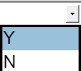 means that the item is an optional requirement specific to the project. “Y” for YES if the option is selected or “N” for NO if the option is not selected.
Note 2: The column “Description” may offer alternative technical choices that shall be fixed prior to the issue “For inquiry” by ticking the appropriate mark box .
# | Item | Description |  |  |  |  |  | Required | Tag |  | Quantity
1 | ON SKID EQUIPMENT
1.1 | Pump including but not limited to:
1.1.1 | Pump | As per API Std 674 and as amended in referenced paragraph 4.2 of this specification. |  |  |  |  |  | X
1.1.2 | Counter flanges for main process connections | Counter flanges as per GS EP PVV 112 or Project piping classes -if any-. |  |  |  |  |  | X
1.2 | Electric motor including but not limited to:
1.2.1 | Main electric motor | As per GS EP ELE 111 and GS EP MEC 101 and as per data sheet referenced in paragraph 5 of this specification. |  |  |  |  |  | X
1.2.2 | Electric terminal box | HV electric terminal box mounted on the electric motor. The supply of the associated cable glands is defined in the data sheet referenced in paragraph 5 of this specification. |  |  |  |  |  | X
1.2.3 | Electric motor cooler | As per data sheet referenced in paragraph 5 of this specification. |  |  |  |  |  | X
1.2.4 | All associated instrumentation and auxiliary junction boxes |  |  |  |  |  |  | X
1.3 | Power transmission equipment including but not limited to:
1.3.1 | Gearbox | As per API Std 677 and as per data sheet referenced paragraph 5 of this specification. |  |  | N/A if pump direct  driven. |  |  | X
1.3.2 | Temperature and vibration probes | As per API Std 677 paragraph 3.4. |  |  | N/A if pump direct  driven. |  |  | X
1.3.3 | LS flexible spacer type coupling | As per paragraph 4.3.3 of this specification. |  |  | N/A if pump direct  driven. |  |  | X
1.3.4 | LS coupling guard | As per paragraph 4.3.3 of this specification. |  |  | N/A if pump direct  driven. |  |  | X
1.3.5 | HS flexible spacer type coupling | As per paragraph 4.3.3 of this specification and GS EP MEC 240. |  |  | X
1.3.6 | HS coupling guard | As per paragraph 4.3.3 of this specification and GS EP MEC 240. |  |  | X
1.4 | Power end frame and pump liquid end oil system (As per GS EP MEC 281 and as per data sheet referenced paragraph 5.6 of this specification) including but not limited to:  Note: only in case hydrodynamic bearings are provided.
1.4.1 | Reservoir |  | As per API Std 614 Figure B.5 - Class I and GS EP MEC 281 part 2 paragraph 4.3.13. |  |  |  |  | X
1.4.2 | Lube oil pump |  | Shaft driven or AC motor driven following GS EP ELE 111. |  |  |  |  | X
1.4.3 | Lube oil cooler |  | Lube oil air cooler made of AISI 316 stainless steel as per GS EP PVV 415 and as per API Std 614 Figure B.5 - Class I |  |  | Lube oil water cooler as per GS EP PVV 412 (oil pressure above water pressure) and as per API Std 614 Figure B.5 - Class I |  | X
1.4.3 |  |  | N/A Off skid
1.4.4 | Lube oil filters |  | As per API Std 614 Figure B.5 - Class I. Twin AISI 316 stainless steel oil filters with continuous flow transfer valve for lube oil. |  |  |  |  | X
1.4.5 | Pressure limiting valve |  | As per API Std 614 Figure B.5 - Class I. |  |  |  |  | X
1.4.6 | Strainer |  | As per API Std 614 Figure B.5 - Class I. |  |  |  |  | X
1.4.7 | All associated piping, piping accessories and valves |  | All associated interconnecting piping, piping accessories and valves made in AISI 316/316L stainless steel on the whole system as per paragraph 4.3.7 of this specification. Tubing is not allowed, except for the instruments impulse lines as per GS EP INS 107, GS EP PVV 102 and GS EP INS 900. |  |  |  |  | X
1.4.8 | All associated instrumentation |  | As per data sheet referenced paragraph 5 of this specification, as per paragraph 4.3.5 of this specification and mounted as per GS EP PVV 102 and GS EP INS 900. |  |  |  |  | X
1.4.9 | One local gauge panel |  | Made of AISI 316/316L stainless steel with instruments as per as per data sheet referenced paragraph 5.6 of this specification. |  |  |  |  | X
1.5 | Base plate including but not limited to:
1.5.1 | Fabricated steel common base plate | As per paragraph 4.3.2 of this specification. |  |  |  |  |  | X
1.6 | Controls & Instrumentation, including but not limited to:
1.6.1 | Terminal junction boxes | All terminal junction boxes located at skid edge as per GS EP INS 101 and GS EP INS 107. |  |  |  |  |  | X
1.6.2 | Cable glands | Cable glands for departing multi-core cables, defined by Project and blinded off suitably for transport and storage. In case the option is not selected, the gland plates shall be pre-drilled and blinded off.
1.6.2 | Cable glands | For all other cables, junction boxes shall be provided with cable gland plates and associated cable glands. |  |  |  |  |  | X
1.6.3 | Instrumentation cables | All instrument cables between instruments and skid mounted junction boxes / local gauge board indicator as per GS EP ELE 161 and GS EP INS 107. |  |  |  |  |  | X
1.6.4 | Instrumentation Cable trays and covers | All necessary cables trays with covers made of AISI 316 between instruments and skid mounted junction boxes as per GS EP INS 107.  Empty cable trays shall be installed for the departing multi-core cables -supplied and installed by others- between the terminal junction boxes and the skid edge. |  |  |  |  |  | X
1.6.5 | Shut down push buttons |  |  |  |  |  |  | X
1.7 | Electrical including but not limited to
1.7.1 | Electrical cables trays and covers | All necessary cables trays with covers made of AISI 316 between all electrical consumers mounted on skid and the skid edge. |  |  |  |  |  | X
2 | OFF SKID EQUIPMENT (shipped loose)
2.1 | Variable Speed Drive system including but not limited to:
2.1.1 | HV Variable Speed Drive | As per data sheet referenced in paragraph 5.3 of this specification and as per GS EP ELE 121. |  |  |  |  |  | X
2.1.2 | Power transformer | As per data sheet referenced in paragraph 5.4 of this specification and as per paragraph 4.17 of GS EP ELE 121. |  |  |  |  |  | X
2.1.3 | Harmonic Filter | As per GS EP ELE 121. |  |  |  |  |  | X
2.2 | Valves, instruments and piping including but not limited to:
2.2.1 | Pulsation suppression devices | Dampeners or accumulators are provided on skid whenever design permits, otherwise will be shipped loose for installation by Contractor. |  |  |  |  |  | X
2.2.2 | External relief valve | External full flow PSV is provided to protect downstream equipment, loose shipped for installation by Contractor. The pump shall be protected by its own internal PSV. |  |  |  |  |  | X
2.3 | Spare parts and special tools including but not limited to:
2.3.1 | Special tools | Detailed scope is given in the paragraph 8.2 of this specification. |  |  |  |  |  | X |  |  | 1 set
2.3.2 | Spare parts for, commissioning and start up | Detailed scope is given in paragraph 8.1.1 of this specification. |  |  |  |  |  | X |  |  | 1 set
2.3.3 | Capital spare parts | Detailed scope is given in the paragraph 8.1.2 of this specification. |  |  |  |  |  | X |  |  | 1 set
3 | MISCELLANEOUS
3.1 | Baseplate anchors and shims | As per paragraph 4.3.2 and Appendix 2 of this specification. |  |  |  |  |  | X
3.2 | Off skid equipment anchors and shims | All anchors and shims for all off skid equipment supplied by Supplier. |  |  |  |  |  | X
3.3 | Piping | All necessary on-skid tubing / piping. |  |  |  |  |  | X
3.4 | Documentation | Set of documents as per Appendix 3 of this specification. |  |  |  |  |  | X |  |  | 1 set
3.5 | Acoustical simulation | As per API Std 674 Annex C, Analysis Approach 2. |  |  |  |  |  | X
3.6 | Package 3D model review | Review of the package 3D models for maintenance areas review as per paragraph 4.3.11 of this specification. |  |  |  |  |  | X |  |  | 1
3.7 | Personal protection | As per paragraph 4.3.9.1 of this specification. |  |  |  |  |  | X
3.8 | Painting and coating | As per paragraph 4.3.8 of this specification. |  |  |  |  |  | X
3.9 | Limit flanges | All limit flanges as per GS EP PVV 112 or project piping classes-if available- equipped with blind flanges for transportation. |  |  |  |  |  | X
3.10 | Package packing and preservation | As per paragraph 9 of this specification. |  |  |  |  |  | X
3.11 | Earthing network | Earthing design and implementation as per GS EP ELE 031 and GS EP INS 107. |  |  |  |  |  | X
3.12 | Lube oil system flushing kit | Kit made of all necessary flexible hoses for machinery bearings bypass. |  |  |  |  |  | X |  |  | 1 set
3.13 | Lifting tools for the complete package | Consists of slings, shackles, and spreader bar as per paragraph 4.3.2.4 of this specification and as per GS EP STR 103. |  |  |  |  |  | X |  |  | 1 set
3.14 | Specific climate considerations | Tropicalization |  | Winterization |  |  | None | X
4 | TESTS
4.1 | Factory tests
4.1.1 | Pump | As per paragraph 7 of this specification. |  |  |  |  |  | X
4.1.2 | Electric motor | As per paragraph 7 of GS EP ELE 111 and data sheet referenced in the paragraph 5.2 of this specification. |  |  |  |  |  | X
4.1.3 | Gearbox (if any) | As per API Std 677 paragraph 4.3. |  |  |  |  |  | X
4.1.4 | Lube oil unit | As per paragraph 7.3 of GS EP MEC 281. |  |  |  |  |  | X
4.1.5 | Complete unit tests | As per paragraph 7 of this specification. |  |  |  |  |  | X
4.1.6 | Noise and vibration tests | As per paragraphs 4.3.9.2 and 7 of this specification. |  |  |  |  |  | X
4.2 | Site Acceptance Tests
4.2.1 | Complete unit tests | As per paragraph 7.5 of this specification. |  |  |  |  |  | X

Vendor shall be responsible for the physical and technical compatibility of the entire package and shall ensure that all equipment and components provided are suitable for the operations intended.

Exclusions
The following equipment are not included in the scope of supply:
- Counter flanges, gasket and bolting for connecting flanges at battery limits of Vendor’s supply (except pump companion flanges in Vendor’s scope)
- All piping outside the package
- Electric and instrument cables outside the package
- All earthing cables outside the package.

Basis of design
This paragraph details the technical specificities of project that are not covered in the Company General Specifications nor in the Project documents.

Particular specification for rotating equipment
This paragraph indicates where the Company General Specifications Project specificities are covered. The paragraphs mentioned in the following charts refer to TOTAL EP General Specifications Referential 2013.

GS EP MEC 240
Paragraph | Data Sheets | Project
5.3 | X
10.3 | X | Site conditions as per paragraph 6.1 of this specification.
12.5.2 | X
12.5.3 | X
13.2.2.1 |  | Drawings as per Appendix 3of this specification.
A.2.5 | X | Site conditions as per paragraph 6.1 of this specification.
A.4.1 | X | Site conditions as per paragraph 6.1 of this specification.

GS EP MEC 281
Note: Applicable only in case hydrodynamic bearings are provided.
Paragraph | Data Sheets | Project
Part 1
4.5.2 |  | Environmental conditions are reported in paragraph 6 of this specification.
4.6.2 |  | List of additional inspections required:
5.1.18 |  | List of special requirements for piping, flanges, gaskets, instruments and o-rings, valves:
5.1.32 |  | Valves according to Vendor CPY Standard.
6.2.1.3 |  | HA HOA starting switch for pump motor | Required | Not required
6.2.2.2 | X
6.2.2.4 | X
6.3.8.1 | X
6.4.2 |  | Refer to paragraph 6 of this specification.
Part 2
4.1.4 | X
4.4.13 |  | Refer to paragraph 6 of this specification.
Part 3
4.2.2 | X
4.5.5 |  | Refer to paragraph 6.1 of this specification.
4.6.4.2 | X

Reciprocating pump - Comments to API Std 674
API | GS
A bullet () at the beginning of a subclause or paragraph indicates that either a decision is required or further information is to be provided by the purchaser. This information should be indicated on the data sheets (see annex A). | Refer to Appendix 6 for data sheet template.
6 Basic Design
- 6.1.3 The Purchaser shall specify the normal operating point and all other required operating points. | Refer to the Project data sheets attached in paragraph 5.1.
- 6.1.5 Control of the sound pressure level (SPL) of all equipment supplied shall be a joint effort of the Purchaser and the Vendor having unit responsibility. | Refer to paragraph 4.3.9.2 Noise level.
- 6.1.6 Unless otherwise specified, cooling water system or systems shall be designed for the following conditions given in Table 2. | Environmental conditions are reported in paragraph 6 of this specification.
- 6.1.16 The equipment, including all auxiliaries, shall be suitable for operation under the environmental conditions specified by the Purchaser. | Environmental conditions are reported in paragraph 6 of this specification.
6.2 Selection of Pump Type | Direct-acting pump are subject to Company approval.
6.3.1 Table 3 and Table 4 represent the maximum allowable speed ratings for reciprocating pumps in continuous service. | Pumps speed shall be limited to 85% of maximum allowable speed indicated in Table 3.
- 6.3.3 The Purchaser shall supply liquid properties. | Refer to the Project data sheets attached in paragraph 5.1.
6.5.2 All process connections shall be flanged or machined and studded, except where threaded connections are permitted by 6.5.5. | Threaded connections are not allowed for suction and discharge sides.
6.5.5 For connections other than main process connections, if flanged or machined and studded openings are impractical, threaded connections for pipe sizes not exceeding DN 40 (11/2 NPS) may be used etc. | Auxiliaries threaded connections are subject to Company approval.
- 6.5.14.3 If specified, ASME B 16.47 Series A flanges shall be provided. | Flanges type as per GS EP PVV 145.
- 6.7.5.2 If specified, or recommended by the Vendor, a flush shall be supplied to the stuffing box. | As per pump data sheet referenced paragraph 5 of this specification.

6.7.5.6 If specified, a minimum DN6 (NPS 1/4) purge connection shall be provided to directly purge fluid to a lantern ring positioned to minimize pumped fluid leakage to the atmosphere. | As per pump data sheet referenced paragraph 5 of this specification.
- 6.8.1 If specified, the provisions of a) to d) of this clause shall apply.  a) Crankshafts shall be wrought or cast in one piece.  b) Forced-lubrication passages in crankshafts shall be drilled.  c) Quintuplex pumps shall have a minimum of three main bearings.  d) Septuplex pumps and larger shall have a minimum of four main bearings. | Delete 'If specified'.
6.8.5 Gear ratings and service factors shall be in accordance with AGMA 6010 etc. | Minimum Gear Service Factors shall be as per API Std 677 table 3.
6.8.13 Vertical pumps that have the liquid end attached directly to the power end shall be fitted with a thermal-barrier when the liquid temperature range is liable to cause condensation in the power end. | Vertical pumps design is not allowed.
6.9 Direct-Acting Pump | Refer to 6.2 here above.
- 6.10.1.2 If specified, or as recommended by the pump Vendor, the power end may be splash, positive pressure, or gravity lubricated. A sight glass, gauge, or oil-level dipstick shall be provided. | As per pump data sheet referenced paragraph 5 of this specification.
6.10.1.3 Unless otherwise specified, pressurized oil systems shall conform to the requirements of the General Purpose Section (Chapter 3) of ISO 10438. | Pressurized lube oil system shall be in SS316L minimum unless otherwise specified by the data sheet referenced paragraph 5 of this specification.
- 6.10.1.4 If specified or if recommended by the Vendor and approved by the Purchaser, a pressure lubrication system shall be supplied to supply oil at a suitable pressure to the pump, the driver, and any other driven equipment, including gears. | Delete 'if specified or if recommended'.
- 6.10.1.8 If specified, the pressure lubrication system shall conform to the requirements of ISO 10438-2 (Special- Purpose Oil Systems). | API Std 614 / ISO 10438-4 data sheet shall be duly completed.  Duty and stand-by motor driven lube oil pumps shall be sized for maximum absorbed power using maximum lube oil viscosity.
- 6.11.1.2 If radiographic, ultrasonic, magnetic particle, or liquid penetrant inspection of welds or materials is required by the ASME Pressure Vessel Code or specified, the procedures and acceptance criteria shall apply. | As per pump data sheet referenced paragraph 5 of this specification.
6.11.1.6 Cast and Nodular iron may be inspected only in accordance with magnetic particle and liquid penetrant methods. | Cast iron, except nodular cast iron is not allowed for pressure-containing parts
- 6.11.1.11 If specified, the hardness of parts, welds, and heat-affected zones shall be verified as being within the allowable values by testing. | As per pump data sheet referenced paragraph 5 of this specification.
- 6.11.2.3 If specified, copper or copper alloys shall not be used for parts which are in contact with process fluids. | As per pump data sheet referenced paragraph 5 of this specification.
- 6.11.2.7 The Purchaser shall specify any erosive or corrosive agents (including trace quantities) present in the process fluids and in the site environment, including constituents that may cause stress-corrosion cracking or attack elastomers. | As per pump data sheet referenced paragraph 5 of this specification.
- 6.11.2.9 If specified, the Vendor shall furnish material certificates that include chemical analysis and mechanical properties for the heats etc. | Delete 'if specified’.
- 6.11.2.10 If mating parts such as studs and nuts of austenitic stainless steel or materials with similar galling tendencies are used, they shall be lubricated with an anti-seizure compound of the proper temperature specification and compatible with the specified process liquid(s). | As per pump data sheet referenced paragraph 5 of this specification.
- 6.11.2.15 The material specification of all gaskets and o-rings exposed to the pumped fluid shall be identified in the proposal. | This clause is applicable.
- 6.11.3.1 In addition to the components outlined in 6.11.2.15, other materials, welds, fabrications and piping shall be PMI tested as specified. | As per pump data sheet referenced paragraph 5 of this specification.
- 6.11.4.5 If specified, for casting repairs made in the Vendor’s shop, repair procedures including weld maps shall be submitted for Purchaser’s approval. | Delete 'If specified'. All repairs shall be duly reported to the Company before any repair is carried out.
- 6.11.6.1 Welding and weld repairs shall be performed in accordance with Table 9. | This clause is applicable.
- 6.11.6.3 a) Accessible surfaces of welds shall be inspected by magnetic particle or liquid penetrant examination after back chipping etc. | As per pump data sheet referenced paragraph 5 of this specification.
- 6.11.7.1 The Purchaser shall specify the minimum design metal temperature the pump will be subjected to in service. | As per pump data sheet referenced paragraph 5 of this specification.

7.1.2.1 Electric motor drivers shall be rated with a service factor of 1.0. The motor rating shall be at least 110% of the greatest power required (including gear and coupling losses) for any of the specified operating conditions. | Delete the ‘NOTE’.GS EP MEC 101 is applicable.
7.1.3 Steam turbine | Steam turbines driver are not covered in this document.
- 7.1.4.2 Coupled gears shall be either single helical or double helical type and shall conform to AGMA 6010. If specified, gear units shall conform to API 677. | Delete 'If specified'. Gear units to conform to API Std 677.
7.2.5 Couplings shall be selected with a service factor not less than that recommended by the coupling Manufacturer for the intended service. | Service factor as per GS EP MEC 240.
- 7.2.8 a) Guards shall enclose the moving elements and the shafts to prevent personnel from contacting moving parts during operation of the equipment train. | This clause is applicable.
- 7.2.8 c) If specified, non-sparking guards of agreed material shall be supplied. | Delete 'If specified'. Non sparking guards are required.
- 7.3.1 Belt drives shall only be used for equipment of 150 kW (200 brake horsepower) or less. | Belt drives shall only be used for equipment of 50 kW or less.
- 7.4.1.3 The upper and, if specified, lower surfaces of mounting plates, and any separate pedestals mounted thereon shall be machined parallel. | As per pump data sheet referenced paragraph 5 of this specification.
- 7.4.2.1 If a base-plate or skid is specified, the Purchaser shall indicate the major equipment to be mounted on it. | The equipment shall be furnished with a single fabricated unit baseplate or skid.
- 7.4.2.3 If specified the base-plate or skid shall be designed to facilitate the use of optical, laser based or other instruments for accurate leveling in the field. | Delete 'If specified'.
- 7.4.2.4 If specified, the base-plate or skid shall be designed for column mounting etc. | For specific design, the base-plate shall be mutually agreed upon by the Purchaser and the Vendor.
- 7.4.3.2 If specified, sub-soleplates shall be provided by the Vendor. | As per pump data sheet referenced paragraph 5 of this specification.
- 7.5.2.3 If specified, a combination of control modes shall be provided. | As per pump data sheet referenced paragraph 5 of this specification.
- 7.5.3.1 Unless otherwise specified, panels shall be made of steel plate at least 3 mm (1/8 in.) thick, reinforced, self supporting and closed on the top and sides. | As per pump data sheet referenced paragraph 5 of this specification.
- 7.5.4.4.3 If specified, thermal expansion pressure-limiting valves shall be provided for accessories or cooling jackets that may be blocked-in by isolation valves. | As per pump data sheet referenced paragraph 5 of this specification.
- 7.5.5.3 If specified, the alarm/shutdown system shall incorporate an event recorder to record the order of occurrence of alarms and shutdowns. | As per pump data sheet referenced paragraph 5 of this specification.
- 7.5.5.4 Temperatures shall be measured by thermocouples or resistance temperature detectors as specified and shall be connected to local panel mounted instruments. | This clause is applicable.
7.7.1.2 Pulsation control devices such as dampeners, accumulators, hydraulic isolators, inhibitors, suppressors, stabilizers, acoustic filters, and selected piping configurations. Pulsation control devices may be supplied by the Purchaser or the Vendor. | Pulsation suppression devices installed upstream and downstream the pump connections shall be provided by the Vendor.
7.7.1.3 The Purchaser shall specify if design analysis for pulsation and vibration control is required, and, if so, which method to follow etc. | Acoustical simulation as per Analysis Approach 2 identified in API Std 674 Annex C is applicable.
- 8.1.1 The Purchaser shall specify the extent of his participation in the inspection and testing. | Each individual pump shall be inspected and tested in accordance with the Appendix 4 of this specification as a minimum.
- 8.1.2 If specified, the Purchaser’s representative, the Vendor’s representative, or both shall indicate compliance in accordance with an inspector’s checklist. | As per pump data sheet referenced paragraph 5 of this specification.
- 8.2.1.1 f) if specified, final assembly maintenance and running clearances. | This clause is applicable.
- 8.2.3.3 If specified, the Purchaser may inspect the equipment and all piping and auxiliaries for cleanliness before heads are welded onto vessels, etc. | As per pump data sheet referenced paragraph 5 of this specification.
- 8.2.3.4 If specified, the hardness of parts, welds, and heat-affected zones shall be verified as being within the allowable values by testing. | As per pump data sheet referenced paragraph 5 of this specification.
8.3.2.5 Tests shall be maintained for a sufficient period of time to permit complete examination of parts under pressure. | Any leakage during tests shall be cause for rejection.
- 8.3.4.1 If specified, the beginning of the mechanical run test shall not occur until oil temperatures have stabilized. | Delete 'If specified'.
- 8.3.4.2 If specified, the pump shall be mechanically run for four hours. | Delete 'If specified'. Each individual pump shall undergo a four hours mechanical running test.

- 8.3.4.3 Unless otherwise agreed, the contract shaft seals and bearings shall be used in the machine for the mechanical running test. | Job shaft seals and bearings shall be used.
8.3.8 If specified, the pump shall be tested for NPSH. | The pump shall be NPSH tested when the NPSHR is within 1 m of NPSHA.
- 8.3.9 If specified, the shop tests described in 8.3.9.1 through 8.3.9.3 shall be performed. | Delete 'If specified'.
- 8.3.9.1 If specified, such components as pumps, gears, drivers and auxiliaries that make up the complete unit shall be tested together. | Delete 'If specified'. Each individual pump package shall undergo a complete package test.
- 8.3.9.2 If specified, the sound-level test shall be performed in accordance with ISO 3744 or other agreed standard. | Delete 'If specified'.
- 8.3.9.3 If specified, the governor response and emergency overspeed trip systems test shall be conducted as agreed between Purchaser and Supplier. | As per pump data sheet referenced paragraph 5 of this specification.
8.4.8 If specified, the fit-up and assembly of machine-mounted piping, intercoolers, etc. shall be completed in the Vendor’s shop prior to shipment. | Delete 'If specified'.
- 9.3.3 The Vendor shall submit progress reports to the Purchaser at intervals specified. | This clause is applicable.

Particular specification for rotating equipment - Packaging

General considerations / Safety and environment
The complete package shall be designed for years of operation at least.
Environmental conditions for the equipment design are indicated in the paragraph 6 of this specification.
When packages have to be installed in hazardous area zone 2, as per IP 15, they shall be specified for gas group IIA and temperature class T3 (200°C) and ATEX European directives 94/9/EC and 1999/92/EEC shall be applied.
In this case, packages shall be certified ATEX εx II 3G and CE marked with the following requirements:
- Any instrumentation component shall be certified ATEX εx II 2G and CE marked. For facilities located outside the European Union (EU countries), alternative IECEx scheme can be applied (IEC Scheme for Certification relating to Equipment for use in Explosive Atmospheres)
- Any electrical component shall be selected in accordance with GS EP ELE 079
- Any mechanical component certified ATEX εx II 3G and CE marked.
Any equipment or system required to be left in operation when a safe or a hazardous area zone 2 becomes a hazardous area zone 1 (such as presence of gas, ventilation failure, etc.) shall be certified ATEX εx II 2G and CE marked.
Package and all accessories shall bear their own marking, according to the mode of protection used.

Package configuration

Number of package base plate supporting point and type
Whatever the type of supporting structure is, package base plate involving reciprocating pumps shall always be designed with multipoint rigid supports and jacking bolts for leveling purpose.
Supporting shall comply with the requirements of GS EP MEC 300 and GS EP STR 103.
20 mm thickness stainless steel shim packs and 50 mm thickness stainless steel sole plates of all the packages as well as anchor bolts shall be provided by Supplier.
Contractor shall install, weld sole plates of all the packages in accordance with the Project specifications and Supplier requirements (number, size, location, material, strength and tightening torque).
The supporting structure shall be machined prior to welding the soleplates.
Refer to Appendix 2 for details.

Package base plate construction details
Package base plate design shall conform to GS EP STR 103 to maintain alignment of the line shaft under all operating condition whether normal, transient and abnormal.
Package base plate shall be designed with either:
- A non slip decking steel plate covering the top of the base plate and a drip pan and gutter all around with 2 drains points of 2” diameter minimum
or
- Grating covering the top of the baseplate and a steel plate continuously welded at the bottom of base plate recovering any oil spill and drain points of 2” diameter minimum.
The pump, drive motor, gearbox (if any) and lube oil system (if any) shall be installed on a continuously welded, carbon steel base frame.
In any case, the complete shaft line skid mounted package shall be shipped in one piece.
All the equipment supported by the skid shall be contained within the skid projection footprint (meaning that no equipment overhung/projection outside the skid footprint is allowed). Projection outside the skid footprint may be allowed for the main motor HV terminal box but is subject to Company approval. When the main motor HV terminal box projects itself on the skid, an opening shall be done in the skid grating to allow passing the HV power cables depending on their allowable bending radius. This shall be evaluated between Company, Contractor and Vendor during the engineering phase.

Package lifting appliances
Package lifting appliances, such as lifting beams or spreader bars, slings, shackles, etc., shall be included in the Vendor scope of supply and designed, tested and certified by an approved authority in accordance with GS EP STR 103.
Lifting appliances shall be load tested at 125% of the safe working load and certified. Visual inspections and NDT (dye penetrant and ultra sonic inspections) shall be performed after the load test.

Load couplings
Couplings shall conform to GS EP MEC 240.

Installation
The package shall be installed as per GS EP MEC 292 requirements.
For packages to be installed on a floating structure, Vendor shall indicate the special devices installed to cope with the FPSO motions and accelerations indicated in the paragraph 6 of this specification. In any case, Vendor shall clearly indicate his layout requirements to ensure proper operation of the lube oil system and the drain system.
Vendor scope of supply shall include a vibration study according to and if required by GS EP MEC 300.

Instrumentation
The package instrumentation shall comply with GS EP INS 101, GS EP INS 102, GS EP INS 107 and GS EP INS 110.
Thermowell design and instruments hook ups shall comply with GS EP INS 900 and GS EP PVV 102.
Supplier shall provide with its technical proposal a preliminary set of vibration and temperature P&ID and interconnecting diagram.
Junction boxes shall be mounted at 1.6 m above grating.

Configuration for P2 type packages
Each package unit shall be supplied according to GS EP INS 110 requirements.
Signals from any on package skid instrument shall be wired up to dedicated junction boxes located at the package skid edges.
Interconnecting cables between ICSS/MCC and skid will be supplied and installed by Contractor. Package Vendor shall adapt the number of junction boxes to the type of multi-core cables in accordance with Contractor specifications. All spare wires shall be earthed through individual terminals, bonding is not permitted.

Electrical
The design, manufacture, inspection and testing of electrical equipment provided with the packaged unit shall comply with GS EP ELE 011.

Piping, valves and vessels

Piping, tubing and pressure vessels
The fabrication, inspection and shipment of pipes, fittings and flanges shall comply with Company piping classes GS EP PVV 112, GS EP PVV 143, GS EP PVV 144, GS EP PVV 145, GS EP PVV 146 and GS EP PVV 147.
All equipment piping systems shall have flanged high point vents and flanged low point drains.
These drains and vents shall terminate with an isolating valve and a blind flange.
All interconnecting piping shall be identified and tagged.
All on-skid piping shall be correctly supported to avoid piping unacceptable vibration.
A single block and bleed valve assembly shall be installed in each instrument take-off connection, except thermowell and vibration probes, and shall be located as close to the parent pipe or equipment as possible.
Double block and bleed valve assemblies instead of single block and bleed shall be provided when operating pressure is over 70 barg.
Take-off connections, including the first valve shall be in accordance with the General Specifications and/or Project piping specification.
Each air-consuming instrument shall be provided with an AISI 316 filter regulator fitted with an AISI 316 pressure gauge and an AISI 316 isolating valve (refer to GS EP INS 137, GS EP PVV 102 and GS EP INS 900). Instrument air tubing shall be made of AISI 316L. Fittings and accessories shall be made of AISI 316L stainless steel.
Threaded connections on any pipework or vessels are not permitted, except tapping points on instrument air distribution header(s).
Pressure vessels as defined per ASME VIII Division 1 paragraph U.1 shall be designed as per GS EP PVV 211 and shall be certified by an authorized agency agreed by the Company. ASME U stamp is not required.
Any required cleaning of piping systems and/or vessels at Vendor’s facilities shall comply with GS EP PVV 175.

Vents
All vents which are interfaced between Supplier and Company shall be routed to the skid edge or to a more appropriate location to be mutually agreed and shall terminate by a flange fitted with a blind flange for transportation purpose.
Oil fume vents shall be provided with oil demisters (if any) and flanged flame arrestors with internals made of AISI 316L stainless steel.

Baseplate drains
All drains which are an interface between the Supplier and Company shall be routed to the skid edge and shall terminate by 2" ANSI 150 # flanges fitted with an isolating valve and a blind flange.
The drains shall be routed to plant hazardous open drain by Contractor.

Painting
Package unit shall be painted according to GS EP COR 350 or GS EP COR 354 according to site environment.
For packages to be operated offshore or in coastal environment:
- Package skids and support structures, piping and pressure vessels within the scope of supply shall be painted according to GS EP COR 350 system P01
- When required by GS EP COR 350, paragraph 3.2, components made of stainless steel shall be painted according to GS EP COR 350, paragraph 3.2
- Rotating machines shall be painted according to Supplier standard suitable for offshore environment, if approved by Company, or according to GS EP COR 350 system P14.

Health Safety and Environment

Hot surfaces
Any hot surface that can be reached by operators shall be insulated in such a way that their maximum skin temperature be lower than 70°C.

Noise level
All definitions, notations, testing methods, calculation methods and calculation procedures shall be in accordance with GS EP MEC 300.
All efforts shall be deployed to limit the average sound pressure level around the pump package at 90 dB(A) at one meter.
Supplier shall submit during tender the expected noise map at one meter of the sound pressure levels in dBa per octave bands, and the maximum sound power level for the pump package.

Miscellaneous

Bolting
Package bolting shall be as follows:
- For diameter above 24 mm, bolting shall be according to GS EP COR 356 paragraph 6
- For diameter up to and including 24 mm, bolting shall be of AISI 321 Stainless steel as a minimum
- Piping bolting shall be in compliance with GS EP PVV 112 and GS EP PVV 146.

Interconnections
The package shall be designed to maximize factory assembly and testing, thus simplifying and reducing to a minimum installation and commissioning operations.
The package shall be wired and designed to ensure minimum installation operations on site. All external connections shall be brought to skid edge:
- Within interconnecting junction boxes for instruments and controls, except for the electric motors and heaters power cables. Segregation shall be as per GS EP INS 110 requirements.
- With flanges for piping, as per GS EP PVV 112 and with counter flanges and associated bolting for pump main flanges (the drawing of these counter flanges shall be submitted to Company for approval).
- Each utility which is interfaced between the Supplier and Company shall be routed through a manifold to a single point.
Interconnecting instruments junction boxes shall be provided with cable gland plates and associated cable glands.
Any structure or item not installed for the transportation shall in any case be fully erected in the Supplier’s workshop, match-marked for ease of reassembly at site.
In addition the package shall be suitable for an exposure to firewater (sea water, when located on offshore site) deluge.

Name plate’s tags and labels
All major equipment shall be identified by AISI 316L stainless steel nameplates attached by AISI 316L stainless steel pins or screws. All operating notices, warning notices and nameplates shall be in the English and language.

Rotation arrows
Direction of rotation arrows shall be clearly and permanently marked on all rotating equipment.

Maintainability and accessibility
For all items within the package, Vendor shall comply with the following requirements:
- Accessibility for operation (position of instruments, legibility of readouts, operation of valves, etc.) and for maintenance. If necessary, an access platform with stairs or ladder shall be provided for equipment that cannot be accessible from the ground.
- Removable gratings or plates shall be provided around the machines to allow access and to protect equipment located in the bottom part of the package.
- Maintainability (disassembly, reassembly, adjustment) with the necessary space and handling devices as appropriate to bring any piece of equipment to dedicated lay down areas.
- Safety instructions.
All the above requirements shall be fully supported by an engineering handling study during Contract execution, for the following components but not limited to: driver, rotors, couplings, electric motors, gears, piping spools, etc.
A design review of the package accessibility and maintainability shall be organized with Company and Contractor prior to package construction. This review shall be supported by Vendor 3D CAD models.
For equipment over 20 kg, jack screws, lifting lugs, eyebolts, or equivalent shall be provided to perform alignment, disassembly and re-assembly.
Equipment/driver alignment must include a minimum of:
- 20 mm AISI 316 stainless steel machined shims
- 3 mm AISI 316 stainless steel final adjustment shims.
These shims are part of the Vendor scope of supply.

Inspections
The inspections shall be conducted according to the Project ITP. As a minimum, the requirements reported in Appendix 4 shall apply. The weight control shall be performed as per GS EP STR 001.

Engineering documentation language and units
The engineering documentation shall be developed as follows:
Language: English and
Units:

Data Sheets

Pump API Std 674 (template in Appendix 6)
Reference / Revision: /

Electric motor
Reference / Revision: /

Variable speed drive
Reference / Revision: /

Power transformer
Reference / Revision: /

Gearbox (if any)
Reference / Revision: /

Lube oil system (if applicable)
Reference / Revision: /

Noise
Reference / Revision: /

Weight
Reference / Revision: /

Data sheets templates
Each data sheet requested in the VDR enclosed in the Appendix 3 of this specification shall be filled in by the Vendor in the Company template format.

Site conditions and utilities

Site conditions
LOCATION
ALTITUDE
CLIMATE
ATMOSPHERIC PRESSURE
Average |  | mbar
Minimum |  | mbar
Maximum |  | mbar

AMBIENT TEMPERATURE
Design (minimum / maximum) |  |  | °C
Normal |  |  | °C
Minimum |  |  | °C
Maximum |  |  | °C

WIND
Normal |  | m/s
Design |  | m/s
Direction

RELATIVE HUMIDITY
Minimum |  | %
Maximum |  | %

ENVIRONMENT
Dust
Smoke
Other

BLAST
Equivalent static pressure (mbar)
CLASSIFICATION TYPE AREA
OPERATIONAL DESIGN CONDITIONS
Project Phase: | During towing | On site | On site
Condition: | Dry | Operating | Damaged
Longitudinal acceleration (Surge) |  |  |  | m/s²
Transversal acceleration (Sway) |  |  |  | m/s²
Vertical acceleration (Heave) |  |  |  | m/s²
Trim angle (Pitch) |  |  |  | °
List angle (Roll) |  |  |  | °

The motions and accelerations are given in the following way (typical):
Surge | X | Roll / List | Rotation / X
Sway | Y | Pitch / Trim | Rotation / Y
Heave | Z | Yaw | Rotation / Z

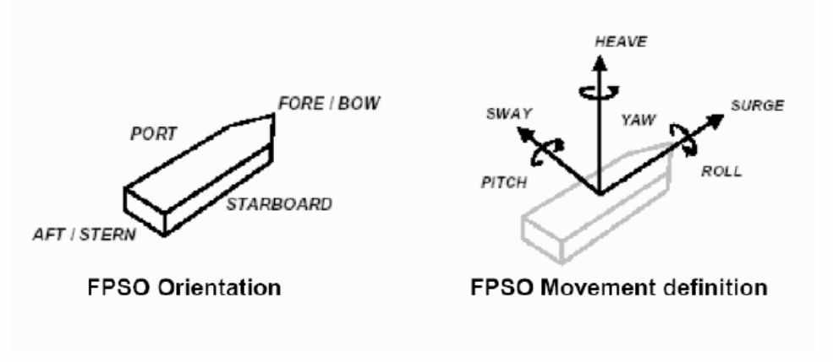
TECHNICAL ROOM ENVIRONMENTAL CONDITIONS
The environmental conditions of technical room in which the UCP will be installed are specified in the document revision .
PACKAGE ORIENTATION ON FPSO
FPSO axis
FPSO axis
Package main axis
Package main axis

Utilities
ELECTRICITY
Refer to:
- Project specification for electrical requirements for packaged units:
rev
- GS EP ELE 011
UCP UPS Earthing Regime (if applicable):
UCP Normal Power Regime (if applicable):
INSTRUMENT AIR and NITROGEN
Type | Instrument Air | Nitrogen
Min/max operating temperature |  |  | °C
Operating temperature |  |  | °C
Min/max operating pressure |  |  | Barg
Operating pressure |  |  | Barg
Oil concentration
Dew point |  |  | °C @ barg

COOLING WATER SYSTEM
Type | Sea Water | Fresh Water
Normal inlet temperature |  |  |  | °C
Minimum inlet temperature |  |  |  | °C
Maximum inlet temperature |  |  |  | °C
Minimum outlet temperature |  |  |  | °C
Maximum outlet temperature |  |  |  | °C
Supply pressure |  |  |  | Barg
Max allowable delta P |  |  |  | Bar
Calorific capacity |  |  |  | kJ/kg°C
Fouling factor |  |  |  | m².°C.h/kcal

Testing
The scope of this chapter is to describe the performance tests (pump and motor) and the string test to be carried on the completely assembled motopump package in Vendor facilities before unit shipment.
The scope of these tests is to verify the satisfactory performance of the pump and of the complete electrical drive system, to demonstrate the satisfactory mechanical behavior of the complete package train under full load conditions and to demonstrate the functionality of the main auxiliary systems of the package.
The pump performance tests may also be performed prior to the string test with testbed equipment. However, pump performance test during string test shall be privileged.
The following tests shall be carried out on the completely assembled package:
- Pre-test activities.
- Reciprocating pump performance test as per API Std 674 § 8.3 and Hydraulic Institute Pump Standards.
- Package full load string test at full speed and full discharge pressure. If the test bench does not have the capability to meet the rated conditions, tests may be run at both the specified discharge pressure with reduced speed and at the rated speed with reduced discharge pressure as recommended by the API Std 674 § 8.3.6.4. This activity shall include the functional test of all the main auxiliary systems of the package and package vibrations measurements if required by GS EP MEC 300.
- One fully assembled package shall be weighted before packing and shipment.
The fully assembled and erected motopump package shall consist of the following main Project components:
- Electric motor fully assembled on its skid with all the relevant auxiliaries including but not limited to pressurization box, cooler, main terminal box
- HV Variable speed drive system (if any)
- Power transformer
- Reciprocating pump(s) fully assembled on its skid including all the auxiliary sealing system and lube oil piping (if applicable)
- Increasing/reducing speed gearbox (if applicable)
- Common base plate fully assembled
- Couplings
- Lube oil console including lube oil coolers (if applicable)
- Lube oil console interconnecting piping (if lube oil system is installed on common base plate)
- Package Unit Control Panels (UCP) (if applicable)
- All the instrumentation.
The following main shop items shall be used for the string test:
- Water coolers for test process cooling
- Automatic acquisition system (for process and machinery data)
- All the equipment necessary for test conduction (piping, throttling valves, motors control center etc.).
Project special tools shall be used for unit erection.
The test procedure shall be issued 8 weeks prior the test (including noise and base plate vibration measurement proposed procedure).
The results of each test shall be recorded in appropriate log sheets provided by Vendor and signed as “witnessed” by all the parties.
After the completion of the tests, Vendor shall issue an official test report including all the above log sheets. Copy of raw data registered during the tests shall be handed over right after each test activity for Contractor inspection record.

Pre-test activities
Before commencing the factory testing of the completely assembled packages, the following minimum pre-test activities shall be carried out:
- Calibration of all Project instruments. Relevant calibration certificates shall be available at the time of the test for Contractor review. Spot checks of instruments calibration shall be required before test commencing
- Instrumentation and electrical equipment insulation and continuity tests
- Control loops check and functional test
- Safety and protection devices operational checks
- Serial link test (if applicable)
- Equipment tagging and labeling check
- Mechanical equipment alignment check
- Leakage tests
- Lube oil system flushing and cleanliness tests according to API Std 614 Annex D.3
- Verification of the dynamic stiffness of the test bench if required by, and as per GS EP MEC 300.
- Direction of rotation check.
The reports relevant to the mechanical equipment alignment check and to flushing and cleanliness checks shall be available for Contractor review during test.
Before commencing the tests the package shall be cleaned by Vendor and shall be visually inspected by Contractor.

Reciprocating pump API Std 674 performance test
The pump performance tests shall be carried out according to API Std 674 and Standards of the Hydraulic Institute to demonstrate the satisfactory performance of the pump.
If more than one identical motopump packages are supplied, this test shall be carried out on all units.
The test procedure shall include a summary table (see below) clearly indicating API Std 674 performance test conditions for guaranteed point as well as the corresponding site conditions.
 | Unit | Guaranteed  Conditions | Measured Value | Deviation  Test/Guaranteed | Limits
Specific Gravity
NPSH R | m |  |  |  | +0
Piston speed | m/s
Displacement | L
Volumetric Efficiency | %
Mechanical Efficiency | %
Power@ max viscosity | Kw
Power@ PSV setting | Kw
Max allowable speed | RPM
Rated Power | Kw |  |  |  | <=4
Suction Pressure | barg
Suction Temperature | °C
Rated capacity | l/min
Discharge pressure | barg
Discharge Temperature | °C
Differential Head | bar

The test procedure shall cover as a minimum the following requirements:
- If the pump is operated at variable speeds, the pump shall be tested at 25, 50, 75, 100, and 125 percent of the rated speed.
- If the test bench cannot accommodate the rated conditions, tests may be run at both the specified discharge pressure with reduced max flow and at the rated flow with reduced discharge pressure.
In addition to the readings necessary for the performance test, a complete set of mechanical readings, including vibrations spectra, shall be taken for each test point.
A FFT real time analyzer shall be available during the test allowing checking the vibration spectra anytime.

Package full load test
This test shall be carried out to demonstrate the satisfactory mechanical behavior of the complete package with contract components under full load conditions and to demonstrate the functionality of the main auxiliary systems of the package.
If more than one identical motopump packages are supplied, this test shall be carried out on all units.
This test shall be carried out according to the following test sequence.
- Cold start up of the unit.
- Increase the speed up from pump minimum operating speed to operating speed and take a complete set of mechanical readings.
- Increase the speed by increments up to the pump maximum allowable speed and take a complete set of mechanical readings for each speed increment.
- Run at maximum continuous speed for minimum 30 minutes. Take a complete set of mechanical readings every 10 minutes.
- Set the process conditions for the 4 hours endurance test at rated conditions (rated speed/ rated flow). For this endurance test, the lube oil (if applicable) shall be at maximum temperature.
During this test a complete set of mechanical readings shall be taken every 15 minutes.
During this test all the Project filters, pumps shall be subject to a changeover test. No trip of the unit shall occur during this activity.
- Trip, wait 30 minutes, and restart the unit bringing the speed up to the maximum allowed speed. The trip may be obtained simulating a over speed, a lube oil (if applicable) low pressure etc.
- Shut down the unit by a normal stop. Record the rundown time of the machine.
The following verifications/measurement shall be performed during the string test:
- Verify correct location of the emergency stops
- Ensure that there is no piping vibration within the skid
- Verify cleanliness report of the lubricating oil (if applicable)
- Measure the seal consumption
- Noise emissions shall be measured and recorded according to the testing procedure proposed by Vendor and approved by Contractor. Noise measurement shall be performed in accordance with GS EP MEC 300 for all equipment.
- Base plate vibrations measurement and recording according to (if required by) GS EP MEC 300.

Electrical
The following electrical parameters shall be recorded during all string tests in all test conditions:
- Motor windings temperature
- Motor bearings temperature
- Motor bearings radial vibrations
- Motor phase/current/voltage.

Site acceptance test
All packages shall be submitted to Site Acceptance Tests (SAT) including a performance test done with the field instrumentation and additional, mutually agreed Contractor instruments, in order to check that the packages comply with the guarantees.
Vendor shall submit a site acceptance test procedure for Company approval. The final test program shall be issued at the ex-works delivery.
The test program shall be established using the following requirements as a minimum:

Pre-test activities
As a minimum, the following activities shall be performed prior to SAT.
- Lube oil circuit cleaning and cleanliness test according to API Std 614 Annex D3 (if applicable)
- Safety and protection devices operational checks
- Calibration of all Project instruments
- Control loops check and functional test
- Serial links test (if applicable)
- Instrumentation and electrical equipment insulation and continuity tests
- Mechanical equipment alignment check
- Test run of the motopump.
These activities are carried out under the responsibility of the Vendor.
Note: These checks shall be part of Company's pre commissioning and commissioning and start-up procedures.

Test conduction
The purpose of this test is to demonstrate that the package exhibits a sound mechanical behavior and complies with the guarantees during 72 hours continuous.
In particular, the following activities shall be done during the 72 hours:
- Pump performances evaluation following the below methodology:
  - The test shall be conducted following the API Std 674 requirements. In case the API Std 674 requirements cannot be fulfilled, the test conditions shall be agreed with Company
  - The analysis of the guarantee point(s) will be done through the capture of two (2) test points (one on the guarantee flow)
- Verification of the mechanical behavior of the complete shaft line running at maximum available power at ambient temperature during the test and maximum allowable speed.
The management of the SAT shall be as per the following scheme:
- SAT preparation by the Contractor (including the coordination with FO to implement the package test procedure in the production environment)
- Package test procedure by the Vendor
- Conduction of the test by FO based on the process conditions requirements given by the Vendor and the Contractor
- The package remains under the Vendor’s responsibility during the SAT.
All the equipment necessary to perform the site acceptance tests shall be provided by the Contractor.
In case of any trip caused by any component of the package itself, the complete 72 hours shall be repeated from the beginning. In case of any trip caused by any external source (process, external power supply, etc.), the test shall be restarted from the point of interruption.

Post-test activities
After the SAT, the following activities shall be performed:
- Removal of the temporary strainer.
- Vendor shall supply of a detailed SAT report including as a minimum the following elements:
  - List of the instruments used during the test
  - Test points log sheets
  - Summary chart of the package performances converted from the test to the guarantee conditions.

Spare parts and special tools
This paragraph gives the minimum requirements of spare parts and special tools for this project. It shall be read in conjunction with GS EP EXP 217.

Spare parts
The Vendor shall provide the spare part lists on Company SPL forms, fully filled up. Company will provide electronic format of these SPL forms.
All spare parts shall have protective coatings applied and be uniquely packed and tagged.
Packing shall give protection for up to 18 months outside storage.
The Vendor shall be fully responsible for all claims attributable to unsuitable or unsatisfactory packing and protection.
Spare parts shall be separately crated from motopump loose items.

Commissioning and start-up spare parts
Supplier shall include in the scope of supply spare parts for commissioning and start up, covering the whole scope of supply of one motopump package, and taking into account the number of pumping units to be delivered:
- Recommended spare parts for main electrical motor
- Recommended spare parts for gearbox, if any
- Recommended spare parts for pump
- Recommended spare parts for any auxiliaries of the here above machinery’s
As a minimum the following spare parts shall be included in the Supplier scope of supply (quantity for 1 or 2 pump trains installed, to double if more than 2 pump trains are installed):
- Ten (10) sets of filter cartridges for any filters of any oil systems.
- For pump:
  - Two (2) sets of hydraulic end gasket and O’rings.
  - Two (2) sets of packing.
  - One (1) set of suction valve.
  - One (1) set of discharge valve
  - One (1) set of valve seat.
- For Motor:
  - One (1) set of bearings.
  - One (1) set of bearing dynamic seals.
  - One (1) set of O’rings for bearing replacement.
All parts used during this commissioning/startup phase shall be replaced to complete the Capital spare parts list hereafter.

Capital spare parts
The following Capital spare parts shall be included in the Supplier scope of supply (quantity for 1 or 2 motopump skids, quantity to be agreed if more than 2 pumps).
These parts come in addition to the commissioning spare parts.
- For main electrical motor:
  - One (1) set of bearings
  - One (1) set of bearing housing dynamic seals
  - One (1) set of O’rings for bearing replacement.
- For the Pump:
  - One (1) set of plunger-cylinder-unit, crosshead, crank- bushing and pump roller bearing.
- For gear, if any:
  - One (1) set of bull and pinion gears with N2 pressurized and pressure monitored steel container
  - One (1) set of gearbox journal and thrust bearings.
- For Couplings:
  - One (1) coupling.
- For lube oil system (if applicable):
  - One (1) set of AC lube oil pump and motor, if any

Special tools
All special tools required for the site installation, commissioning and maintenance of the package and their auxiliaries shall be furnished.
All special tools required to perform the following activities shall be provided:
- Erection, operation and maintenance: these tools will remain the property of Company
- Commissioning: These tools will be sent back to Supplier at his own cost.
As a minimum the following shall be supplied:
- For erection, operation and maintenance:
  - All necessary spreader bars and slings to lift into position the unit
  - Jigs for shaft alignment
  - Removal tool kit for any main load coupling
  - Electrical motor special tools
  - Driven equipment special tools
  - Recharging kit for any blade accumulator
  - Pump erection tools
- Flushing kits for all lube oil system (if applicable)
A detailed list with comprehensive identification, part number, tool drawing and application tool drawing shall be provided during Contract stage.
Any tools, standard and special, required to perform the pre-commissioning and commissioning activities at the Supplier premises shall be provided.
All special tools shall be properly identified and tagged.
Their functionality shall be described in the operating manuals.
Supplier shall provide a lockable weatherproof container for storage of special tools fitted with shelves and bench with vice.

Preparation for shipment
The purpose of the preservation and shipment requirement is to assure the best economical protection against adverse atmospheric weather, corrosion build up and mechanical damage due to storage and transportation from Vendor (Manufacturers, Packagers and Contractors) premises to Contractor yard and from Contractor yard to Company site.
The Vendor and/or Manufacturer shall issue necessary procedures which shall be applied to any equipment to cover:
- The preservation during workshop storage
- The preservation, packing and fastening of equipments during transportation from Vendor facilities to Contractor yard construction
- The preservation during the construction works on the Contractor yard
- The preservation, packing and fastening of equipments during towing from construction yard to Company site.
The procedures shall contain a check list including all preservation and packing tasks.
The hereafter requirements shall also be applied to the capital spares delivered with the Contract. The capital spares shall always be preserved and packed for long term outdoor storage.

Preservation
The preservation duration will be selected by the Project in the package data sheet and/or equipment data sheets.
Two types of preservation can be applied depending on Project needs: short term preservation or long term preservation.
The considered preservation shall be valid for shipment between:
- Vendor premises and Contractor yard
- Contractor yard and Company site.
The short term preservation shall cover a period up to six (6) consecutive months after processing of the preservation. The considered storage shall be outdoor without protection.
The long term preservation shall cover a period up to twelve (12) consecutive months and be annually renewable during five (5) years.
The desiccant products shall be free of DMF (dimethyl fumarate) content and shall be selected from Silica base. The regeneration of desiccant products is a mandatory requirement and shall be done by heating.
The desiccant products shall conform to the NF H00-320 or DIN 55473 or US MIL D 3464E standards.
The VCI and VPI shall conform to the US MIL-STD-2073-1 E standard. However necessary care shall be taken to use approved products compatible with the materials needing to be preserved.
All desiccant products locations shall be provided with a metallic label indicating their presence.
The last mechanical and/or performance runs can be done with anti-corrosion additives mixed with the lube oil. However Vendor shall demonstrate that the anti-corrosion additives shall not compromise the life of the equipment.
All opening shall be closed with metallic blind and gasket to be air and water tight.
Metallic labels with necessary cautions and instruction to remove preservative products prior equipment start-up shall be provided.
The labels shall be made of metal with black marking on yellow back ground.

Electrical motor
After completion of the tests, the following shall be performed as a minimum:
- Draining of liquid such as water, lube oil from systems where required
- Drying of circuits
- Cleaning of reservoirs with lint-free rags
- Spraying of TectylTM or VCI in the air system
- Spraying of TectylTM or VCI in the water cooling system
- Spraying of TectylTM or VCI in the lube oil system
- Insertion of desiccant product in the motor junction boxes, in motor bearing cases, and in coolers by means of perforated metallic baskets fixed to blinds
- Preservation from foreign matters entrance
- Sealing of openings
- Running space heaters
- Circulating instrument dry air or nitrogen
- Regular winding resistance measurement in order to verify equipment integrity.

Gearbox
After completion of the tests, the following shall be performed as a minimum:
- Draining of liquid such as water, lube oil from systems
- Drying of systems
- Cleaning of reservoirs with lint-free rags
- Spaying of TectylTM or VCI in the reservoir and casing
- Spaying of TectylTM or VCI on the gear teeth
- Insertion of desiccant product inside the gear casing by mean of metallic basket welded to the closing blinds
- Preservation from foreign matters entrance by blinds
- Sealing of openings.

Pumps
After completion of the tests, the following shall be performed as a minimum:
- Draining of liquid such as water, lube oil from systems
- Drying of systems
- Cleaning of reservoirs with lint-free rags
- Spaying of TectylTM or VCI in the reservoir, lube system and casing
- Spraying of TectylTM or VCI in the pump casing
- Insertion of desiccant product inside the reservoir
- Preservation from foreign matters entrance by metallic blinds
- Sealing of openings.

Instrumentation and electrical auxiliaries
After completion of the tests, the following shall be performed as a minimum:
- Draining
- Drying
- Insertion of desiccant products in instrument junction boxes and in the instrument head
- Sealing of openings.

Auxiliaries
The package auxiliaries generally include piping, filters, coolers, heat exchangers, heaters, valves, tanks, structural frames, equipment needed for the operation of the package and not herewith listed.
- Draining of liquid such as water, lube oil from systems where required
- Drying of circuits
- Cleaning of reservoirs lint-free rags
- Spraying of TectylTM or VCI in the air system
- Spraying of TectylTM or VCI in the water cooled system
- Spraying of TectylTM or VCI in the lube oil system
- Spraying Water resistant wax TectylTM and wrapping on all non painted interfaces
- Insertion of desiccant product in the piping system, junction boxes, equipments cases (including ducting) by means of perforated metallic baskets fixed to blinds or soft bags
- Preservation from foreign matters entrance
- Sealing of opening.

Packing

Weather protection
The design of the packing shall procure an optimal weather protection during oversea transportation and Contractor yard storage.
During the detail engineering phase, Contractor, in conjunction with Vendor, has to issue and submit the preservation and sea fastening procedures to Company representative for approval.
Contractor shall be fully responsible of equipment preservation until provisional acceptance on site.
The weather protection shall be made of heat welded multilayer film (polyester, aluminum, polyethylene) and shall be installed around the package. All lifting appliances and lifting points shall be provided outside the weather protection and shall not be subject to losses of sealing. The film shall conform to the NF H00-310 or US MIL PRF 131K standards.
Prior to weld and seal the multilayer film, the hereafter sequences shall be applied, but are not limited to:
- A sweeping with Nitrogen shall be performed in order to remove the internal moisture as much as possible to get low residual humidity.
- A set of desiccant bags shall be included to absorb residual moisture and trap during transportation and storage the moisture passing through the multilayer film envelope.
- A moisture indicator (sensitive paper) shall be included inside the envelope prior sealing to perform the traceability of the internal atmosphere during transport and storage.

Mechanical and infestation protection
The mechanical and infestation protection shall be performed by a use of multilayer wooden plates (plywood).
The multilayer wooden plates shall be sea water resistant in case of overseas transportation. A selection of multilayer wooden plates in accordance with marine immersion resistant, french standard CTBX or equal classification requirements is required.
The construction of the overall mechanical protection shall be done in such a way that internal or external members shall not damage the weather protection.
The construction shall be in such a way that rodents and insects cannot enter inside the box.
All sensitive parts like antifriction bearing, rotor shaft, shall be locked in place and insulated by means of shock absorber. The rotor locking devices shall be labeled with metallic instructions and cautions label with black making on yellow colored back ground labels shall be provided.

Fastening
All devices needed for the fastening, whatever the transportation mode considered (sea, onshore, rails, dirty and/or ice roads), shall be provided external to the mechanical protection. The fastening shall not affect the weather/mechanical protection integrity.
The fastening shall be part of the equipment design engineering phase and shall be provided to avoid any modification and/or welding on the equipment during its installation until completion.
During towing transportation, the 3 points mounted packages shall be locked in position to avoid any failure of the supports.
The AVM’s (Anti-Vibration Mount) shall be delivered with the dedicated locking tools and locking devices for transportation.
The gimbals (spherical bearing supports) shall be with the dedicated locking tools and locking devices for transportation.
The use of jacking tools and temporary support tools may be required for installation and/or transportation. The supply of those tools shall be done by the package Vendor along with the sub plate and the sole plate for the fixing of these tools.
The sub plate shall be directly welded by the Vendor and/or Manufacturer on the main base plate during the construction of the base plate, the sole plate shall be directly welded to the support by Contractor during the construction of the support.

Marking
The minimal requirements for marking shall conform to the ISO 780 code in addition to the specific requirement of the project.

Loose shipped items and auxiliaries
The loose shipped items delivered with the Contract (including commissioning and start-up spare parts) shall be preserved as per clause 9.1 and shall be packed inside a VCI plastic bags as per clause 9.2.1 and clause 9.2.2 during transportation from Vendor facilities to Contractor yard and from Contractor yard to Company site, except for structural frames and ducting when part of the scope of supply.
The packing boxes shall be provided with:
- Internal or external vibrations and shocks absorbers
- External lifting and handling devices and fastening provisions
- External marking in accordance with ISO 780 and Project specific requirements
- Internal harness and/or means for fastening
- Moisture indicator
- Internal or external provision for documentation storage
- External blank marking area and/or location to attached the AWB (Air Way Bill).

Transportation
The Notified body responsible for transportation between Vendor facilities and port of shipment shall perform the assessment of the means, risks and constraints.
It shall be clearly specified in the Vendor proposal the means to be used for transportation, the loading of the equipments and the induce constraints due to sea, road, rails transportation in term of equipment assembly and number of packs.
A preliminary packing list including packing dimensions and weight table shall be attached to the Vendor proposal to give possibility to Company to assess the transportation impacts prior Contract award.
The handling, loading and unloading procedures and the lifting drawings shall be part of the engineering phase and shall be developed by the Vendor.
The spreader bars, the lifting beams and ancillaries (slings, shackles) shall be supplied by Vendor and shall be load tested and certified by third party notified body. The use of synthetic slings is not allowed.

- Definitions and abbreviations
AVM Anti-Vibration Mount
Company Total E&P or any Total E&P subsidiary
Contractor Any Company Total E&P has signed a Contract with for the Engineering, Procurement, Construction and Installation of a part of a project
DMF Dimethyl Fumarate
FO Field Operations
HMI Human Machine Interface
ICSS Integrated Control and safety System
ITP Inspection test plan
MCC Motor Control Center
NDT Non Destructive Test
Package Prefabricated process or utility self-contained unit, generally able to operate on its own, supplied fully tested and ready for immediate installation
PLC Programmable Logic Controller
SAT Site Acceptance Test
SPL Spare Parts List
Supplier or Vendor The package Supplier or Vendor
UCP Unit Control Panel
VCI Volatile Corrosion Inhibitor
VPI Vapor Phase Inhibitor
VSDS Variable Speed Drive System
VTMS Vibration & Temperature Monitoring System
- Baseplate installation
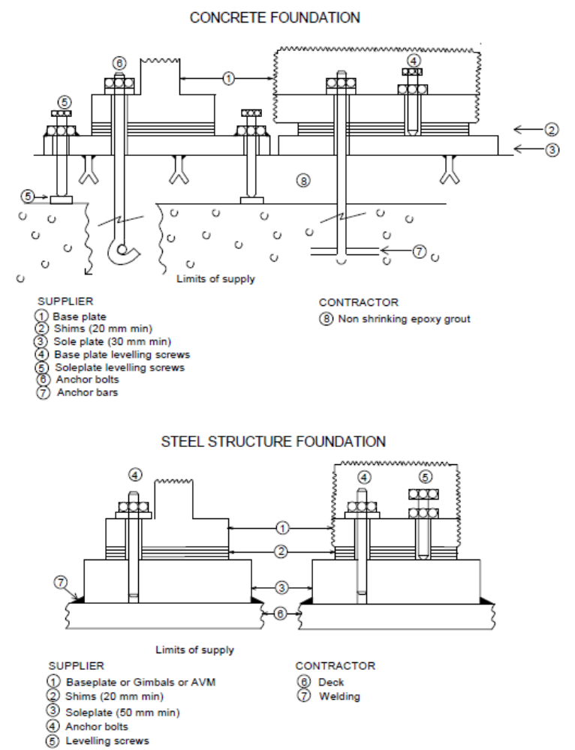
- Vendor Document Register (VDR)
The following documents shall be delivered by the Package Vendor. This list is a mandatory base frame but might be extended on a Project basis.
- Documents to be supplied with offer.
Item | Designation | (1)
1 | GENERAL DOCUMENTS
1.1 | General
1.1.1 | Vendor document register | X
1.1.2 | Installation and operating manual index
1.1.3 | Installation and operating manual
1.1.4 | Preservation procedure
1.1.5 | Packing procedure
1.1.6 | Weight data sheets with CoG | X
1.1.7 | Special tools list
1.1.8 | Start up and commissioning spare parts list
1.1.9 | Operating spare parts list (with prices)
1.1.10 | Capital spare parts list
1.1.11 | Declaration of conformity for ATEX
1.1.12 | Monthly report
1.2 | Procedures & Reports
1.2.1 | Painting procedure
1.2.2 | Pump performance (API Std 674) test procedure
1.2.3 | Gearbox test procedure (if applicable)
1.2.4 | Lube oil system test procedure (if applicable)
1.2.5 | Package full load string test procedure
1.2.6 | Package site acceptance test procedure
1.2.7 | Reports for all the above tests ⁽²⁾
1.3 | Manufacturing / Quality / HSE documents
1.3.1 | Quality control plan
1.3.2 | Inspection and test plan
1.3.3 | NDE procedures
1.3.4 | Welding procedures
1.3.5 | Vessel/exchanger code calculation notes
1.3.6 | Material certificates
1.3.7 | All tests and inspections certificates
1.3.8 | QA/ QC (Manufacturing data book) index
1.3.9 | QA/ QC (Manufacturing data book) Dossier
2 | STRUCTURAL
2.1 | Foundation drawing - Plan view
2.2 | Foundation drawing - Elevation view
2.3 | Foundation loadings (static and dynamic loads, permanent and temporary location)
2.4 | Baseplate calculation note including modal analysis and lifting appliance
2.5 | Lifting equipment general arrangement including lifting calculation
3 | MECHANICAL
3.1 | Arrangements
3.1.1 | General arrangement drawing - Plan view
3.1.2 | General arrangement drawing - Elevation view
3.1.3 | General arrangement drawing - Isometric view
3.1.4 | General arrangement drawing including piping (plan, elevation and isometric views)
3.1.5 | Limits of supply table (interface and connection schedule)
3.1.6 | Allowable nozzles loads
3.1.7 | Lube oil console arrangement drawing (if applicable)
3.1.8 | Mechanical packing System arrangement drawing
3.2 | Data sheets
3.2.1 | Pump data sheet (as per API 674 data sheets) | X
3.2.2 | Gearbox data sheet (if applicable) | X
3.2.3 | Couplings (low and high speed) data sheets
3.2.4 | Lube oil system data sheets (as per data sheets in GS EP MEC 281 appendix) (if applicable)
3.2.5 | Other (PSV, pulsation suppression devices etc.)
3.3 | P&IDs & Lists
3.3.1 | PID | X
3.3.2 | P&ID symbols table
3.3.3 | Utility list | X
3.3.4 | Equipment list
3.3.5 | Lubrication list and schedule
3.4 | Detail drawings
3.4.1 | Pump outline drawing
3.4.2 | Pump cross section drawing
3.4.3 | Pump sub assemblies drawings
3.4.4 | Gearbox outline drawing (if applicable)
3.4.5 | Gearbox cross section drawing (if applicable)
3.4.6 | Couplings (low and high speed) drawings
3.4.7 | Nameplate drawings (pump, gearbox…)
3.5 | Calculations & Performances data
3.5.1 | Pump performances curves | X
3.5.2 | Analysis Approach 2 (Acoustical Simulation)
3.5.3 | Pump lateral analysis
3.5.4 | Gearbox lateral analysis
3.5.5 | Shaft line torsional analysis
3.5.6 | Package noise data sheet | X
4 | ELECTRICAL
4.1 | List of required document as per GS EP ELE 011, GS EP ELE 111, GS EP ELE 121 and GS EP ELE 141. The data sheets will be supplied according to DS EP ELE 111, DS EP ELE 112, DS EP ELE 121 and DS EP ELE 141. | X
4.2 | Electrical load list | X
5 | INSTRUMENTATION
5.1 | General
5.1.1 | Package functional analysis (including pump, motor, VSD… and all auxiliaries)
5.1.2 | Instruments hook ups
5.2 | Data sheets
5.2.1 | Instruments data sheets
5.3 | P&IDs & Lists
5.3.1 | Vibration and temperature P&ID (if applicable) | X
5.3.2 | Instruments list including service, range, trip and alarm levels
5.3.3 | Instruments and electrical cables list
5.4 | Diagrams
5.4.1 | Interconnecting diagram (instrumentation and electrical) | X
5.4.2 | Earthing diagram
5.4.3 | Logic diagrams
5.4.4 | Cause and effect chart
5.4.5 | Instrument loop diagrams
5.4.6 | Junction boxes terminal strips
6 | PIPING, VALVES and VESSELS
6.1 | General
6.1.1 | Piping classes | X
6.2 | Calculations & Performances data
6.2.1 | Calculation notes for safety relief valves, pulsation suppression devices
- The package string test report shall include pictures of the package (four side views and four isometric views).
- Minimum inspection requirements
As a minimum, the following inspections shall be conducted on the package:
- Functional, performance, NPSH and mechanical running test of all units
- Final inspection
- Final dossier data book review.

Note: This list does not include the inspections to be conducted on each individual component constituting the package.
- Deviations to the contractual documents
If deviations are waived during the bid phase, they shall be listed in the following pages in the purchase revision.

The deviation list shall exhibit at least the following:
- Reference of the specification
- Paragraph of the specification
- Description of the deviation
- Reason for deviation
- Vendor proposal
- Company final position.

The deviations that are not accepted by Company shall appear in this list in order to give a complete overview of the technical discussions.

The following list contains pages.

Note: The deviation list might not be attached to this specification but referenced under a project document (as reported below).

Project document reference:
Revision .
- Data sheets
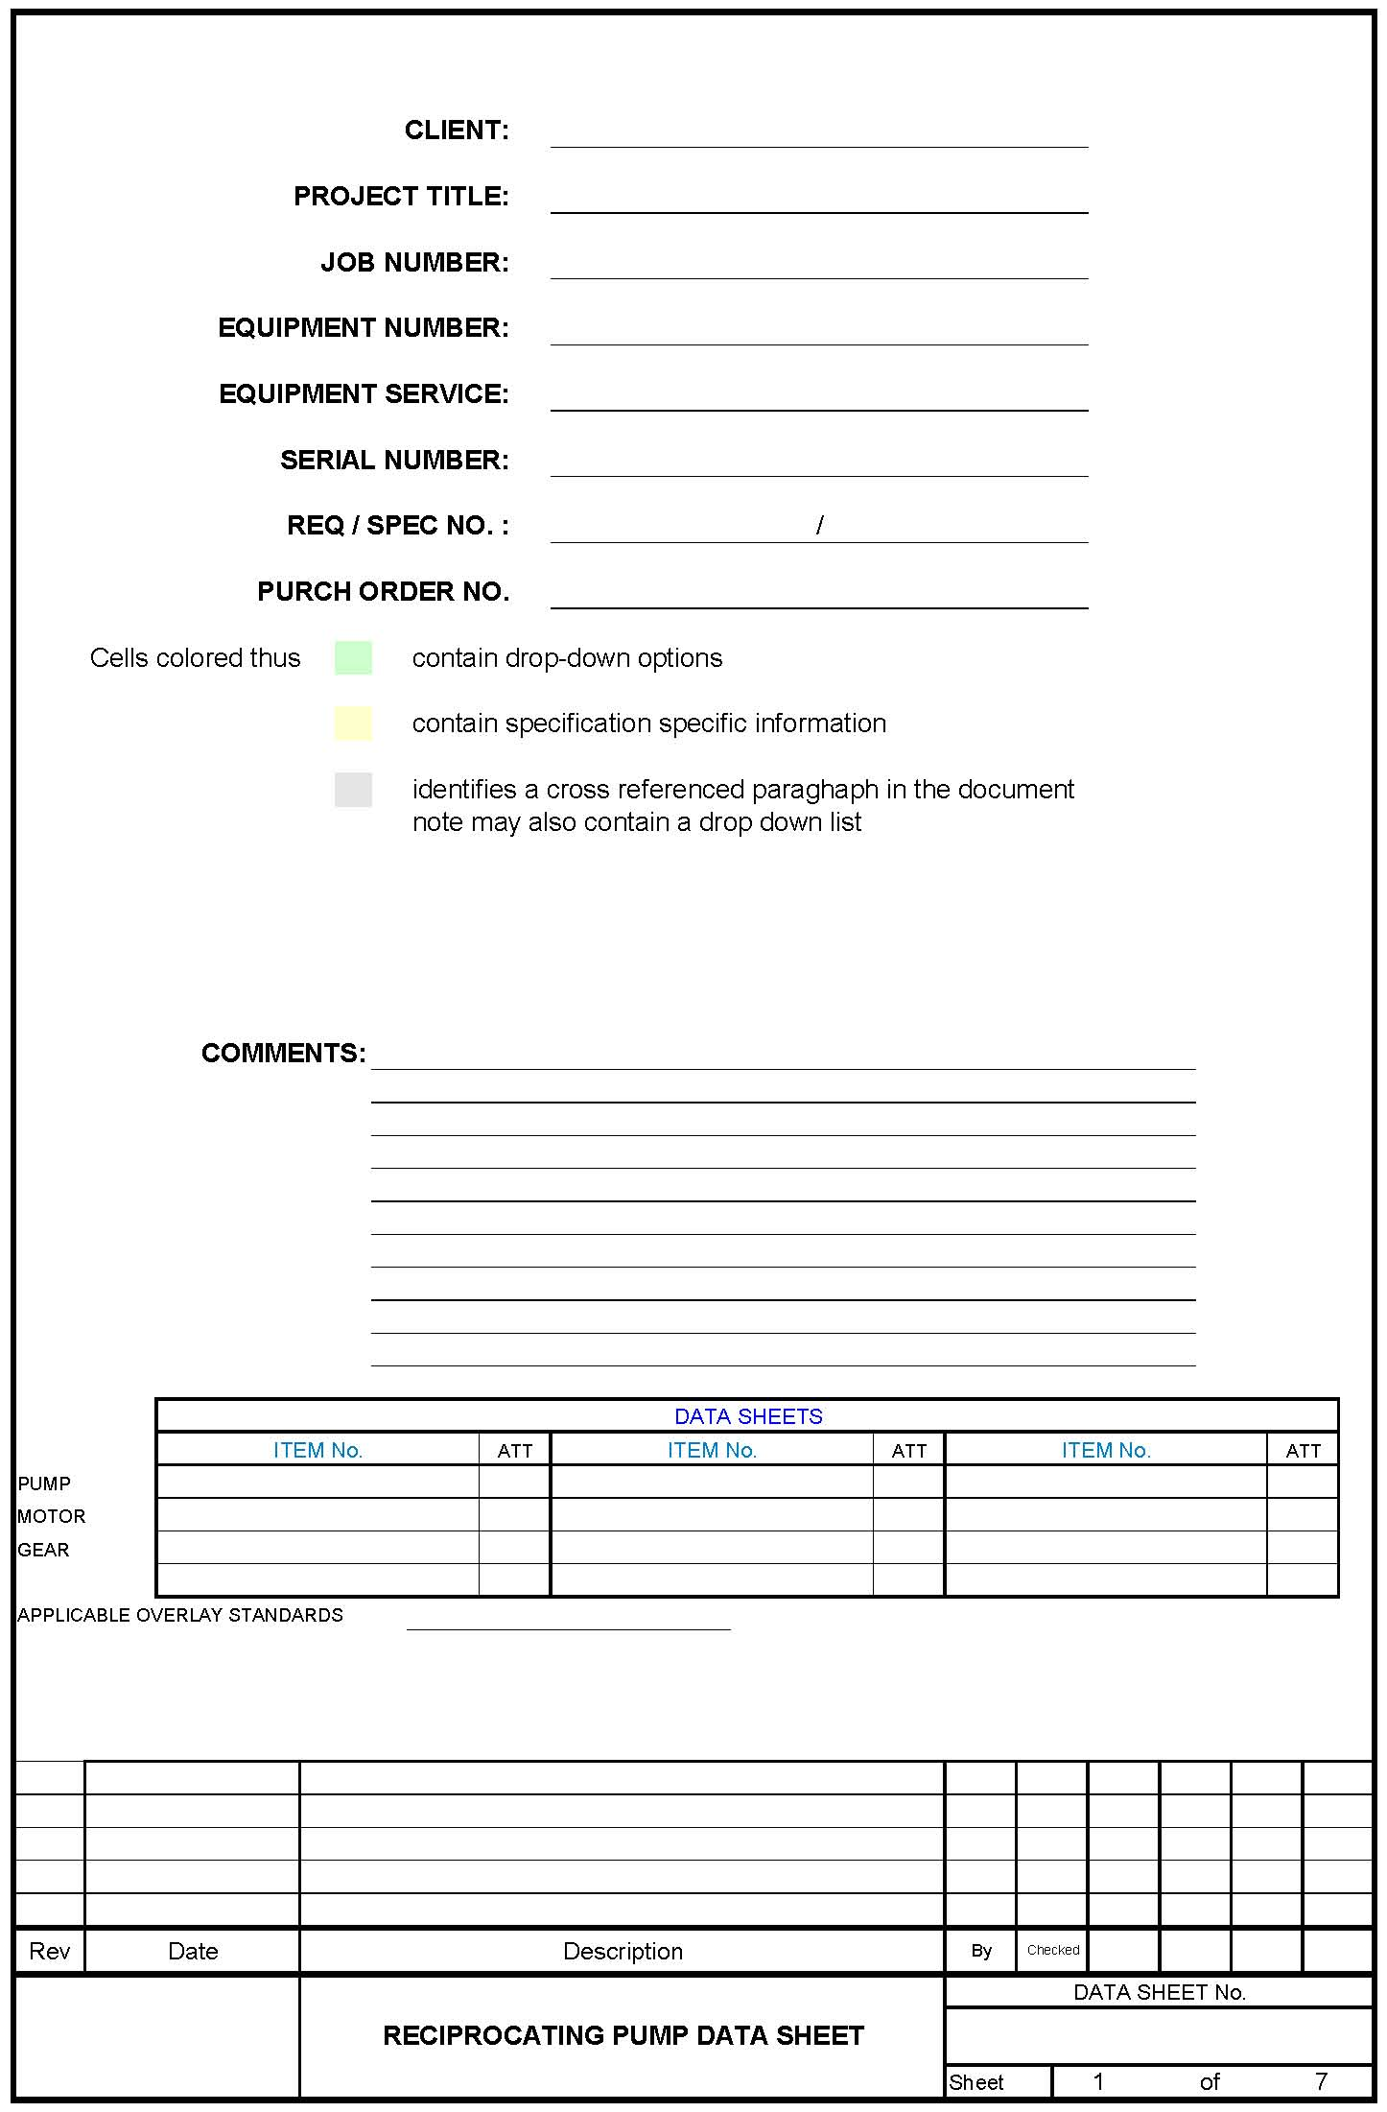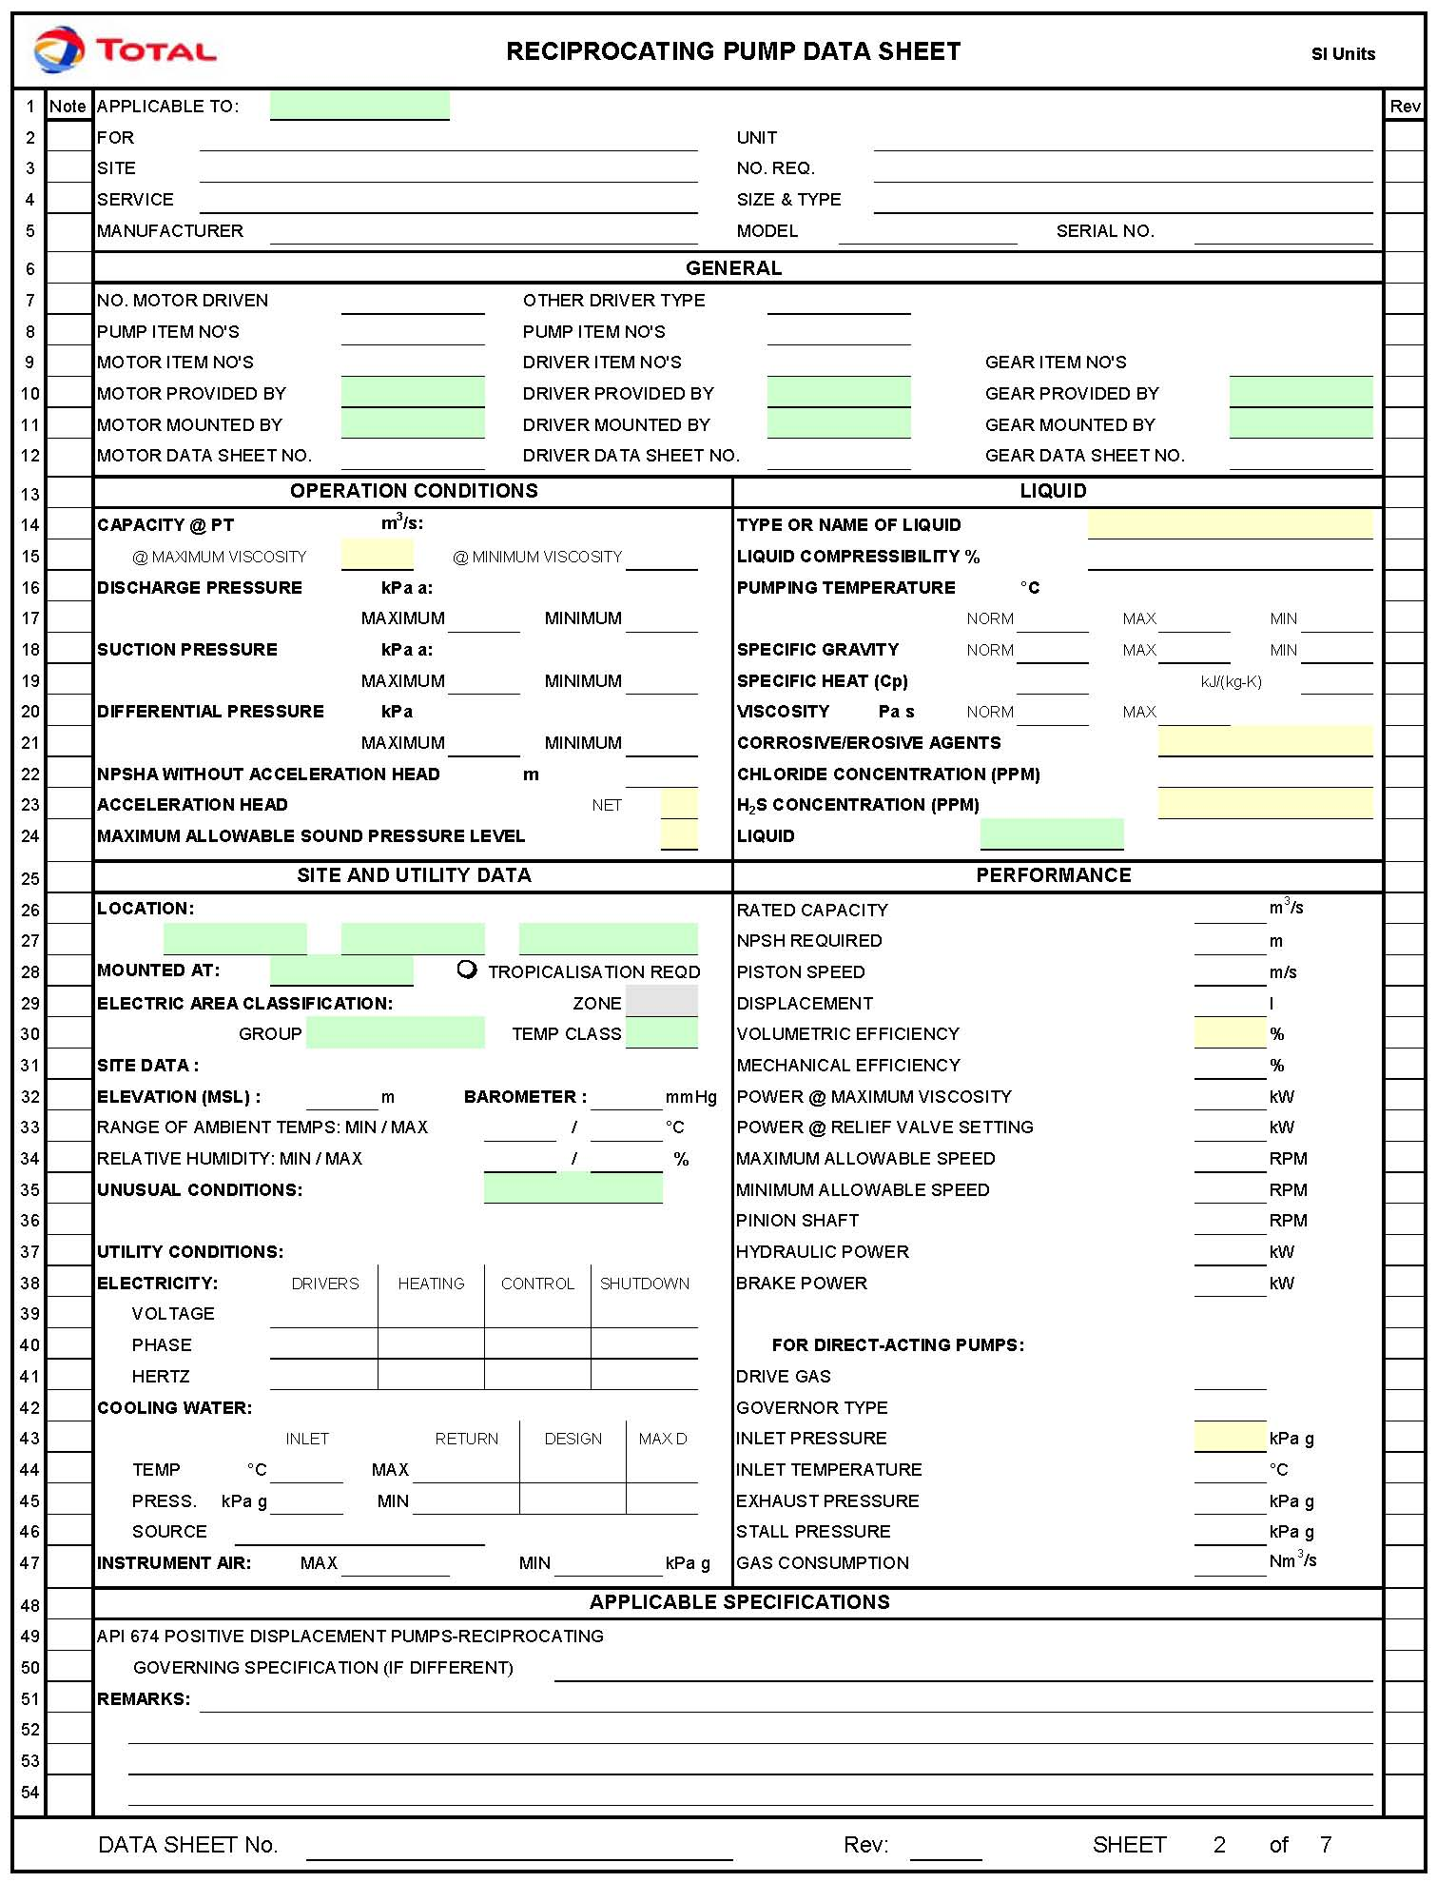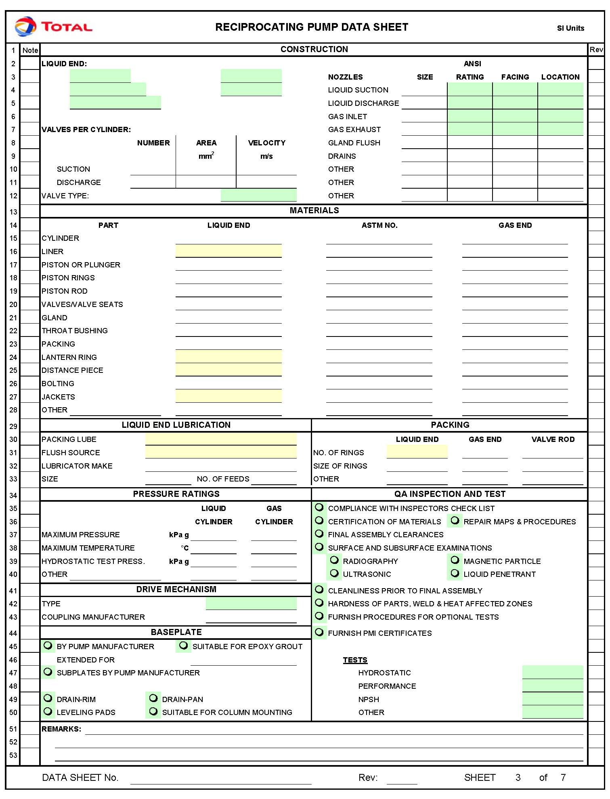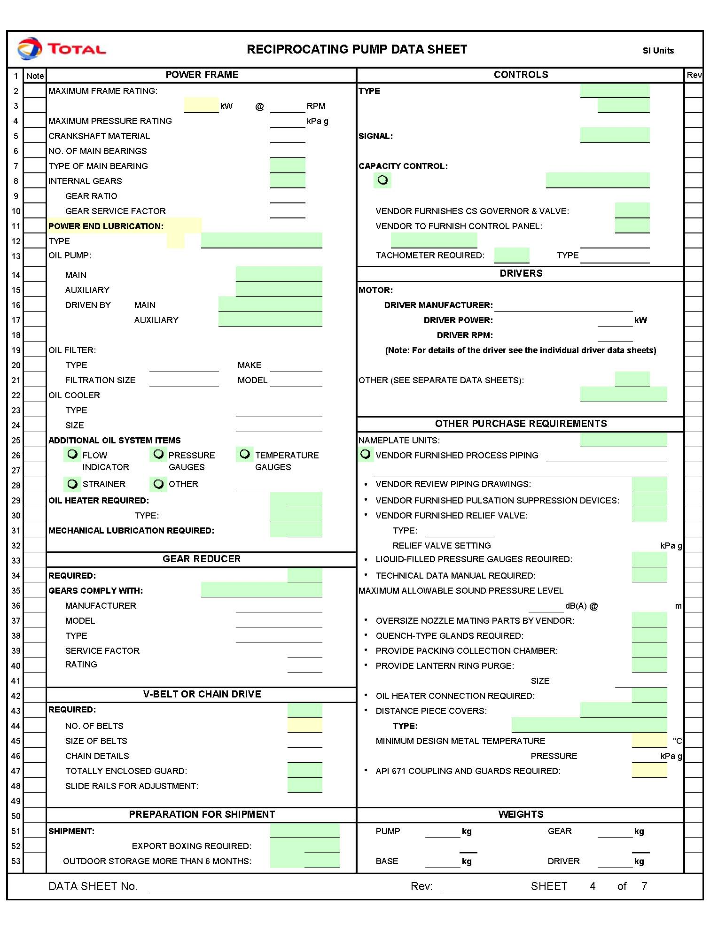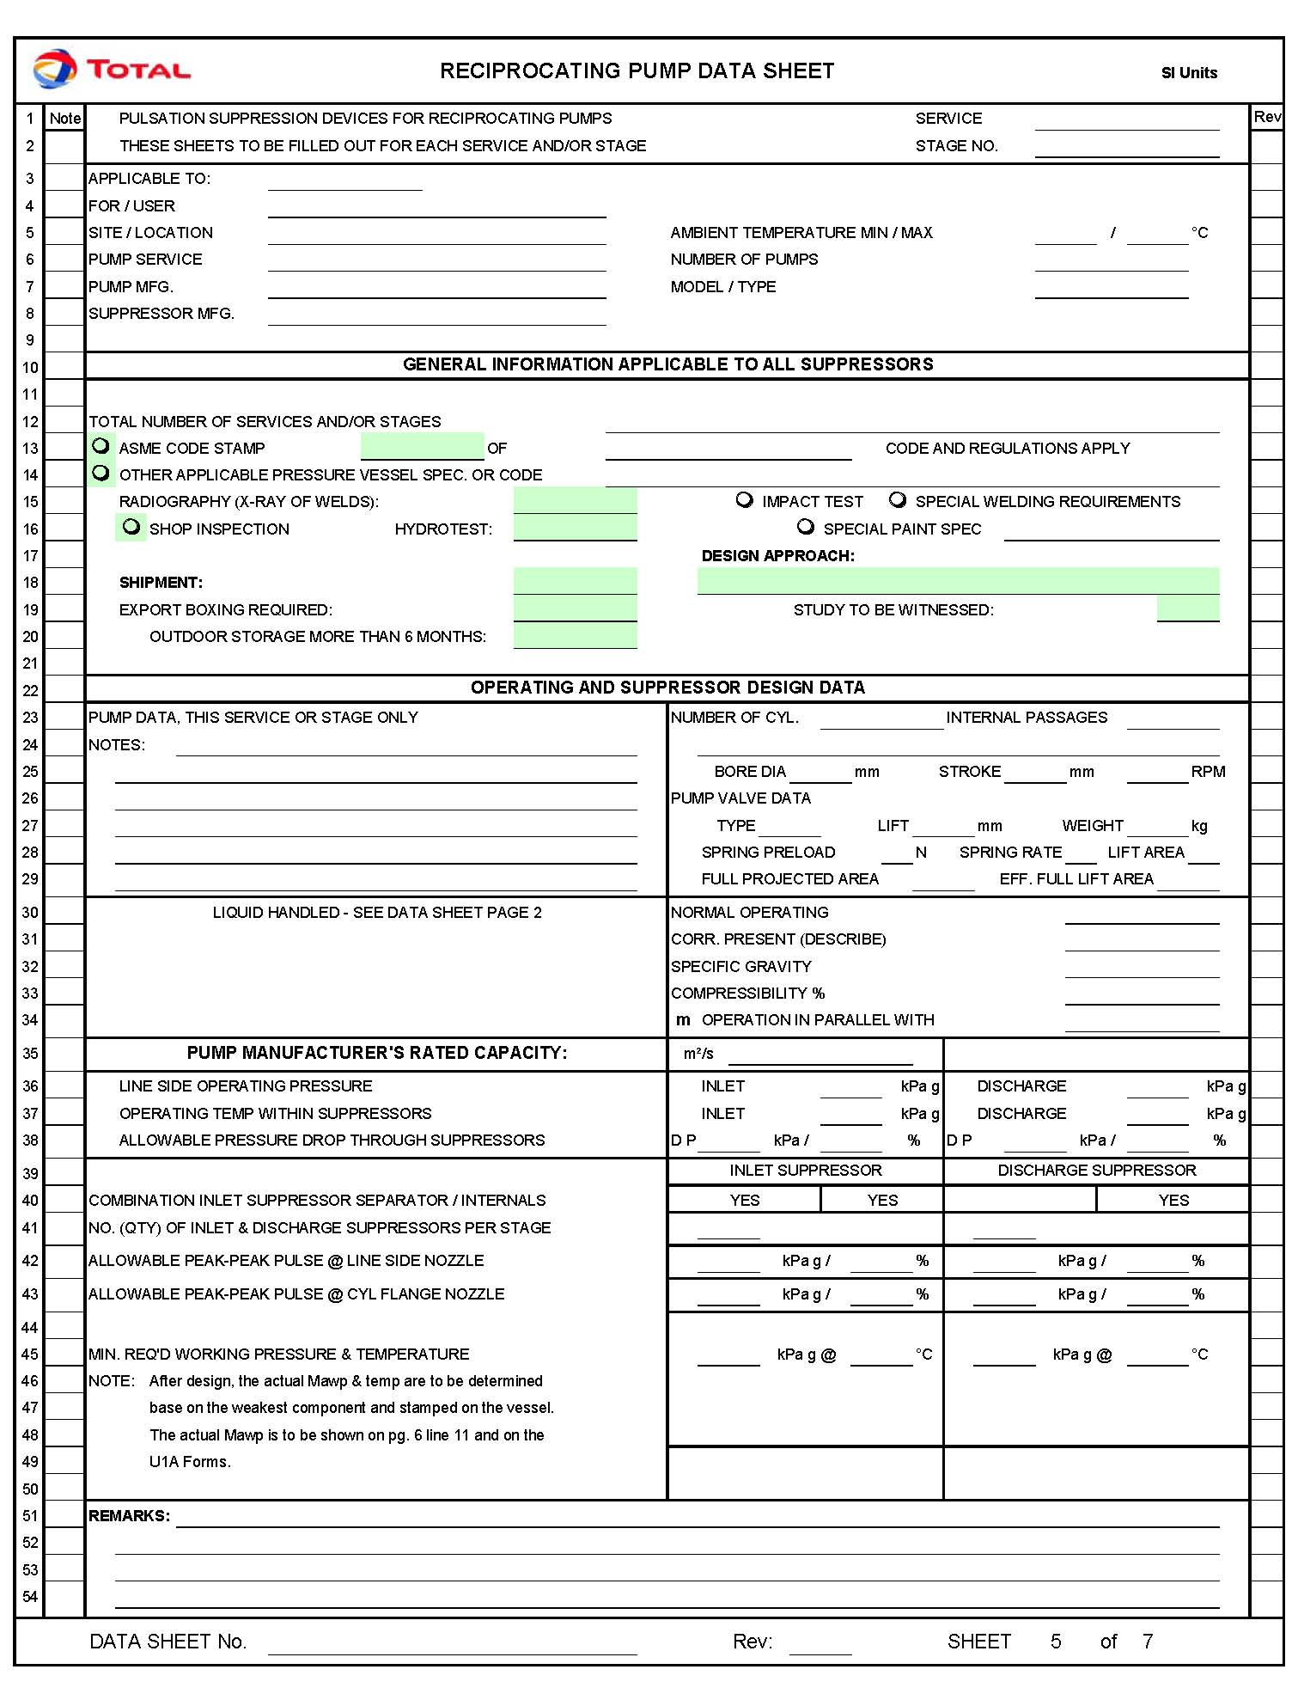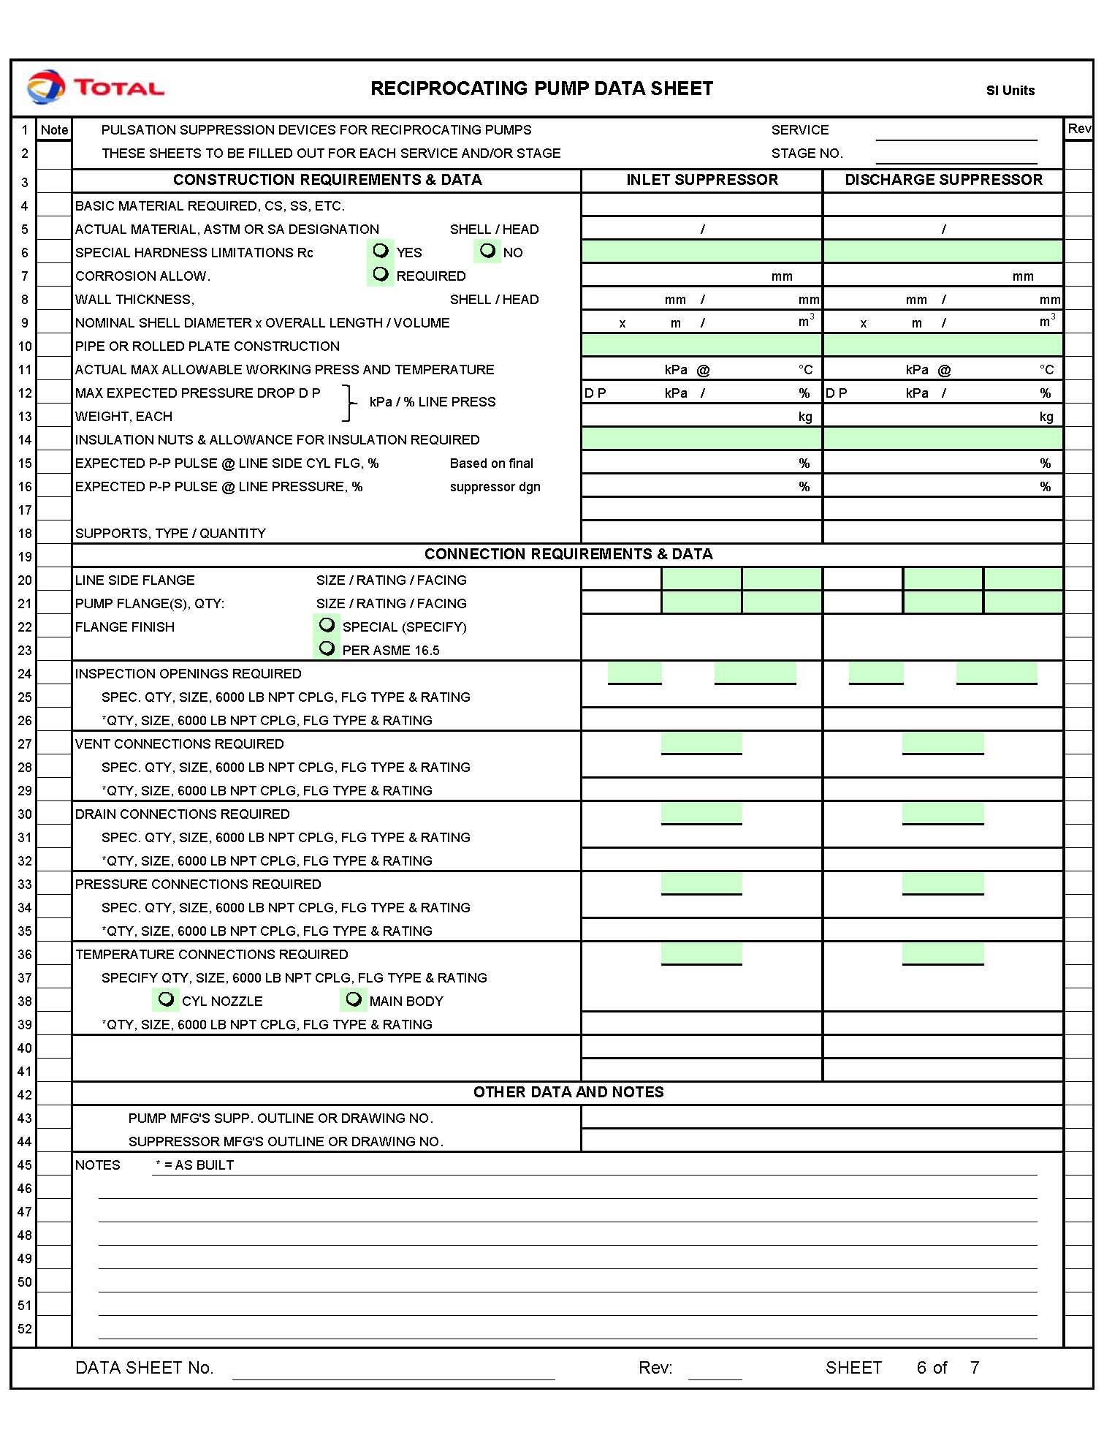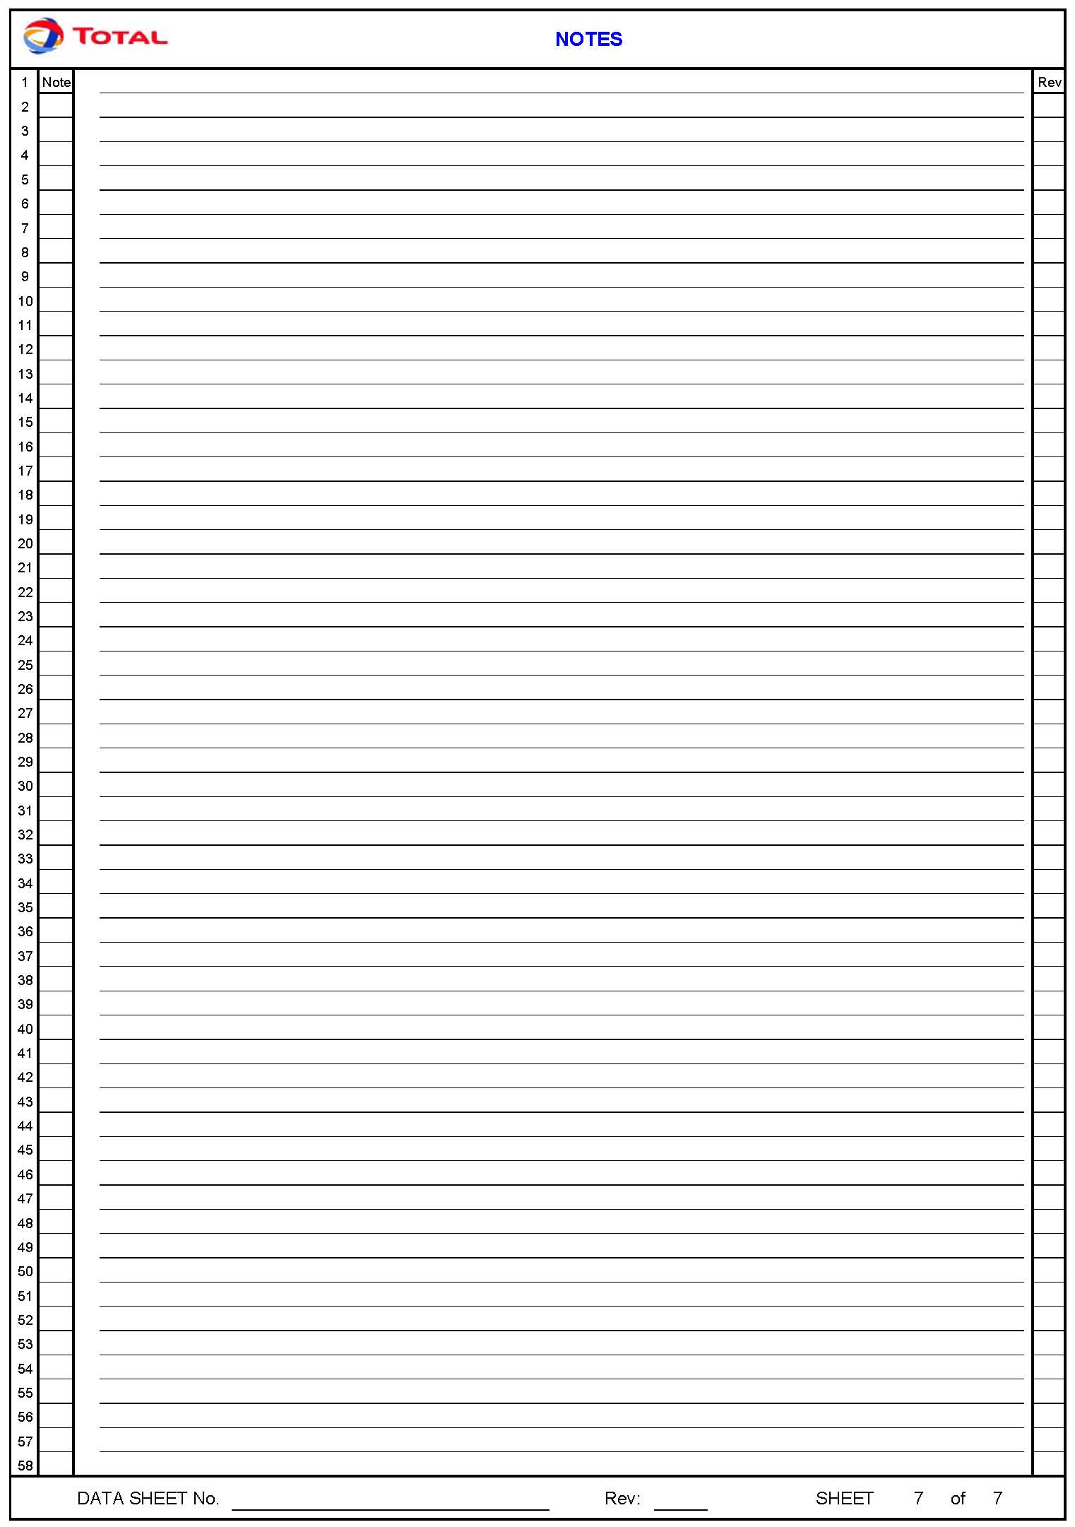

Reference to Articles 100/118 of the Treaty of Rome
Reference to Articles 95/137 of the Treaty of Amsterdam

