GENERAL SPECIFICATION
ROTATING MACHINERY
GS EP MEC 033

Rotating Machine Package Specification
Air Compressor and Air Dryer

02 | 10/2012 | Updated
01 | 01/2012 | Updated
00 | 01/2011 | First issue
Rev. | Date | Purpose of the revision

Owning entity: DEV/TEC | Managing entity: DEV/TEC/MTH

Project Specification n° |  | Revision:
 |  | Date:

Contents
Preamble 4
1. Scope 5
1.1 Purpose 5
1.2 Application 5
1.3 General rules 5
2. Reference documents 6
3. Scope of supply and exclusions 10
3.1 Scope of supply 10
3.2 Exclusions 13
4. Basis of design 14
4.1 General considerations / safety and environment 14
4.2 Architecture 14
4.3 Instrument air quality 15
4.4 Operating conditions 15
4.5 Amendments and supplements to ANSI/ISA-7.0.01 15
4.6 Coupling and coupling guards 18
4.7 Package configuration 18
4.8 Enclosure 19
4.9 Electrical 20
4.10 Piping, valves and pressure vessels 20
4.11 Installation 20
4.12 Instrumentation 20
4.13 Painting 24
4.14 Heal Safety and Environment 24
4.15 Miscellaneous 24
5. Data sheets 27
5.1 Air compressor 27
5.2 Electric motor 27
5.3 Noise 27
5.4 Weight 27
5.5 Data sheets templates 27
6. Site conditions and utilities 28
6.1 Site conditions 28
6.2 Utilities 30
7. Tests 31
7.1 Factory tests (workshop) 31
7.2 Site acceptance tests 33
8. Spare parts and special tools 35
8.1 Spare parts 35
8.2 Special tools 35
9. Preparation for shipment 36
9.1 Preservation 36
9.2 Packing 38
9.3 Transportation 40
Appendix 1 Definitions and abbreviations 41
Appendix 2 Package schematic 42
Appendix 3 Baseplate installation 44
Appendix 4 Vendor Document Register (VDR) 45
Appendix 5 Minimum inspection requirements 48
Appendix 6 Deviations to the contractual documents 49
Appendix 7 Data sheet 50

Preamble

Scope

Purpose
This specification relates to the packaging of the Air Compressor and Air Dryer Packages and specifies the minimum design and construction requirements for the equipment that make the package. It is an exhaustive document detailing the scope of supply and the associated design rules requested by TOTAL E&P for the procurement of Air Compressor and Air Dryer Packages.

Application
This document applies to the design of all Oil Free Rotary Air Compressor and Air Dryer packages. It excludes any other type of air compressor.

General rules
All deviations from this specification or the documents referred to herein shall be stated in writing in the Appendix 6 of this specification. In the absence of such a statement, it is assumed that the requirements of the specifications are met without exception. Failure to meet the requirements of this specification and referenced documents shall be corrected at Supplier’s cost. Exceptions and deviations to the specifications shall be part of Supplier’s proposal and will be subject to Company approval.
Where this specification, or any other project document, allows the Supplier to propose an “option”, the Supplier shall clearly state the selected option in his bid.
In cases the Supplier provides outsourced equipment, he shall be responsible for the coordination of the Sub-Suppliers, and ensuring the full compatibility of all the equipment. In particular, they shall be compatible in terms of safety, environment, operability, dimensions, weight, performance, control, noise and vibration behavior.
Components not mentioned in this specification that are necessary for the operation of the equipment or required by certifying agency, regulatory bodies or by law, shall be Supplier standard components.
The present document remains a General Specification as long as the modifiable forms are not completed. It becomes the Project Specification once these modifiable forms are completed and shall therefore not be considered as a General Specification any more.
Then, the General Specification shall be attributed a Project reference number with the associated Project front page.
Preamble shall be completed with the Project description (location, number of machines, etc.).
If Project specificities require amendments to non modifiable parts of this specification or to the documents referred to herein, they shall be considered as deviations and stated in writing in the Appendix 6 of this specification.
This specification will then be issued in two steps:
- Issued “for inquiry”
- Issued “for purchase”.
The applicable documents shall be considered in the following order:
- Local regulations
- Classification Society Rules (If applicable)
- Frame agreement if available
- This completed specification and associated data sheets
- Referenced General Specifications
- Referenced Project specifications
- Codes and standards.

Reference documents
The reference documents listed below form an integral part of this General Specification.
External Documents
Unless otherwise stipulated, the applicable version of these documents, including relevant appendices and supplements, is the latest revision published at the effective date of this document.
Reference | Title
1999/92/EEC  (ATEX 118¹/ATEX 137²) | European Directive 1999/92/EEC (16/12/99) on minimum requirements for improving the safety and health protection of workers potentially at risk from explosive atmospheres
94/9/EC  (ATEX 100a/ATEX 95) | European Directive 94/9/EC (23/03/94) on the approximation of the laws of the Member State concerning equipment and protective systems intended for use in potentially explosive atmosphere
ANSI/ISA-7.0.01 | Quality standard for Instrument Air
API Std 672 | Packaged, Integrally Geared Centrifugal Air Compressors for Petroleum, Chemical, and Gas Industry Services
DIN 55473 | Auxiliary means of packaging - Desiccant in bag - Technical delivery conditions
IP 15 | Area Classification Code for Petroleum Installation handling flammable fluids - July 2005 (3rd edition)
ISO 10816-3 | Mechanical vibration - Evaluation of machine vibration by measurements on non-rotating parts - Part 3: Industrial machines with nominal power above 15 kW and nominal speeds between 120 r/min and 15 000 r/min when measured in situ
ISO 1217 | Displacement compressor - Acceptance Tests
ISO 5167 | Measurement of fluid flow by means of pressure differential devices inserted in circular cross-section conduits running full
ISO 780 | Packaging. Pictorial marking for handling of goods
ISO 8573-1 | Compressed air - Part 1: Contaminants and purity classes
NF H00-310 | Industrial packagings. Flexible and heat sealing protection materials of low coefficient of water vapour transmission (P < 0.3 g/m² 24 h)
NF H00-320 | Packaging. Desiccant. Specifications and tests
US MIL-STD-2073-1 E | Standard Practice for Military Packaging
US MIL D 3464E | Desiccants, activated, bagged, packaging use and static dehumidification
US MIL PRF 131K | Performance Specification Barrier Materials, Watervaporproof, Greaseproof, Flexible, Heat- Sealable.

Total General Specifications
Unless otherwise stipulated, the applicable version of these documents, including relevant appendices and supplements, is the latest revision published in the applicable yearly collection.
TOTAL EP General Specification Referential is applicable for the following Project:

The following Company specifications are fully applicable to all purchased equipment as listed in paragraph 3.1 completed by the technical details reported in paragraph 4 and taken into account accepted deviations as listed in Appendix 6. The second level General Specifications mentioned in each individual specification are not applicable if they are not listed in the below tables. The standards, professional documents, regulations and codes mentioned in each General Specification are applicable.
The following list may also be complemented with other specific Project detailed specifications which would include additional requirements, as applicable or deemed necessary by Company or Contractor.
Reference | Title
GS EP COR 350 | External protection of offshore and coastal structures and equipment by painting
GS EP COR 354 | External protection of onshore structures and equipment by Painting
GS EP COR 356 | Corrosion Protection of Fasteners for Subsea and Topside Applications
GS EP ELE 011 | Electrical requirements for packaged units
GS EP ELE 031 | Design of earthing and bonding systems
GS EP ELE 079 | Electrical apparatus for potentially explosive gas atmospheres
GS EP ELE 111 | Induction motors
GS EP ELE 161 | Electrical cables
GS EP EXP 217 | Requirements to Vendors, Suppliers and EPC`S for spare parts
GS EP INS 101 | Instrumentation engineering, supply and construction general requirements
GS EP INS 102 | Instrumentation identification
GS EP INS 104 | Design of generation and distribution of instrument air or gas
GS EP INS 107 | Design and installation of instrumentation links
GS EP INS 110 | Instrumentation for package units
GS EP INS 135 | Cyber Security requirements for design and supply of ICSS and Package Systems
GS EP MEC 101 | Driver Power Sizing
GS EP MEC 292 | Rotating Machines Packages Installation Requirements
GS EP MEC 300 | Noise and Vibration of Rotating Machine Packages
GS EP PVV 112 | Piping material class
GS EP PVV 143 | Metallic pipes
GS EP PVV 144 | Fittings
GS EP PVV 145 | Flanges
GS EP PVV 175 | Cleaning of piping and vessels
GS EP PVV 211 | Design and fabrication of pressure vessels according to ASME VIII
GS EP STR 001 | Weight monitoring and weighing offshore units
GS EP STR 103 | Design and fabrication of skids and equipment supporting structures

In case one of the previous General Specifications is completed with one or more Project specific detailed specification(s), then these detailed specifications (and their respective revision) shall be added to the following list.
Project Documents (to be completed by Company or Contractor)
 | Designation | Rev | Reference
1 | PID’s (*)
2 | Layout (*)
3 | Project specification for electrical requirements for packaged units (*)
4 | Instrument tagging specification (*)
5 | Instrument list database specification (*)
Note: All the documents identified by (*) shall be available along with this specification for the issue for inquiry and for purchase.
Project data sheets are listed in paragraph 5.

Scope of supply and exclusions

Scope of supply
The Vendor shall be responsible for the design, supply of materials, manufacture, assembly, supply of drawings and data, all Sub-Vendor co-ordination, testing, delivery and guarantees of the below components:
Note 1: The column “Required” indicates the level of requirement of each item, according to the below rule:
- “X” means that the item is a base case requirement.
- “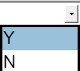 means that the item is an optional requirement specific to the project. “Y” for YES if the option is selected or “N” for NO if the option is not selected.
Note 2: The column “Description” may offer alternative technical choices that shall be fixed prior to the issue “For inquiry” by ticking the appropriate mark box .
# | Item | Description |  |  |  | Required | Tag | Quantity
1 | ON SKID EQUIPMENT
1.1 | Air compressor package including but not limited to:
1.1.1 | Dry (oil free) air compressor | As per data sheet enclosed in paragraph 5 of this specification. |  |  |  | X
1.1.1 | Dry (oil free) air compressor | 2x100% duty |  | 3x50% duty |  | X
1.1.2 | Inter stage and after coolers | As per paragraph 4.5.3 of this specification. |  |  |  | X
1.1.3 | Moisture separators and drains | As per paragraph 4.5.4 of this specification. |  |  |  | X
1.1.4 | Lube oil system | Common self contained lube oil system. |  |  |  | X
1.1.5 | On-skid local gauge board | As per paragraph 4.12.6 of this specification. |  |  |  | X
1.1.6 | Air intake filter system | As per paragraph 4.5.1 of this specification. |  |  |  | X
1.1.7 | Inlet & Outlet silencers | As per paragraph 4.14.2 of this specification. |  |  |  | X
1.1.8 | Vibration sensors | As per paragraph 4.12.3 of this specification. |  |  |  | X
1.2 | Main electric motor including but not limited to:
1.2.1 | Main electric motor | As per GS EP ELE 111 and as per data sheet referenced in paragraph 5 of this specification. |  |  |  | X
1.2.2 | Cable glands | As defined in the data sheet referenced in paragraph 5 of this specification. |  |  |  | X
1.2.3 | Vibration and temperature monitoring | As per GS EP ELE 111 and as per data sheet referenced in paragraph 5 of this specification. |  |  |  | X |  | set
1.2.4 | All associated instrumentation and auxiliary junction boxes |  |  |  |  | X |  | set
1.3 | Base plate including but not limited to:
1.3.1 | Fabricated steel common base plate | As per paragraph 4.7.2 of this specification. |  |  |  | X
1.4
1.4.1 | 2 x 100% Pre-filters | As per paragraph 4.5.5 of this specification. |  |  |  | X
1.4.2 | One set of twin heatless adsorption type air dryer | As per paragraph 4.5.6 of this specification. |  |  |  | X
1.4.3 | 2 x 100 % after-filters | As per paragraph 4.5.7of this specification. |  |  |  | X
1.4.4 | On / Off automatic valves (ROV) | As per paragraph 4.5.5 of this specification. |  |  |  | X
1.4.5 | Manual isolation valves | As per Appendix 2 of this specification. |  |  |  | X
1.4.6 | Safety relief valves | As per paragraph 4.12.2 of this specification. |  |  |  | X
1.4.7 | On skid local gauge board | As per paragraph 4.12.6 of this specification. |  |  |  | X
1.4.8 | Fabricated steel common base plate | As per paragraph 4.7.2 of this specification and as per GS EP STR 103. |  |  |  | X
1.5 | Power transmission equipment including but not limited to:
1.5.1 | Gearbox | If required. |  |  |  | X
1.5.2 | Semi flexible coupling | As per paragraph 4.6 of this specification. |  |  |  | X
1.5.3 | Rigid coupling guard | As per paragraph 4.6 of this specification. |  |  |  | X
1.6 | Enclosure including but not limited to:
1.6.1 | Acoustic Enclosure | As per paragraph 4.8 of this specification. |  |  |  | X
1.6.2 | Air Ventilation System | As per paragraph 4.8.1 of this specification. |  |  |  | X |  | sets
1.7 | Control and instrumentation including but not limited to:
1.7.1 | Junction boxes | All necessary instrumentation junction boxes at skid edges as per GS EP INS 101 and GS EP INS 107. |  |  |  | X |  | sets
1.7.2 | Cable glands | Cable glands for departing multi-core cables, defined by Project and blinded off suitably for transport and storage. In case the option is not selected, the gland plates shall be pre-drilled and blinded off. |  |  |  |  |  | sets
1.7.2 | Cable glands | For all other cables, junction boxes shall be provided with cable gland plates and associated cable glands. |  |  |  | X |  | sets
1.7.3 | Instrumentation cables | All instruments cables between Instruments and skid mounted terminal Junction boxes / local gauge board as per GS EP ELE 161 and GS EP INS 107. |  |  |  | X |  | sets
1.7.4 | Instruments cables trays | All necessary cables trays with covers made of AISI 316L between instruments and skid mounted junction boxes as per GS EP INS 107.  Empty cable trays for the multi-core cables (supplied and installed by other) between the terminal junction boxes and skid edge. |  |  |  | X |  | sets
1.8 | Electrical including but not limited to:
1.8.1 | Electrical cables trays | All necessary cables trays with covers made of AISI 316L between all electrical consumers mounted on skid and the skid edge. |  |  |  | X |  | sets
2 | OFF SKID EQUIPMENT (Shipped Loose)
2.1 | UCP | UCP including PLC for control/safety, panel mounted HMI. As per GS EP INS 110 and paragraph 4.12.4 of this specification. |  |  |  | X
2.2 | ICSS interface | Communication cards, relays, signal convertors, etc. to interface with ICSS and support systems (if any). |  |  |  | X |  | sets
2.3 | VTMS | Vibration and Temperature Monitoring System to control the complete shaft line vibration and temperature sensors integrated inside UCP. |  |  |  |  |  | sets
2.4 | Soft starter for main electric motor | As per motor data sheet referenced in paragraph 5 of this specification.
2.5 | Dew point analyzer | Moisture monitoring/ dew point analyzer as per paragraph 4.15.1 of this specification.
2.6 | Wet air receiver | As per paragraph 4.15.2 of this specification.
2.7 | Dry air receiver | As per paragraph 4.15.2 of this specification.
2.8 | Interconnecting piping | Interconnecting piping between all air compressor skids. |  |  |  |  |  | sets
2.9 | Interconnecting piping | Interconnecting piping between air compressor skid and air dryers skid. |  |  |  |  |  | sets
2.10 | Special tools | Refer to paragraph 8.2 of this specification. |  |  |  | X
2.11 | Spare parts for commissioning and start–up | Refer to paragraph 8.1.1 of this specification. |  |  |  | X
2.12 | Capital spare parts | Refer to paragraph 8.1.2 of this specification. |  |  |  | X
3 | MISCELLANEOUS
3.1 | Baseplate anchor bolts and shims | As per Appendix 3. |  |  |  | X |  | sets
3.2 | Off skid equipment anchors and shims | All anchors and shims for all off skid equipment supplied by SUPPLIER. |  |  |  | X
3.3 | Lifting tools for the complete package | Consists of slings, shackles and spreader bar as per paragraph 4.7.4 of this specification and as per GS EP STR 103. |  |  |  | X
3.4 | Limit flanges | All limit flanges as per GS EP PVV 112 or Project piping classes -if available- equipped with blind flanges for transportation. |  |  |  | X
3.5 | Maintenance laptop | Including software for UCP configuration. |  |  |  | X
3.6 | Backup | Complete backup hard disk with application software, PLC program, HMI and any firmware prior to shipment. |  |  |  | X |  | sets
3.7 | Software | OEM CD/DVD for any software used with full licenses. |  |  |  | X |  | sets
3.8 | Documentation | Set of documents as per Appendix 4 of this specification. |  |  |  | X
3.9 | Earthing network | Earthing design and implementation as per GS EP ELE 031 and GS EP INS 107. |  |  |  | X |  | sets
3.10 | Package preservation | As per paragraph 9.1 of this specification. |  |  |  | X
3.11 | Painting | As per paragraph 4.13 of this specification. |  |  |  | X |  | sets
3.12 | Specific climate considerations | Tropicalization | Winterization |  | None | X
4 | TESTS
4.1 | Factory tests
4.1.1 | Main electric motor | As per paragraph 7 of GS EP ELE 111 and data sheet referenced in paragraph 5 of this specification. |  |  |  | X
4.1.2 | Air compressor package | As per ISO 1217 and paragraph 7.1 of this specification. |  |  |  | X
4.1.3 | Air dryers | As per paragraph 7.1 of this specification. |  |  |  | X
4.1.4 | UCP | UCP integration and communication test at Sub-Vendor premise as per paragraph 7.1.4 of this specification and paragraph 7.4 and Appendix 5 of GS EP INS 110. |  |  |  | X
4.1.5 | Air compressor and air dryers package complete unit tests | As per paragraph 7.1.3 of this specification. |  |  |  | X
4.1.6 | Noise and vibration test | As per paragraph 7.1.3 of this specification. |  |  |  | X
4.2 | Site acceptance tests
4.2.1 | Air compressor and air dryers package complete unit tests | As per paragraph 7.2 of this specification. |  |  |  | X

Vendor shall be responsible for the physical and technical compatibility of the entire package and shall ensure that all equipment and components provided are suitable for the operations intended.

Exclusions
The following equipments are not included in the scope of supply:
- Counter flanges, gaskets and bolting for connecting flanges at battery limits of Vendor’s supply
- All piping outside the package
- Electric and instrument cables outside the package
- All earthing cables outside the package.

Basis of design
This paragraph details the technical specificities of Project that are not covered in the Company General Specifications nor in the Project documents.

General considerations / safety and environment
The complete package shall be designed for years of operation.
Environmental conditions for the equipment design are indicated in the paragraph 6 of this specification.
When packages have to be installed in hazardous area zone 2, as per IP 15, they shall be specified for gas group IIA and temperature class T3 (200°C) and ATEX European directives 94/9/EC and 1999/92/EEC shall be applied.
In this case, packages shall be certified ATEX εx II 3G and CE marked with the following requirements:
- Any instrumentation component shall be certified ATEX εx II 2G and CE marked. For facilities located outside the European Union (EU countries), alternative IECEx scheme can be applied (IEC Scheme for Certification relating to Equipment for use in Explosive Atmospheres)
- Any electrical component shall be selected in accordance with GS EP ELE 079
- Any mechanical component certified ATEX εx II 3G and CE marked.
Any equipment or system required to be left in operation when a safe or a hazardous area zone 2 becomes a hazardous area zone 1 (such as presence of gas, ventilation failure, etc.) shall be certified ATEX εx II 2G and CE marked.
Package and all accessories shall bear their own marking, according to the mode of protection used.
The UCP, located in the Instrument Technical Room, will be designed for a non hazardous area.
When packages are installed in non hazardous area, electrical and instrumentation devices shall be certified by Notified Body as suitable for use in a hazardous area and shall comply with the European 94/9/EC (ATEX 100a / ATEX 95) and the 1999/92/EEC (ATEX 118 / ATEX 137).
Any electrical component shall be certified in accordance with GS EP ELE 079.
Packages and all their auxiliaries may be ATEX self certified by the air compressor and air dryer packages Supplier.

Architecture
Refer to Air compressor package schematic attached in Appendix 2.

Instrument air quality
The quality of the instrument air at the outlet of the air drum shall be in accordance with ANSI/ISA-7.0.01 - Section 5, amended as follows:
- Temperature dew point as per GS EP INS 104
- Particle size as per paragraph 4.5.7 of this specification and ISO 8573-1 Quality Class 0
- Oil free as per ISO 8573-1 Quality Class 0 requirement.

Operating conditions
Each compressor shall have devices for Normal and Automatic start up in case of failure of the other(s).
In normal condition, instrument and service air flow shall be supplied by the main compressor(s) in service. The standby air compressor shall start automatically if one of the main compressor(s) fails or if the air pressure in the instrument and service air drum falls below a preset value.
If instrument air pressure drops below a preset value, service air shall be cut off.

Amendments and supplements to ANSI/ISA-7.0.01

Supplement to ANSI/ISA-7.0.01 - Annex B - Section B.1.1.1 - Intake filters
The suction system of each compressor shall be fitted with an air filter.
The size of each air filter shall be designed for six months of continuous normal operation in the local environment conditions without replacement of the filter cartridge (maximum allowable pressure loss 50 mbar).
Air inlet shall be supplied with an AISI 316L connecting flange in case air needs to be taken from a clean and non hazardous area.
Air inlets shall be supplied with birds screen and designed to avoid rain water ingress and shall be made of AISI 316L Stainless Steel.
The air filter shall be fitted with a differential pressure gauge readable at ground level.

Amendments and supplements to ANSI/ISA-7.0.01 - Section B.1.1.2 - Compressor
Compressor Manufacturers shall be considered on the basis of a successful proven design with associated reference list for similar sized machines operating in equivalent service conditions. References will be verified prior to any purchase.
For electric motor above 55 kW, compressors shall be designed for a maximum discharge pressure of 10 barg for water cooled design or 8 barg for air cooled type. Compressor discharge pressure of 13 barg shall be subject to Company approval.
Compressor operating discharge pressures shall be defined on the Project equipment data sheet.
Dry screw compressors are compressors that use no oil in the parts exposed to the compressed air.
Oil-free screw compressors shall be utilized for all flow-rates up to 5000 Nm³/h subject to Supplier provision of a successful application reference list.
For flow above 5000 Nm³/h, integrally geared centrifugal compressors as per API Std 672 may be proposed.
The compressor design flow shall account for the requirements of instrument and service air, and dryer regeneration and associated margin as defined in GS EP MEC 101 with no negative tolerance. Design conditions shall be based at full flow, on the maximum ambient temperature, maximum ambient relative humidity and minimum inlet pressure (clogged inlet filter).
For FPSO applications, hull air compressors shall be air cooled type if they contribute to FPSO black-start capability. For all other applications, including FPSO topsides, water-cooled compressors may be proposed provided that the associated cooling water system is fed from the essential switchboard. The cooling water piping interface connections shall be manifolded within the package with single terminations at package skid edges. Cooling water outlet shall be fitted with ROV controlled by the package UCP.
Each air compressor shall be fitted with a full flow discharge valve. The Vendor shall provide and identify any further relief valves necessary for correct and safe operation included in his package and advise the valves sizing basis.

Supplement to ANSI/ISA-7.0.01 Section B.1.1.3 - After-cooler
The air/air blast cooler radiator shall meet the requirements of the Regulations concerning pressure vessels of the country in which the air unit is to be installed. The air cooler shall be sized according to the maximum package enclosure ambient temperature. The maximum temperature of cooled air shall be 10°C above the ambient temperature.
For packages to be installed offshore or in a coastal environment, the bundles shall be made of one of these materials: AISI 316L stainless steel or higher grade, aluminum minimum ASTM grade 5000 or aluminum protected by a coating type HERESITE® from SAKAPHEN.
The fan shall be directly driven by an electric motor or by the compressor and made of corrosion proof material. Fan blades and its guard shall be made of non sparking material. Materials shall be clearly stated in technical proposal. Any piece of equipment made of aluminum shall be minimum ASTM grade 5000.
In case of water-cooled compressors and subject to the above conditions, water-cooled after-coolers may be proposed.

Supplement to ANSI/ISA-7.0.01 - Section B.1.1.3 - Moisture separators
The moisture separators shall be located downstream of each cooler (inter-stage and after-coolers).
It shall be sized according to the maximum relative humidity of the installation site.
Inter-stage and final moisture separators shall be suitably protected against high water level.
Condensates shall be evacuated by draining system based on UCP control. Manual isolation valve and manual drain valve shall be collected and routed to the edge of the skid.
Drain valves type shall be based on proven experience on similar design, material shall be corrosion proof and approved by the Company.

Amendments and supplements to ANSI/ISA-7.0.01 - Section B.1.1.6 - Air treatment systems
Each unit shall include at least the following devices:
- 2 x 100% of dryer design flow pre-filters (one in service, one in standby), filtration degree: 5 μm with isolating valves and differential pressure measurement with alarm, fitted with automatic drains traps, manual isolation valve and manual drain valve collected and routed to the skid edge
- Two (2) heatless adsorption type air dryers (one in operation + one in standby mode) and associated piping and valves, each one designed for at least 1.7 times nominal flow of one compressor in 2 x 100% compressor configuration or 1.3 times nominal flow of one compressor in 3 x 50% compressor configuration
- 2 x 100% of dryer design flow after-filters (one in service, one in standby) with isolating valves and differential pressure measurement with alarm, fitted with manual drain valve collected and routed to the skid edge
- ROV downstream after-filters for remote dryers selection shall be provided
- Interconnection piping
- Instrumentation
- Isolating and depressurizing valves required for a safe maintenance.
Pressure drop across the air treatment system package limit shall not exceed 0.7 bar with clogged filters and 0.3 bar with clean and new filters.

Amendments and supplements to ANSI/ISA-7.0.01 - Section B.1.1.6.2 - Air dryer
The air dryer shall be heatless adsorption type.
Special attention shall be given to the balancing, depressurization and pressurization phases, in particular those of the periodic regeneration cycles.
Air dryer outlets shall be fitted with silencers.
The regeneration sequence shall be fully automatic and controlled by the package control system.
The two dryer columns shall be fitted with ball valves for pipe diameter higher than 2 inches or pneumatic piston valves for smaller piping diameter. Valves shall be fitted with pneumatic actuator driven by solenoid valves.
Solenoid valves shall comply with GS EP INS 101.

Supplement to ANSI/ISA-7.0.01 - Section B.1.1.6.3 - After-filter
The after-filter shall have a filtration degree of 1 μm.
This filter shall be designed for six months of continuous normal operation without filter cartridge replacement.

Amendment to ANSI/ISA-7.0.01 - Figure B.1 - Compressed air drying system: desiccant dryer
The by-pass line is not required since the system is designed with 2x100% air treatment.

Coupling and coupling guards
Coupling shall be equipped with structurally rigid spark-proof coupling guard.

Package configuration
Electric motor driven air compressors, air coolers, moisture separators and, if practical, air treatment system shall be installed on a common skid.
Flexible hoses are not accepted, except those which are part of compressor Manufacturer standard.

Number of package base plate supporting points and type
Whatever the type of supporting structure is, concrete or offshore structure, package base plate shall be multipoint rigid design with jacking bolts for leveling purpose.
Supporting shall comply with the requirements of GS EP MEC 300 and GS EP STR 103.
Contractor shall install and weld sole plates on all packages in accordance with the Project specifications, if any, and Supplier requirements.
The supporting structure shall be machined prior to welding the soleplates.
Refer to Appendix 3 for details.

Base plate construction details
Package base plate shall be multipoint rigid design with jacking bolts for leveling purpose. Package base plate design shall conform to GS EP STR 103 to maintain alignment of the line shaft under all operating conditions whether normal, transient and abnormal.
Package base plate shall be designed with either:
- A non slip decking steel plate covering the top of the base plate and a drip pan and gutter all around with 2 drains points of 2” diameter minimum
or
- Grating covering the top of the base plate and a steel plate continuously welded at the bottom of base plate recovering any oil spill and drain points of 2” diameter minimum.
All the equipment supported by the skid shall be contained within the skid projection footprint (meaning that no equipment overhung/projection outside the skid footprint is allowed).

Baseplate drains
All drains which are an interface between the Supplier and Contractor shall be routed to the skid edge and shall terminate by 2" ANSI 150 # RF flanges fitted with a blind flange.
The drains shall be routed to plant hazardous open drain by the Contractor.

Package lifting appliances
Package lifting appliances, such as lifting beams or spreader bars, slings, shackles, etc., shall be included in the Vendor scope of supply and designed, tested and certified by an approved authority in accordance with GS EP STR 103.
Lifting appliances shall be load tested at 125% of the safe working load and certified.
Visual inspections and NDT (dye penetrant and ultra sonic inspections) shall be performed after the load test.

Enclosure
An acoustic enclosure shall be provided to comply with the specified environment conditions and noise requirements. For offshore and coastal environment, the enclosure shall be made of AISI 316L stainless steel.
When internal perforated liners are required to maintain acoustic insulation, these liners shall be made of AISI 316L stainless steel.
The enclosure shall include side doors and removable panels to allow equipment maintenance and removal.
Hinges, rod assemblies and door handles shall be of heavy duty type made of AISI 316L stainless steel.

Air process intake/air ventilation system
When air compressor packages are installed in hazardous or restricted area, the Contractor shall source the air process and the inlet ventilation ducting for fresh air intakes to enclosure with following main features:
- Fresh air intakes to enclosure shall be located in a safe area, at least 2 meters away from a hazardous area
- The location of the air filter intake shall not be less than 2 meters above local ground level to prevent from ingress of swirling dust, insects etc.
- The complete air ventilation ducting and housing shall be made of AISI 316L stainless steel
- The air inlet ventilation ducting shall be equipped with cleanable and barrier type filters
- Air ventilation inlet shall be protected from water ingress, such as provided with weather louvers and water demister
- Enclosure ventilation air outlet shall be located 5 meters at least from any machinery combustion air exhaust termination.
When freezing is likely to occur, adequate provision shall be made to prevent from ice formation.

Lighting
The lighting inside enclosed areas, such as package enclosure, shall be designed for routine maintenance and inspection. It shall be permanent and supplied from the essential switchboard.

Gas detectors
When air compressor packages are installed in hazardous or restricted area, flammable gas detection system at any air process intake, ventilation air inlet shall be excluded of the scope of the Supplier and included in the scope of the Contractor.
Necessary support within battery limit shall be part of Supplier scope.
Air process intake and ventilation air inlet shall be fitted each with three gas detectors.

Electrical
The design, manufacture, inspection and testing of electrical equipment provided with the packaged unit shall comply with GS EP ELE 011.

Piping, valves and pressure vessels
The fabrication, inspection and shipment of pipes, fittings and flanges shall comply with Company GS EP PVV 143, GS EP PVV 144 and GS EP PVV 145.
Air system piping shall be in AISI 316L minimum.
Package limit flanges shall be in accordance with GS EP PVV 112 or Project piping classes (if any).
Air receivers (when included in the Vendor scope) shall be designed, manufactured and inspected as per GS EP PVV 211. This requirement does not apply to air dryers, pre and post filters.
All main piping systems shall have low point drains.
These drains shall terminate with an isolating valve plugged.
All interconnecting piping at skid edge shall be identified and tagged.
Any required cleaning of piping systems and/or vessels at Vendor’s facilities shall comply with GS EP PVV 175.
The standardization of size system (metric or imperial) and Manufacturer of instrument tubing and fittings shall be finalized and standardized prior to Contractor award.

Installation
The package shall be installed as per GS EP MEC 292 requirements.
For packages to be installed on a floating structure, Vendor shall indicate the special devices installed to cope with the FPSO motions and accelerations indicated in the paragraph 6 of this specification. In any case, Vendor shall clearly indicate his layout requirements to ensure proper operation of the lube oil system and the drain system.
Vendor scope of supply shall include a vibration study according to and if required by GS EP MEC 300.

Instrumentation
The package instrumentation shall comply with GS EP INS 101, GS EP INS 102, GS EP INS 107 and GS EP INS 110.
Supplier shall provide with its technical proposal a preliminary set of vibration and temperature P&ID and interconnecting diagram.
Junction boxes shall be mounted at 1.6 m above grating.

General
The air compressor and air dryer packages are categorized as “P3 type Package”.
- All instruments shall be installed and terminated up to junction boxes or local gauge boards or to unit control panel at the skid edge
- Interconnecting junction boxes shall be provided with cable gland plates and associated cable glands
- Segregation of signals between LV, control, digital and analog cables terminals shall be done as per GS EP INS 110 requirements.

Instrumentation
At least the following instruments shall be installed:
Unit component | Required instrument | Instrument action |  | Transmission to installation control system (ICSS)
Air inlet filter differential pressure | PDIT | Alarm
Compressor Lube oil pressure | PIT | Shutdown of the unit |  | Yes
Compressor Lube oil Temperature | TIT | Shutdown of the unit |  | Yes
Compressor air discharge temperature LP | TIT | Shutdown of the unit |  | Yes
Compressor air discharge temperature HP | TIT | Shutdown of the unit |  | Yes
Compressor air discharge pressure LP | PIT | Alarm
Compressor air discharge temperature LP after cooler | TIT | Shutdown of the unit |  | Yes
Compressor air discharge temperature HP after cooler | TIT | Shutdown of the unit |  | Yes
Compressor air discharge pressure | PIT | Shutdown of the unit |  | Yes
Compressor control pressure | PCV
Inter stage Moisture separator drain level | LSHH | Shutdown of the unit | Yes
Final Moisture separator drain level | LSHH | Shutdown of the unit | Yes
Inter stage relief valve | PSV
Compressor outlet relief valve | PSV
Air Dyer Skid
Pre-filter differential pressure | PDIT1 & PDIT2 | Alarm
Air Inlet Temperature upstream air dryer | TIT | Shutdown of the unit | Yes
Air Inlet Pressure upstream air dryer | PIT | Start dryer cycle @ 4 barg | Yes
After-filter differential pressure | PDIT1 & PDIT2 | Alarm
Air Dryer relief valves | PSV
Air outlet downstream of after-filter | Connection for moisture/ dew point analyzer

Vibration sensors
For rating power higher than 500 kW, each compressor bloc stage and the gear shall be fitted with one (1) accelerometer.
Additionally, for rating power higher than 500 kW, electric motor shall also be fitted with one (1) accelerometer per bearing.

Unit Control Panel
Each package unit shall be supplied with its dedicated UCP compliant with GS EP INS 110 and GS EP INS 135 requirements.
Interconnecting cables between UCP and skid, and in between UCP and ICSS/MCC will be supplied and installed by Contractor. Package Vendor shall adapt the number of terminals in marshalling cabinets and junction boxes to the type of multi-core cables in accordance with Contractor specifications. All spare wires shall be earthed through individual terminals, bonding is not permitted.

HMI
The HMI shall gather together all information coming from each PLC. The HMI shows on screen the whole network air compressors system including but not limited to lube oil, compressor load/ unload status, running/ stopped status, dryers sequences. A special screen shall be dedicated to alarms and trips for each system. Records historic page of all alarms and trips is expected.

Communication
The communication with ICSS shall be carried out through redundant Modbus System. Trip signals from/ to the ICSS are hard wired.
Signals from any on package skid instrument required by the control system shall be wired up to dedicated boxes located at the package skid edges.

Control philosophy
Three running modes are considered:
- Remote
- Automatic local
- Local.

Remote mode
The air compressor system shall be normally controlled by its UCP and operated from the ICSS Operator workstation. The remote mode is the normal running mode.
Start/Stop orders are coming from the ICSS. Compressors priority and regulation are managed by the ICSS in which case commands on UCP are not available.

Automatic local mode
In case of communication failure with ICSS, this mode shall take over controls through signal from PT installed on each compressor discharge. The air compressors sequences are managed by the HMI.

Local mode
Local mode is possible subject to:
- The local selector installed on UCP panel and the ICSS switch are both on "local mode"
- The air compressor will be started and stopped from the local gauge panel located on the air compressor skid.
Whatever the running mode selected, all safety functions are managed by the UCP.

Local gauge panel
Units shall be equipped with a local on-skid control panel suitably accessible and visible and comprising the following:
- Emergency shutdown push button
- Local start push button (green)
- Local stop push button (red)
- “Default” annunciator
- “Running” annunciator
- Lube oil pressure gauge
- Air compressor discharge temperature gauge
- Air compressor discharge pressure gauge.
This local panel shall be connected to the air compressor UCP.

Painting
Package unit shall be painted according to GS EP COR 350 or GS EP COR 354 according to site environment.
For packages to be operated offshore or in coastal environment:
- Package skids and support structures, piping and pressure vessels within the scope of supply shall be painted according to GS EP COR 350 system P01
- When required by GS EP COR 350, paragraph 3.2, components made of Stainless steel shall be painted according to GS EP COR 350, paragraph 3.2
- Rotating machines shall be painted according to Supplier standard suitable for offshore environment, if approved by Company, or according to GS EP COR 350 system P14.

Heal Safety and Environment

Hot surfaces
Any hot surface that can be reached by Operators shall be insulated in such a way that their maximum skin temperature be lower than 70°C.

Noise requirements
All definitions, notations, testing methods calculation methods and calculation procedures shall be in accordance with GS EP MEC 300.
All efforts shall be deployed to limit the average sound pressure level around the package at following values:
- Equipment within an enclosure: 85 dB(A) at one meter
- Equipment without enclosure: 90 dB(A) at one meter.
Supplier shall submit during Tender the expected noise map at one meter of the sound pressure levels in dBa per octave bands, and the maximum sound power level.

Miscellaneous

Dew point analyzer
The Vendor shall quote as an option the provision of a dew point analyzer providing details and proven experience references. The analyzer shall be located in the Unit Control Panel and linked to ICSS. The moisture probe shall be installed at common outlet of the skid package.

Air receivers
Air receivers shall be designed according to pressure vessels Project specifications and fitted with draining facilities.
The internal part shall be coated with a corrosion resistant system.
A by-pass is required from inlet to outlet to allow vessel maintenance.

Bolting
Package bolting shall be as follows:
- For diameter above 24 mm, bolting shall be according to GS EP COR 356 paragraph 6
- For diameter up to and including 24 mm, bolting shall be of AISI 321 Stainless steel as a minimum.

Name plate’s tags and labels
All major equipment shall be identified by AISI 316L Stainless Steel nameplates attached by AISI 316L Stainless Steel pins or screws. All operating notices, warning notices and nameplates shall be in the English and language and as indicated in Project documents.

Rotation arrows
Direction of rotation arrows shall be clearly and permanently marked on all rotating equipment.

Maintainability and accessibility
For all items within the package, Vendor shall comply with the following requirements:
- Accessibility for operation (position of instruments, legibility of readouts, operation of valves, etc.) and for maintenance. If necessary, an access platform with stairs or ladder shall be provided for equipment that cannot be accessible from the ground.
- Removable gratings or plates shall be provided around the machines to allow access and to protect equipment located in the bottom part of the package.
- Maintainability (disassembly, reassembly, adjustment) with the necessary space and handling devices as appropriate to bring any piece of equipment to dedicated lay down areas.
- Safety instructions.
All the above requirements shall be fully supported by an engineering handling study during Contract execution, for the following components but not limited to: driver, rotors, couplings, electric motors, gears, piping spools, etc.
A design review of the package accessibility and maintainability shall be organized with Company and Contractor prior to package construction. This review shall be supported by Vendor 3D CAD models.
For equipment over 20 kg, jack screws, lifting lugs, eyebolts or equivalent shall be provided to perform alignment, disassembly and re-assembly. Equipment/driver alignment must include a minimum of:
- 20 mm AISI 316 stainless steel machined shims
- 3 mm AISI 316 stainless steel final adjustment shims.
These shims are part of the Vendor scope of supply.

Inspections
The inspections shall be conducted according to the Project ITP. As a minimum, the requirements reported in Appendix 5 shall apply. The weight control shall be performed as per GS EP STR 001.

Engineering documentation language and units
The engineering documentation shall be developed as follows:
Language: English and
Units:

Data sheets

Air compressor
Reference / Revision: /

Electric motor
Reference / Revision: /

Noise
Reference / Revision: /

Weight
Reference / Revision: /

Data sheets templates
Each data sheet requested in the VDR enclosed in the Appendix 4 of this specification shall be filled in by the Vendor in the Company template format.

Site conditions and utilities

Site conditions
LOCATION
ALTITUDE
CLIMATE
ATMOSPHERIC PRESSURE
Average |  | mbar
Minimum |  | mbar
Maximum |  | mbar

AMBIENT TEMPERATURE
Design (minimum / maximum) |  |  | °C
Normal |  |  | °C
Minimum |  |  | °C
Maximum |  |  | °C

WIND
Normal |  | m/s
Design |  | m/s
Direction

RELATIVE HUMIDITY
Minimum |  | %
Maximum |  | %

ENVIRONMENT
Dust
Smoke
Other

BLAST
Equivalent static pressure (mbar)
CLASSIFICATION TYPE AREA
OPERATIONAL DESIGN CONDITIONS
Project Phase: | During towing | On site | On site
Condition: | Dry | Operating | Damaged
Longitudinal acceleration (Surge) |  |  |  | m/s²
Transversal acceleration (Sway) |  |  |  | m/s²
Vertical acceleration (Heave) |  |  |  | m/s²
Trim angle (Pitch) |  |  |  | °
List angle (Roll) |  |  |  | °

The motions and accelerations are given in the following way (typical):
Surge | X | Roll / List | Rotation / X
Sway | Y | Pitch / Trim | Rotation / Y
Heave | Z | Yaw | Rotation / Z

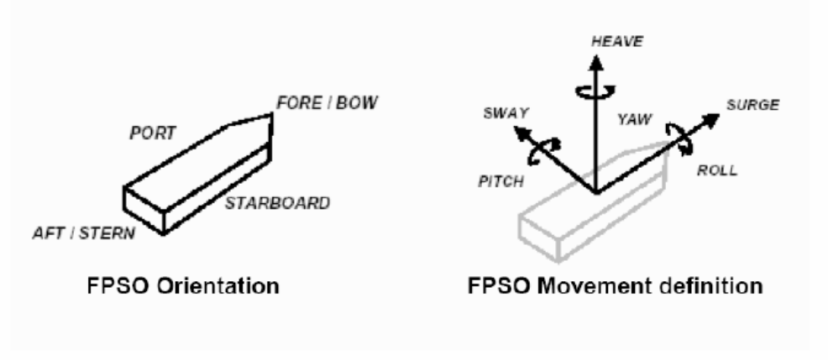
TECHNICAL ROOM ENVIRONMENTAL CONDITIONS
The environmental conditions of technical room in which the UCP will be installed are specified in the document revision .
PACKAGE ORIENTATION ON FPSO
FPSO axis
FPSO axis
Package main axis
Package main axis

Utilities
ELECTRICITY
Refer to:
- Project specification for electrical requirements for packaged units:
rev
- GS EP ELE 011
UCP UPS Earthing Regime:
UCP Normal Power Regime:
COOLING WATER SYSTEM
Type | Sea Water | Fresh Water
Normal inlet temperature |  |  |  | °C
Minimum inlet temperature |  |  |  | °C
Maximum inlet temperature |  |  |  | °C
Minimum outlet temperature |  |  |  | °C
Maximum outlet temperature |  |  |  | °C
Supply pressure |  |  |  | Barg
Max allowable delta P |  |  |  | Bar
Calorific capacity |  |  |  | kJ/kg°C
Fouling factor |  |  |  | m².°C.h/kcal

Tests

Factory tests (workshop)
The scope of this chapter is to describe the factory tests to be carried on the completely assembled air compressor and air dryer packages in Vendor facilities before unit shipment.
Factory tests shall demonstrate the correct design, manufacture and operation of the equipment and its satisfactory performance in accordance with the conditions identified in the mechanical data sheet. Works testing shall include a combined compressor package/dryer factory test to demonstrate compliance of the complete package with mechanical data sheet and specified performance requirements.
The following tests shall be carried on the completely assembled package:
- Performance testing of individual equipment item (electric motor, compressor, dryers)
- Pre-test activities
- Performance and mechanical running test of air compressor and air dryer packages. This activity shall include the functional test of all the main auxiliary systems of the package
- Assembled package shall be weighted before packing and shipment.
The following documentation shall be issued by Supplier prior the factory tests in workshop:
- Issue of the factory test procedures
- Issue “As built” drawings relevant to factory test,
The test procedure shall be issued 8 weeks prior the test (including noise and vibration measurement proposed procedure).
The results of each test shall be recorded in appropriate log sheets provided by Vendor and signed as “witnessed” by all the parties.
After the completion of the tests, Vendor shall issue an official test report including all the above log sheets. Copy of raw data registered during the tests shall be handed over right after each test activity for Contractor inspection record.
All tests identified as factory tests will be witnessed by Company or their representative.

Performance test
Performance testing of individual equipment items:
- Performance test of air dryers
- Electric motor routine test
- Performance test of each air compressor at 100% load.

Pre-test activities
Before commencing the factory testing of the completely assembled packages, the following minimum pre-test activities shall be carried out:
- Checking the compliance of the equipment with the Project specifications
- Weights and dimensional checks before packing
- Checking the certificates of compliance for the hazardous area components
- Calibration of all Project instruments. Relevant calibration certificates shall be available at the time of the test for Contractor review. Spot checks of instruments calibration shall be required before test commencing
- Instrumentation and electrical equipment insulation and continuity tests
- All instrumentation and electrical equipment functions shall be verified, including simulation, shut-downs and remote signals
- Control loops checks and functional test
- Instruments, controls, alarms and safety devices
- Safety and protection devices operational checks
- Serial link test
- Equipment tagging and labeling checks
- Mechanical equipment alignment check
- Pneumatic pressure tested piping system with compressed air or nitrogen
- Leakage tests with air compressed at max operational pressure
- Lube oil flushing and cleanliness
- Verification of the dynamic stiffness of the test bench as per GS EP MEC 300.
The reports relevant to the mechanical equipment alignment check and to flushing and cleanliness checks shall be available for Contractor review during test when applicable.
Before commencing the tests the package shall be cleaned by Vendor and shall be visually inspected by Contractor.

Performance and mechanical running tests
Supplier shall provide all temporary equipment required for implementation of the tests, including, but not limited to temporary connections, hardware to simulate signals and interfaces external to the supplied equipment etc.
Supplier shall be responsible, as well for providing all utility services needed to perform the test in proper conditions.
The complete unit test, four (4) hours uninterrupted continuous duration, shall be carried out on units fully erected, commissioned and shall involve all Contract equipment listed in the scope of supply.
The complete unit test shall consist of two (2) x 100% or three (3) x 50% compressors and two (2) x 100% dryers connected together.
When three (3) x 50% configuration, two (2) x 50% compressors, at a time, and one (1) x 100% dryer shall be run together for four (4) hours each.
The compressors shall be operated at the rated point, and the flow from the each compressor and each one dryer, shall be verified to be at the guarantee conditions specified on the mechanical data sheets.
The complete unit test shall consist of:
- Performance and mechanical test of compressors with Contract electric motors, Contract air dryers, all Contract auxiliaries items, Contract UCP and associated instrumentation
- Flow shall be verified by means of flow transmitter and orifice plate, flange type according to ISO 5167
- Instrument air analysis in accordance with the guidelines of ANSI/ISA-7.0.01 - Annex C - Section C.3 - Tests. The Dew point shall be monitored
- Emergency trips such as but not limited to manual stop, low lube oil temperature, etc.
- Operational checks such as but not limited to start/stop normal sequences, emergency stop sequences, etc.
- Noise measurements shall be performed when unit is at full load as per GS EP MEC 300
- Vibration record.
Vibration shall be measured during the shop test of the assembled machine operating over the agreed speed range. Acceptance limits shall be as per ISO 10816-3. Contract vibration monitoring equipment shall be used.
All running parameters shall be recorded every thirty minutes.
Each test shall be subject to a test report issued by Supplier and submitted to Company and Contractor.

Communication link test
Factory test shall also include PLC communication tests with Contractor supplied control system.
Contract UCP shall be 100% checked and tested, including all input/output simulations and all logic and sequences at the control panel Manufacturer’s premises prior to dispatch the equipment to the unit assembling location.

Site acceptance tests
Site acceptance of the unit will be pronounced only after the satisfactory completion of the field acceptance tests.
Such tests shall demonstrate that the air compressor and air dryer package meet the mechanical and performance requirements within the specified operating range and conditions.
This test shall be carried out on the site or at integration yard, in operating conditions, with the air compressor and air dryer packages connected to the distribution network.

Spare parts and special tools
This paragraph gives guidelines to set the choice of spare parts and special tools for this project. It shall be read in conjunction with GS EP EXP 217.

Spare parts

Commissioning and start-up spare parts
As a minimum, Vendor shall supply the following spare parts:
Compressor:
- Pre-filters
- Air filters elements
- Compressor oil filters
- Solenoid valves
- Gaskets.
Programmable Logic Controller (PLC):
- Power cards
- Digital input/output cards
- Analog input cards
- Fuses, lamps, relays.
Dryer skid:
- Pre-filters
- Post-filters.

Capital or insurance spare parts
The Vendor shall quote the following:
- A spare compressor set (complete LP and HP rotor and casing) fully tested as identified as per paragraph 7 of this specification
- Complete LP and HP pinions
- One set of gearbox bearings
- Bull gear.

Special tools
Where special tools and fixtures are required to disassemble, assemble or maintain the packages, they shall be identified, listed and included in the Supplier quotation and furnished as part of the initial supply of the package.
Installation kit for spare LP and HP compressors is required as a minimum.

Preparation for shipment
The purpose of the preservation and shipment requirement is to assure the best economical protection against adverse atmospheric weather, corrosion build up and mechanical damage due to storage and transportation from Vendor (Manufacturers, Packagers and Contractors) premises to Contractor yards and from Contractor yards to Company site.
The Vendor and/or Manufacturer shall issue necessary procedures which shall be applied to any equipment to cover:
- The preservation during workshop storage
- The preservation, packing and fastening of equipment during transportation from Vendor facilities to Contractor yard construction
- The preservation during the construction works on the Contractor yard
- The preservation, packing and fastening of equipment during towing from Construction yard to Company site.
The procedures shall contain a check list including all preservation and packing tasks.
The hereafter requirements shall also be applied to the capital spares delivered with the Contract. The capital spares shall always be preserved and packed for long term outside storage.

Preservation
The preservation duration will be selected by the Project in the package data sheet and/or equipment data sheets.
Two types of preservation can be applied depending on Project needs: short term preservation or long term preservation.
The considered preservation shall be valid for shipment between:
- Vendor workshop and Contractor yard
- Contractor yard and site.
The short term preservation shall cover a period up to six (6) consecutive months after processing of the preservation. The considered storage shall be outside without protection.
The long term preservation shall cover a period up to twelve (12) consecutive months and be annually renewable during five (5) years.
The desiccant products shall be free of DMF (dimethyl fumarate) content and shall be selected from Silica base. The regeneration of desiccant products is a mandatory requirement and shall be done by heating.
The desiccant products shall conform to NF H00-320 or DIN 55473 or US MIL D 3464E standards.
The VCI (Volatile Corrosion Inhibitor) and VPI (Vapor Phase Inhibitor) shall conform to the norm US MIL-STD-2073-1 E. However necessary care shall be taken to use approved products compatible with the materials needing to be preserved.
All desiccant products locations shall be provided with a metallic label indicating their presence.
The last mechanical and/or performance runs can be done with anti-corrosion additives mixed with the lube oil. However Vendor shall demonstrate that the anti-corrosion additives shall not compromise the life of the equipment.
All opening shall be closed with metallic blind and gasket to be air and water sealed.
Metallic labels with necessary cautions and instruction to remove preservative products prior equipment start-up shall be provided.
The labels shall be made of metal with black marking on yellow back ground.

Compressor
After completion of the tests, compressor Manufacturer standard preservation shall be applied following the below tasks, not limited to:
- Draining
- Drying
- Cleaning
- Insertion of desiccant product where necessary
- Sealing of openings with metallic blinds.

Instrumentation and electrical auxiliaries
- Draining
- Drying
- Insertion of soft bags desiccant products in instrument junction boxes and in instrument head
- Sealing of openings.

Control panels
- Draining, where needed
- Drying
- Cleaning of panels
- Packing of all equipments not rack mounted
- Insertion of soft bags desiccant product inside the control panel
- Positive locking of all doors
- Sealing of openings.

Auxiliaries
The package auxiliaries generally include piping, filters, heat exchangers, valves, ducting, structural frames.
- Draining
- Drying
- Cleaning
- Spraying, if any, of TectylTM or VCI
- Spraying Water resistant wax TectylTM and wrapping on all non painted interfaces
- Sealing of opening.

Packing

Weather protection
The design of the packing shall procure an optimal weather protection during oversea transportation and Contractor yard storage.
During the detail engineering phase, Contractor, in conjunction with Vendor, has to issue and submit the preservation and sea fastening procedures to Company representative for approval.
Contractor shall be fully responsible of equipment preservation until provisional acceptance on site.
The weather protection shall be made of heat welded multilayer film (polyester, aluminum, polyethylene) and shall be installed around the package. All lifting appliances and lifting points shall be provided outside the weather protection and shall not be subject to losses of sealing. The film shall conform to NF H00-310 or US MIL PRF 131K standards.
Prior to weld and seal the multilayer film, the hereafter sequences shall be applied, but are not limited to:
- A sweeping with Nitrogen shall be performed in order to remove the internal moisture as much as possible to get low residual humidity
- A set of desiccant bags shall be included to absorb residual moisture and trap during transportation and storage the moisture passing through the multilayer film envelope
- A moisture indicator (sensitive paper) shall be included inside the envelope prior sealing to perform the traceability of the internal atmosphere during transport and storage.

Mechanical and infestation protection
The mechanical and infestation protection shall be performed by a use of multilayer wooden plates (plywood).
The multilayer wooden plates shall be sea water resistant in case of overseas transportation. A selection of multilayer wooden plates in accordance with marine immersion resistant, french standard CTBX or equal classification requirements is required.
The construction of the overall mechanical protection shall be done in such a way that internal or external members shall not damage the weather protection.
The construction shall be in such a way that rodents and insects cannot enter inside the box.

Fastening
All devices needed for the fastening, whatever the transportation mode considered (sea, onshore, rails, dirty and/or ice roads), shall be provided external to the mechanical protection. The fastening shall not affect the weather/mechanical protection integrity.
The fastening shall be part of the equipment design engineering phase and shall be provided to avoid any modification and/or welding on the equipment during its installation until completion.

Marking
The minimal requirements for marking shall conform to the ISO 780 code in addition to the specific requirement of the Project.

Compressor specific
The compressor shall be preserved as per clause 9.1.1 and packed as per clause 9.2 during transportation from Vendor facilities to Contractor yard and from Contractor yard to Company site.
All sensitive parts like antifriction bearing, rotor shaft, shall be locked in place and insulated by means of shock absorber. The rotor locking devices shall be labeled with metallic instructions and cautions label with black making on yellow colored back ground labels shall be provided.
The locking devices shall be supplied by the Vendor.
For capital spares, internal or external vibrations and shocks absorbers and shock loggers shall be provided. Drop acceleration limit shall be indicated by the Supplier.

Loose shipped items and auxiliaries
The loose shipped items delivered with the Contract (including commissioning, start-up and capital spare parts) shall be preserved as per clause 9.1 and shall be packed inside a VCI plastic bags as per clause 9.2.1 and clause 9.2.2 during transportation from Vendor facilities to Contractor yard and from Contractor yard to Company site.
The packing boxes shall be provided with:
- Internal or external vibrations and shocks absorbers.
- External lifting and handling devices and fastening provisions
- External marking in accordance with ISO 780 and Project specific requirements
- Internal harness and/or means for fastening
- Moisture indicator
- Internal or external provision for documentation storage
- External blank marking area and/or location to attached the AWB (Air Way Bill).

Transportation
The Notified body responsible for transportation between Vendor facilities and port of shipment shall perform the assessment of the means, risks and constraints.
It shall be clearly specified in the Vendor proposal the means to be used for transportation, the loading of the equipments and the induced constraints due to sea, road, rails transportation in terms of equipment assembly and number of packs.
A preliminary packing list including packing dimensions and weight table shall be attached to the Vendor proposal to give possibility to Company to assess the transportation impacts prior Contract award.
The handling, loading and unloading procedures and the lifting drawings shall be part of the engineering phase and shall be developed by the Vendor.
The spreader bars, the lifting beams and ancillaries (slings, shackles) shall be supplied by Vendor and shall be load tested and certified by third party notified body. The use of synthetic slings is not allowed.

- Definitions and abbreviations
Company Total E&P or any Total E&P subsidiary
Contractor Any Company Total E&P has signed a Contract with for the Engineering, Procurement, Construction and Installation of a part of a project
DMF Dimethyl Fumarate
HMI Human Machine Interface
ICSS Integrated Control Safety system
ITP Inspection Test Plan
MCC Motor Control Center
NDT Non Destructive Test
OEM Original Equipment Manufacturer
Package Prefabricated process or utility self-contained unit, generally able to operate on its own, supplied fully tested and ready for immediate installation
PLC Programmable Logic Controller
SAT Site Acceptance Test
SPL Spare Parts List
Supplier or Vendor The package Supplier or Vendor
UCP Unit Control Panel
VCI Volatile Corrosion Inhibitor
VPI Vapor Phase Inhibitor
VTMS Vibration & Temperature Monitoring System
- Package schematic
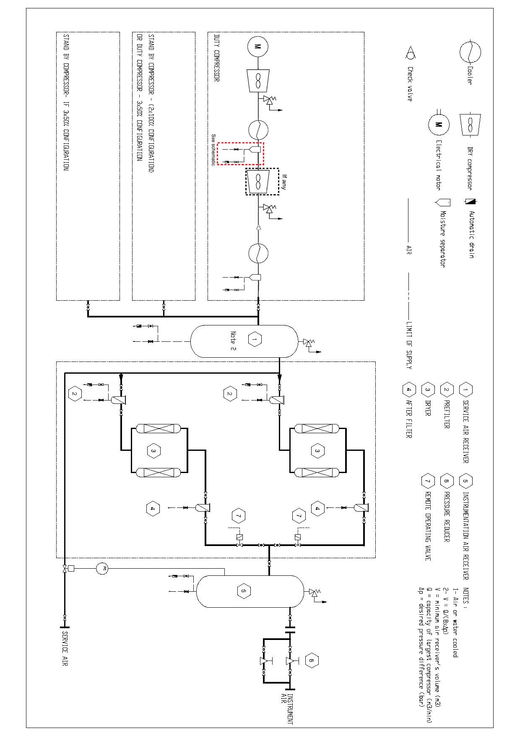
Schematic for drain level control
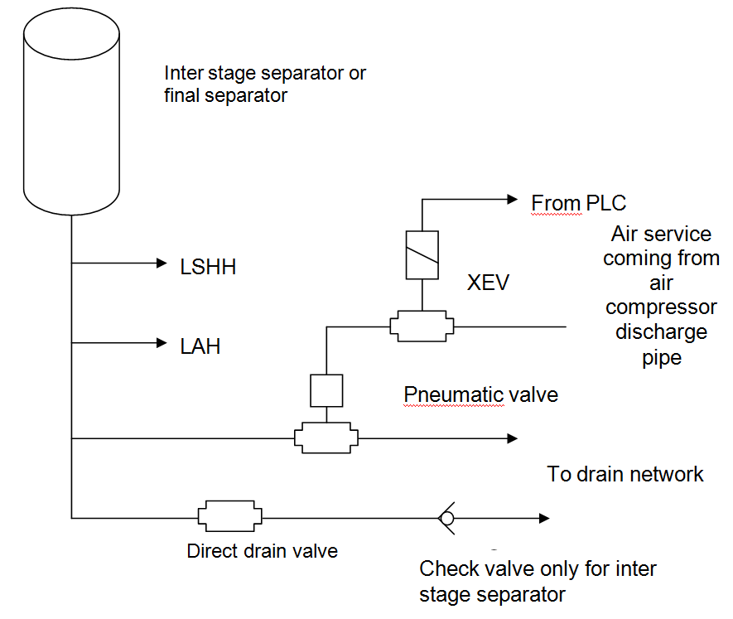
- Baseplate installation
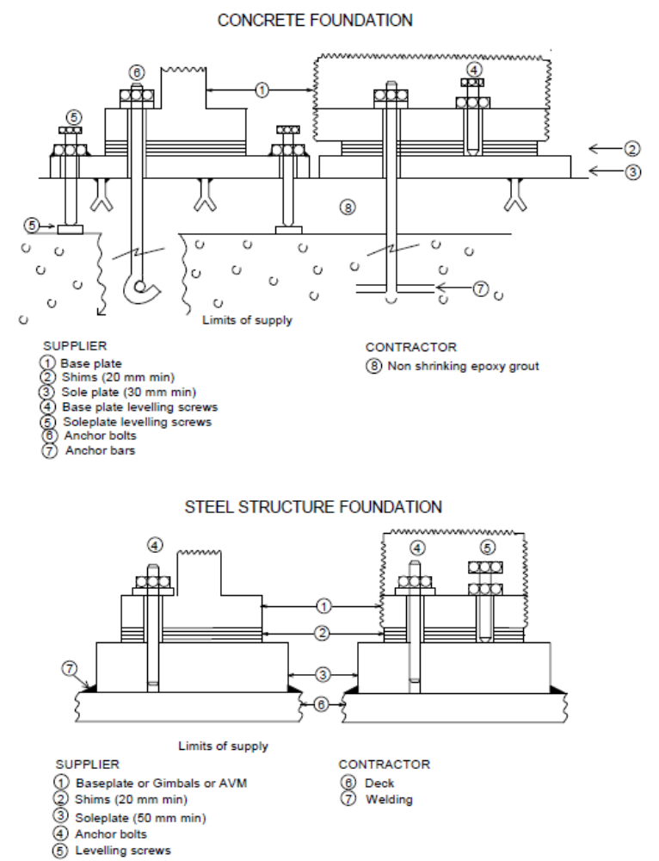
- Vendor Document Register (VDR)
The following documents shall be delivered by the Package Vendor. This list is a mandatory base frame but might be extended on a Project basis.
(1) Documents to be supplied with offer.
Item | Designation | (1)
1 | General
1.1 | Vendor document register | X
1.2 | Deviation list | X
1.3 | Monthly report
1.4 | Sub-Vendors List | X
1.5 | Quality Plan
1.6 | Inspection and Test Plan | X
1.7 | Declaration of conformity for ATEX
2 | Arrangements
2.1 | General Arrangement drawing for Air compressor and Air dryer Packages | X
2.2 | Foundation Drawings
2.3 | Limits of supply table (interface and connection schedule) | X
2.4 | Allowable nozzles loads
2.5 | Lifting Drawing
2.6 | Unit Control Panel | X
3 | Data sheets
3.1 | Air compressor data sheet | X
3.2 | Air dryer data sheet | X
3.3 | Heat Exchanger Data sheet
3.4 | Electric motor data sheet | X
3.5 | Noise data sheet
3.6 | Weight data sheet
3.7 | Maintenance data sheet
3.8 | Instruments data sheet
3.9 | Other data sheets (LV motors, valves, lube oil filters etc.)
4 | P&IDs & Lists
4.1 | P&ID symbols table
4.2 | PFD and PID’s | X
4.3 | Equipment list / Bill of materials | X
4.4 | Load and Utilities List | X
4.5 | Lubrication list and schedule
5 | Detail drawings
5.1 | Compressor Outline drawing
5.2 | Compressor sectional drawing and associated part list
5.3 | Outline drawings (moisture separators, coupling, heat exchangers, pre-filters, ROV, PSV…)
5.4 | Electric motor Outline drawing
5.5 | Electric motor sectional drawing and associated part list
5.6 | Electric motor terminal box Outline
5.7 | Local gauge Outline
5.8 | Dew point analyzer Outline
5.9 | Wet/ Dry air receivers drawing
5.10 | Equipment data plate drawing
5.11 | Isometrics of lines
5.12 | Piping Classes | X
6 | Instrumentation and Controls
6.1 | Junction Boxes dimension and termination diagram
6.2 | Control philosophy and Functional analysis
6.3 | Instruments hook up Diagrams
6.4 | Instruments list
6.5 | HMI displays
6.6 | PLC software
6.7 | Instruments and electrical cables list
6.8 | Modbus list including addressing
6.9 | I/O list
6.10 | Instrument index S4l format
6.11 | Alarm / shut down list
6.12 | Interconnecting diagram (instrumentation and electrical)
6.13 | Earthing diagram
6.14 | Logic diagrams
6.15 | Cause and effect chart
6.16 | Instrument loop diagrams
6.17 | UCP terminal strips
6.18 | Junction boxes terminal strips
6.19 | Wiring diagrams
6.20 | Obsolescence dossier
7 | Calculations & Performances data
7.1 | Process performance calculation air dryer
7.2 | Lateral analysis calculation note
7.3 | Baseplate calculation note
7.4 | Safety relief valve calculation
7.5 | Other calculation notes (valves, actuators, flow transmitters, etc.)
7.6 | Pressure vessel code calculation for dryer/vessel
8 | Manuals/ procedures/ other lists
8.1 | Painting specification
8.2 | Installation and operating manual index
8.3 | Installation and operating manual
8.4 | Special tools list
8.5 | Start up and commissioning spare parts list | X
8.6 | Priced operating spare parts list
8.7 | Capital spare parts list | X
8.8 | Packing index and packing list
8.9 | Storage prior and after erection procedure
8.10 | Weighing procedure
8.11 | Performance/ mechanical running test procedure
8.12 | UCP test procedure
8.13 | Factory test for complete package procedure
8.14 | SAT procedure
8.15 | Reports for the above tests (2)
8.16 | Preservation procedure
8.17 | Packing procedure
9 | Manufacturing / Quality / HSE documents
9.1 | NDE procedures
9.2 | Welding procedures
9.3 | Material certificates
9.4 | All tests and inspections certificates
9.5 | QA/ QC (Manufacturing data book) index
9.6 | QA/ QC (Manufacturing data book) Dossier
(2) The package string test report shall include pictures of the package (four side views and four isometric views)
- Minimum inspection requirements
As a minimum, the following inspections shall be witnessed by the Company:
- Functional, performance and mechanical running test of all air compressors and air dryers units
- Final inspection
- Final Dossier data book review.

Note: This list does not include the inspections to be conducted by Contractor and by Third Party or Classification Company on each sub-equipment composing the package.
- Deviations to the contractual documents
If deviations are waived during the bid phase, they shall be listed in the following pages in the purchase revision.

The deviation list shall exhibit at least the following:
- Reference of the specification
- Paragraph of the specification
- Description of the deviation
- Reason for deviation
- Vendor proposal
- Company final position.

The deviations that are not accepted by Company shall appear in this list in order to give a complete overview of the technical discussions.

The following list contains pages.

Note: The deviation list might not be attached to this specification but referenced under a project document (as reported below).

Project document reference:
Revision
- Data sheet
Data sheet DS EP MEC 033.
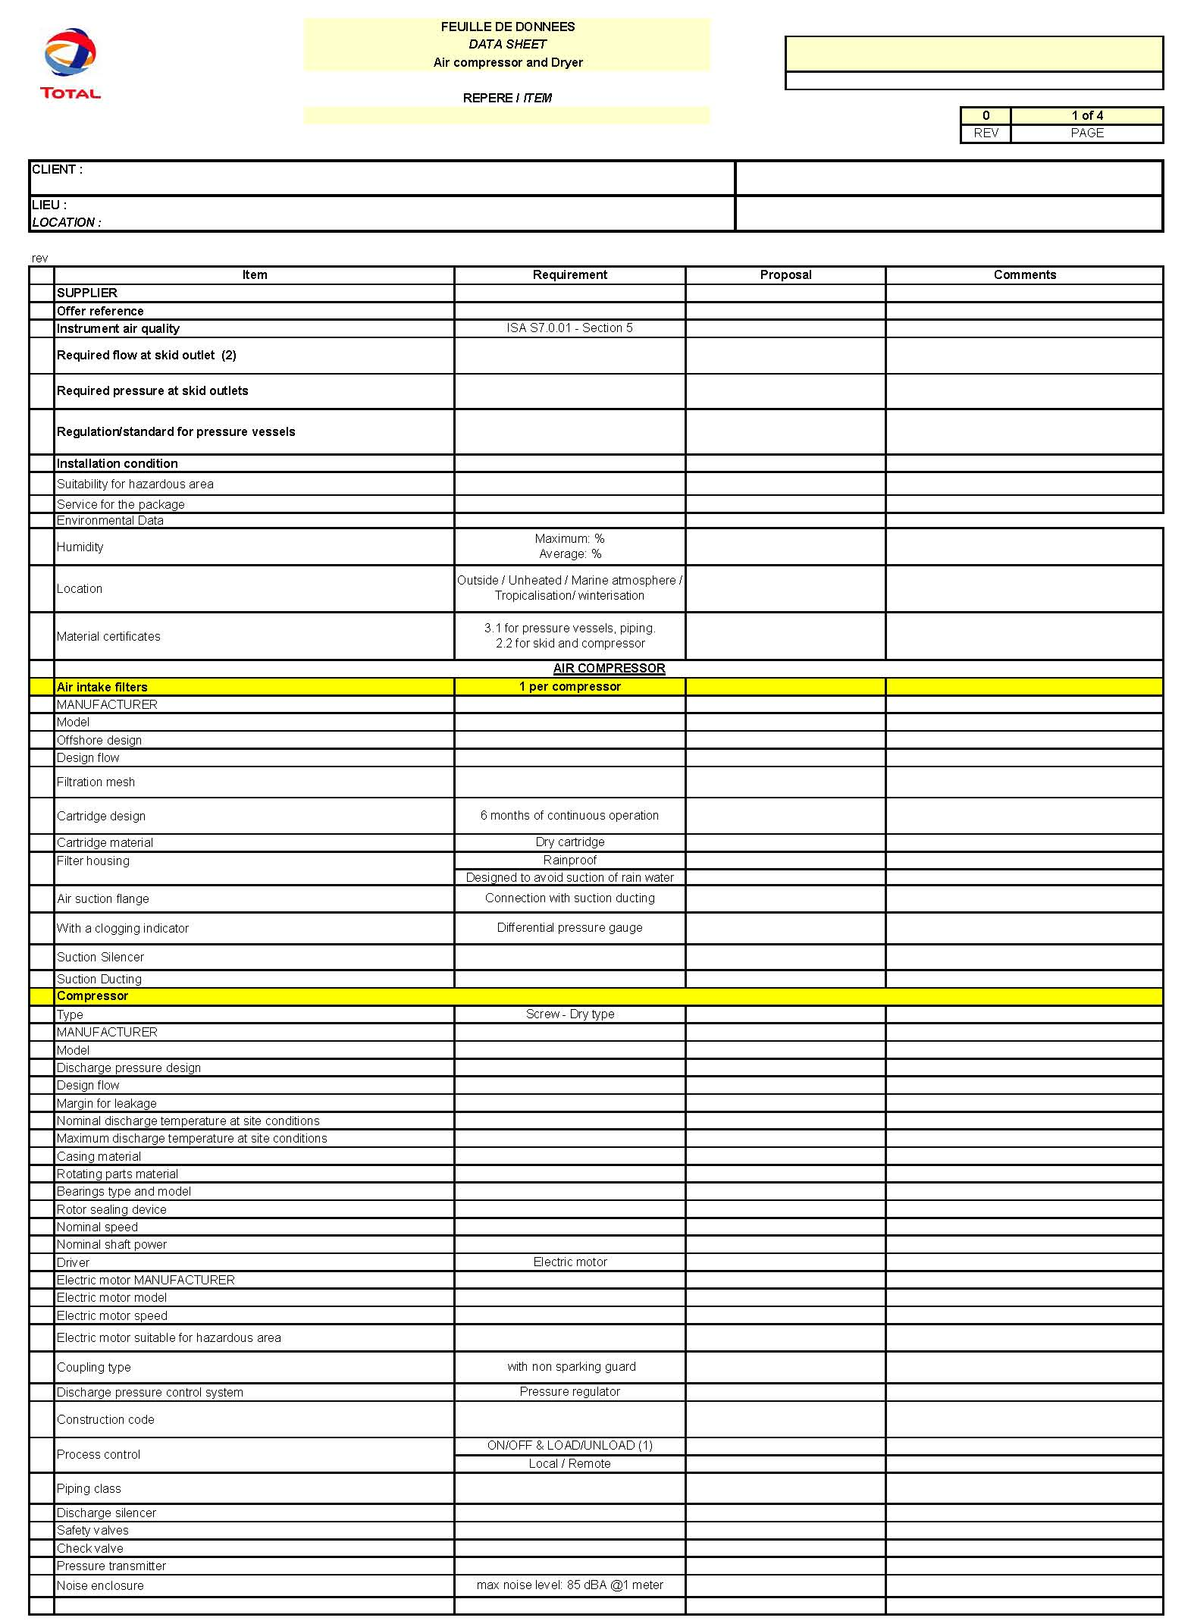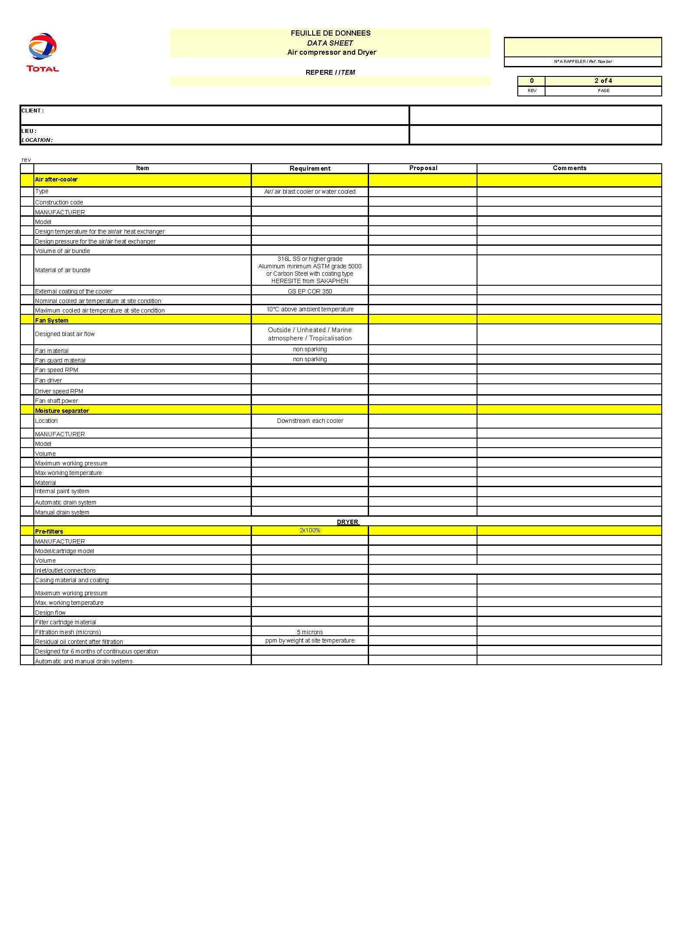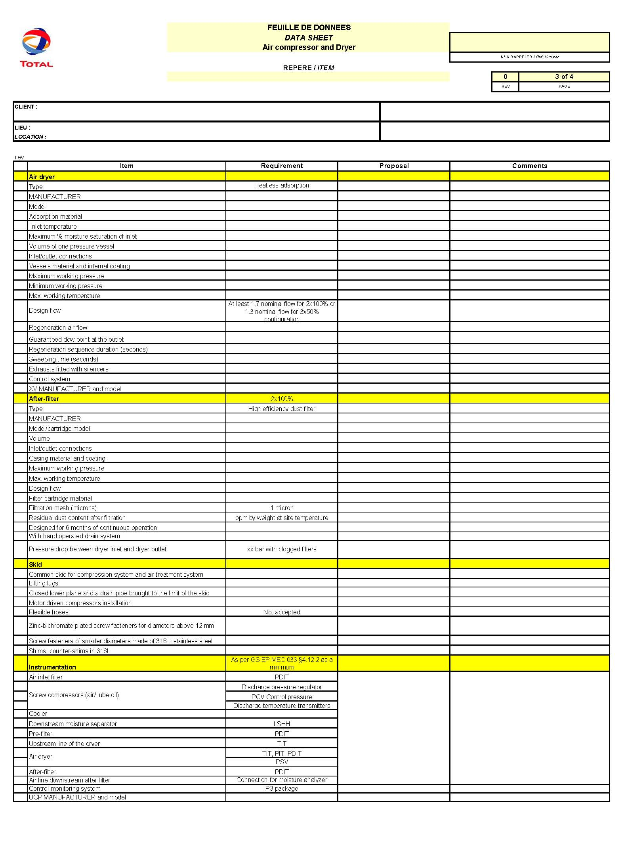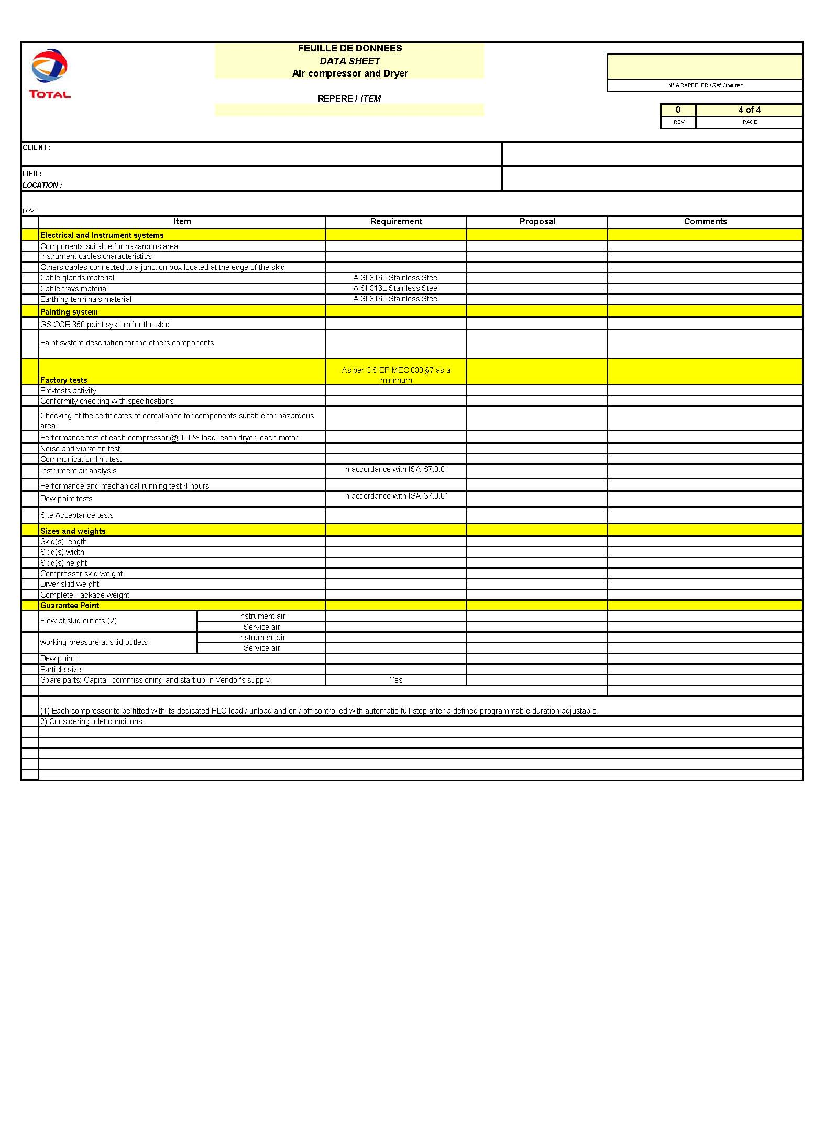

Reference to Articles 100/118 of the Treaty of Rome
Reference to Articles 95/137 of the Treaty of Amsterdam

