- The project, which started in April 1996, had the objective of providing a unified structural integrity evaluation method which is applicable across a wide range of European industries.
- The project covered three types of work areas,
- the first of was been to bring together existing information from many different sources through collation and review exercises.
- Secondly, the gathered information was enhanced through experimental and modeling work to improve the scope, quality and validation of the information.
- The third step was the derivation of a structural integrity assessment procedure with the aim of representing a 'best practice' approach for use by engineers in a range of European Industries.
- In order to achieve these aims the project was divided into five task areas addressing:
- Weld Strength Mis-match, Failure of Cracked Components, Probabilistic Methods,
- Residual Stresses and Procedure Development. The overall procedure draws on the
- consortium's experience gained in various assessment procedures, including, but by no
- means limited to, BS PD 6493, R6, the Engineering Treatment Model (ETM) and large scale tests such as those of wide plate specimens.

- The SINTAP procedure is only concerned with the evaluation of plastic collapse and
- fracture. Other failure modes such as fatigue, environmental damage, high temperature
- creep and creep crack growth are not the subject of this procedure

- This procedure is divided into the following areas:
- (I) Description and Methodology
- (II) Inputs and Calculations
- (III) Further details and compendia
- (IV) Alternatives and additions to standard methods

- In this document, the results of a fracture assessment may be represented either in
- terms of a crack driving force or a failure assessment diagram. In the former, the crack
- driving force (for example, the applied J-integral) can be plotted as a function of flaw
- size for different applied loads, or as a function of load for different flaw sizes and
- compared to the material's resistance to fracture. In the latter, an assessment is
- represented by a point or a curve on a diagram and fracture judged by the position of
- the point or curve relative to a failure assessment line. Wherever possible, these two
- approaches have been made consistent so that the results of an assessment are not
- dependent on the representation chosen.

- Applicability: The procedure described is based on fracture mechanics principles and is applicable to the assessment of metallic structures containing actual or postulated flaws. The purpose of the procedure is to determine the significance, in terms of fracture and plastic collapse, of flaws present in metallic structures and components.

- This document mapped three major application for itself: 1-Design Phase 2- Fabrication Phase and 3- Operational Phase
- In formations in this standard are grouped into following: (I) Description, (II) Inputs and, Calculations, (III) Further Details and Compendia, (IV) Alternatives and Additions to Standard Methods
- The methods described in this procedure were derived by collating existing information, and by the undertaking of experimental and analytical modeling work.
- The materials to which the procedure can be applied cover the full range of metallic materials although emphasis throughout has been on welded steels since more data are available for this class of materials and these account for the majority of cases to which the methods would be applied.
- The procedure is applicable to combinations of brittle fracture and plastic collapse.
- Two approaches for determining the integrity of cracked structures and components have been selected for the SINTAP procedures. The first uses the concept of a Failure Assessment Diagram (FAD) and the second a diagram which uses a crack driving force curve (CDF). Both approaches are based on the same scientific principles, and give identical results when the input data are treated identically.

- In the FAD approach, both the comparison of the crack tip driving force with the material's
- fracture toughness and the applied load with the plastic load limit are performed at
- the same time. In the CDF approach the crack driving force is plotted and compared
- directly with the material's fracture toughness. Separate analysis is carried out for
- the plastic limit analysis There is no technical advantage in using one approach over the other.

- There are two options for this, one characterising the initiation of fracture (whether by
- ductile or brittle mechanisms), the other characterising crack growth by ductile
- tearing.

- The scatter in ductile fracture toughness is generally much less than in brittle fracture toughness, and for this reason the result may be based upon the minimum value obtained in a set of three specimens tests.

- Partial Safety Factors are factors which can be applied to the individual input variables
- which will give a target probabilistic reliability without the need to perform a full probability
- analysis.

- It should be noted, however, that the homogeneous material procedure is safe to use for mismatch cases when used with the tensile properties of the lower strength constituent of the joint

- material’s tensile properties exist, the minimum value should be used to calculate Lr consistent with the level of analysis, while best estimates should be used to calculate f(Lr) and Lrmax
- .
- All standard and advanced levels of analysis require the material’s fracture properties to be
- in the form of fracture toughness data. In some circumstances these may be as specified,
- or from test certificates supplied with the material, but in most cases they will be from
- specially conducted tests. The fracture data should relate to the material product form,
- microstructure (parent material, weld or heat affected zone ) and temperatures of interest.

- Characteristic values of the fracture toughness, Kmat, Jmat, or δmat, must be chosen by the
- user for the analysis. For assessing against the initiation of cracking a single value of
- fracture toughness is required, while for assessing in terms of ductile tearing, characteristic
- values will be a function of crack growth

- Where it is not possible to obtain fracture toughness data, the analyst may use the default
- option for initiation where the characteristic value is based upon correlations with the
- material’s Charpy impact data

- For the purposes of this procedure, secondary stresses
- cannot affect the failure of the structure under plastic collapse conditions, and all other
- stresses must be classed as primary

- In metallurgical terms, materials can fail in one of two mechanisms: ductile and brittle. The
- brittle mechanism is characteristic of ferritic and bainitic steels at low temperatures, but it
- can occur in other materials. Unless crack arrest occurs, the initiation of brittle fracture
- coincides with structural failure. As the temperature of a ferritic or bainitic steel is increased,
- the brittle fracture toughness rises markedly, until a temperature is reached where brittle
- fracture is no longer the prevailing failure mechanism. This is the transition temperature,
- above which the fracture mechanism is by ductile tearing. This ductile fracture is also the
- failure mechanism of most other materials and it is characterised by a resistance curve. Incontrast to the brittle fracture toughness, which appears as a single value of toughness
- defining the initiation of brittle fracture, the resistance curve is a rising function of crack
- extension. This resistance curve property means that, in structures made of ductile
- materials, structural failure does not generally coincide with the onset of ductile tearing, but
- occurs after some amount of crack growth. The amount of crack growth leading to
- structural failure is dependent upon geometry, loading and the resistance curve. An
- initiation analysis uses a characteristic value of toughness equivalent to the onset of
- cracking, whether brittle or ductile, while a ductile tearing analysis needs characteristic
- values which allow for ductile tearing.

- In the absence of appropriate fracture toughness data, Charpy data can be used to give a conservative estimate of fracture toughness by using appropriate correlations.

- he desirability of having appropriate toughness data cannot be emphasised too strongly,
- as this may be one of the main determinants in the accuracy of the assessment. The
- different mechanisms of fracture result in different forms of fracture toughness data, and
- these are treated in different ways in the recommended procedures. For brittle fracture, the
- recommended method is based on the concept of the Master Curve and maximum
- likelihood (MML) statistics. For ductile tearing, the minimum value of a set of three results is
- usually sufficient

- For fully ductile behaviour the toughness or resistance curve obtained depends upon the amount of tearing.

- Ductile tearing does not proceed by a weakest link model, and so ductile tearing data is not analysed using the MML method

- E399-08 Standard Test Method for Linear-Elastic Plane-Strain Fracture Toughness K Ic of Metallic Materials

- The stresses to be considered in the assessment are those which would be calculated by a
- stress analysis of the unflawed structure.

- In general, primary stresses are stresses which, if high enough, could cause failure by plastic collapse in the absence of any other failure mode intervening, while secondary stresses could not.

- 
- For fully penetrating flaws, or for flaws which requires to
- be recharacterised as fully penetrating, the yield load is the so-called global yield load,
- defined as the rigid-plastic limit load of the structure, calculated for a rigid-plastic material
- with a yield stress equal to Re. For part penetrating flaws, the yield load is the local limit
- load, i.e., the load needed to cause plasticity to spread across the remaining ligament,
calculated for an elastic perfectly plastic material of yield stress Re.

- The parameter ρ(a) takes account of plasticity corrections required to cover interactions
between σP and σS stresses and depends not only on flaw size but also on the magnitude of
the σP stresses (i.e., on Lr). A method for calculating σ is given in III.2.

- For semi-elliptical flaws, KI varies with location around the crack front, the maximum value being dependent on the stress gradient. Some solutions provide averaged values of KI while others provide values at specific locations, typically at the major and minor axes. Maximum values should always be used, where these are available.

- SINTAP has used an alternative value for ρ which is called V exactly same Φ as in API579
As an alternative to the additive factor q used for determining Kr in equation II.4.2, the SINTAP project has developed a multiplying factor, V. If this factor is preferred, the definition of Kr changes to that in equation II.4.3. The calculation of V is described in III.2, The two approaches are fully compatible using the recommended definitions of ρ and V.
- This document sets out a step-by-step procedure for assessing the integrity of structures containing defects.

- 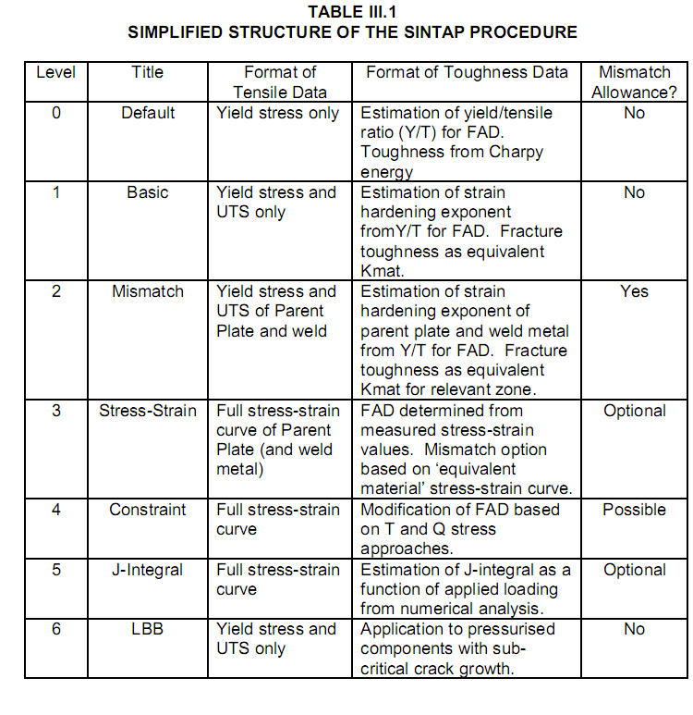
- The Level 0 curve is the easiest
- to apply and requires only the yield stress to be known; Level 1 is applicable to homogeneous
- materials and requires a knowledge of the ultimate strength as well as the yield strength;
- Level 2 is a specific mis-match assessment level and requires knowledge of yield stress and
- ultimate tensile stress of base metal and weld metal. Level 3 requires additional information on
- the material stress-strain properties and can be applied to homogeneous materials or those
- cases where weld strength mis-match is an issue; Level 4 invokes constraint treatment while
- Level 5 requires results of detailed elastic-plastic analysis of the defective component. Level 6
- is applicable only to fluid - containing structures.

- Note, however, that an assessment is insensitive to the precise value of toughness in collapse-dominated situations. Greater benefit in obtaining a more precise value of fracture toughness occurs for assessments towards the left-hand fracture-dominated part of the failure assessment diagram

- SINTAP has a compendium of solutions which contains both stress intensity factors and limit loads.

